SECTION-10

CUSTOMS OF SERVICES

Introduction

1. The Services have their own customs some of which have been handed down from the distant past while some others are of more recent origin. A custom is an established usage and consist of positive actions which are reasonably and universally accepted. Customs make for a more orderly life and when continued for a long period, they become “Unwritten Law”.

2. The customs of the Armed Forces are traditional and belong to the noblest of professions viz., the profession of arms. Chivalry and comradeship in arms count above every thing else. The maintenance of tradition is a tremendous unifying and driving force. It develops esprit-de-corps.

3. To a novice the customs and traditions of the Armed Forces may seem peculiar but once their origin is analysed and the meaning understood, it would be found that they are of immense value in developing the ‘esprit-de-corps’ and the pride in one’s service.

4. In the subsequent paras, some of the customs and traditions of the Services have been explained.

Saluting

5. It is customary in the services that a junior salutes his senior. This is done by bringing the open palm to one’s cap. The origin of the custom is traced to antiquity but it is said that the custom started when one person intending to establish his good intentions, opened his palm to show that he held no offensive weapon. Later, during the days of the Knights, one would disarm himself by lifting his open hand to his head to throw back his visor and thereby reveal his features. He thus indicated his recognition to the other person as a friend. The outcome of these ceremonies is the present day salute.

6. The present day hand salute in the Army and the Air Force consists of bringing the open palm to the side of the head including the cap. In the Navy, however, the hand is raised to the cap with the palm downwards. It is said that this is done so as not to show “grubby” hands of the sailors working on the deck.

7. The salute with the sword is a relic of the days when the crusaders kissed the cross on their sword before engaging in combat. To indicate friendliness to somebody, he would lower the sword and lay open his defence to show his trust, in the other person.

8. The “present arms” with the rifle is symbolic of disarming oneself. The rifle is held in such a position as to suggest that is being offered as a mark of trust and friendship.

9. The dipping of the tank gun, or the ensign on a ship and wings of the aircrafts over the saluting base are all symbolic of a gesture of friendship and trust in the person being saluted. It would, therefore, be seen that there is nothing subservient in saluting another person. It is mark of trust, friendliness and respect for the person. The custom should be followed scrupulously and one must take pride in it. At the same time, it is the duty of the person being saluted to respond to the salute with equal pride.

Paying of Compliments

10. Whether on or off parade, whether in uniform or mufti, officers are expected to pay normal compliments to their seniors in rank. This is not only a matter of discipline but also of common courtesy, and must be observed scrupulously at all times. Never ‘acknowledge’ a salute from an other rank, as though it was your right, but return it smartly and with pride:-

(a) When in Uniform. In civil life, when one meets a lady or gentleman out of doors, it is normal to take off one’s hat to her or him. The military equivalent of this is to salute when in uniform. The correct way to wish a lady or gentleman when in uniform and not wearing head dress is to come to attention and bow slightly, say the appropriate words of greeting and shaking hands if the person greeted offers her or his hand.

(b) When in Mufti. As officers are permitted to wear plain clothes to put them at ease and to save them the formalities connected with uniform, they should pay the same courtesies that a civilian would pay when meeting a lady or a superior or an elderly person. Thus it would be proper to raise the hat, or rise if seated or bow slightly and greet the person concerned appropriately, ie. “good morning” or “ good evening”.

(c) If other ranks recognize you and salute, never fail to return it in the proper manner. Do not salute if without head dress , but just say “Ram Ram” or “Sat Sri Akal” according to the class of the other rank. Raise your hat if you are wearing one.

Saluting National Flag

11. It is customary to salute the National Flag when it is being hoisted or hauled down at ‘Reveille and Retreat’. Officers will face the flag staff, stand to attention and salute. NCC Cadets and other ranks only stand to attention. The same custom is observed in case of the Regimental Flag. When Reveille or Retreat is being sounded all ranks will come to attention if they are within hearing distance of the bugle and remain at ‘Attention’ till the bugle ends. It is not followed while under a roof.

National Anthem

12. If played during a ceremonial parade, all officers in uniform stand at attention and salute. In mufti, all officers stand at attention and remove their hats. NCC Cadets only stand at attention and do not salute.
Courtesy on Warship

13. On boarding or leaving a ship of the Indian Navy, an officer must salute the quarter-deck. If the ‘Officer on the watch’ is present at the quarter-deck, he will salute a senior officer on the occasion or return the salute of the junior officers.

On Other Occasions

14. When riding bicycle/horse or riding a mechanical vehicle, the soldier will not salute because of the danger in taking off his eyes from the road. But when stationery, eyes right or left will be given without removing the hands from the wheel or bar as the case may be. When a group of soldiers are standing in vishram they will come to attention and senior most soldier among them alone will salute. When two or more officers are together senior most officer among them will return the salute.

Decoration and Medals

15. The decorations and medals a serviceman is permitted to wear are visible vidence of the recognition and reward he had earned for outstanding acts of personal bravery and distinguished service in theatres of war or during a national emergency. Decorations and medals are potential incentives to greater efforts and are instrumental in building and maintaining good morale.

Dress

16. It is a custom, as well as requirement that serviceman and NCC Cadets present a good appearance at all time. In old days servicemen’s uniforms were very colourful and won admiration of the general public. Today, the uniforms have been changed to suit modern requirement of camouflage, utility, hygiene and economy. They still earn the nations admiration. Therefore, it is imperative that the serviceman and NCC Cadets take pride in their uniforms and always present a good turn-out.

Battle Honours

17. Battle honours are given to Unit / Regiments by the Government for the heroic act done by Units / Regiments as a whole. The winners of battle honours rightly take a lot of pride in them.

Colours

18. Colours are symbolic of the spirit of a Regiment. The sight of the colours creates a feeling of pride in soldiers and from ancient history have served as an inspiration for heroic acts of self-sacrifice. The origin of the colours can be traced back to the early battles when they marked the commander’s position on the battlefield. It also served as rallying point in battle. Till late in the 19th century, colours were taken into battle and were always kept in the front so that the soldiers could see them and draw inspiration. It was a matter of honour that the Regiment would not let their colours fall.

19. Later, owing to the altered form of attack and the increased range of musketry, the colours were not carried into battle. The colours, however, retain their pride of place in the Regiments. Now-a-days the colours are laid in place of honour, usually the officers’ mess or quarter guard.

20. The colours are awarded to a regiment by the President for their honourable service and all the battle honours of the Regiment are emblazened on the colours.

21. All infantry regiments, with the exception of rifle regiments, carry colours. Armoured Corps regiments carry standard and guidons with the exception of the Lancers.

Officer Mess

22. General. An Officer’s mess is an institution which influences all aspects of an officer’s life. It moulds his character and his way of life to a great extent. Mess customs and traditions instill in officers particularly the younger ones, a strong sense of loyalty and co-operation, and an even stronger sense of esprit-de-corps. The mess is a common home of all officers of a unit.

23. Dress Officers take pride in their turnout, whether in uniform or in plain clothes. Do not enter the mess with a cap or hat on. A brush is provided outside the ante-room so that officers can brush their shoes before they enter the mess. Officers should ensure that the guests they invite do conform to their mess rules in regard to dress in the mess. If they are not properly dressed, they should not be taken into the ante-room, but entertained in some other room, verandah or in the garden.

24. Conduct in the Mess. The following general points govern an officers conduct in the mess:-

(a) If there is an officer of field rank in the mess when you enter, bow slightly to him with an appropriate greeting, ie. “good morning” or “good evening”. Similarly, when an officer of field rank enters the room, you must stand up and greet him. Officers must stand up and greet the senior dining member when he enters the mess.

(b) When a visitor, Service or civilian, regardless of rank, enters mess, one must stand up and greet him courteously and offer him a drink or a smoke. Make him feel at home but never force drinks on anybody.

(c) Be punctual on all occasions.

(d) Do not visit the mess during working hours unless you are on the sick list or on leave or have to go there in connection with some work. In nine cases out of ten you are neglecting your duty elsewhere and everybody knows it.

(e) Do not discuss controversial or forbidden subjects, ie. religion or politics. Avoid talking “shop” as far as possible. Never indulge in loose gossip about women.

(f) Before you turn on the radio/TV ask others present if they have any objection.

(g) Dogs or other pets should not be taken in-side the mess.

(h) You must treat the mess property as your own. Do not remove anything from the mess without the permission of the president of the mess committee.

(j) The mess “suggestions book” if one exists, is not meant for entering complaints. It is meant for constructive suggestions for improvement of the mess. In marking suggestions avoid sarcasm or attempts at humour.

(k) If you are reading a newspaper or magazine and a senior officer of your unit comes in, getup and offer the paper to him if it is the only copy in the mess. Similarly, if you are sitting comfortably under a fan or in front of a fire, getup offer your seat to a senior officer when he arrives, if no other such seat is available.

(l) Bridge and some other games, at very small stakes, are the only “gambling” games permitted in a mess.

(m) You may read a newspaper or a periodical during breakfast and lunch but not at dinner. It is “not done” to read a book in the dining room.

25. Visitors and Guests. Do not invite all and sundry to your mess. Select your guests. You must obtain the permission from the president of the mess committee before you invite a guest to a regimental function. On regimental guest nights and other regimental social functions in the mess, every member is a host. It is the duty of members to see that no guest in left unattended.

26. Dinner Nights. A dinner night in the mess is a parade. Officers who have not signed out or not had permission to dine out, must be present at least five minutes before the scheduled time at which dinner commences.

27. Table Manners. Use the napkin and use correct knives and forks. Never pile your plate. If you want to have more have a second helping. Eat with your mouth closed and without making any sound. Do not talk when there is food in your mouth. Do not lean over the table for a any dish which is out of your reach instead ask your neighbour.

Smoking

28. It is improper for an officer/cadet to be seen smoking whilst in uniform on the following occasions:-

(a) Whilst saluting.

(b) Whilst marching with troops except during halts with the permission of senior.

(c) Whilst on parade or at range, at sports meet, obstacles course and such like functions.

Introductions

29. Introductions sometimes present difficulties. The normal rule is that a gentleman is introduced to a lady, a single women to a married woman, a younger to an older and a junior to a senior. Whilst introducing the names of both parties should be given clearly, e.g, “Major KALIA, may I introduce Mr KAPOOR” or “Mrs DEV, may I introduce Lieutenant Colonel KUMAR”.

Paying Compliments to Ladies

30. All officers will pay compliments to ladies on meeting them, even if a General meets wife of a Lt and recognizes her, he pays compliments to that lady. In uniform,
compliment is paid by saluting and in civil dress, the ladies are greeted in the normal way.

Conclusion

31. In conclusion, it must be emphasised that the customs and traditions in the Army and the other services are “Unwritten Laws” which every member of the service should observe thoroughly. The observance of the custom and traditions is a tremendous unifying force and facilitates admission into the clan of the “Men at arms”. The customs and traditions are of immense value in developing the esprit-de-corps and the pride in one’s service.

SECTION-11

IMPORTANCE OF GROUP/TEAM WORK

Definition of Group

1. A group can be defined as any number of people who share goals, often communicate with one another over a period of time, and are few enough so that each individual may communicate with all the others, person-to-person. Two or more people interacting to achieve a common objective is also called a group.

Classification / Types of Groups

2. Classification of group according to evolutions of primary goals is an given below:-

(a) Friendship Group. It evolves informally to meet its members’ personal security, esteem and belonging needs.

(b) Task Group. It is created by the management to accomplish certain organization goals. Task group can further be classified as under:-

(i) Formal Groups. They are established by an organization to facilitate the achievement of the organization goals.

(ii) Informal Group. It is one that develops out of the day-to-day activities, interactions and sentiments of the members for the purpose of meeting their social needs.

(iii) Effective Group. An effective group is one which has the following characteristics:-

(aa) Its members know why the group exists; they have shared goals.

(ab) Its members support agreed upon guidelines and procedures for making decisions.

(ac) Its members communicate freely among themselves.

(ad) Its members have learned to receive help from one another and to give help to one another.

(ae) Its members have learned to deal with conflict within the group.

(af) Its members have learned to diagnose individual and group processes and improve their own and the group’s functioning.
Importance of Group

3. In a group people come together to achieve some common objectives for which they work in a structured fashion and utilise resources to reach pre-determined goals and targets.

4. A group carries a lots of power in it. One work which seems impossible, can be done by a group strength very easily. We have a number of examples of group work around us. India is itself a great example of group work. India is probably the only country in the world where people belong to different languages, having different cultures, modes of living, clothing, feeding habits and even different Gods and deities. Inspite of all these differences, they live together in harmony and even believe to be the children of one mother called “Mother India”.

5. We are one large nation with one central authority. In India we have unity in diversity and we work together to make our country a developed country. It is because of the strength of the nation as a group only that India could achieve freedom in 1947.

Characteristics of a Mature Group

6. (a) An increasing ability to be self directed (not dependent on the leader).

(b) An increased tolerance that progress takes time.

(c) An increasing sensitivity to their own feelings and those of others.

(d) Improvement in the ability to withstand tension, frustration and disagreement.

(e) A perception of the common denominators, which bind the group as well as areas of individual difference.

(f) A better ability to anticipate realistic results of behavior to channel emotions into more socially acceptable ways of expressing these emotions.

(g) An increased ability to change plans and methods as new situations develop.

(h) A decrease in time needed to recover from threatening group situations. Peaks and valleys of emotional group crises become less personal.

(j) Increased efficiency in locating problems, engaging in problem solving and providing help to individuals as needed.

(k) A willingness to face one`s own responsibilities and to assist others when help is needed.

(l) An acceptance of the right of the other person to be different.

Definition of Team

7. When two or more people who are interdependent, who share responsibility for outcomes, who see themselves and are seen by others as an intact social entity in a larger social system are called as “Teams”. When teams are formed, its member must have (or quickly develop) the right mix of complementary competencies to achieve the team’s goals. Also its members need to be able to influence how they will work together to accomplish those goals.

Importance of Team

8. A team is a small number of employees with complementary competencies (abilities, skills and knowledge) who are committed to common performance, goals and working relationship for which they hold themselves mutually accountable.

9. A key aim of teamwork is group synergy, namely the achievement of high quality as a result of combined individual contributions . Synergy can help you solve complex problems because you will be working with people who have a wide range of skills and perspective. Students working in teams benefit particularly from brainstorming and bouncing ideas of each other, learning from each other, discussing work in teams outside contact times and checking results.

10. In a team we can establish an agreed set of team guidelines. We know team members, their strengths, and preferred ways of working and preferred roles. We can discuss the task problems to arrive at a shared understanding and summarise this shared understanding of any project.

Types of Teams

11. (a) Functional Teams. They usually represent individuals who work together daily on a cluster of ongoing and independent tasks. Functional teams often exist within functional departments, marketing, production, finance, auditing, human resources and the like.

(b) Problem Solving Teams. They focus on specific issues in their areas of responsibility, develop potential solutions and are often empowered to take actions within defined limits.

(c) Cross - Functional Teams. They bring together the knowledge and skills of people from various work areas to identity and solve mutual problems.

(d) Self - Managed Teams. They normally consist of employees who must work together effectively daily to manufacture entire product (or major identifiable component) or service.

Characteristics of a Team

12. (a) Illusion of invulnerability.
(b) Collective rationalization.
(c) Unquestioned belief.
(d) Stereotypical views.
(e) Direct pressure.
(f) Self censorship.
(g) Shared illusion of unanimity.

CHAPTER-VI

CIVIL AFFAIRS/DISASTER MANAGEMENT

INDEX

CHAPTER-VI CIVIL AFFAIRS/ DISASTER MANAGEMENT |  | JD/JW | SD/SW
SECTION-1 | Civil Defence Organisation and its Duties | √ | √
SECTION-2 | Types of Emergencies /Naturals Disaster | √ | √
SECTION-3 | Fire Fighting | √ | √
SECTION-4 | Essential Services and their Maintenance | √ | √
SECTION-5 | Protection | √ | -
SECTION-6 | Role of NCC during Natural Hazards | √ | -
SECTION-7 | Traffic Control in Disaster Management under Police Supervision | - | √
SECTION-8 | Disaster Management during Flood/Cyclone | - | √
SECTION-9 | Disaster Management during Earth Quake | - | √
SECTION-10 | Setting up Relief Camp during  Disaster Management | - | √
SECTION-11 | Assistance in Removal of Debris | - | √
SECTION-12 | Collection and Distribution of Aid Material | - | √
SECTION-I3 | Message Services | - | √

SECTION-1

CIVIL DEFENCE ORGANISATION AND ITS DUTIES

Introduction

1. The aim of war is to force the ‘National will’ on the enemy. This is achieved by crippling his capacity to withstand war, by demoralising the population, destruction of production potential and rupturing of communication. To minimise the suffering caused by the war, it is necessary to take civil defence measures.

Civil Defence (CD)

2. It is a measure adopted by the civilian population, Government, local self bodies and voluntary organisation etc. during the war to minimize the effects of enemy action on men and material. In short, it is the defence of the citizen by the citizen.

3. Civil defence is the much misunderstood subject because it is often confused with the air raid precautions taken during the war. There are many other measures necessary to deal with effects of direct and indirect raids and such measures can not be disassociated from the civil defence measures. Civil defence measures consist of the following:-

(a) Protective Preventive Measures. Measures which may be taken before an air raid, such as dispersal of population and industries, camouflage, preparation of shelter, warning and training etc.

(b) Control Measures. The measures taken immediately after the raid, such as reconnaissance, reporting of damage and unexploded bombs, rescue of casualties, control of services, clearance of debris and extinguishing of fires.

(c) Restorative Measures. The measures which become necessary after an air raid include feeding, providing shelter and clothing, salvage of property, disposal of dead, disposal of unexploded bombs, control of infection and contamination, repair of damages caused to utility services etc.

Organisation at District Level

4. In a district the District Magistrate is the ultimate authority on CD. He is designated as the controller of Civil Defence. He is responsible for implementation of all CD measures by the district departmental heads such as Civil Surgeon, Superintendent of Police, PWD Engineer, Publicity Officers etc. They are appointed by him as in-charge of various civil defence services. He also constitutes an Advisory Committee out of the people possessing qualities of leadership and discipline who can arouse and sustain public interest in the Civil Defence Services.

Civil Defence Service

5. At local level the various existing agencies will be responsible for organising suitable CD services on the subject entrusted to the agency in normal times, e.g. Civil S Surgeon in charge of Casualty Services, Civil Defence officer in charge of Supply Services and so on. The various civil defence services are as under:-

(a) Headquarters Service. This service works under control of CD.

(b) Warden’s Service. It is a link between the public and the authorities. This service is responsible for organizing self help parties, fire parties and to check light restrictions, report damages and guide homeless to the Rest Centres.

(c) Fire Fighting Service. They detect small fires and put out the same.

(d) Casualty Services. The functions of this service are:-

(i) Rendering first aid on the spot.

(ii) Providing transport to casualties for short distances.

(iii) To send various causalities for further treatment.

(e) Communication Services. This service is responsible for:-

(i) Receipt and dissemination of air raid warning.

(ii) Provision of co-ordination and control facilities.

(iii) Provision of communication between warden posts, control centres through messengers or telephone etc.

(f) Training Services. This service is responsible to train the necessary staff in the Civil Defence duties.

(g) Rescue Services. Their duty is to rescue the injured and personnel trapped under the debris.

(h) Welfare Services. It is responsible to supply information about missing and dead etc. to provide shelter, food and clothing and to arrange evacuation from vulnerable areas.

(j) Depot and Transport Services. It is this service which is responsible to send various services to the scene of incident and provide necessary transport required from time to time.

(k) Salvage Service. It is responsible to salvage the damaged property and keep it in safe custody.
(l) Corpse Disposal Service. This service is responsible for collection, identification and disposal of dead bodies.

(m) Supply Service. This service is responsible for planning, organising and procuring necessary equipment for CD Services and proper storage and quick distribution of equipment at the time of need.

(n) Besides the above noted services the CD organisation will be required to set up Repair and Demolition Parties and make arrangements for the care of animals through appropriate existing agencies operating in the town.

6. Working of all the above noted services will be co-ordinated by the Headquarters Services working under the direct control of CD Controller. NCC can help the Civil Defence by helping them in Welfare Services and Message Services.

SECTION-2

TYPES OF EMERGENCIES /NATURALS DISASTERS

Introduction

1. Since the dawn of civilization, human society, natural environment and disasters have been closely interlinked. Natural disasters and the increasing environment degradation world-wide are serious threats to development. Natural disasters threaten all three dimensions of development to include economic, social and environmental. In the past twenty years, earthquakes, volcanic eruptions, landslide, floods, tropical storms, droughts and other natural calamities have killed over three million people, inflicted injury, disease, homelessness and misery on one billion others, and caused billons of dollars of material damage. Currently annual global economic costs related to disaster events average US$1200 billion per year and it is likely to double by the Year 2025. 80 percent of the world’s population resides in developing countries and it has been estimated that upto 60 percent of these people are highly vulnerable to floods, severe storms and earthquakes. Besides 90 percent of the natural disasters and 95 percent of the total disaster-related deaths world-wide, occur in the developing countries. Since the 1960s, economic losses due to disasters have increased at least fivefold. These losses are growing largely due to the increasing concentration of population and investments in vulnerable locations as well as inadequate measures to reduce risk.

2. The term disaster is commonly used to denote any odd event natural or man made which brings about immense misery to a region and it becomes difficult to cope with the situation through local resources.
Classification of Disasters

3. Disasters can be classified based on nature of onset (rapid/ slow), natural and manmade disasters as under:-

- Natural Disaster.

(i) Wind Related - Storm, Cyclone, Tornado, Storm surge and Tidal waves.

(ii) Water Related - Flood, Cloudburst, Flash flood, Excessive rains and Drought.

(iii) Earth Related - Earthquake, Tsunamis, Avalanches, Landslides and Volcanic eruptions.
- Man Made Disasters.
(i) Accidents. Road, Rail, Air, Sea and Building collapse.
- Industrial Mishaps. Gas Leak, explosion, sabotage and safety breach.
- Fire. Building, Coal and Oil.
- Forest Fire. In tropical countries forest fires are often manmade.
- Contamination/Poisoning. Food, water, illicit-liquor and epidemics.
- Terrorists Activities.
- Ecological. Pollution (air, water, noise), soil degradation, loss of biodiversity, global warming, sea level rise, toxic wastes and nuclear accidents.
- Warfare. Conventional, chemical and nuclear.

4. A few important ones are described below:-

(a) Earthquake. Layers of rock make up the earth’s surface. Rocks do not bend or break easily. Tension caused by movement of Earth’s plates, build up over the years until the rocks can take the strain no longer. Suddenly they crack and shift, sending out shock waves, and reducing anything built on the surface to rubble. This is what we call an earthquake. The shock of the initial earthquake may be followed by a series of aftershocks over the next few days. These fade as the rocks settle down into their new positions.

(b) Tsunamis. This giant wave is caused by an undersea earthquake. Vibrations rush through the ocean at hundreds of kilometers an hour. When they reach shallow waters they slow down and build up into vast waves, at times 76m (250 ft) tall. The tsunami crashes onto the shore, sweeping away anything in its way.

(c) Volcanoes. Volcano is like a vent or chimney to the earth’s surface from a reservoir of molten rock, called magma, deep in the crust of the earth. The eruption occurs when slabs of rock forming the Earth’s surface, called plates, begin to move. When old plates collide, and one is ground down beneath the next, the plates melt and produce very violent volcanoes. Other types of volcanoes also exist, such as those that form as new plates grow. The molten material wells from the mantle, spurting up as quiet volcanoes. Some volcanoes lie away from the plate edges, above a very active spot in the Earth’s mantle. A study shows that approximately 600 volcanoes are active or have erupted. On an average, about 50 volcanoes erupt every year. At present, about 10 percent of the world’s population lives on or near potentially dangerous volcanoes.

(d) Landslides. Landslides generally occur as secondary effects of heavy rains storms, earthquakes and volcanic eruptions. It occurs as a result of changes, either sudden or global or gradual in the composition and structure of rocks or hydrology or vegetation on a slope. It covers a wide variety of landforms and processes involving the movement of soil under the influence of gravity.

(e) Hurricanes. Sometimes called Tropical Cyclones, typhoons, or willy-willies, hurricanes can rip up trees, destroy crops, and flatten buildings. Torrential rain causes flooding and coastal regions may be swamped by huge waves whipped up by winds that blow as fast as 300 km/h (185 mp). Hurricanes start to form when the Sun’s heat stirs up moist air over the oceans, where the temperature at the centre of the storm, called the eye, can be more than 300 km (185 miles) across and the winds only gale force. But as the eye narrows to about 50 km (30 miles) across, the winds begin to swirl around it at hurricane force. Every year, violent storms with torrential rains and very strong winds bring widespread devastation to coastlines and islands lying in their paths. Cyclones pose a major threat to lives and property in many parts of the world.

(f) Flood. It can arise from abnormally heavy precipitation, dam failures, rapid snow melting, river blockages or even burst water mains. It is usually sudden in onset. Types of floods can further be classified into Inland and Coastal floods. Major floods result in physical damage, deaths and injuries, problems in drinking water supply and food shortages and displacement of population.

(g) Drought. If, over about two weeks, there is less than 0.2 mm (1/100in) of precipitation, there is said to be a drought. Without reservoirs, there is not enough water for people and crops. Some places have extreme drought which lasts for many years. Droughts have disastrous and long term impact on the economy and can affect a large segment of the society which may last for months and in some cases several years. Generally, drought situation may be defined as a temporary reduction in water or moisture availability significantly below the normal or expected amount for a specific period. Drought is a slow onset phenomenon.

SECTION-3

FIRE FIGHTING

1. During the war, enemy is likely to cause maximum damage by bombing. Fire being the major cause of destruction during war, it is imperative that a country should be prepared to fight this evil.

What is Fire

2. When we light, flame is produced during combustion, which is called `Fire’. To produce fire a combustible substance must be heated to a certain temperature before it can burn.

Constituents

3. The following three elements are essential for combustion and its continuation :-

(a) Oxygen.

(b) Sufficient heat to raise the temperature of fuel to its burning point or ignition temperature.

(c) Combustible or burnable material (Solid, Liquid or Gas).

4. It should, therefore, be remembered that three things or conditions are necessary to start a fire and to sustain it. Fuel (Combustible material), Oxygen (Air) and sufficient Heat to raise the temperature of the fuel to its burning point, must be present at the same place and time.

Modes of Spread

5. The fire spreads by the transmission of heat in one or any combination of the following four ways:-

(a) Conduction. Transfer of heat by the intermediary material. Many materials which will not burn easily particularly metals are good conductors for transmitting heat. These materials when heated by the fire may ignite other combustible material with which these may be in contact.

(b) Convection. Transfer of heat through gases or smoke, Gases tend to rise until ceiling or roof is reached after which they spread sideways in a mushroom manner and ignite combustible materials located at higher levels than the original fire e.g. fire spreading onto top floor. The best method to check this is to remove or cool the combustible materials.

(c) Radiation. Radiation means transfer of heat from the source of fire, without heating the midway media e.g. air. The effect of radiation can be countered by forming a ‘water curtain’ between the fire and the object to be protected or the object may be removed or cooled.

(d) Direct Burning. This phenomenon is self-explanatory. Direct burning is often due to a combination of the above two or three factors viz, conduction, convection and radiation.

Fire Fighting

6. Fire can be extinguished if any one or more of the three main constituents are removed from the scene of fire. The fire can thus be extinguished by:-

(a) Starvation. Starvation means removal of fuel combustible material and it can be achieved by either segregation of fire and un-burnt fuel by removing either of them e.g. removing un-burnt combustible materials from a room on fire with the help of hook or otherwise or division of a large fire into several smaller ones to prevent the radiated heat from setting alight combustible material at some distance.

(b) Cooling. Cooling implies the removal of heat to lower the temperature of burning material to a point below its ignition point. This is usually achieved by water. When water is poured over a burning material, it absorbs heat, becomes hot and flows away or is converted into steam. The burning substance loses heat to the water and its temperature comes down to below its ignition temperature and so the fire is extinguished.

(c) Smothering. Smothering means ‘Choking’ or restricting the supply of Oxygen (Air) to the burning material. This is also called ‘blanketing’ and is achieved by sealing all the burning material from Oxygen (Air) by covering it with sand/dry earth/ foam or by creating an atmosphere over the fire of heavier than air inert gas.

7. To effect the above noted methods, the fire services and fire parties are organised.

House Fire Parties

8. It consists of four persons who carry stirrup pumps and water buckets. They act as fire watchers and work under the orders of the wardens. They carry one stirrup pump, two buckets, one torch and one hand axe. One steel helmet and one whistle per member is envisaged as personal equipment.

Auxiliary Fire Services

9. This consists of eight persons with Trailer pump which can throw water at the fire from a distance. The members of this Service are drawn from the Home Guards.

Fire Fighting Equipment

10. These appliances could be divided into the following four categories:-

(a) Fire Extinguishers.

(b) Stirrup Pumps.

(c) Buckets/Ghee Tin (Water /sand containers)

(d) Fire Beaters and Hooks.
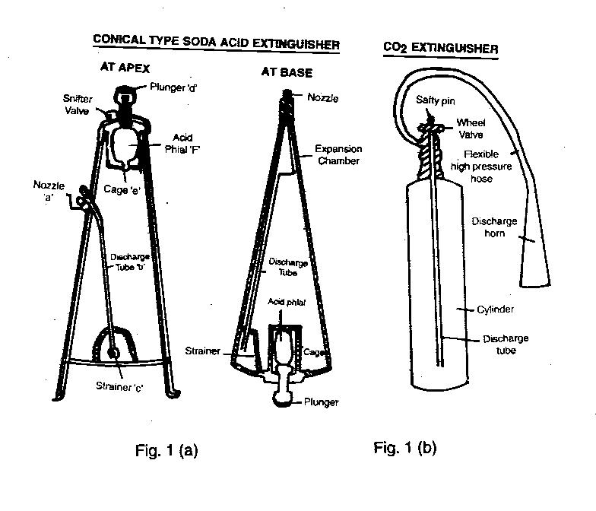

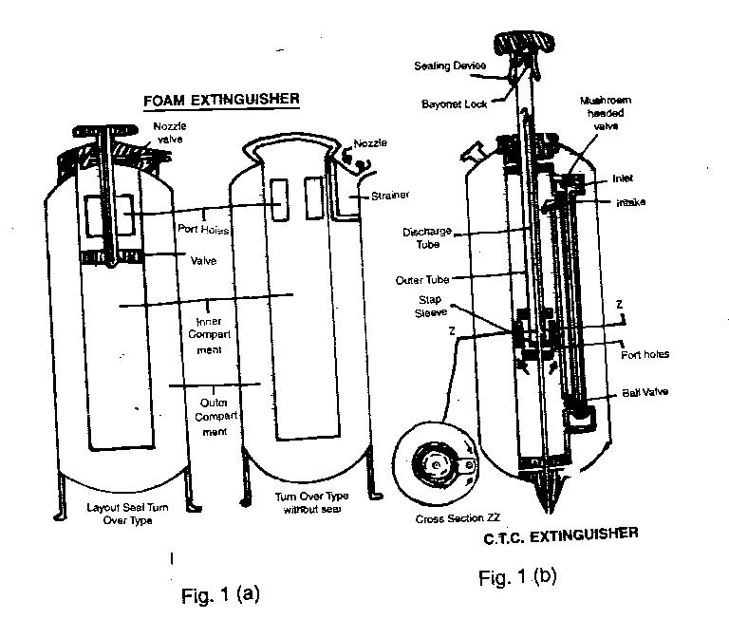
Fire Extinguishers

11. For the convenience of study, these could be grouped as under:-

(a) Fire extinguishers for extinguishing fires involving ordinary combustible material, where the cooling effect is achieved by water or solution containing large percentage of water. Under this group comes ‘Soda Acid Extinguishers’. Such extinguishers are conical /cylindrical in shape.

(b) Fire Extinguishers with chemicals, solution or dry, exclusively meant for extinguishing fires involving inflammable liquids such as oils, fats, grease, etc. where blanketing the fire to isolate it from Oxygen (Air) is required. Under this group comes ‘Foam Type Extinguishers’ and ‘ Dry Chemical Powder Extinguishers’.

(c) Fire extinguishers with chemicals either liquid, gas or dry, mainly to fight fires involving ‘Live’ electrical equipment etc. where the use of an electrically non-conductive extinguishing agent is of foremost importance. Under this group comes CTC Carbon dioxide and Dry Chemical Extinguishers.

12. The main advantages of these extinguishers are:-

(a) They are easy to operate.

(b) They need only one man to operate and carriage to another place.

(c) They are very useful in the initial stage of fire.

13. The disadvantages of these extinguishers are:-

(a) The use is limited as the duration of the working of the extinguishers is approximately one to two minutes.

(b) The cost of these extinguishers is prohibitive.

(c) These extinguishers require constant care and careful maintenance.

Stirrup Pumps

14. The stirrup pump is an excellent piece of first aid fire fighting equipment designed for use on small fire. It is very useful in localising and controlling fires with limited water supplies. Water spray from this equipment may be used on small fires for cooling the combustible material or the surrounding of scene of fire.

15. It is generally operated by a team of four members but in an emergency a team of two members can also operate it effectively. The water jet produced by this pump can hit the ground at a distance not less than 9 meters from the nozzle. The consumption of water is about 1 to 1-1/2 gallons per minute. The spray produced by this pump can reach 15 to 20 feet away from the nozzle with water consumption ¾ gallons per minute.

Bucket/Ghee Tins

16. Buckets/Ghee Tins are ideal for storing water and sand for fighting small fires. They could be easily carried by one person from one place to another.

Fire Beaters/Hooks

17. Beaters made of wire net in a rectangular shape and hooks made of iron fitted on bamboo poles are ideal for separating the burning and unburnt combustible material and extinguishing by beating the small fires.

SECTION-4

ESSENTIAL SERVICES AND THEIR MAINTENANCE

Introduction

1. The term ‘Essential Services’ means any public utility services, public safety or the maintenance of infrastructure and services necessary for the life of the community, non-availability of which would result in the infliction of grave hardship to the country as such.

Essential Services

2. Essential services primarily comprise:-

(a) Postal, telegraph or telephone service.
(b) Railways, road, air and sea transport service for the carriage of passengers or goods.

(c) Running of ports of (b) above.
(d) Provision of water, electricity and sanitation.
(e) Medical services and essential supplies.
(f) Production and supply of essential commodities.
(g) Running of mint and security presses.

Maintenance of Essential Services

3. These services are maintained by Govt at all cost and there are very rigid acts and provisions to ensure continuity of these services since without them life in country will go out of gear. Very strict provisions in law exist against personnel going on strike, refusing to work overtime or any other conduct which is likely to result in cessation or substantial retardation of work in maintaining these services. At district level, each district is required to prepare in advance, contingency plans to tackle the likely disturbances in continuity of these services. The relief measures to be catered in the contingency plans are discussed in succeeding paras.

4. Medical

(a) Medical facilities including first aid and hospitalisation.
(b) Plans to subdue likely sources of infection.
(c) Immunisation of population in relief camps to prevent spread of epidemics.

(d) Rescue of trapped persons.
(e) Disposal of dead bodies and carcasses.
5. Communication

(a) Maintenance of uninterrupted telecommunication through telephone /tele fax, mobile phones, VHF transmitters etc.

(b) Dissemination of information, monitoring media coverage and quelling rumours.

6. Transport

(a) Maintenance of rail/road communications with special attention to:-

(i) Damaged rail/ road network as it directly relates to the delivering of relief supplies by vehicles.

(ii) Possibility of bypassing damaged sections of the roads.

(b) Extent of containers that can be moved inland.

(c) Availability of maintenance facilities and spare parts.

(d) Measures for security of cargo in transit.

7. Infrastructure

(a) Infrastructure of roads and bridges, communications, water and electricity supply, sewerage and essential buildings such as schools/ colleges and health centres may be required to be rebuilt/ repaired .

(b) Housing and rehabilitation.

(c) For economic rehabilitation, funding and various new opportunities to be created, in addition to getting the destroyed stocks replenished, for restoration of livelihood.

8. Miscellaneous

(a) Provision of Military, Para Military assistance.

(b) Speedy establishment of Control Room and deployment of human and material resources in a short time.

Role of Cadets

9. Being qualified in First aid, Home Nursing, Signals and having developed leadership traits and learnt about Social Services and Civil Defence, the cadets of NCC could assist in maintaining the following essential services and important tasks in any and every part of the country:-

(a) Telephone exchange – as operators.

(b) Hospitals- as nurses and as links between doctors, nurses, patients and hospital technicians. They could also help in maintaining hospital discipline and security.

(c) First Aid Centres- establish and run these centres.

(d) Assist civil defence wardens in carrying out their duties.

(e) Carry out neighbourhood campaigns by motivating people to create self assistance groups.

(f) Counteract gossip and roumours to restore the morale of the people.

(g) Assist the civil authorities whenever feasible and to the best of ability. Some of the areas where cadets can help are:-

(i) Search for and rescue trapped people.

(ii) Salvage destroyed structures and property.

(iii) Distribution of relief material to the affected population for their temporary sustenance.

(iv) Coordinate the relief flow from out-side and ensure maximum coverage of territory in provision of relief stores, food and water avoiding wastage and duplication of work in the same area.

(v) Repair and restore essential services to enable rescue and relief work and for normalization of activities.

SECTION-5

PROTECTION

Warning

1. Timely warning of approaching enemy aeroplanes affords time for the people to take shelter and to enforce various civil defence measures including crash black out. Also warning about the withdrawal of threat are required for the people to come out of shelters and resume their work. Hence an efficient warning system will ensure sufficient warning time to take effective civil defence measures.

External Warning System

2. The collection and transmission of messages are included in the external warning system. Under this system the messages regarding the approaching and departing enemy aircrafts are passed by Air Force to the Regional CD Control Centres and from them to the Divisional Control Centres and from them to the Sub Divisional Control Centres.

Internal Warning System

3. Dissemination of the messages in an area under the jurisdiction of a CD Town Control Centre constitutes Internal Warning System. An air raid warning by the town control centre will be communicated to the CD units through telephones, radio link or messenger, who will in turn inform the general public by sounding sirens.

Type of Air Raid Messages

4. (a) Preliminary Caution. It is received by a limited number of officials on the special warning list such as Headquarters of Civil Defence Organisation, Police Fire brigade etc. This is called as `Air Raid Message-Yellow’.

(b) Action Warning. This warning is given when certain aircrafts are sighted towards a particular town for attack which may be attacked within five minute. This warning is called ‘Air Raid Warning-Red’. On receipt of this message, the sirens (hooters) are sounded for two minutes (a short blast followed by a long blast repeated at intervals of 3 seconds).

(c) Raider Passed. This means that raiding aircrafts have left the towns warned, or no longer appear to threaten these towns. This message is also called ‘Air Message- Green’. A continuous siren for two minutes is sounded.

(d) Cancel Caution. This means that the threat is over. This is called the ‘Air Message -White’ This message is passed on to only those who received the preliminary caution.

Protection Against Air Attack

5. The effects of bombing by the enemy aircraft can be reduced by training the public in taking the protective measures in the face of enemy threat. The risk of casuality could be reduced by taking adequate cover such as :-

(a) In the Trenches. The size of these trenches could be 8’ to 10’ long. 2’ to 2 ½’ wide and 4’ to 6’ deep. Eight to ten feet long units are dug in a zig-zag manner with an angle of 80 degrees to 100 degrees between each leg.

(b) In the Open. Lie on the ground with face downward resting on elbows with hands clasped behind the head so that chest is not in contact with the ground. Put a rolled handkerchief in between teeth.

(c) In a Vehicle. Park the vehicle in a side lane leaving the ignition key in its place and take cover in the open.

(d) Inside the Building. Be near the inside wall of the building. Places below staircases, archways, doorways, corners and under the cots are safer.

(e) In a Train. Turn off the lights and crawl under seats. On no account look outside the windows.

(f) In the Cinema. Remain seated on your seats.

(g) In a Bullock Cart or Tonga. Unyoke animals, tie them to the nearest tree or a pole, take shelter as in the open.

(h) Protection of Doors and Windows. Doors and windows can be screened by walls and sand bags.

Protection Against Aircraft Bombing

6. The protection against aircraft bombing is necessary for maintenance of morale of the people and saving the important installations. The important principle of protection is to interpose between the place of explosion and the object to be protected, anything which can neutralize the object to be protected, any thing which can neutralize the destructive effects of the bomb.

Methods of Protection

7. (a) Dispersion. Dispersion means reduction of congestion in the area of likely targets. No habitation should be allowed with in a radius of 500 to 1000 yards of Ammunition Factories, Aerodromes and so on.

(b) Camouflage and Concealment. It means denial of identity of the likely targets by camouflaging them artificially. This may be achieved by painting, by creating smoke screens, by black out or creating false targets.

(c) Shelters for the Public. The shelters for the people could be of two types- one to shelter large number of people called public shelters and the other to shelter families. Both of these could be either especially constructed or selected from the existing building.

Anti Splinter Measures

8. Unprotected glass is a potential source of danger as it is smashed by the blast and the splinters fly at great speed. These splinters may be cause of injury to human being and damage to property and machinery. As a protectional measure all the glasses should be removed and replaced by wooden paneling. Where it is not possible to remove the glass, anti splinter measures should be taken by fixing ½” wire netting or plywood screen very close to the glass. This could also be achieved by taking anti-splinter measures by pasting fabric/paper to the glass with the help of adhesive.

Sand Bagging

9. The splinters might travel through the opening like door and windows causing injury to persons and property. To prevent this, opening could be closed by erecting baffle walls. The thickness of these walls may depend upon the materials used. Width of brick walls should not be less than 13-1/2” and that of sand bags wall should be 30” to give standard protection.

Rescue Party

10. As a result of enemy air raids, many buildings will be damaged. A large number of people will be buried under debris and a large number may find themselves trapped on upper floors of high buildings. Rescue parties are required to rescue the trapped persons from damaged buildings. Rescue parties are formed by earmarking suitable Home Guard personnel and giving them requisite training for being able to perform the task of rescuing people in emergencies.

Composition

11. A Rescue Party will consist of eight persons which includes leader, six rescuers and one driver-cum-store-keeper. They are provided with a vehicle having sufficient capacity to carry the personnel and the equipment required for rescue operations.

Location

12. They are located at the Civil Defence Depots.

Training

13. Training in rescue techniques and rescue operations will be imparted by the instructors, who are trained specially for this purpose.

Operation Procedure

14. On receipt of report of damage during an air raid the officer-in-charge, control/sub-control centre orders for the despatch of the required number of Rescue Parties from Depot to the place of incident. On arrival at the site, the Rescue Party Leader reports to the Warden and collects necessary information regarding the number and the whereabouts of the causalities trapped. He carries out the recee based on information and observation and formulates his line of action and starts rescue operations.

Debris Clearance

15. Debris clearance may be necessary where no information is available as to the approximate position of the trapped persons. Some times debris may have to be removed to clear a road block at the site of damage. Whenever there is a reasonable chance of recovering causalities, the debris clearance should be carried out by Rescue Party. The debris should, if possible be removed clear of the damaged building and not merely from one part of the site to another. The general clearance of debris for making roads/paths for vehicular traffic should be carried out simultaneously.

Methods of Rescue

16. There might be occasions when a stretcher is not available. Therefore, some other means must be employed to rescue the casualties. Such means are known as emergency methods of rescue, they are:-

(a) Methods Suitable for One Rescuer. Human Crutch, Pick-a-back (reverse), Fireman’s lift. Rescue crawl, Removal downstairs, Bowline drag and Toe drag.

(b) Methods Suitable for More than One Rescuer. Two handed seat, Three handed seat, Fourhanded seat, Fore and Aft method, Two-man Human Crutch, Clothes lift, Blanket lift.

(c) Improvised Stretcher. Blankets, sheets or rugs salvaged from the site can be converted into improvised stretchers by using small poles, broom handles etc.

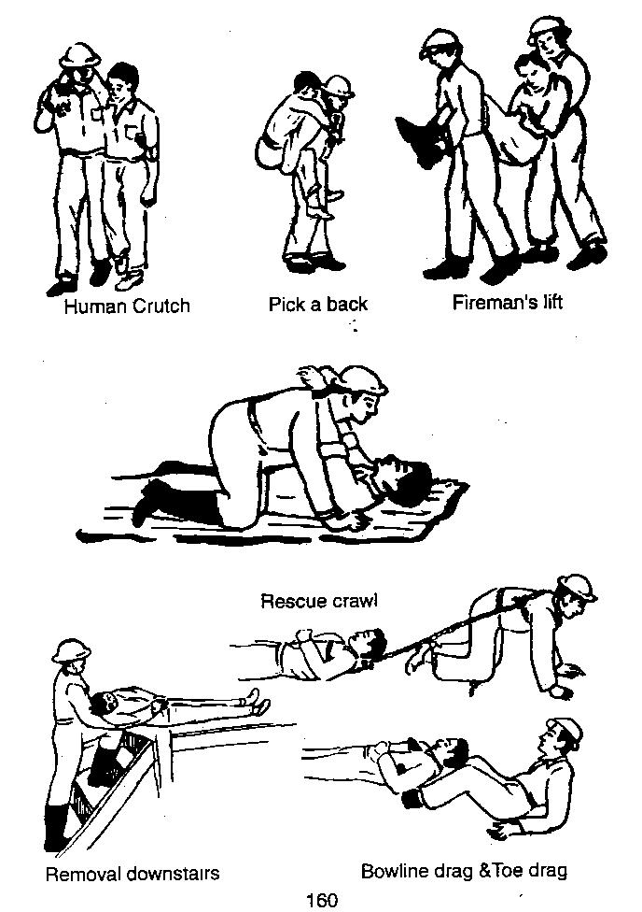

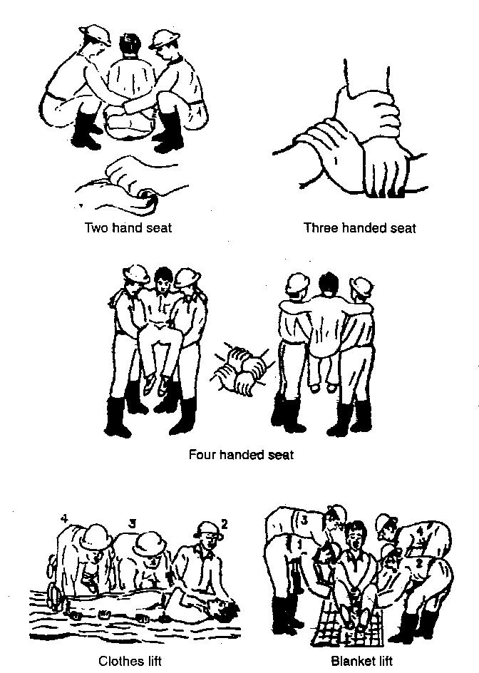

(d) Rescue from High Buildings. Rescue from high buildings would be necessitated when certain persons may find themselves trapped on the upper floors of high buildings. The methods used for this purpose are, Leaning ladder method, Ladder hinge method, Sliding stretcher on two parallel ropes, Sliding stretcher on one or two ladders and Two point and Four point suspension method.

Evacuation of Casualties

17. All casualties after being rescued are given immediate fist aid by the First Aid Party and those requiring the attention of the doctor are transferred to the First Aid Post. Here the injured are seen by the doctor, who may dispose them off in one of the following three ways:-

(a) If the injury is trivial, it is attended to and patient is allowed to go home.

(b) If the injury is moderate but does not require admission to hospital, it
is treated and patient is allowed to go home and directed to report again as needed.

(c) If the injury is severe and requires immediate treatment, the patient is transported in the First Aid Post ambulance to the nearest hospital.

CD Patrol Lookouts

18. Warden selects volunteers from the localities under him to work as CD patrols / lookouts. They are made responsible to ensure lighting restrictions and also to collect information about unexploded bombs, fires and damage to the buildings and keep the warden posted.

Messenger Service

19. Messenger service works under the orders of officer-in-charge communication service. Their duty is to carry messages from warden posts to control/sub control centres and vice versa. They are authorized on the scale of one per post.

Routes and Location

20. Each warden will keep the map of the area showing the boundaries of various posts, areas with its streets, roads, houses and important places. The map should also show the shelters, fire stations, CD Depots, First Aid Post and Hospitals.

SECTION-6

ROLE OF NCC DURING NATURAL HAZARDS

Introduction

1. NCC can play a significant role in the management of the after effects of natural calamities and disasters. With its organisational capability, strength and quality of its cadres, involvement of NCC in disaster relief will provide able assistance to the nation as well as an avenue to the youth in showing its commitment to the society, play a significant role in forming correct attitudes, feelings of sympathy in respect of fellow human beings and also result in personal growth and improved self image of the cadets. The NCC will in turn benefit immensely with its enhanced image.

2. Cadets being young and exuberant can be selectively employed through correct selection of areas of intervention. Indoctrination and strict supervision of their activities will ensure success of cadets. Some disaster situations may, however, demand functioning of cadets on their own. It would, however, be preferable to determine their areas of activity and responsibility in any disaster situation beforehand and limit the same to an indirect support role, while the direct intervention is left to the experts in the field. Ordinarily participation should be restricted to 2nd/3rd year SD/SW cadets only and selection of boys and girls should depend on area and distance from home town.

Role of NCC

3. NCC cadets can effectively assist the state system in management which could take shape in the form of:-

- Traffic Management under supervision.
- Search and Rescue.
(c) First Aid and evacuation of rescued people.
(d) Helping in setting up and administration of Relief Camps.
(e) Collection, loading and dispatch of medical aid, material, food and other articles of relief.

(f) Conduct of cultural and recreational activities for victims to boost their morale at later / rehabilitation stages.

Points for Consideration

4. NCC is an extra-curricular activity of students and the cadets are not like embodied soldiers available at all times. Some points for employment of cadets are as under:-

(a) JD/JW cadets are young and may not be considered suitable for such operations. SW cadets may be used for softer jobs like providing medical assistance or manning exchanges during strikes of nurses or telephone operators. Only SD cadets may be found suitable for helping in natural calamities like earthquakes, land-slides and floods.

(b) Suitable bonds would be required to be obtained from parents of cadets.

(c) Cadets are never readily available to be mustered at short notice because they are busy with their studies at schools/colleges. It is only during camps that the cadets are available and can be launched at short notice.

(d) Cadets are not adequately trained for specialized tasks related to Disaster Management. Suitable training must be given to them during institutional training.

(e) Adequate allowances would require to be allocated for the cadets taking part in these activities.

(f) Joint schemes with the State Disaster Relief machinery would be required to be made in which NCC cadets may be incorporated.

(g) Adequate signal equipment and other disaster relief equipment would be required to be authorised to NCC to carry out necessary training.

(h) NCC cadets would have to carry out rehearsals alongwith the Army, Police, Fire Fighting forces and others in the State.

5. A number of international and national NGOs are active in the area of disaster preparedness and response. The national voluntary agencies working in various aspects of disaster mitigation, including risk reduction, preparedness and response. NCC is required to actively participating in disaster relief management in concerned states. Therefore, there is a need for a coordinating body for emergency relief efforts with each state government. The objective of such a coordinating body could be to strengthen the role of NCC in:-

- Emergency preparedness.
- Emergency response (both immediate and in reconstruction efforts).
- Mitigation.
Areas of Collaboration between Government and NCC Agencies

6. Potential areas identified for collaboration by Government of India (GOI)- NCC in emergency programming, particularly with respect to preparedness are:-

- Conceptual Aspects
(i) Different vulnerability: Who is affected by a disaster? How to identify them?

(ii) Participation of community in planning and implementing relief activities.

(iii) Education and training of affected communities.

(iv) Disaster preparedness cells.

(v) Developing training modules for NCC.

(vi) Long term disaster plans to be linked with development objectives.

- Administrative Aspects

(i) Organisational capabilities.
(ii) Facilitate coordinated access to donor groups.
(iii) Directory of NCC.
(iv) GOI-NCC forum.
(v) Develop NCC emergency preparedness plans.
- Community Training

(i) Develop staff capabilities.
(ii) Develop NCC emergency preparedness plans.
(d) Community Participation

(i) Mobilise participation in designing relief activities.
(ii) Mobilise participation in implementing relief activities.
(iii) Train communities in disaster preparedness.
(e) Communications. Improve on-site communications capacity.

Do’s and Don’ts During Disasters

7. Earthquake

(a) If You Live in an Earthquake-Prone Area

  - Learn about its causes and effects. Speak about them in a clam and composed manner.

  - Keep in a handy place, a torch and a portable transistor radio.

  - Arrange your home in such a way that it is possible to move more easily, keeping corridors clear of furniture and toys.

  - Attach shelves, gas cylinders, vases and flowerpots to the walls of your home.

  - Place heavy or bulky objects on the floor or on the lowest shelves.

  - Teach all members of your family how to turn off the electricity, water and gas supply.

(b) During an Earthquake

(i) Keep calm and keep others calm.

(ii) If you are at home or inside a building or an auditorium:-

(aa) Do not rush to the doors or exists; never use the lifts; keep well away from windows, mirrors, chimneys and furniture.

(ab) Protect yourself by staying under the lintel of an inner door, in the corner of a room, under a table or even under a bed.

(c) If You are in the Street

(i) Walk towards an open space, in a calm and composed manner. Do not run and do not wander the streets.

(ii) Keep away from buildings, especially old, tall or detached buildings, electricity wires, slopes and walls which are liable to collapse.

- If You are Driving. Stop the vehicle away from buildings, walls, slopes, electricity wires and cables and stay inside the vehicle.

(e) After an Earthquake

  - Keep calm, switch on the transistor radio and obey any instructions you hear on the radio.

(ii) Keep away from beaches and low banks of rivers. A huge wave may sweep in.

(iii) Expect aftershocks.

(f) Culture of Prevention.

(i) Turn off the water, gas and electricity.

(ii) Do not smoke and do not light matches or use a cigarette lighter. Do not turn on switches. There may be gas leaks or short-circuits.

(iii) Use a torch.

(iv) If there is a fire, try to put it out. If you cannot, call the fire brigade.

(v) If people are seriously injured, do not move them unless they are in danger.

(vi) Immediately clean up any inflammable products that may have spilled (alcohol, paint etc).

(vii) If you know that people have been buried, tell the rescue teams. Do not rush and do not worsen the situation of injured persons.

(viii) Avoid places where there are loose electric wires and do not touch any metal object in contact with them.

(ix) Do not drink water from open containers without having examined it and filtered it through a sieve, a filter or an ordinary clean cloth.

(x) Eat something. You will feel better and more capable of helping others.

(xi) If your home is badly damaged, you will have to leave it. Collect water containers, food and ordinary and special medicines.
(xii) Do not re-enter badly damaged buildings and do not go near damaged structures.

(xiii) Do not walk around the streets to see what has happened. Keep clear off the streets to enable rescue vehicles to pass.

8. Cyclone. Listen to the radio for advance information and advice. Allow considerable margin for safety. A cyclone may change direction, speed or intensity within a few hours. So stay tuned to the radio for updated information.

- If the Storm Force Winds or Severe Gales are Forecast for Your Areas

(i) Store or secure loose boards, corrugated iron, rubbish tins or anything else that could become dangerous.
(ii) Tape up large windows to prevent them from shattering.

(iii) Move to the nearest shelter or vacate the area if this is ordered by the appropriate government agency.

- When the Storm Hits

(i) Stay indoors and take shelter in the strongest part of your house.

(ii) Listen to the radio and follow instructions.

(iii) Open windows on the sheltered side of the house if the roof begins to lift.

(iv) Find shelter if you are caught in the open.

(v) Do not go outside or to a beach during a break in the storm.

(c) Cyclones are often accompanied by large storm surges from the ocean or lakes and the precautions listed for floods should be taken if you live near the coast.

9. Flood

- Listen to the radio for advance information and advice.

- Disconnect all electrical appliances and move all valuable personal and household goods and clothing out of reach of flood water, if you are warned or if you suspect that flood waters may reach the house.

- Move vehicle, farm animals and movable goods to the highest ground nearby.

- Prevent dangerous pollution. Move all insecticides out of reach of the water.

- Turn off electricity/gas and lock all outside doors and windows if you have to leave the house.

- Do not enter floodwaters on foot if you can avoid it.

- Never wander around a flooded area.

10. In the event of disaster, the NCC should respond in an organised manner, so that its coordination with Government of India, State Government and the District Administration becomes easier. This is essentially the purpose of GOI-NCC partnership in disaster management.

SECTION-7

TRAFFIC CONTROL IN DISASTER MANAGEMENT
UNDER POLICE SUPERVISION

Introduction

1. Disaster causes substantial damage to life and property and its impact effects life beyond the boundaries of one state. To avoid this chaos due to breakdown of command and control and general law and order effected by lack of or no communication means it is necessary that systems and organisations are set in place to ensure that evacuation and subsequent reconstruction can be carried out smoothly. The major confusion is caused, due to movement of men and transport moving out to secure areas and of over jealous volunteers rushing in to help. Thus police in general and traffic police in particular, play an important role in a disaster management loop.

2. NCC cadets are a genuine and potential work force who can be utilized to aid the civil authorities during such periods where civil authorities are short on trained personnel. However for the cadets to be usefully employed it is important to educate them on the role of traffic police during such situations.

Objectives of Traffic Police

3. Objectives of traffic police during disaster are as under:-

(a) To help in smooth handling of a disaster situation from law and order point of view.

(b) To help in providing adequate safety and security to the VIPs/protected persons and the common people affected by the disasters.

(c) To help in securing the property of people affected by a disaster.

(d) To assist in evacuation of the injured persons to the near by hospitals on priority.

(e) To ensure crowd control at the affected place as well as at respective hospitals and to prevent riots, looting etc.

(f) To ensure all possible help to the fire service, medical and other paramedical personnel in handling the disaster.

(g) To help in ensuring proper access to the fire brigade, ambulances, VIPs and other functionaries authorised to visit the scene or to carry out the rescue/relief operation.

(h) To ensure cordoning of the area to restrict movement of onlookers and other vehicular and pedestrian traffic.

(j) To help in ensuring collection of intelligence on the possibility of such disasters.

(k) To ensure better liaison and co-ordination with official of Apex/Civic bodies and others responsible while handling the disasters.

(l) To help in proper identification of the dead and injured.

(m) To help in adequate mobile patrolling in and around the affected area.

(n) To ensure that all officials responsible to deal with the situation are thoroughly conversant with their duties and responsibilities.

Responsibilities of Traffic Police and Employment of Cadets

4. Responsibilities of local traffic police and where cadets can be employed during disaster management stage are as under:-

(a) Immediate Action. On receipt of the information about any Disaster taking place, Dy SP concerned shall rush to the spot immediately with his quick reaction team equipped with adequate communication equipment, rescue material, protective gear, warning signs and contact numbers; assess the situation and inform the SSP about the situation SSP should arrange for additional force from local resources. Some cadets can form part of the group which goes for the immediate action.

(b) Initial Law and Order. Local traffic police shall rush to the spot with ropes, search lights and other items for maintaining law and order. Cadets can be incorporated with the local police personnels.

(c) Cordoning. The entire affected area shall be cordoned off and no collection of crowd be allowed there. Cadets can be used to cordon off effected areas.

(d) Casualty Management. The Traffic Police plays an important role in traffic control and guidance in the chain of evacuation of casualties as injured persons shall be evacuated to the nearby hospital by the PCR vans, ambulances and other modes of conveyance. Cadets can accompany the casualty or be employed as pointsman or liaison officer at hospitals..

(e) Traffic Flow. No traffic shall be allowed to pass through the affected areas and necessary diversion shall be made accordingly. Diversion points can be manned by cadets in co-ordination with traffic police.

(f) Emergency Vehicle. The local traffic police shall ensure clear passage for emergency vehicles until traffic arrangements are made. Cadets can be employed to check and ensure that only emergency vehicles are permitted to the right of way.

(g) Rescue Services. Help shall be provided to the rescue services and volunteers in all possible manner. This will include guiding the fire tenders, ambulances etc to the place of incident through a clear route. Cadets can be cooperated with rescue services and volunteers to guide and escorting duties.

(h) Adequate Reserve. Adequate force be kept at the scene of occurrence for traffic control. Cadets can form part of the reserve forces to aid traffic police.

(j) Maint of Records of Incidents. The entire scene of incident must be videographed as early as possible with a view to reconstruct the scene of occurrence, during the course of investigation. Cadets can be employed to videograph and carryout tasks in maintaining of records of incidents.

5. Miscellaneous Points

(a) The mock exercise of various Disaster Management Authorities and groups should be conducted from time to time. Cadets must participate in mock exercise to understand their role and drawbacks noted must be improved upon.

(b) Following details should be available with all concerned authorities and all locations can be visited and details coordinated by the cadets and NCC authorities for it to be of use during disaster management.

  - List of vital installations and buildings falling in the jurisdiction of a district.

  - List of major hospitals/nursing homes, causalities and ambulances service functioning in the district.

  - List of licensed Blood Banks.

  - Availability of heavy duty cranes.

  - List of persons/agencies having earth moving/rescue equipments.

  - Important telephone numbers for disaster management authorities/ groups.

  - List of Fire Static water tanks.

  - List of Officials of Home Guard and Civil Defence and NCC Directorate.

  - List of NGOs/Voluntary organization to be contacted at the time of disaster.

  - List of colleges and schools falling in the sector.

  - List of big temples, Gurudwaras, Masjids and Churches situated in district.

  - List of market associations.

SECTION-8

DISASTER MANAGEMENT DURING FLOOD/CYCLONE

Introduction

1. India is a large land form with peculiarity of varied geographical features. It has many rivers flowing through it and is surrounded by sea on its three sides and high mountain ranges to its North and a plateau to its central part. Though this makes India unique it also brings along vagaries of climatic and weather changes and other geographical phenomenon. Flood and cyclones have been an integral part of India’s history. The rivers bring along huge volume of water and the cyclones from the sea bring along miseries of high velocity winds and water. Both floods and cyclone cause unimaginable damage to people and property devastating lives of large number of our countrymen. It is therefore imperative that both floods and cyclone need to be studied in conjuncture with each other as also their management during disaster.

Flood

2. Floods have ravaged portions of India from times immemorial. Though floods are one of the very few well-recorded natural phenomena, the catastrophic damages caused by them attracted focused attention in recent decades. With increasing population pressure and accelerated economic development, the adverse effects of floods are being increasingly felt now. Floods cause great distress whenever they damage crops and property and endanger lives. Floods are generally defined as a relatively high flow of water or a stage in a river resulting in the inundation of low land. Therefore, the term flood is also used to convey all outflow due to jamming or blocking of rivers by landslides and inadequate drainage to carry away surface water speedily.

3. Vast stretches of land are submerged under water causing adverse effects such as destruction or damage to houses, property, bridges, roads and other means of communications and lives lost. Dense population, weak infrastructure and rapid urbanization aggravate the problem.

4. The Central Water Commission is the nodal agency of the Government of India for flood forecasting. They have been involved in scientific flood forecasting on most interstate rivers regularly, managing over 150 flood forecasting stations. In addition, the various state governments have their own flood forecasting stations to meet their respective particular needs. The forecasting procedure involves trained hydrological and meteorological specialists while its wide dissemination are handled by the district administration. In river systems which extend beyond the political boundaries of India, there is a need to receive useful data to indicate field conditions there so that flood forecasts become useful and reliable. In yet other cases, there is the need to share such forecasts as also hydrometlogical data on shared river systems for mutual benefit and to be cooperative. India has such cooperative arrangements, existing or under contemplation, with the neighboring nations as are mutually agreeable. Meteorological data exchange on a regional basis is also an existing practice. Various approaches to deal with floods are available. These include modifying the floods not to allow water to accumulate, susceptibility of people to flood damages and the loss burden inflicted by floods.

Cyclone

5. Cyclones are one of the most disastrous natural hazards in the costal areas of the tropics and are responsible for deaths and destruction more than any other natural calamity. Cyclones bring with them extremely violent winds, heavy rain causing floods and storm surge causing coastal inundation. As they move westward or northwestward, those forming in the Bay of Bengal come to the Indian terrority while those forming in the Arabian Sea generally go away from India but sometimes they turn around to hit Gujrat. Fierce winds spiralling anti-clockwise in the northern hemisphere blow around the cyclone centre. Cyclones generally move 300-500 km in 24 hours over the ocean. On an average, about 5-6 cyclones form in the Bay of Bengal and the Arabian Sea every year, out of which 2 or 3 may be severe. Flood generated by cyclone rainfall are more destructive than winds. Rainfall of the order of 20 to 30 cm per day is common.

6. Severe tropical cyclones are responsible for large number of causalities and considerable damage to property and agricultural crop. The destruction is confined to the coastal districts and the maximum destruction being within 100 km from the centre of the cyclone and on the right side of the storm track. Cyclone forecasts are provided though six cyclone warning centres located at Calcutta, Bhubaneswar, Visakhapatnam, Chennai, Mumbai and Ahmedabad. Cyclones are tracked with the help of INSAT, powerful cyclone detection radars and conventional meteorological observations including weather reports from ships.

Preparations

7. The preparedness means measures which enable government agencies, private organizations, communities, and individuals to respond rapidly and effectively to disaster situations. The preparedness measures include the formulation of viable disaster mitigation plans. The prevention of tropical cyclone formation is not within the realm of possibility. However, the loss of human lives and destruction of properties can be minimised by adopting prescribed short and long term measures for risk reduction. Efforts have to be very comprehensive inclusive of public education and awareness campaign ahead, provisions for the issuance of timely warnings, development of orderly evacuation plans, and preparations for providing the evacuees with food, clothing and shelter on emergency basis. The moment the disaster strikes will also mark the start of the emergency response periods. The immediate onsite responses are spontaneous actions of local residents but their effectiveness could be improved by advance training. The speed and efficiency of the community reaction to save lives and mitigate suffering and losses is determined by adequate planning, training and rehearsals.

8. Relief Measures. These can be broadly divided into three distinct periods as follows:-

(a) Warning Period. This is the period when the warning signals are sounded indicating the extent and area that is likely to get affected by the floods/Cyclones. During this period the civil administration will be gearing itself to evacuate the local population, cattle and the movable property to safe areas. Therefore the focus of assistance will be in evacuation measures. Actions to be taken are pooling of resources, establishment of liaison cell, earmarking/identifying areas of rehabilita-tion and preparing check list.

(b) Flood Period. This is the period when the floods have already hit the areas under threat. This period may last from 2 to 10 days, by which time the water may recede to safe levels. During this period, the people in the areas that are inundated require succour in the form of food, medicines and shelter. The administration will be working towards providing these. Therefore, the focus of NCC should be to provide assistance in the form of boats with personnel who can reach the affected areas with succour. Due to limited resources with the NCC, civil administration would have to make elaborate arrangements for this phase.

(c) Recuperation Period. This phase is envisaged for the period when the floods have receded and the administration is in the process of clearing the debris and normalising the civic amenities. Assistance during this period to various organisations will be of immense value. The material and personnel resources stand as in other operations where as the role of NCC in this phase is in providing assistance to technical hands establishing the civil amenities. Debris removal, including the carcasses and the dead bodies, forms the major task, whilst there is a high probability of epidemic disease spreading in the region.

Assistances Required

9. Types of Assistances Required.

- Flood/Cyclone Warning.
(b) Shelter Management.
(c) Evacuation & Rescue.
(d) First aid & Medical.
(e) Sanitation.
(f) Relief.
(g) Carcass Disposal.
(h) Patrolling and Liaison.

Organisation

10. The organisation for disaster management will be the existing organisation of NCC. To carry out disaster rescue and emergency relief operations readily with utmost speed, the DDG will be the decision maker who will act autonomously, keeping DG NCC informed. The implementers will be the Group Commanders and the Unit Commanders.

Method of Contacting NCC Cadets

11. Most effective method is that cadets themselves speak to each other and form into working groups, other methods of contacting NCC cadets will be through :-

(a) Radio / TV.
(b) Contact telephone numbers.
(c) Jeep with loudhailer.
(d) By word of mouth.
Execution of Assistance

12. All NCC cadets, both boys and girls, junior and senior along with motivated and responsible men, women and youth volunteers can implement and supervise the activities of the contingency plan. The Group/Battalion form small action groups of 20 to 30 members each, depending on the convenience. Each group is given a particular responsibility like warning dissemination, rescue, relief etc. Details of which are given in succeeding paras. Each group will have distinct activities to carry out before, during and after the flood/cyclone. These groups will have to be formed well in advance. They will have to be imparted basic training and mock up exercises will have to be carried out regularly.

(a) Relief Group. The member of the group collect and distribute relief such as food supply, cloth, kerosene, diesel, utensils etc and coordinate all the relief requirement of the other action groups. Both the boy and girl cadets have to be capable of interacting with the local authorities to ensure adequate supplies reach the villages in time.

(b) Warning Group. Members of this group could be cadets from JD. They have to be trained to understand radio warning and act fast to spread the warning throughout the area of responsibility. Some members should have a radio before the flood/cyclone. This group has to monitor weather forecast through wireless radio, TV, transportation and communication aids are needed to pass on warning. Cycles, boats and other transport and megaphones, drums and other communication aids would be obtained. During and after the flood/cyclone, this group should join other groups.

(c) Shelter Management Group. The members of this group can have maximum cadets from JW/SW. They will be at the shelter and safe houses looking after the evacuees’ food, water and medication requirements. This group can also coordinate with the government authorities to ensure that health and nutrition facilities are available for the extra vulnerable groups, like women and children.

(d) Evacuation and Rescue Groups. The members of this group have to be physically strong (both SD and SW), and should be trained in basic evacuation and rescue method. The members of this group should coordinate with state government to get facilities for rescue and evacuation in terms of rescue training. Rescue infrastructure and equipment.

(e) First Aid Medical Groups. There should be equal number of JD/SD and JW\SW cadets in this group. Those with some knowledge of nursing will be preferable. The members will have to go through intensive training and drills for first aid medical reasonability.

(f) Sanitation Groups. This group can consist of girl and boy cadets, who will look after the sanitation responsibilities both at the shelter as well as outdoors.

(g) Carcass Disposal Groups. Rotting and undisputed carcasses create unhygienic conditions and have to be disposed off immediately. Their disposal becomes an extremely important task. The members of this group have to be psychotically and physically able to carry out this task and should have been medically protected. They will be imparted appropriate training for carrying out this task. If possible the Civil Defence Volunteers, members from the NSS\boys Scouts can be included in this group.

13. Miscellaneous

(a) Command and Control. The over all command and control of the operation rests with the group commander of the groups. The group commander constantly provides feedback to the DDG who will be monitoring this from the directorate. Group commander is to nominate a unit to coordinate the operation with one or more flood/cyclone control liaison officers. Telephonic communication will be severely affected in the event of floods. Therefore it is imperative that alternate source of communications are identified and included in the operation. Press note must be made and distributed for wide coverage, photo and video cover must be arranged at the scene of participation.

(b) Honours and Incentives. Undertaking task in the event of the floods is voluntary and organisation driven. It is a service performed outside call of one’s duty and therefore require due recognition. It is encouraging and stimulating to the NCC volunteers to be recognised by the media during their dedicated work. Therefore the liaison officer must be in constant liaison with the local and national press and electronic media.

