CHAPTER-VII

OBTACLE TRAINING

INDEX

CHAPTER-VII OBTACLE TRAINING |  | JD/JW | SD/SW
SECTION-1 | Obstacle Course | √ | √

SECTION-1

OBSTACLE COURSE

General

1. The aim of obstacle training is to instill self-confidence and generate team spirit in the cadets by teaching them to successfully cross obstacles individually and as team members. Obstacle training is very important for the NCC cadets as it infuses courage, patience in them and makes them physically fit. Initial training is given to cadets in PT dress, and later on with packs and weapons.

TYPES OF OBSTACLES

2. Straight Balance. It is a wooden beam, which is 1 ½ ft above ground level, having 3” width 4” breadth, & 12 ft in length. In this cadet has to walk on the obstacle and balance himself with his arms.

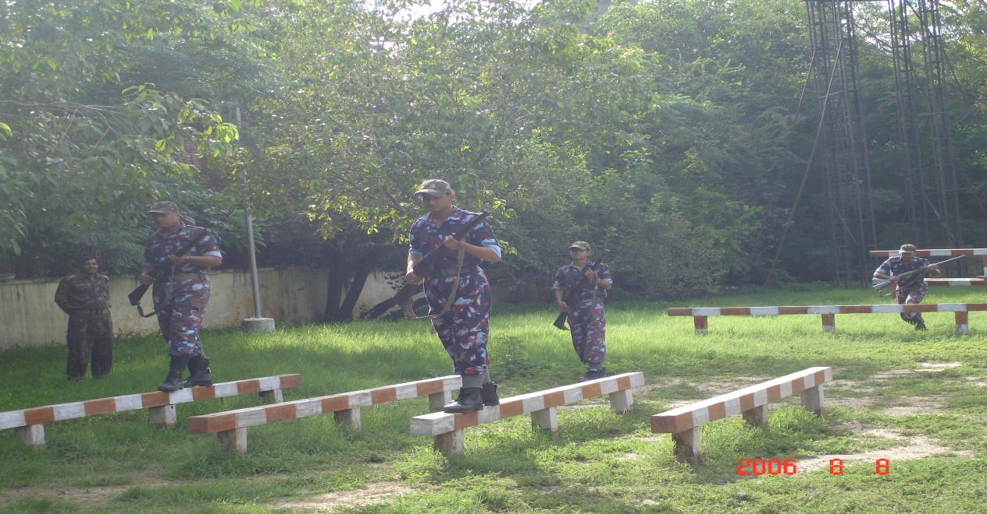
Straight Balance

2. Clear Jump. The obstacle is wooden beam 2 ½ ft from the ground. Cadet has to jump over this wooden beam without using any part of the body.

3. Zig Zag Balance. It has a structure of wooden beam 30 ft in length, with 3 inch width and 1 ½ ft above the ground and is constructed in a zig-zag manner. The Cadet has to negotiate the obstacle similar to straight balance.

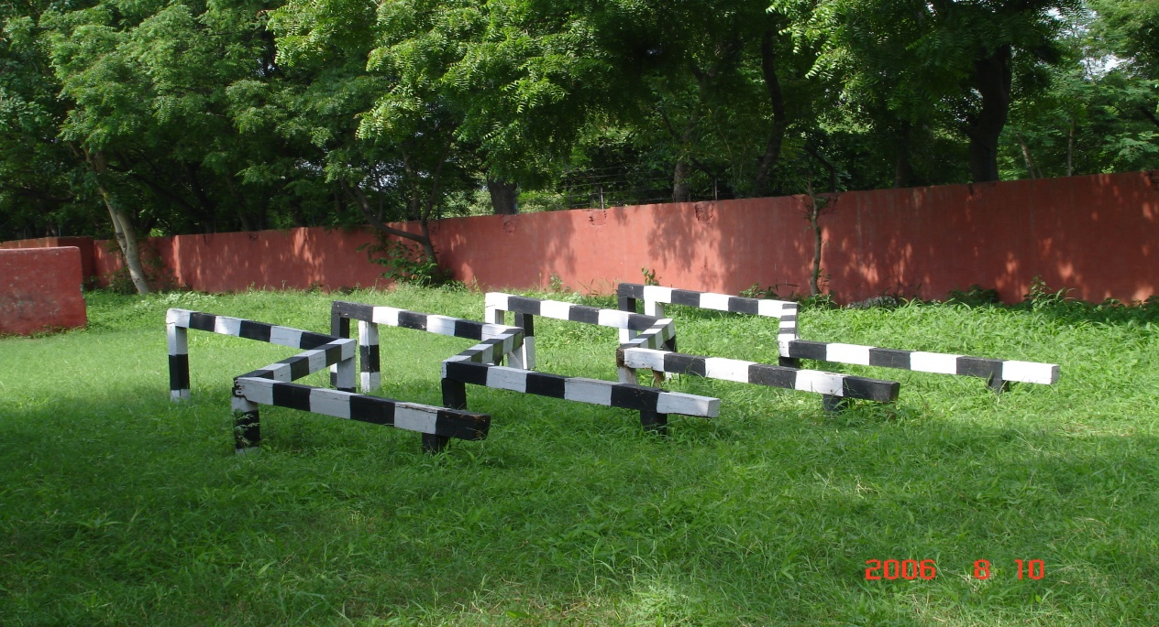
Zig Zag Balance

4. High Wall. The cemented wall is 6 ft in height, 12 ft in length. Cadet has to run, jump and set his one hand on the wall and then push his body upwards and jump over the other side.

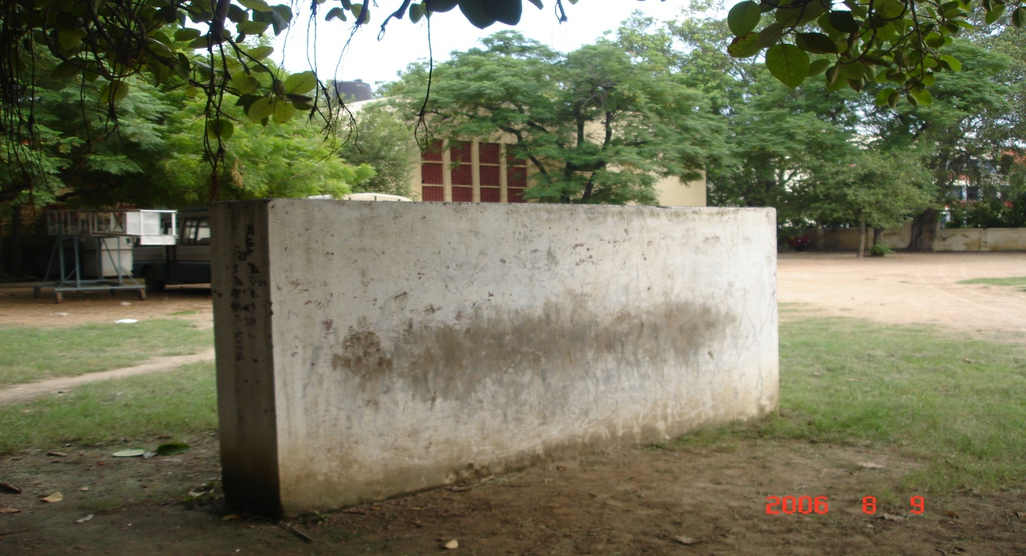

High Wall

5. Double- Stride Jump. The obstacle is composed of two ditches each of approximately 6-8 ft in length, 4-5 ft wide and 3-4 ft deep separated by a small gap of approx 9-12 inch. The cadet have to jump across the two ditches by jumping over the first ditch, placing one foot on the gap and jumping across the second ditch.

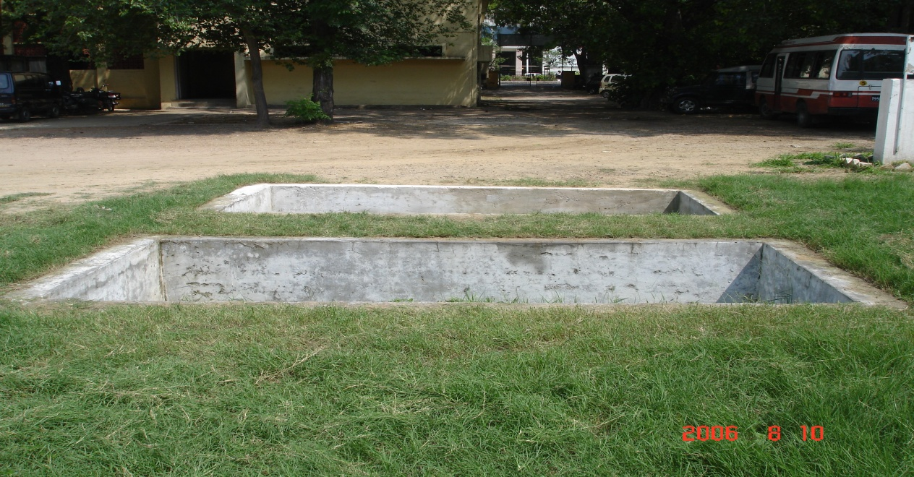
Double- Stride Jump

6. Right Hand Vault. This wooden structure is 3 ½ ft above the ground. The cadet is required to jump over the obstacle using the right hand as support on the beam.

7. Left Hand Vault. It is similar to right hand vault . Cadet has to take support of wooden beam with left hand and jump across.
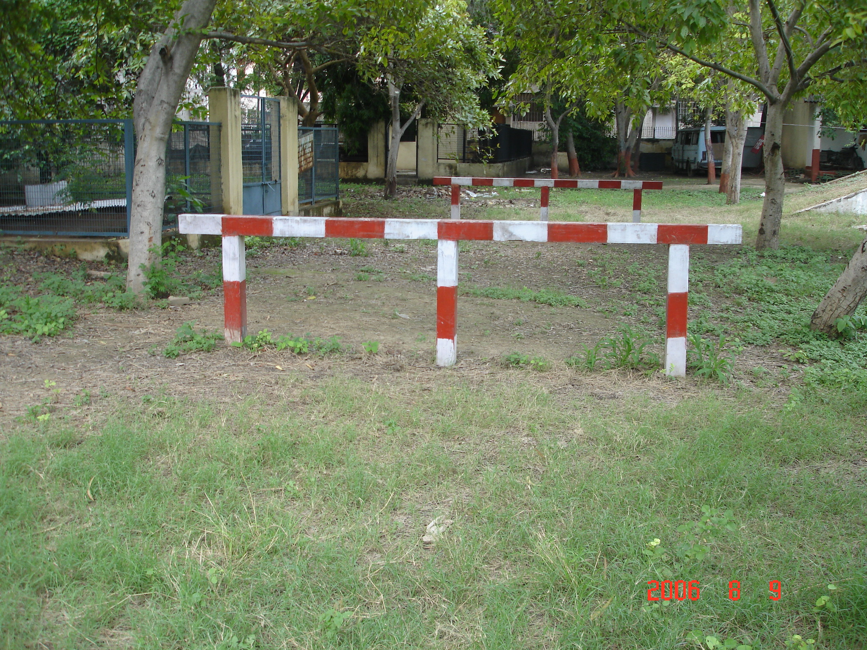

8. Ramp. It is a slant, which is 15ft in length. 18 ft in width and 4 ½ ft in height. One has to run from a distance and on reaching the top cadet has to take a long leap.

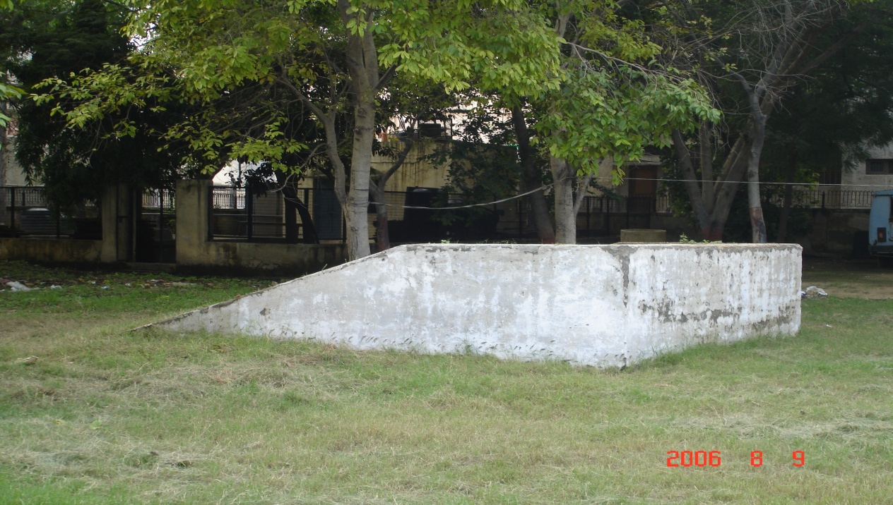
Ramp

9. Gate Vault. This is a wooden structure which has two beams at height of 3 ft and 5 ft respectively, both 18 ft long. One has to cross the gate by holding upper beam with both hands and by putting one’s feet on 3 ft gate and jump across.

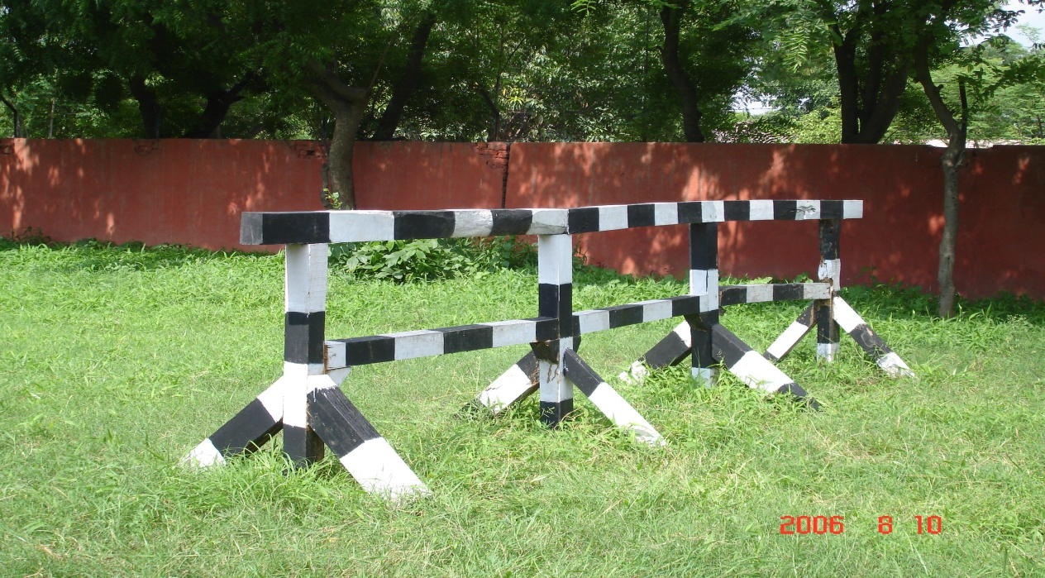

Gate Vault

CHAPTER-VIII

HOME NURSING

INDEX

CHAPTER-VIII HOME NURSING
(ONLY FOR SW)
SECTION-1 | Introduction to Home Nursing
SECTION-2 | The Roller Bandage and its Application
SECTION-3 | The Sick Room: Preparation, Cleaning and Lighting, Ventilation
SECTION-4 | Pulse, Respiration and Temperature Taking and Recording
SECTION-5 | Observation of the Sick Signs and Symptoms to be Noted
SECTION-6 | Feeding a Helpless Patient
SECTION-7 | Medicines and their Administration
SECTION-8 | Fever, Infection, Disinfection and Specific Infectious Diseases
SECTION-9 | Operation: After Care, Dressing of Wounds
SECTION-I0 | Poisons and First Aid

SECTION -1

INTRODUCTION TO HOME NURSING

Introduction

1. Nursing plays a very important role in the recovery of a patient. While the doctor prescribes a course of treatment, it is the nurse who actually translates it into action. It is on the efficient nursing of the case that the whole success of the treatment depends.

2. A large number of people have to be nursed at home either because their sickness is not so severe or because on being discharged from hospital they convalesce at home. It is here that skill in home nursing comes in. A girl cadet trained in home nursing can be an asset to a family as she can by her care keep a patient’s condition from deteriorating and can nurse him back to health. Thus home nursing can be defined as functioning of a person, with all the efficiency and qualities of a nurse, in one’s own home, taking care of the establishment and reducing the intensity and the frequency of sickness to the barest minimum.

Qualities of a Nurse

3. A good nurse must possess the following qualities:-

(a) Honesty and Truthfulness. A nurse should be honest to her profession. She should confess her mistake whenever she makes any, and not risk the life of the patient by hiding it.

(b) Sympathy and Understanding. A good nurse should deal with the patient with understanding and sympathy. She should sympathetically appreciate the pain and suffering of the patient.

(c ) Cheerfulness, Gentleness and Willingness. A cheerful nurse reduces the sufferings of the patients to half. Her gentleness reduces their pain and discomfort. Her willingness and eagerness to help is instrumental in making them bear their troubles with a smiling face. “A warm smile may be more therapeutic than a dose of medicine”.

(d) Obedience and Discipline. A nurse should have self discipline and should obey the orders of the doctor and carry them out without argument.

(e) Observant. A Nurse should observe the minutest details of the patient’s condition. If there is the slightest change in the patient’s condition, she should immediately report it to the Doctor. She should also observe whether the hospital equipment is functioning properly or not.

(f) Tact and Sense of Humour. A tactful nurse can deal easily with the patient who becomes irritable due to disease. Her sense of humour also helps her in bearing the hardships of her profession cheerfully.

SECTION -2

THE ROLLER BANDAGE AND ITS APPLICATION

General

1. Rollers bandages are made of various materials and are of various lengths and width according to the part on which they are applied.

(a) Bandage for Finger - 1” wide
(b) Bandage for Head and Arm - 2 ½”
(c ) Bandage for Trunk - 6”
(d) Bandage for Leg - 3 ½”

General Rules for Application

2. The rules for applications are:-

(a) Face the causality.

(b) Hold the head of the bandage in the right hand.

(c ) Apply the outer side of the free end to the part and where possible lock it in position by a superimposed turn.

(d) Bandage firmly from below upwards and from within outwards over the front of the limb.

(e) Apply the layer of the bandage so that it covers neither too tight nor too loose.

(f) When completed secure the bandage by a safety pin or adhesive strapping.

Method of Application

3. There are three methods of applying the roller bandage:-

(a) The Simple Spiral. This is only used when the part is of uniform thickness, for example , finger or wrist. The bandage is carried out in a spiral direction.

(b) The Reverse Spiral. This is used in bandaging those parts of the limbs where there is varying thickness. This is made by a number of spiral turns in which the bandage is reversed downward upon itself at each circuit of the limb.

(c ) The Figure of 8. It is used for bandaging in the neighborhood of a joint such as knee or elbow. This is applied by passing the bandage obliquely round the limb alternately upward and downwards, the loops resembling the figure of ‘8’.

SECTION -3

THE SICK ROOM:PREPARATION, CLEANING,
LIGHTING AND VENTILATION

General

1. The sick room should be that room of the house which is away from all noise and through which there is no passage. However, it should have a bathroom and lavatory close by. It should face South or South-West.

Preparation

2. A sick room should not have too many things. However, it should be comfortably furnished. There should be a comfortable bed, a bed side table, two chairs and one easy chair. A cupboard for keeping equipment should also be there. A wash basin with jug of water, soap, nail brush and towel must be arranged on a stool or small table. If possible a curtain stand may be arranged. A waste paper basket should be kept at a convenient place.

Cleaning

3. Dirt and dust are depressing to a sick person and retard his recovery. Moreover, these are the biggest source of illness as they harbour germs of various diseases. Hence due importance should be given to the daily cleaning of the room. The following points should be kept in view:-

(a) All cleaning work should be done without disturbing the patient after the toilet is over and the bed remade.

(b) Light furniture should be removed before the room is swept and dusted. After dusting, each piece should be wiped with a weak solution of disinfectant and then polished with dry cloth.

(c ) Dusting should be done with a damp cloth. The floor should be cleaned after scattering damp tea leaves so that dust does not rise.

(d) At night, flowers should be removed from the vases and fresh flowers arranged in the morning.

Lighting

4. The light should not fall direct on the face of the patient. It should come from behind or the sides. There should be a shaded lamp on the side of the patient. There should be another shaded light for the nurse, so placed, that she can do her job without disturbing the patient. A well protected light can quite serve the purpose.

Ventilation

5. Fresh air is essential for human existence. One of the important processes of living is inhalation and exhalation. The dirty air exhaled by the breathing process is replaced by clean, fresh air inhaled by nostrils. The foul breath breathed out gets mixed up with fresh air and is to be separated so that fresh air is available for the breathing process to continue.

6. Cross Ventilation. Ventilation means the availability of pure, fresh air in abundant quantity. It also means bringing inside a house or a place of work plenty of sunlight. This is done through doors, windows and open spaces. For a good flow of air, there should be doors and windows in opposite directions exactly facing each other and at the same level. To be considered a well ventilated house the various doors and windows should face the direction of the sun light so that sunlight flows in, in ample quantity to drive away all moisture and darkness. Lack of fresh air, darkness and moisture cause many dangerous diseases such as tuberculosis and rickets.

7. Wide Streets with Open Spacing. Besides cross ventilation in the house there should be open space around the house also. Congested localities cannot have proper flow of fresh air.

8. Effects of Stagnant Air. Effects of impure air on health are terrible. If there is no flow of fresh air, temperature would rise and humidity increases. This would produce headaches, drowsiness, nausea, loss of appetite, depression and a tendency to catch cold quickly. There would be diminished resistance to infectious diseases and people would become dull and incapable of concentration. Poor ventilation results in rickets in children. Tuberculosis is caused when there is over crowding and insufficient ventilation. It is one of the common communicable diseases in India. The bacteria of Tuberculosis is passed from the patient to a healthy person through sputum or through droplet infection. Dark and crowded houses help in the spreading of diseases.

9. Cleaning of Air Through Trees. In the process of breathing, dirty gases are exhaled. The environs of cities get polluted because of a large number of factories emitting smoke and harmful gases. Smoke is discharged by trains, trucks and buses also. To lessen this pollution, trees should be planted in large numbers. Trees help in the process of purifying air.

10. Effects of Heat. Good ventilation means that not only should there be plenty of air but also the temperature of the air should be comfortable. It should not be full of foul smell or smoke. Moist air gives rise to diseases. If the air is hot it causes exhaustion, nausea and headache. Heat stroke also may take place. Hence during summer, air should be kept flowing through cross ventilation and cooling measures adopted.

SECTION -4

PULSE , RESPIRATION AND TEMPERATURE
TAKING AND RECORDING

General

1. The patient’s quick recovery depends very much on the efficient routine care by the nurse. Daily routine should be planned according to the patient’s habits and followed regularly unless some sudden change in the patient’s condition requires some adjustment.

Pulse

2. Pulse. The pulse is the heart beat and is most commonly felt at the radial on the point of the wrist . The average pulse rate is 72 beats per minute. In case of infants, is 100 to 140 beats per minute and in case of children 90 to 100 beats per minute.

3. Taking Pulse. The rate of the pulse changes with the change in emotions and while doing exercise. To count pulse, the patient should be made to sit down in bed. The arm must be relaxed and in a prone position. To take pulse, the tips of the first three fingers should be laid down on the radial artery at the base of the palm. The index finger should be nearest to the palm of the patient’s hand. The thumb should be placed at the back of the hand. The pulse can be easily felt. Count beats in a minute keeping an eye on the second’s hand in your watch.

4. The result should be immediately entered in the pulse column of the TPR Chart.

Respiration

5. The inhalation and exhalation of a person is called respiration. It is rhythmical and quiet. The normal rate is 15 to 20 times a minute and can be counted by the heaving of the chest. It changes according to age.

(a) Infants 30-40 per minutes.
(b) Children 24-28 per minute.
(c ) Adults 15-20 per minute.
6. Exercise and Emotional State Increases Respiration

(a) To check respiration correctly, count while keeping the fingers on the pulse so that the patient is not aware of it.

(b) Any difficulty in breathing must be reported immediately.

(c ) While counting respiration, note rhythm, rate and depth of respiration.

Temperature

7. Temperature. The normal temperature of a man is between 97° and 99° F. There is slight ½ ° F variation between the daily temperature in the morning and evening. The lowest temperature is between 2 AM and 4 AM.

8. Measuring Temperature. It is important to know how to measure temperature. The body temperature is taken by the clinical thermometer which is a device consisting of a bulb containing mercury and a glass tube which has a white bank to reflect the tiny mercury band. The range of the thermometer is 95° F to 110° F. The degrees are indicated by black lines. A figure is written after every 5°. An arrow indicates the normal level of temperature i.e 98.4° F.

(a) Normal temperature by mouth is 98.4° F or 37° C.
(b) By axilla or groin it is 1° F lower than by mouth.
(c) By rectum, it is 1° F higher than by mouth.
(d) Fahrenheit is changed to centigrade by the formula

F-32° x 5/9 = C

9. Method. Keep the bulb of the thermometer pressed under the armpit or beneath the tongue or in the groin for 2 minutes. Take the reading and record in the temperature column of the TPR Chart

Recording of TPR Chart

10. The TPR Chart is a morning and evening record of the patient’s temperature, pulse and respiration with some other details such as the number of times the patient had motions and the amount of urine passed. This helps the doctor in learning about the latest condition of the patient at one glance.

SECTION -5

OBSERVATION OF THE SICK: SIGNS AND
SYMPTOMS TO BE NOTED

Reports

1. The most important duty of the nurse is to give a correct account of the condition of the patient to the doctor. Her report should be based on detailed observation and not on
assumptions. She should not take any risks and must go on writing down all her observations regarding the following:-

(a) Appearance of the Patient

(i) The colour of the skin whether pale, flushed blue or yellow.

(ii) Whether moist or dry, hot or cold, smooth or rough, covered with rashes, bruises or discoloured.

(iii) If any swelling or oedema.

(iv) If pain, its place and duration.

(v) Facial expression and other signs of discomfort.

(b) Temperature, Pulse and Respiration. Take temperature, pulse and respiration twice a day or four times a day or eight time a day, as desired by the doctor and maintain TPR Chart.

(c ) Stools

(i) Frequency and whether it shows constipation or diarrhoea condition.

(ii) Colour

(aa) Normal brown.

(ab) Clay coloured which shows obstructive jaundice.

(ac) Black shiny which shows bleeding from the stomach or duodenum.

(ad) Full black which shows effect of medicines like iron.

(iii) Composition. Presence of abnormal material as blood, pus, gall stones, worms, undigested food. Specimen of stool is to be left for the doctor to see in a well covered container.

(d) Urine. In case of urine the following should be observed:-

(i) Frequency. Increased frequency, is due to inflammation of the bladder.

(ii) Quantity

(aa) Urine output is reduced in fever, in conditions of dehydration and in a acute nephritis.

(ab) Urine quantity is increased in case of diabetes and inflammation of the kidneys.

(iii) Colour Abnormalities

(aa) Red – Due to presence of a lot of blood.

(ab) Dark Greenish Brown – Due to presence of bile.

(ac) Smoky – Due to some blood being present.

(ad) Orange, Green or Blue – Due to presence of some drugs.

(iv) Deposits. If the urine is allowed to stand, the following may be observed:-

(aa) A sandy deposit white or pink.

(ab) A whitish cloud showing mucous.

(ac) A thick greenish deposit due to pus.

( Early morning specimen should be kept in a clear, covered , glass bottle).

(e) Cough and Sputum. Report on it must state:-

(i) Amount.
(ii) Colour.
(iii) Whether expectorated easily or with difficulty.

(f) Vomit

(a) Quantity.
(b) Time in relation to food.
(c) Whether it causes pain or relieves it.
(d) Material vomited such as blood.

SECTION -6

FEEDING A HELPLESS PATIENT

1. While feeding a helpless patient, the bed and the side table should be properly and neatly arranged. The nurse should give full attention to the patient so that patient does not feel that he/she is being hurried through a meal.

(a) Feeding a Patient on Fluid Diet. The mouth of the patient should be washed and wiped. If the patient can sit up, the fluid can be given in a cup or in a glass. If the patient wants to take fruit juice with a straw he/she should be given that. But it should be ensured that the straw is absolutely clean. If the patient can not sit up, he/she should be fed with a feeding cup or a feeder. The bed clothes should be protected by placing a clean napkin beneath the patient’s mouth. The nurse should place her left arm, under the first pillow to raise the patient’s head slightly. The flow of the fluid should be regulated so that too much of it does not flow into the patient’s mouth. One mouthful should be given at one time pausing to allow her time for chewing. Feeding can be done with a tea spoon also. In case of jaw injuries, a small rubber tube is attached to the spout of the feeding cup and then put between the teeth. The patient should be given small quantity to swallow at one time. After feeding the patient, lips should be wiped with a clean towel.

(b) Feeding with Solid Food. Food should be served in an attractive manner arranged attractively on a side table. One dish should be brought at one time .The food should be served hot. It should be put in a plate in the kitchen before bringing to the patient. Patient should be fed with a spoon. As soon as food is finished the plate should be removed.

SECTION-7

MEDICINES AND THEIR ADMINISTRATION

1. A Nurse has to take great care with medicines. She should fully understand the doctor’s prescription and keep the medicines well labelled and properly stored. There should be three separate shelves of a cup board, one for lotions, one for medicines and the third one for poisons.

2. All poisonous lotions should be marked “for external use only”. No unlabelled medicine should be ever used. All stale lotions should be thrown in the sink, as they undergo change and may turn dangerous. In hospitals the key medicines should be kept locked.

3. A nurse should know the symbols often used in prescriptions, such as:-

(a) Measuring Liquids:

1 minim (m) = One drop
60 Minims = One drachm
8 drachms = One ounce (2 table spoonfuls)
20 ounces = a pint (o)

(b) For Measuring Solid Drugs:

GR = Grain
1 GR = 60 mg
30 GRs = 1 Ounce
GRMS = Grams

(c) Abbreviations Most Commonly Used :

Aq = Water
Aq Distt = Distilled water
Liq = Liquid
Mist = Mixture
IV = Intra muscular
Sc = Subcutaneous
Ol = Oil
Pulv = Powder
Tict = Tincture
Ung = Ointment
Aa = Of each
Ac = Before food
Pc = After food
Ad Lib = Liberally
Alt days = Alternative days
OD = Once in a day (24 hours)
BD = Twice a day
TDS = Three times a day
QID = Four times a day
CM = Tomorrow morning
RS = At bed time
ON = Tomorrow night
SOS = If necessary once
STAT = At once
OM = Every morning
PRN = Whenever required
PR = Per rectum
PV = Per vagina
Administering Medicines

4. Proper administration of medicines is most important, as on it depends, the very life of the patient. Hence if there be any doubt the doctor should be asked to clear it. Guess should not be used. The following points should be kept in mind while giving medicines:-

(a) While Giving Liquid Medicines

(i) Check the label with the prescription. If handling a new medicine read the instructions carefully.

(ii) Shake the medicine well.

(iii) Put your thumb near the correct marking of dosage on the medicine glass. Hold the glass in level with the medicine bottle. Pour away from the label so that it does not become illegible. Replace the cork immediately.

(iv) Read the instructions once again before actually giving the medicine to the patient.

(v) Take the medicine on a tray with a glass of water and spoon in case the medicine requires stirring. If the medicine has a bitter taste, give the patient some sweet drink.

(vi) Put the medicine bottle in the correct place.

(vii) Never pour back any unused medicine, throw it away.

(b) Other Medicine.

(i) In case of pills, tablets, capsules and powder, remember that a pill has a sugar coating and a capsule has a gelatine coating and hence can be easily swallowed with water. Tablets if not swallowed by the patient may be crushed and put on the back of the tongue for swallowing. Powder must be poured at the back of the patient’s tongue and water poured in his mouth.

(ii) Iron mixture should be given with straws so that the teeth are not stained. If the patient is not too weak, he/she should be asked to clean his/her teeth.

SECTION -8

FEVER, INFECTION, DISINFECTION AND
SPECIFIC INFECTIOUS DISEASES

Fever

1. Whenever there is an inroad of disease germs in the body, due to some infection, it raises its temperature to put up a fight against the invasion. The state of more than normal temperature is called ‘Fever’.

2. The normal temperature of the body is 97° F to 99° F. The temperature above 99° causes pain, restlessness, headache and body ache. Moderate temperature from 99° F to 103° F is called Pyrexia. High temperature from 103° F to 105° F is called High Pyrexia. Very high temperature over 105° F is called Hyper -Pyrexia. Fever may be:-

(a) Constant. In this the temperature remains the same all the 24 hours as in pneumonia and scarlet fever.

(b) Intermittent. The temperature rises very high and falls very low. It appears when there is severe infection.

(c ) Remittent Fever. This is a very high fever. It rises more than 1° during 24 hours. It is found in case of tuberculosis and sepsis.

(d) Irregular. It has no set pattern of rise and fall of temperature.

Infection

3. The spreading of germs of a disease from a sick person to a healthy person is called infection. There are various ways in which infection take place, such as:-

(a) Through Air. Disease germs spread from a sick person to a healthy person when the sick person breathes out foul germs and fit person inhales it. The germs are harboured by the healthy person till they multiply and become strong enough to show symptoms of the disease. Diseases like tuberculosis and influenza spread in this manner.

(b) Through Water. Water gets contaminated when patients of a disease wash into it their faeces, urine, sputum and vomit. These germs are carried by rivers and streams and sink into wells, ponds and lakes. When this water is used by healthy persons for washing and drinking, the germs remain dormant in his body till his resistance becomes poor and he falls victim to diseases. Cholera, enteric fever, dysentery, typhoid and jaundice spread in this manner.

(c ) Through Insects. Germs of various diseases are carried by insects. The anopheline female mosquito, house fly, sand fly, fleas, ticks all act as carriers of disease. The mosquito, sand fly, fleas and ticks bite a patient, take the germs of the diseases in their blood, harbour them till they find a healthy man to bite and pass on the germs into his blood, till after a period, the healthy person also starts showing signs of the disease. Malaria, plague and sand fly fever, all spread like this. Insects like the housefly sit on the excreta, vomit and sputum of patients of various diseases, get the germs in their wings and legs and then sit on the food which is to be taken by healthy persons. In this manner they pass the infection to those who eat it. Cholera, diarrhoea, dysentery, jaundice, typhoid spread in this manner.

Disinfection

4. It means destroying the disease germs through various methods. It is to break the chain of infection. The following are the important disinfectants:-

(a) Physical Agents

(i) Light.
(ii) Heat - both dry and moist.
(b) Chemical Agents

(i) Gases.

(ii) Liquids.

(iii) Solids.
Physical Agents

5. The physical agents are:-

(a) Light. Sunlight is nature’s most effective and powerful germ- killer. The ultra-violet and blue–violet rays kill the germs. This is the reason why the clothes of a sick person should be spread in sun.

(b) Dry Heat. Fire is the other important purifier. It kills germs by burning. All heaps of refuse can be burnt and the place can be disinfected. A hot iron can disinfect the clothes by being applied to the seams which require disinfecting.

(c ) Moist Heat. Moist heat is used for disinfecting in two ways i.e. by boiling and by steaming. Boiling kills germs very rapidly. Drinking water can be purified by boiling. Linen and crockery also can be disinfected by boiling. All the hospital equipment such as surgical instruments and trays are disinfected in this manner. Steam is also used for sterilizing all hospital linen and dressing and bandaging equipment. Sterilizing drums and autoclaving chambers are used for letting steam penetrate through holes and sterilize large stocks of linen, gloves and dressing material such as bandages, cotton gauze etc.

Chemical Agent

6. The chemical agents are:-

(a) Gases. These are used for disinfecting building and ships etc. The room should be totally sealed for successful disinfecting, Formaldehyde gas is a very powerful germ killer. Chlorine is used for water purification.

(b) Liquids. Formaline 40 % solution becomes a good disinfectant. Phenyl and Cresol are other disinfectants. The usual strength is 1 percent but, for quick action, 2 ½ or 5 percent solution may be required. Carbolic Acid is another powerful disinfectant. This is used for surgical purpose. Potassium permanganate solution is good for ‘pinking’ well to kill cholera germs.

(c ) Solids. Lime is a very good disinfectant for lime washing of wells, for sprinkling in dust bins and spreading outside bathrooms and lavatories in camps.

SECTION - 9

OPERATION: AFTER CARE, DRESSING OF WOUNDS

General

1. Post operative nursing is as essential as pre–operative care. Very clean and hygienic conditions are required to help in quick healing of the wound and for keeping it from turning septic. The patient is to be protected against acute pain by giving him timely analgesics, morphine or pethidine as per doctor’s instructions

Dressing of Wounds

2. The following should be done to help in quick healing of wounds and keep them from turning septic:-

(a) The hand should be properly washed so that the infection is not caused while the wound is being dressed. Sterilized gloves should be worn.

(b) Everything that is used while dressing the wound should be properly sterilized so that the wound does not get infected.

(c ) All dressing material should be taken out of the autoclaving drum and kept in sterilized packing. It should not be touched by hand. Soiled dressing should be thrown properly in a covered waste bin and not allowed to be on the floor as this causes foul smell and makes the patient very uncomfortable. It also causes severe infection and creates serious problems for the operated person.

(d) The wound should be cleaned with proper solutions. Very strong lotions would damage the tissue and the healing process would get very slow.

(e) Fresh air and sunshine assist in the quick recovery of a patient. These should be available to him in plenty. However, he should not feel too warm and uncomfortable.

(f) Bandages should be so applied that they do not constrict the part which is operated upon. There should be no obstruction to the free circulation of blood so that the healing process is not restricted.

(g) Proper diet should be given to the patient. Sufficient quantity of vitamin C must be ensured for quick healing.

(h) The patient should be made to feel fit and kept cheerful.

SECTION -10

POISONS AND FIRST AID

General

1. Any substance which, if taken in large quantity causes damage to the human system or may cause death, is called poison. Poisons may be in the form of chemicals, solid or liquid or can be in the shape of gas.

Means of Poison Intake

2. (a) Poisons can be swallowed by eating or drinking.

(b) Poisons enter the system by breathing in the form of fumes or smoke.

(c ) Poisons enter the body through injections or through bites such as snakes or rabid dogs. Poison can be:-

Type of Poison

3. (a) Corrosive. Acids and alkalies such as sodium hydroxide, nitric acid, sulphuric acid, potassium hydroxide. These burn lips, throat, food passage and cause severe pain.

(b) Irritants. These are poisons which cause vomiting and diarrhoea. These are arsenics and mercury etc.

(c) Stimulants. These affect the nervous system. These are intoxicants and alcoholic drinks. They cause convulsions and depression of the nervous system.

(d) Depressors. These like opium obstruct the vital functions of the body.

First Aid

4. The first aid in such situation is to:-

(a) Arrange to remove the patient to hospital immediately.

(b) Note down the name of the poison if the empty bottle is there. Preserve if there is any remaining portion of the poison.

(c ) Keep in some container any vomited matter, if it is there.

(d) If the patient has not taken any corrosive matter induce vomiting.

(e) If he is unconscious lay him with head turned to one side keeping his tongue out. If his respiration is failing, give artificial respiration.

(f) If the patient is conscious and the poison which he has taken is known, the following steps may be taken:-

(i) If he has taken some acid give him some alkali such as chalk, milk of magnesia and baking soda water.

(ii) If it is alkali give him 2 table spoonful of vinegar or lime juice water. Make the patient drink plenty of water or give something to drink such as milk or barley water or raw eggs.

(iii) If the patient has taken some disinfectant like cresol, carbolic acid or sleeping tablets like luminal, give two table spoonful of common salt with water or raw eggs.

(iv) In case of opium and morphia poisoning, give a few crystals of potassium permagnate in a tumbler of water and make the patient vomit.

(v) If there is gas poisoning, move casualty out of the room having gas. If the breathing is obstructed give artificial respiration. The domestic antidote for poisoning is a mixture of tea powder or burnt toast and milk of magnesia mixed in equal portion.
CHAPTER-VII

OBTACLE TRAINING

INDEX

CHAPTER-VII OBTACLE TRAINING |  | JD/JW | SD/SW
SECTION-1 | Obstacle Course | √ | √

SECTION-1

OBSTACLE COURSE

General

1. The aim of obstacle training is to instill self-confidence and generate team spirit in the cadets by teaching them to successfully cross obstacles individually and as team members. Obstacle training is very important for the NCC cadets as it infuses courage, patience in them and makes them physically fit. Initial training is given to cadets in PT dress, and later on with packs and weapons.

TYPES OF OBSTACLES

2. Straight Balance. It is a wooden beam, which is 1 ½ ft above ground level, having 3” width 4” breadth, & 12 ft in length. In this cadet has to walk on the obstacle and balance himself with his arms.

Straight Balance

2. Clear Jump. The obstacle is wooden beam 2 ½ ft from the ground. Cadet has to jump over this wooden beam without using any part of the body.

3. Zig Zag Balance. It has a structure of wooden beam 30 ft in length, with 3 inch width and 1 ½ ft above the ground and is constructed in a zig-zag manner. The Cadet has to negotiate the obstacle similar to straight balance.

Zig Zag Balance

4. High Wall. The cemented wall is 6 ft in height, 12 ft in length. Cadet has to run, jump and set his one hand on the wall and then push his body upwards and jump over the other side.

High Wall

5. Double- Stride Jump. The obstacle is composed of two ditches each of approximately 6-8 ft in length, 4-5 ft wide and 3-4 ft deep separated by a small gap of approx 9-12 inch. The cadet have to jump across the two ditches by jumping over the first ditch, placing one foot on the gap and jumping across the second ditch.

Double- Stride Jump

6. Right Hand Vault. This wooden structure is 3 ½ ft above the ground. The cadet is required to jump over the obstacle using the right hand as support on the beam.

7. Left Hand Vault. It is similar to right hand vault . Cadet has to take support of wooden beam with left hand and jump across.

8. Ramp. It is a slant, which is 15ft in length. 18 ft in width and 4 ½ ft in height. One has to run from a distance and on reaching the top cadet has to take a long leap.

Ramp

9. Gate Vault. This is a wooden structure which has two beams at height of 3 ft and 5 ft respectively, both 18 ft long. One has to cross the gate by holding upper beam with both hands and by putting one’s feet on 3 ft gate and jump across.

Gate Vault

CHAPTER-VIII

HOME NURSING

INDEX

CHAPTER-VIII HOME NURSING
(ONLY FOR SW)
SECTION-1 | Introduction to Home Nursing
SECTION-2 | The Roller Bandage and its Application
SECTION-3 | The Sick Room: Preparation, Cleaning and Lighting, Ventilation
SECTION-4 | Pulse, Respiration and Temperature Taking and Recording
SECTION-5 | Observation of the Sick Signs and Symptoms to be Noted
SECTION-6 | Feeding a Helpless Patient
SECTION-7 | Medicines and their Administration
SECTION-8 | Fever, Infection, Disinfection and Specific Infectious Diseases
SECTION-9 | Operation: After Care, Dressing of Wounds
SECTION-I0 | Poisons and First Aid

SECTION -1

INTRODUCTION TO HOME NURSING

Introduction

1. Nursing plays a very important role in the recovery of a patient. While the doctor prescribes a course of treatment, it is the nurse who actually translates it into action. It is on the efficient nursing of the case that the whole success of the treatment depends.

2. A large number of people have to be nursed at home either because their sickness is not so severe or because on being discharged from hospital they convalesce at home. It is here that skill in home nursing comes in. A girl cadet trained in home nursing can be an asset to a family as she can by her care keep a patient’s condition from deteriorating and can nurse him back to health. Thus home nursing can be defined as functioning of a person, with all the efficiency and qualities of a nurse, in one’s own home, taking care of the establishment and reducing the intensity and the frequency of sickness to the barest minimum.

Qualities of a Nurse

3. A good nurse must possess the following qualities:-

(a) Honesty and Truthfulness. A nurse should be honest to her profession. She should confess her mistake whenever she makes any, and not risk the life of the patient by hiding it.

(b) Sympathy and Understanding. A good nurse should deal with the patient with understanding and sympathy. She should sympathetically appreciate the pain and suffering of the patient.

(c ) Cheerfulness, Gentleness and Willingness. A cheerful nurse reduces the sufferings of the patients to half. Her gentleness reduces their pain and discomfort. Her willingness and eagerness to help is instrumental in making them bear their troubles with a smiling face. “A warm smile may be more therapeutic than a dose of medicine”.

(d) Obedience and Discipline. A nurse should have self discipline and should obey the orders of the doctor and carry them out without argument.

(e) Observant. A Nurse should observe the minutest details of the patient’s condition. If there is the slightest change in the patient’s condition, she should immediately report it to the Doctor. She should also observe whether the hospital equipment is functioning properly or not.

(f) Tact and Sense of Humour. A tactful nurse can deal easily with the patient who becomes irritable due to disease. Her sense of humour also helps her in bearing the hardships of her profession cheerfully.

SECTION -2

THE ROLLER BANDAGE AND ITS APPLICATION

General

1. Rollers bandages are made of various materials and are of various lengths and width according to the part on which they are applied.

(a) Bandage for Finger - 1” wide
(b) Bandage for Head and Arm - 2 ½”
(c ) Bandage for Trunk - 6”
(d) Bandage for Leg - 3 ½”

General Rules for Application

2. The rules for applications are:-

(a) Face the causality.

(b) Hold the head of the bandage in the right hand.

(c ) Apply the outer side of the free end to the part and where possible lock it in position by a superimposed turn.

(d) Bandage firmly from below upwards and from within outwards over the front of the limb.

(e) Apply the layer of the bandage so that it covers neither too tight nor too loose.

(f) When completed secure the bandage by a safety pin or adhesive strapping.

Method of Application

3. There are three methods of applying the roller bandage:-

(a) The Simple Spiral. This is only used when the part is of uniform thickness, for example , finger or wrist. The bandage is carried out in a spiral direction.

(b) The Reverse Spiral. This is used in bandaging those parts of the limbs where there is varying thickness. This is made by a number of spiral turns in which the bandage is reversed downward upon itself at each circuit of the limb.

(c ) The Figure of 8. It is used for bandaging in the neighborhood of a joint such as knee or elbow. This is applied by passing the bandage obliquely round the limb alternately upward and downwards, the loops resembling the figure of ‘8’.

SECTION -3

THE SICK ROOM:PREPARATION, CLEANING,
LIGHTING AND VENTILATION

General

1. The sick room should be that room of the house which is away from all noise and through which there is no passage. However, it should have a bathroom and lavatory close by. It should face South or South-West.

Preparation

2. A sick room should not have too many things. However, it should be comfortably furnished. There should be a comfortable bed, a bed side table, two chairs and one easy chair. A cupboard for keeping equipment should also be there. A wash basin with jug of water, soap, nail brush and towel must be arranged on a stool or small table. If possible a curtain stand may be arranged. A waste paper basket should be kept at a convenient place.

Cleaning

3. Dirt and dust are depressing to a sick person and retard his recovery. Moreover, these are the biggest source of illness as they harbour germs of various diseases. Hence due importance should be given to the daily cleaning of the room. The following points should be kept in view:-

(a) All cleaning work should be done without disturbing the patient after the toilet is over and the bed remade.

(b) Light furniture should be removed before the room is swept and dusted. After dusting, each piece should be wiped with a weak solution of disinfectant and then polished with dry cloth.

(c ) Dusting should be done with a damp cloth. The floor should be cleaned after scattering damp tea leaves so that dust does not rise.

(d) At night, flowers should be removed from the vases and fresh flowers arranged in the morning.

Lighting

4. The light should not fall direct on the face of the patient. It should come from behind or the sides. There should be a shaded lamp on the side of the patient. There should be another shaded light for the nurse, so placed, that she can do her job without disturbing the patient. A well protected light can quite serve the purpose.

Ventilation

5. Fresh air is essential for human existence. One of the important processes of living is inhalation and exhalation. The dirty air exhaled by the breathing process is replaced by clean, fresh air inhaled by nostrils. The foul breath breathed out gets mixed up with fresh air and is to be separated so that fresh air is available for the breathing process to continue.

6. Cross Ventilation. Ventilation means the availability of pure, fresh air in abundant quantity. It also means bringing inside a house or a place of work plenty of sunlight. This is done through doors, windows and open spaces. For a good flow of air, there should be doors and windows in opposite directions exactly facing each other and at the same level. To be considered a well ventilated house the various doors and windows should face the direction of the sun light so that sunlight flows in, in ample quantity to drive away all moisture and darkness. Lack of fresh air, darkness and moisture cause many dangerous diseases such as tuberculosis and rickets.

7. Wide Streets with Open Spacing. Besides cross ventilation in the house there should be open space around the house also. Congested localities cannot have proper flow of fresh air.

8. Effects of Stagnant Air. Effects of impure air on health are terrible. If there is no flow of fresh air, temperature would rise and humidity increases. This would produce headaches, drowsiness, nausea, loss of appetite, depression and a tendency to catch cold quickly. There would be diminished resistance to infectious diseases and people would become dull and incapable of concentration. Poor ventilation results in rickets in children. Tuberculosis is caused when there is over crowding and insufficient ventilation. It is one of the common communicable diseases in India. The bacteria of Tuberculosis is passed from the patient to a healthy person through sputum or through droplet infection. Dark and crowded houses help in the spreading of diseases.

9. Cleaning of Air Through Trees. In the process of breathing, dirty gases are exhaled. The environs of cities get polluted because of a large number of factories emitting smoke and harmful gases. Smoke is discharged by trains, trucks and buses also. To lessen this pollution, trees should be planted in large numbers. Trees help in the process of purifying air.

10. Effects of Heat. Good ventilation means that not only should there be plenty of air but also the temperature of the air should be comfortable. It should not be full of foul smell or smoke. Moist air gives rise to diseases. If the air is hot it causes exhaustion, nausea and headache. Heat stroke also may take place. Hence during summer, air should be kept flowing through cross ventilation and cooling measures adopted.

SECTION -4

PULSE , RESPIRATION AND TEMPERATURE
TAKING AND RECORDING

General

1. The patient’s quick recovery depends very much on the efficient routine care by the nurse. Daily routine should be planned according to the patient’s habits and followed regularly unless some sudden change in the patient’s condition requires some adjustment.

Pulse

2. Pulse. The pulse is the heart beat and is most commonly felt at the radial on the point of the wrist . The average pulse rate is 72 beats per minute. In case of infants, is 100 to 140 beats per minute and in case of children 90 to 100 beats per minute.

3. Taking Pulse. The rate of the pulse changes with the change in emotions and while doing exercise. To count pulse, the patient should be made to sit down in bed. The arm must be relaxed and in a prone position. To take pulse, the tips of the first three fingers should be laid down on the radial artery at the base of the palm. The index finger should be nearest to the palm of the patient’s hand. The thumb should be placed at the back of the hand. The pulse can be easily felt. Count beats in a minute keeping an eye on the second’s hand in your watch.

4. The result should be immediately entered in the pulse column of the TPR Chart.

Respiration

5. The inhalation and exhalation of a person is called respiration. It is rhythmical and quiet. The normal rate is 15 to 20 times a minute and can be counted by the heaving of the chest. It changes according to age.

(a) Infants 30-40 per minutes.
(b) Children 24-28 per minute.
(c ) Adults 15-20 per minute.
6. Exercise and Emotional State Increases Respiration

(a) To check respiration correctly, count while keeping the fingers on the pulse so that the patient is not aware of it.

(b) Any difficulty in breathing must be reported immediately.

(c ) While counting respiration, note rhythm, rate and depth of respiration.

Temperature

7. Temperature. The normal temperature of a man is between 97° and 99° F. There is slight ½ ° F variation between the daily temperature in the morning and evening. The lowest temperature is between 2 AM and 4 AM.

8. Measuring Temperature. It is important to know how to measure temperature. The body temperature is taken by the clinical thermometer which is a device consisting of a bulb containing mercury and a glass tube which has a white bank to reflect the tiny mercury band. The range of the thermometer is 95° F to 110° F. The degrees are indicated by black lines. A figure is written after every 5°. An arrow indicates the normal level of temperature i.e 98.4° F.

(a) Normal temperature by mouth is 98.4° F or 37° C.
(b) By axilla or groin it is 1° F lower than by mouth.
(c) By rectum, it is 1° F higher than by mouth.
(d) Fahrenheit is changed to centigrade by the formula

F-32° x 5/9 = C

9. Method. Keep the bulb of the thermometer pressed under the armpit or beneath the tongue or in the groin for 2 minutes. Take the reading and record in the temperature column of the TPR Chart

Recording of TPR Chart

10. The TPR Chart is a morning and evening record of the patient’s temperature, pulse and respiration with some other details such as the number of times the patient had motions and the amount of urine passed. This helps the doctor in learning about the latest condition of the patient at one glance.

SECTION -5

OBSERVATION OF THE SICK: SIGNS AND
SYMPTOMS TO BE NOTED

Reports

1. The most important duty of the nurse is to give a correct account of the condition of the patient to the doctor. Her report should be based on detailed observation and not on
assumptions. She should not take any risks and must go on writing down all her observations regarding the following:-

(a) Appearance of the Patient

(i) The colour of the skin whether pale, flushed blue or yellow.

(ii) Whether moist or dry, hot or cold, smooth or rough, covered with rashes, bruises or discoloured.

(iii) If any swelling or oedema.

(iv) If pain, its place and duration.

(v) Facial expression and other signs of discomfort.

(b) Temperature, Pulse and Respiration. Take temperature, pulse and respiration twice a day or four times a day or eight time a day, as desired by the doctor and maintain TPR Chart.

(c ) Stools

(i) Frequency and whether it shows constipation or diarrhoea condition.

(ii) Colour

(aa) Normal brown.

(ab) Clay coloured which shows obstructive jaundice.

(ac) Black shiny which shows bleeding from the stomach or duodenum.

(ad) Full black which shows effect of medicines like iron.

(iii) Composition. Presence of abnormal material as blood, pus, gall stones, worms, undigested food. Specimen of stool is to be left for the doctor to see in a well covered container.

(d) Urine. In case of urine the following should be observed:-

(i) Frequency. Increased frequency, is due to inflammation of the bladder.

(ii) Quantity

(aa) Urine output is reduced in fever, in conditions of dehydration and in a acute nephritis.

(ab) Urine quantity is increased in case of diabetes and inflammation of the kidneys.

(iii) Colour Abnormalities

(aa) Red – Due to presence of a lot of blood.

(ab) Dark Greenish Brown – Due to presence of bile.

(ac) Smoky – Due to some blood being present.

(ad) Orange, Green or Blue – Due to presence of some drugs.

(iv) Deposits. If the urine is allowed to stand, the following may be observed:-

(aa) A sandy deposit white or pink.

(ab) A whitish cloud showing mucous.

(ac) A thick greenish deposit due to pus.

( Early morning specimen should be kept in a clear, covered , glass bottle).

(e) Cough and Sputum. Report on it must state:-

(i) Amount.
(ii) Colour.
(iii) Whether expectorated easily or with difficulty.

(f) Vomit

(a) Quantity.
(b) Time in relation to food.
(c) Whether it causes pain or relieves it.
(d) Material vomited such as blood.

SECTION -6

FEEDING A HELPLESS PATIENT

1. While feeding a helpless patient, the bed and the side table should be properly and neatly arranged. The nurse should give full attention to the patient so that patient does not feel that he/she is being hurried through a meal.

(a) Feeding a Patient on Fluid Diet. The mouth of the patient should be washed and wiped. If the patient can sit up, the fluid can be given in a cup or in a glass. If the patient wants to take fruit juice with a straw he/she should be given that. But it should be ensured that the straw is absolutely clean. If the patient can not sit up, he/she should be fed with a feeding cup or a feeder. The bed clothes should be protected by placing a clean napkin beneath the patient’s mouth. The nurse should place her left arm, under the first pillow to raise the patient’s head slightly. The flow of the fluid should be regulated so that too much of it does not flow into the patient’s mouth. One mouthful should be given at one time pausing to allow her time for chewing. Feeding can be done with a tea spoon also. In case of jaw injuries, a small rubber tube is attached to the spout of the feeding cup and then put between the teeth. The patient should be given small quantity to swallow at one time. After feeding the patient, lips should be wiped with a clean towel.

(b) Feeding with Solid Food. Food should be served in an attractive manner arranged attractively on a side table. One dish should be brought at one time .The food should be served hot. It should be put in a plate in the kitchen before bringing to the patient. Patient should be fed with a spoon. As soon as food is finished the plate should be removed.

SECTION-7

MEDICINES AND THEIR ADMINISTRATION

1. A Nurse has to take great care with medicines. She should fully understand the doctor’s prescription and keep the medicines well labelled and properly stored. There should be three separate shelves of a cup board, one for lotions, one for medicines and the third one for poisons.

2. All poisonous lotions should be marked “for external use only”. No unlabelled medicine should be ever used. All stale lotions should be thrown in the sink, as they undergo change and may turn dangerous. In hospitals the key medicines should be kept locked.

3. A nurse should know the symbols often used in prescriptions, such as:-

(a) Measuring Liquids:

1 minim (m) = One drop
60 Minims = One drachm
8 drachms = One ounce (2 table spoonfuls)
20 ounces = a pint (o)

(b) For Measuring Solid Drugs:

GR = Grain
1 GR = 60 mg
30 GRs = 1 Ounce
GRMS = Grams

(c) Abbreviations Most Commonly Used :

Aq = Water
Aq Distt = Distilled water
Liq = Liquid
Mist = Mixture
IV = Intra muscular
Sc = Subcutaneous
Ol = Oil
Pulv = Powder
Tict = Tincture
Ung = Ointment
Aa = Of each
Ac = Before food
Pc = After food
Ad Lib = Liberally
Alt days = Alternative days
OD = Once in a day (24 hours)
BD = Twice a day
TDS = Three times a day
QID = Four times a day
CM = Tomorrow morning
RS = At bed time
ON = Tomorrow night
SOS = If necessary once
STAT = At once
OM = Every morning
PRN = Whenever required
PR = Per rectum
PV = Per vagina
Administering Medicines

4. Proper administration of medicines is most important, as on it depends, the very life of the patient. Hence if there be any doubt the doctor should be asked to clear it. Guess should not be used. The following points should be kept in mind while giving medicines:-

(a) While Giving Liquid Medicines

(i) Check the label with the prescription. If handling a new medicine read the instructions carefully.

(ii) Shake the medicine well.

(iii) Put your thumb near the correct marking of dosage on the medicine glass. Hold the glass in level with the medicine bottle. Pour away from the label so that it does not become illegible. Replace the cork immediately.

(iv) Read the instructions once again before actually giving the medicine to the patient.

(v) Take the medicine on a tray with a glass of water and spoon in case the medicine requires stirring. If the medicine has a bitter taste, give the patient some sweet drink.

(vi) Put the medicine bottle in the correct place.

(vii) Never pour back any unused medicine, throw it away.

(b) Other Medicine.

(i) In case of pills, tablets, capsules and powder, remember that a pill has a sugar coating and a capsule has a gelatine coating and hence can be easily swallowed with water. Tablets if not swallowed by the patient may be crushed and put on the back of the tongue for swallowing. Powder must be poured at the back of the patient’s tongue and water poured in his mouth.

(ii) Iron mixture should be given with straws so that the teeth are not stained. If the patient is not too weak, he/she should be asked to clean his/her teeth.

SECTION -8

FEVER, INFECTION, DISINFECTION AND
SPECIFIC INFECTIOUS DISEASES

Fever

1. Whenever there is an inroad of disease germs in the body, due to some infection, it raises its temperature to put up a fight against the invasion. The state of more than normal temperature is called ‘Fever’.

2. The normal temperature of the body is 97° F to 99° F. The temperature above 99° causes pain, restlessness, headache and body ache. Moderate temperature from 99° F to 103° F is called Pyrexia. High temperature from 103° F to 105° F is called High Pyrexia. Very high temperature over 105° F is called Hyper -Pyrexia. Fever may be:-

(a) Constant. In this the temperature remains the same all the 24 hours as in pneumonia and scarlet fever.

(b) Intermittent. The temperature rises very high and falls very low. It appears when there is severe infection.

(c ) Remittent Fever. This is a very high fever. It rises more than 1° during 24 hours. It is found in case of tuberculosis and sepsis.

(d) Irregular. It has no set pattern of rise and fall of temperature.

Infection

3. The spreading of germs of a disease from a sick person to a healthy person is called infection. There are various ways in which infection take place, such as:-

(a) Through Air. Disease germs spread from a sick person to a healthy person when the sick person breathes out foul germs and fit person inhales it. The germs are harboured by the healthy person till they multiply and become strong enough to show symptoms of the disease. Diseases like tuberculosis and influenza spread in this manner.

(b) Through Water. Water gets contaminated when patients of a disease wash into it their faeces, urine, sputum and vomit. These germs are carried by rivers and streams and sink into wells, ponds and lakes. When this water is used by healthy persons for washing and drinking, the germs remain dormant in his body till his resistance becomes poor and he falls victim to diseases. Cholera, enteric fever, dysentery, typhoid and jaundice spread in this manner.

(c ) Through Insects. Germs of various diseases are carried by insects. The anopheline female mosquito, house fly, sand fly, fleas, ticks all act as carriers of disease. The mosquito, sand fly, fleas and ticks bite a patient, take the germs of the diseases in their blood, harbour them till they find a healthy man to bite and pass on the germs into his blood, till after a period, the healthy person also starts showing signs of the disease. Malaria, plague and sand fly fever, all spread like this. Insects like the housefly sit on the excreta, vomit and sputum of patients of various diseases, get the germs in their wings and legs and then sit on the food which is to be taken by healthy persons. In this manner they pass the infection to those who eat it. Cholera, diarrhoea, dysentery, jaundice, typhoid spread in this manner.

Disinfection

4. It means destroying the disease germs through various methods. It is to break the chain of infection. The following are the important disinfectants:-

(a) Physical Agents

(i) Light.
(ii) Heat - both dry and moist.
(b) Chemical Agents

(i) Gases.

(ii) Liquids.

(iii) Solids.
Physical Agents

5. The physical agents are:-

(a) Light. Sunlight is nature’s most effective and powerful germ- killer. The ultra-violet and blue–violet rays kill the germs. This is the reason why the clothes of a sick person should be spread in sun.

(b) Dry Heat. Fire is the other important purifier. It kills germs by burning. All heaps of refuse can be burnt and the place can be disinfected. A hot iron can disinfect the clothes by being applied to the seams which require disinfecting.

(c ) Moist Heat. Moist heat is used for disinfecting in two ways i.e. by boiling and by steaming. Boiling kills germs very rapidly. Drinking water can be purified by boiling. Linen and crockery also can be disinfected by boiling. All the hospital equipment such as surgical instruments and trays are disinfected in this manner. Steam is also used for sterilizing all hospital linen and dressing and bandaging equipment. Sterilizing drums and autoclaving chambers are used for letting steam penetrate through holes and sterilize large stocks of linen, gloves and dressing material such as bandages, cotton gauze etc.

Chemical Agent

6. The chemical agents are:-

(a) Gases. These are used for disinfecting building and ships etc. The room should be totally sealed for successful disinfecting, Formaldehyde gas is a very powerful germ killer. Chlorine is used for water purification.

(b) Liquids. Formaline 40 % solution becomes a good disinfectant. Phenyl and Cresol are other disinfectants. The usual strength is 1 percent but, for quick action, 2 ½ or 5 percent solution may be required. Carbolic Acid is another powerful disinfectant. This is used for surgical purpose. Potassium permanganate solution is good for ‘pinking’ well to kill cholera germs.

(c ) Solids. Lime is a very good disinfectant for lime washing of wells, for sprinkling in dust bins and spreading outside bathrooms and lavatories in camps.

SECTION - 9

OPERATION: AFTER CARE, DRESSING OF WOUNDS

General

1. Post operative nursing is as essential as pre–operative care. Very clean and hygienic conditions are required to help in quick healing of the wound and for keeping it from turning septic. The patient is to be protected against acute pain by giving him timely analgesics, morphine or pethidine as per doctor’s instructions

Dressing of Wounds

2. The following should be done to help in quick healing of wounds and keep them from turning septic:-

(a) The hand should be properly washed so that the infection is not caused while the wound is being dressed. Sterilized gloves should be worn.

(b) Everything that is used while dressing the wound should be properly sterilized so that the wound does not get infected.

(c ) All dressing material should be taken out of the autoclaving drum and kept in sterilized packing. It should not be touched by hand. Soiled dressing should be thrown properly in a covered waste bin and not allowed to be on the floor as this causes foul smell and makes the patient very uncomfortable. It also causes severe infection and creates serious problems for the operated person.

(d) The wound should be cleaned with proper solutions. Very strong lotions would damage the tissue and the healing process would get very slow.

(e) Fresh air and sunshine assist in the quick recovery of a patient. These should be available to him in plenty. However, he should not feel too warm and uncomfortable.

(f) Bandages should be so applied that they do not constrict the part which is operated upon. There should be no obstruction to the free circulation of blood so that the healing process is not restricted.

(g) Proper diet should be given to the patient. Sufficient quantity of vitamin C must be ensured for quick healing.

(h) The patient should be made to feel fit and kept cheerful.

SECTION -10

POISONS AND FIRST AID

General

1. Any substance which, if taken in large quantity causes damage to the human system or may cause death, is called poison. Poisons may be in the form of chemicals, solid or liquid or can be in the shape of gas.

Means of Poison Intake

2. (a) Poisons can be swallowed by eating or drinking.

(b) Poisons enter the system by breathing in the form of fumes or smoke.

(c ) Poisons enter the body through injections or through bites such as snakes or rabid dogs. Poison can be:-

Type of Poison

3. (a) Corrosive. Acids and alkalies such as sodium hydroxide, nitric acid, sulphuric acid, potassium hydroxide. These burn lips, throat, food passage and cause severe pain.

(b) Irritants. These are poisons which cause vomiting and diarrhoea. These are arsenics and mercury etc.

(c) Stimulants. These affect the nervous system. These are intoxicants and alcoholic drinks. They cause convulsions and depression of the nervous system.

(d) Depressors. These like opium obstruct the vital functions of the body.

First Aid

4. The first aid in such situation is to:-

(a) Arrange to remove the patient to hospital immediately.

(b) Note down the name of the poison if the empty bottle is there. Preserve if there is any remaining portion of the poison.

(c ) Keep in some container any vomited matter, if it is there.

(d) If the patient has not taken any corrosive matter induce vomiting.

(e) If he is unconscious lay him with head turned to one side keeping his tongue out. If his respiration is failing, give artificial respiration.

(f) If the patient is conscious and the poison which he has taken is known, the following steps may be taken:-

(i) If he has taken some acid give him some alkali such as chalk, milk of magnesia and baking soda water.

(ii) If it is alkali give him 2 table spoonful of vinegar or lime juice water. Make the patient drink plenty of water or give something to drink such as milk or barley water or raw eggs.

(iii) If the patient has taken some disinfectant like cresol, carbolic acid or sleeping tablets like luminal, give two table spoonful of common salt with water or raw eggs.

(iv) In case of opium and morphia poisoning, give a few crystals of potassium permagnate in a tumbler of water and make the patient vomit.

(v) If there is gas poisoning, move casualty out of the room having gas. If the breathing is obstructed give artificial respiration. The domestic antidote for poisoning is a mixture of tea powder or burnt toast and milk of magnesia mixed in equal portion.

CHAPTER-IX

INTRODUCTION TO INFANTRY WEAPONS

INDEX

CHAPTER-IX INTRODUCTION TO INFANTRY WEAPONS
(SD ONLY)
SECTION-1 | Characteristics of 7.62mm SLR, Ammunition, Firepower, Stripping, Assembling and Cleaning
SECTION-2 | SLR Filling, Emptying of Magazine, Sight Setting,  Lying Position , Holding, Aiming and Firing
SECTION-3 | Characteristics of 5.56mm INSAS Rif Ammunition , Firepower, Stripping, Assembling and Cleaning
SECTION-4 | Characteristics of 7.62mm Light Machine Gun (LMG)  Ammunition , Firepower, Stripping, Assembling and Cleaning
SECTION-5 | Technical Data of Infantry Weapons (84mm RL, Grenade No 36 HE, 30mm AGL, 7.62mm MMG, 106m RCL, 81mm Mortar and ATGM (FAGOT)).

SECTION-1

CHARACTERISTICS OF 7.62MM SLR, AMN, FIREPOWER,
STRIPPING, ASSEMBLING AND CLEANING

CHARACTERISTICS OF 7.62MM SLR, AMN, FIREPOWER

1. Calibre - 7.62 mm.

2. Length

(a) With short butt - 1126.50mm (44.35in).

(b) With normal butt - 1139.20mm (44.85 in) .

(c) With long butt - 1151.90mm (45.35in).

(d) Length of rifle with bayonet - 1397.00mm (55 in).

3. Weight

(a) Rifle only - 4.4 kg.

(b) Rifle with full mag - 5.1 Kg.

(c) Rifle with full mag and - 5.392 kg.
bayonet

(d) Bayonet - 0.283 kg.

(e) Empty Mag - 0.255 kg.

(f) Full mag - 0.709 kg.

5. Range

(a) Effective range - 275 m (300 yds).

(b) Sight range - 200 yds to 600 yds.

6. Sight Radius - 533.40 mm (21.77in).

7. No of Grooves - 06 (Six).

8. Pitch - 1 turn in 304.8mm (12 in).
9. Twist of Rifling - Right Hand.

Amn (Cart SA Ball 7.62mm)

10. (a) Calibre - 7.62mm.

(b) Weight of cart - 23.07gm ± 0.65 gm.

(c) Length of cart - 71.16mm ± .76mm
(2.80-0.03 in).

(d) Weight of bullet - 9.33 ± 0.13 gm
(144 ± 2 gm).

(e) Powder charge - NC Powder.

(f) Muzzle velocity - 815m/2700ft ± 30 ft/S
(at 27.43m(90ft from muzzle).

(g) Wt of cart case - 10.89 gm.

(h) Wt of propellant charge - 2.85 gm.

4. Rate of Fire

(a) Normal - 5 rds per min.

(b) Rapid - 20 rds per min.

(c) Faster than rapid - 60 rds per min.

11. System of operation - Gas operation.

12. Mag capacity - 20 rds.

STRIPPING, ASSEMBLING AND CLEANING
OF 7.62MM SLR

Introduction

1. Rifle is the basic weapon of an infantry soldier and therefore it is the responsibility of the soldier to keep the rifle in serviceable condition. Rifle is a reliable weapon. It fires accurately in all kinds of weather and terrain. It is a gas operated, air cooled and semi automatic weapon.

Preparation

2. (a) Ensure rifle is empty.

(b) Put safety catch on `S’ and remove the mag.

(c) Cock the rifle. Rifle should not be stripped without cocking. If rifle is stripped without cocking hammer plunger may fall down.

(d) Press the stud and remove the bayonet, then remove the sling. Ensure back sight is at the rear most position and leaf is lowered.

Equipment

3. Rifle, mag, bayonet, scabbard, sling, oil bottle, pull through, cleaning kit box and drill cartridge.

Sequence

4. Prior to stripping following measures are to be taken to check the chamber:-

(a) Take left foot to front, simultaneously throw the rifle in front of the body with right hand and hold hand guard with left hand and pistol grip with right hand, muzzle facing up at an angle of 45°.

(b) Ensure safety catch is on `S’ and cock the rifle. For cocking, open cocking handle and pull it behind. Secure holding opening catch with left hand and then take left hand on the hand guard.

(c) Turn the rifle to the left and check ejection slot for empty mag and chamber.

(d) On order,pull cocking handle to the rear and then leave it to move forward. Put safety catch on `R’ and press the trigger.

Stripping

5. (a) Gas Plug and Piston

(i) When cut portion of gas plug is facing upward- press the gas plunger with drill cart or combination tool and turn gas plug in clockwise direction so that gas plug is separated from the block.

(ii) When cut position of gas plug is facing downward- press the gas plug while opening to prevent gas plug from jumping and falling.

(iii) Remove piston and spring. Separate piston from piston spring by turning movement of piston spring.
(b) Slide and Breach Block

(i) Hold hand guard firmly, muzzle facing downward.

(ii) Pulling body locking catch rearward and pressing butt downward, strip the rifle.

(iii) When rifle is stripped in this position do not press trigger without securing hammer to prevent trigger mechanism to develop fault.

(iv) Remove body cover by pulling it backward.

(v) Hold return rod and pull backward. To prevent breach block from falling keep your finger underneath.

(vi) Keeping return rod towards own side, turn slide upside down. Fit the breach block to the slide. With the help of right hand fingers, lift breach block from front side and separate breach block while pressing rear part of the firing pin with thumb.

(c) Firing Pin and Extractor

(i) While pressing rear portion of firing pin, remove firing pin from returning pin. Remove the firing pin.

(ii) Fix combination tool pin in the plunger hole of the rear of extractor. Hold breach block firmly and pull combination tool rearward so that extractor claw comes out. Remove extractor and spring.

(d) Arctic Trigger

(i) Take kneeling position.

(ii) Ensure safety catch is on `S’.

(iii) With the help of combination tool open the screw of piston grip and separate trigger.

(iv) Turn trigger guard inward and fix in the piston grip.

(v) Tighten the screw with combination tool.

(vi) After removing trigger guard, rifle to be used safely.

(viii) To reassemble repeat sequence in reverse order.

Assembling

6. (a) Extractor and Firing Pin

(i) To assemble extractor, hold breach block in the similar manner as it was held for stripping. Press plunger with the help of combination tool, fix extractor and spring in the slot. Gradually release pressure from the plunger. Ensure extractor is fixed correctly.

(ii) Fix spring on top of firing pin and insert the firing pin from rear of breach block. Now, while pressing firing pin spring, fix firing pin retaining pin.

(b) Breach Block and Slide

(i) Hold slide upside down, lift breach block from right hand and insert the other part of firing pin in slide hole. Fix breach block while pressing backward.

(ii) Lift rifle, muzzle facing downward, hold slide and breach block from right hand. Keeping the fingers below breach block, insert them in the body and fix the body cover.

(iii) Ensure safety catch is on `S’. Assemble the rifle.

(c) Piston and Gas Plug

(i) Fix piston spring on the piston.

(ii) Insert piston and spring in the cylinder and fix gas plug while pressing. With help of drill cart or combination tool press gas plunger and turn gas plug in anti clock wise direction so that cut portion comes up. Remove pressure from plunger and ensure gas plug is assembled.

Cleaning

7. (a) Cleaning Material

(i) Pullthrough.

(ii) Oil bottle.

(iii) Combination tool.

(iv) Gas regulator key screw driver.

(v) Cylinder/Chamber cleaning brush.

(vi) Rifle cleaning brush.

(vii) Graphite grease tube.

(viii) Chindi.

(b) Daily Cleaning

(i) After ensuring rifle is empty, strip the rifle. Remove extractor and mag only if they are dusty or wet.

(ii) Fix cleaning brush or combination tool and clean the chamber.

(iii) Barrel Cleaning

(aa) Open the pullthrough.

(ab) Fix 10x 5 cm chindi in the center loop. Close the rifle and
insert the pullthrough from breach side and pull it out from muzzle side. Ensure chord does not rub the flash hider. Repeat this action several times till such time the barrel is clean.

(ac) To check base, open the rifle and look from muzzle side to check dirt in the grooves.

(ad) Using 10x 3.75 cm chindi, oil the barrel with help of pull-through.

(iv) Cylinder Cleaning. Insert pullthrough from the top with chindi size 10x 5 cm. Holding pullthrough from either end, clean the cylinder.

(v) Cylinder Oiling. Using 10x5 cm chindi oil the cylinder.

Cleaning of Rifle Parts by Using Brush and Oil

8. (a) After cleaning slide and body cover fix them in the rifle and assemble the rifle.

(b) Clean gas plug, piston rod, and spring and assemble them.

(c) Clean flash hider, bayonet, barrel, fore sight, gas block, gas regulator, sling swivel and hand guard. Also clean outer side of body, cocking handle, safety catch, trigger, trigger guard, butt frame, joint pin, magazine catch, holding opening catch, back sight, carrying handle, pistol grip, butt lever and butt plate.

SECTION-2

SLR : FILLING, EMPTYING OF MAGAZINE, SIGHT SETTING,
LYING POSITION , HOLDING, AIMING AND FIRING

SLR : FILLING, EMPTYING OF MAGAZINE, SIGHT SETTING
Aim

1. To fill magazine (mag), set sight and empty mag.

Filling of Mag by Hand

2. Check mag before filling. Inspect the mag for any damage to the body and check the tension of the mag spring. Hold the mag in such a manner that the larger side is facing outward. Clean the rounds to be filled, take the rounds in such a manner that rim is facing towards the larger part of the mag and align the round and push it inside the mag. Count each round filled. Generally 20 rounds are filled in the mag however, only 15 rds are filled in desert terrain.

Filling of Mag by Filler

3. A filler is also provided with the help of which rounds can be filled quickly and with ease in the mag.

Emptying of Mag

4. To empty the mag, use a pointed object / charger clip. Press alternate rounds and rounds will come out. Continue till all the rounds are taken out.

Setting Sight

5. The back sight has 3 to 6 figures marked on its side which indicate a range for 300 to 600 yds. When the sight is pulled completely behind, the range is 200 yds. In order to increase or decrease the range, press the catch and move the slide in such a way that the required range marking is seen behind the slide. Generally the sight should be set on 200 yds.

Loading and Unloading of Rifle

6. When the filled mag is fixed to the rifle and safety catch is on ‘S’ the rifle is considered to be loaded. When rifle is cocked and live round is in the chamber and safety catch is on ‘R’, the rifle is considered as ready. When the mag is empty and there is no round in the chamber and the safety catch is on ‘S’ the rifle is considered as empty.
Actions on Orders for Loading Mag

7. On order load, put your left foot in front and slightly left, simultaneously with the right hand throw the weapon in front and centre of the body in such a way that left hand is on hand guard and right hand is holding the weapon at the pistol grip, index finger on the trigger guard and rifle at approximately 45° angle. Ensure safety catch is on ‘S’. Open your pouch, remove empty mag and keep it in the pouch. Take out filled mag from the pouch and while inspecting it attach it to the rifle. Close pouch button and hold front guard with the left hand.

Ready

8. On orders of ‘Ready’ or when target is visible, cock the rifle and ensure that the round has entered the chamber. Put safety catch on ‘R’ and index finger on the trigger.

Make Safe

9. Remove index finger from the trigger. Put safety catch on ‘S’. Remove the mag, open pouch and put the mag in the pouch. Turn the rifle slightly to the right and pull the cocking handle to the rear. Ensure that the round from the chamber has come out. Let the cocking handle move forward. Put safety catch on ‘R’ and press the trigger. Put the safety catch on ‘S’ and mount filled mag. Pick up the round, clean it and fill it in the other mag.

Unloading

10. On orders of ‘unload’, complete the action of ‘make safe’. In the end instead of filled mag put empty mag on the rifle.

LYING POSITION AND HOLDING
Lying Position

11. Step out the left foot in marching position. Throw the rifle with the right hand and hold the hand guard of the rifle with the left hand. Taking support of the right hand, lie on the ground. Points to be seen in this position are:-

(a) Right foot toe, left elbow and target should be in one line.
(b) Flash hider should not touch the ground.
(c) Body position should be slightly at an angle to the target.
(d) Legs should be open as per body comfort and inner heels should be touching the ground.

(e) Carrying handle should be at its place to prevent interference in aiming and ejection.

(f) Hold hand guard with the left hand and pistol grip with the right hand, keeping index finger outside the trigger guard. Take the rifle as far forward so that it can be brought easily to the shoulder.

(g) To stand up, pull rifle backward with left hand, close left foot, taking support of the right hand stand up and take the rifle to ‘baju shastra’.

Holding
12 Left hand. Keep the rifle between the thumb and the index finger of the right hand. Hold should be comfortable and pull the rifle slightly backward. The rifle should be in line of the target. If the target is high then pull the left palm to own side, the muzzle will get raised. If the target is low take action vice versa. Keep the left hand straight and left elbow under the magazine as much possible. If you feel uncomfortable the rifle will shake and the hold will become loose.

13 Shoulder. Hold the butt firmly in the gap of right shoulder to lessen the recoil effect. During firing the rifle will remain firm at the shoulder.

14 Right Hand. Hold pistol grip with right hand firmly. To fix the butt of the rifle firmly to the shoulder, push the rifle backward with right hand. Keep the index finger on the trigger in such a manner that it can work independently.

15 Right Elbow. Right elbow should be slightly right and ahead of the body. By this both shoulders are straight and firing position is balanced.
16 Head. Keep the head on the butt in such a way that it is slightly to the left and downward. Ensure that the rifle is not pressed with the head. Cheek should be pressed to the butt. Every firer should bear in mind that position of the head on the butt should be the same. Eye should be at the same distance from the back sight aperture. Do not rest the cheek bone on the butt.

17 Breathing. If we breathe normally rifle will move with the movement of the chest. Therefore, take a long breath before the fire and hold the breath. Then aim and fire. Ensure breath is not held for more than 8 seconds, within this time the trigger should be pressed.

SLR AIMING AND FIRING
Method of Good Aiming

18. Close one eye.

19. See the target through the aperture and select the point of aim.

20. Align the foresight to the point of aim.

21. Ensure sights are straight and tip of the foresight and point of aim are seen through the centre of the aperture. (Hold the rifle straight, close one eye, look at the foresight through the centre of the aperture. Align centre of the target and tip of foresight through the centre of the aperture).

22. Types of Fire

(a) Deliberate.
(b) Snap shooting.
(c) Rapid fire.

23. Deliberate Fire. Firing at enemy position after seeing the flash or smoke of enemy fire is called deliberate fire. Deliberate fire is also carried out at the range.

(a) On order of ‘fire’ keep safety catch on ‘R’ and take aim.

(b) Keeping control on breath, with good aim and without any movement of rifle press the trigger.

(c) Follow through every round fired. After fire, hold rifle firmly for a few seconds, by doing this firer will know the difference between the place of hit and point of aim on the target.

(d) Release the pressure from the trigger and bring the rifle down.

(e) Again take the rifle to the shoulder and fire at the rate of five rounds per minute. During firing count the balance rounds in the magazine in your mind.

(f) On order of ‘stop’, separate index finger from the trigger. Bring the rifle down and put the safety catch on ‘S’. If necessary change the magazine and close pouch button.

(g) On order ‘Go on’ put safety catch on ‘R’ and continue firing.

24. Snap Shooting. In this, firing is carried out on the targets that appear for a few seconds. Snap shooting fire is similar to deliberate fire except that all actions are carried out fast and there is very less time between sighting of target and fire.

25. On Order ‘Line Position, Bhar, Range and Ready’

(a) On order ‘Samne Dekh’, put safety catch on ‘R’ and look for the target in the area.

(b) When the target is observed, take aim fast and fire two rounds continuously.

(c) When the enemy drops down or hides behind cover, stop firing and be ready to fire again.

(d) ‘Stop’ and ‘Go On’ and counting of round is carried out as in deliberate fire.

26. Rapid Fire. When a large number of rounds are fired continuously with speed it is called rapid fire. This fire is also like snap shooting fire, difference is that in this more number of rounds are fired. Firer should be capable to fire more than 20 rounds in a minute effectively.

(a) On order ‘Samne Dekh’, put safety catch on ‘R’ and observe the area.

(b) On order ‘Rapid Fire’ fire accurately with speed on the target.

(c) Continue firing till the time enemy is completely destroyed.

(d) On order ‘Stop Go on’ action and counting of rounds is to be carried out as in case of deliberate fire.

(e) During ‘rapid fire’ when there is a break in firing, cool the rifle. To do this pull the cocking handle behind and fix holding opening catch. The live round will come out from the hot chamber. It will enable cool air to enter the chamber and the bore of the rifle. To continue fire, pull cocking handle slightly behind and let it move forward.

SECTION-3

CHARACTERISTICS OF 5.56MM INSAS RIF, AMMUNITION , FIREPOWER, STRIPPING, ASSEMBLING AND CLEANING

CHARACTERISTICS, AMMUNITION AND FIREPOWER

1. Calibre - 5.56mm.

2. Length of Rifle without bayonet - 960mm.

3. Length of Rifle with bayonet - 1110mm.

4. Length of Barrel - 464mm.

5. Weight

(a) Fixed butt with empty mag - 3.6 kg.

(b) Fixed butt with loaded mag - 3.69 kg.

(c) Empty mag - 90 gms.

(d) Full mag - 340gm.

(e) Bayonet - 305 gm.

6. Effective Range - 400 mtr.

7. Sight Radius - 470mm.

8. Muzzle velocity - 900m/s.

9. Principle of operation - Gas Op.

10. Penetration - 3mm at 700m.

11. Mode of fire - Single shot & three
round burst (TRB).
12. Rate of Fire

(a) Normal - 60 rds/min.

(b) TRB (Three Round Burst) - 90 rds/min.

(c) Intense - 150 rds /min.

(d) Cyclic - 600 to 650 rds/min.
Type of Amn

13. (a) Ball Rd.
(b) Tracer Rd.
(c) Blank Rd.
(d) HD Cart.

STRIPPING, ASSEMBLING AND CLEANING

Introduction

14. 5.56mm INSAS rifle is the basic weapon of a soldier. It is the responsibility of the soldier to take care of his weapon. Stripping, assembling and cleaning of this weapon is very easy. If a soldier maintains the weapon properly it will produce good results.

Removing Mag

15. Hold the mag with left hand and press the mag catch to the front with thumb and remove the mag.

Stripping Assembly Cover

16. Cock the rifle and keep the change lever on `S’. Press lever locking retainer with left hand and press the retainer to the front with right hand thumb. When retainer moves to the front, it is free from locking retainer. Now, lift the assembly opening cover and move to the front.

Stripping of Recoil Spring

17. While pressing retainer make the recoil spring assembly free from the guide and move it out.

Stripping of Piston Extension Assembly

18. Hold rear portion of piston extension and while pressing it downward, remove it from the rifle.

Stripping of Breach Block

19. Hold piston extension with left hand turning it upside down and with the right hand, slide out the breach block from the recess.

Stripping of Firing Pin

20. Remove locking pin with the help of drift. Firing pin will come out.

Stripping of Extractor

21. Drift tool is used for stripping of the extractor. Press the extractor with the left hand thumb. Then press access pin with pointed portion of the drift. Access pin will come out. Now remove the extractor and spring from its recess.

Stripping of Gas Plug and Project Sight

22. With the help of drift, remove the pin fixing gas plug and while pressing gas plug remove the gas block. Now the projector sight will also get removed.

Stripping of Hand Guard

23. The front edge of hand guard is in the cup near the gas block. Straighten the pin locking and remove it with the help of drift. Shifting the cup towards gas block, remove the hand guard.

Stripping of Mag

24. While pressing retainer dimple remove bottom plate. Remove retainer spring and the platform.

Assembling of 5.56mm INSAS Rifle

25. Assembling of the rifle is carried out in reverse sequence of stripping as under :-

(a) Assembling of mag.
(b) Assembling of extractor and firing pin.
(c) Assembling of hand guard.
(d) Assembling of piston extension and breach block.
(e) To insert piston extension assembly in gas cylinder and bracket.
(f) To insert recoil spring assembly in piston extension.
(g) To insert piston extension assembly and recoil spring in body housing.
(h) To close cover assembly and loading of retainer.
(j ) Fix mag.

Inspection after Assembling of Rifle

26. (a) Remove mag.
(b) Move change lever to `R’.
(c) Cock the rifle.
(d) Ensure piston extension has completely moved forward.
(e) Move change lever to `S’.
(f) Try to press trigger, it will not get pressed.

Cleaning of 5.56mm INSAS Rifle

27. Items required for cleaning are :-
(a) Oil bottle with oil.
(b) Brush cleaning bore.
(c) Brush cleaning chamber.
(d) Pullthrough.
(e) Rod cleaning barrel.
(f) Tool adjusting for sight / rear sight.
(g) Tool removing repair case.
(h) Chindi.
(j) Drift.

Rifle Parts to be Oiled

28. (a) Complete breach block less its face.
(b) Mag catch.
(c) Trigger mechanism.
(d) Rifle spring assembly.

Rifle Parts Not to be Oiled

29. (a) Barrel.
(b) Cylinder gas.
(c) Plug gas.
(d) Piston extension assembly.
(e) Mag platform site.

30. Field strip the rifle and clean its parts. Clean bore with pullthrough and chindi. Oil the bore. Oil brush cleaning cylinder, and clean cylinder gas. Clean cylinder with pullthrough and chindi. Gas affected parts like breach block, piston, extension and firing pin to be cleaned carefully so that gas fouling is completely removed.. After cleaning, parts requiring oil to be oiled with a piece of cloth. .Do not rub hard outer surface of the rifle with soaked oil.

SECTION-4

CHARACTERISTICS OF 7.62MM LIGHT MACHINE GUN (LMG)
AMMUNITION , FIREPOWER, STRIPPING, ASSEMBLING AND CLEANING

CHARACTERISTICS ,AMMUNITION AND FIREPOWER,

1. Calibre - 7.62mm.

2. Weight -

(a) Gun IA - 9.242 Kg.

(b) Gun IB - 9.185 Kg.

(c) Gun IC - 9.865 Kg.

(d) Barrel Assembly - 2.721 Kg.

3. Length

(a) Gun - 1130mm (44.45 inch).

(b) Barrel Assembly - 621.25mm (24.25inch).

4. No of Grooves - 06 (Six).

5. Pitch of rifling - Turn in 304.8mm.

6. Twist of rifling - Right Hand.

7. Type of Sight -

(a) Fore sight - Adjustable blade type.

(b) Back Sight - Aperture graduated.

8. Sight Radius - 744.447 mm.
9. Sight range - 200 to 2000 yds.

10. System of operation - Gas

11. Rate of Fire

(a) Normal - 28 rds (One mag) per min.

(b) Rapid - 112 rds (four mag) per min.

(c) Cyclic - 450 – 500 rds per min.

12. Effective Range

(a) On bipod - 500 yds.

(b) On tripod - 1000 yds.

13. Magazine

(a) Type - Box type.

(b) Capacity - 30 rds.

(c) Being filled - 28 rds.

(d) Weight empty - 396.89gms.

(e) Weight filled - 1.106 kg.

14. Mounting Tripod

(a) Weight - 13.6 Kg.

(b) Height with legs spread- 26.5 inch.

(c) Traverse - 21° right to left.

(d) Elevation - 19°.

(e) Depression - 42°.

7.62MM LMG STRIPPING, ASSEMBLING AND CLEANING

Introduction

15. 7.62mm LMG is the basic weapon of the infantry. It is gas operated and can fire burst and single shot. It is a simple and sturdy weapon. Handling of this weapon is easy and it has effective fire range upto 500 yds mounted on bipod and 1000 yds mounted on tripod.

Preparation

16. (a) Open magazine opening cover.

(b) Pulling cocking handle backward with the right hand, cock LMG and move the cocking handle forward. Open ejection opening cover with the left hand.

(c) Ensure there is no round in the chamber and there is no stoppages in the body.

(d) Shift change lever to `A’ or `R’. Press trigger. Close mag opening cover with right hand and ejection opening cover with left hand.

(e) Check pouch, drill cart and mag for any live round.

Stripping and Assembling

17. Piston Group

(a) Stripping

(i) Open mag opening cover with right hand and ensure moving parts (chalwale purje) are ahead.

(ii) Push body locking pin from left to right

(iii) Pull the butt so that return spring rod comes out of the body.

(iv) Keeping return spring rod to left pull cocking handle to rear with jerk and move it forward.

(v) If piston does not move to rear in this manner then put th finger in the ejection slot.

(vi) Now remove the piston and the breach block.

(vii) Pull the breach block slightly behind and separate piston.

(b) Assembling

(i) Ensure registered No of breach block and piston are same.

(ii) Keep breach block over the piston.

(iii) Ensure body locking pin is completely open.

(iv) Keeping returning rod to one side insert piston group in the body and ensure breach block is completely adjusted over the piston.

(v) Ensure piston group is completely inside the body. Push the butt to the front and close the body locking pin.

(vi) Cock the LMG. Shift change lever to `A’ or `R’ and press trigger to check if piston group is joined properly.

Barrel Group

18. (a) Stripping

(i) Keep LMG straight and move carrying handle up.

(ii) Press barrel nut catch and lift it up to maximum limit.

(iii) With the help of carrying handle remove barrel from body. Ensure that while doing this action, rear part of the barrel is not damaged.

(iv) Gas regulator has four positions and every position has a mark to its left side. Smallest mark is along with smallest hole whose number is 1.Biggest hole is numbered as 4. On top of gas block there is a zero mark. Gas regulator should be set on mark 3 for LMG to fire effectively.

(b) Assembling

(i) Set gas regulator.

(ii) Ensure mag opening cover is completely closed and barrel nut catch is moved up.

(iii) Insert barrel in the body without applying force.

(iv) Close barrel nut catch and ensured it is locked.

(v) Slide carrying handle downward.

Butt Group

19. (a) Stripping. Hold the body and pull the butt rearward.

(b) Assembling. Hold the body and holding pistol grip insert it in the recess.

Body and Bipod Group

20. (a) Stripping. Hold the bipod and turning the body slightly to the left remove it from the bipod sleeves.

(b) Assembling. For assembly complete the action in reverse order.

Cleaning

21. (a) Using single pullthrough clean and oil as it is carried out for rifle.

(b) Join the brush with cylinder cleaning rod and wrap 4” x 4” chindi and clean from muzzle end. For oiling cylinder use 4” x 4” chindi with single pullthrough.

(d) Assemble the LMG and then cock the LMG to check if all parts are working.

SECTION-5

TECHNICAL DATA OF INFANTRY WEAPONS

84 mm RL

1. Stands for - 84mm Rocket Launcher Carl Gustav.

2. Calibre - 84mm.

3. Origin - Swedon.

4. Make - Breech loaded, mechanically
operated recoilless wpn.

5. Funtional principles - Breech loaded and precussion fired.

6. Recoil Principle. - Recoiless.

7. Weight. - 16.1 Kg.

(a) Wt of telescopic sight - 1.1 Kg.
(b) Wt of mount - 0.8 Kg.

(c) WT of RL - 14.2 Kgs.

8. Length - 113 cms.

9. Range.

(a) HEAT

(i) Mov Tgt - 400m.

(ii) Sty tgt. - 500m.

(b) HE - 1000m.

(c) Smk - 1300m (15 mtr width).

(d) ILL - 2100m (Illuminates 400mx500m
area).

10. Rate of fire - 6 Rds per min.

11. Back blast - 15m (at 45° angle).

12. Muzzle Velocity

(a) HEAT - 310m per sec.

(b) HE - 240m per sec.

(c) Smk - 240 m per sec.

(d) ILL - 260m per Sec.

13. Sight Radius - 296mm.

14. Armour Penetration (HEAT Rd) - 400 mm (40 cms).

15. Amn

(a) HEAT rd.

(b) HE rd.

(c) SMOKE rd.

(d) ILLUMINMATION rd.
(e) TPT (Target Practising Tracer)rd.

(f) 9mm sub calibre.

Grenade No 36 HE

1. Approx weight - 700 gm.

2. Tube launching Mk-I - 127 gm.

3. Length of tube launching - 15cm (6 inches).

4. Range - 50-150 m.

(a) Killing Area - 8 m (9 Yards)
radius from point to burst.

(b) Casualty Area - 135m (150 yards) radius
from point to burst.

(c) Danger Area - 270m (300 yds) radius from
point to burst.

5. 4 sec fuze can be thrown by hand from 20-30m (25-35 yds).

6. 7 Sec fuze is fired from gren launcher 3A fitted on 7.62mm SLR with the help of tube launching NK-I.Air burst can be fired by using a 4 sec fuze with gren effective against enemy in open.

7.62mm AK-47 Rifle

1. Calibre - 7.62mm.

2. Length

(a) Full Length - 870mm.

(b) Butt folded - 645 mm.

3. Weight

(a) Empty rifle - 3.15 Kg.

(b) Filled Rifle - 4.6 Kg.
(c) Empty Mag - 322 gm.

(d) Filled mag - 827 gm.

4. Effective Rg - 400 mtr.

5. Grooves - 4 (right side).

6. Sight radius - 378mm.

7. Muzzle velocity - 715 m/sec.

8. Mag capacity - 30 rds.

9. Rate of fire

(a) Single shot - 40 rds/min.

(b) Burst of fire - 100 rds/min.

10. Principle - Gas selective fire.

11. Locking system - Rotating bolt (Front locking).

30mm Automatic Grenade Luncher -17(AGL-17)

1. Calibre - 30mm.

2. Weight

(a) Launcher - 18 Kg (without sight).

(b) Mount - 12 Kg.

(c) Weight of Barrel is 2 Kg and it can be detached from the Launcher.

3. Range

(a) Direct - 1700m.

(b) Indirect - 1700m.

4. Rate of Fire

(a) Normal - 50 Gren/Min.

(b) Rapid - 100 Gren/Min.

(c) Cyclic - 350 to 400 Gren/Min.

5. Max elevation - 67°.

6. Max Depression - 14°.

7. Max Traverse - 26°.

8. Rifling - 16 Grooves(rt twist).

9. Amn

(a) Gren ka wazan - 350 gm.

(b) Cart Case ka wazan - 75 gm.

(c) Gren ki Lambai - 132.8mm.

(d) Cart case ki lambai - 28mm.

10. Sight – PAG-17

(a) Sight ka wazan - 1 Kg.

(b) Sight with case - 3.5 Kg.

(c) Magnification - 2.7 times.

(d) Field of view - 13.

11. Amn box

(a) One belt - 10 Gren.

(b) One amn box - Contains 3 belts.
- Capacity – 30 gren.
Filled - 29 gren.

12. Muzzle velocity - 185m sec.

13. Killing area - 7m all round from pt of burst.

7.62mm Gun Machine 2A Medium Machine Gun

1. Calibre - 7.62mm.

2. Weight

(a) Total - 24.4 Kg.

(b) Gun - 10.2 Kg.

(c) Tripod - 14.2 Kg.

3. Effective Range - 1800 mtr.

4. Rate of Fire

(a) Normal - 100 rounds per minute.

(b) Rapid - 200 rounds per minute.

(c) Cyclic - 600-1000 rounds per minute.

5. Belt capacity. - 235 rds.

6. Traverse

(a) Free traverse - 360° (6400 miles).

(b) Controlled traverse - 11°.

7. Elevation

(a) Free elevation - 33°.

(b) Controlled Elevation - 5°.

8. Muzzle Velocity - 815mtr/sec or 2700 ft/sec.

9. Beaten Zone

(a) At 600 mtr - 100 mtr x 1 mtr.

(b) At 1000 mtr - 75 mtr x 2 mtr.

(c) At 1800 mtr - 50 mtr x 4 mtr.

10. Safety Angle - 60 mils .

106 mm Recoil Less Gun (RCL)

1. Calibre - 106mm.

2. Weight - 219 Kg.

3. Rate of fire

(a) Normal - 1 rd/min.

(b) Rapid - 1rd in appx 6 sec.

4. Range

(a) Max Range - 7500m (Indirect).

(b) Max rg - 2000m (Direct).

(c) Stationary Tgt - 1100m.

(d) Moving Tgt - 800m.

5. Muzzle Velocity

(a) 106 Rcl gun - 502 m/s.

(b) Spotter rd - 533 m/s.

6. Armr Penetration - 40 to 50cm.

7. Misc

(a) 15 min cooling pd after every 5 rds is essential.

(b) A.50 spotter rif is coaxially mtd on the gun for obtaining rg and lead of a tgt.

(c) Amn used - HEAT.

81mm Morter

1. Calibre - 81mm.

2. Weight

(a) Mortar without sight - 40.6 Kg

(b) Sight with case - 4.7 Kg.

3. Rate of fire.

(a) Slow - 6-8 bombs/min.

(b) Normal - 9-11 bombs/min.

(c) Rapid - 12-20 bombs/min

4. Range

(a) Min rg - 90m.

(b) Max rg - 5000m.

5. Danger Area - 90m all round from pt of burst.

6. Killing Area - 5.5m all around from pt of brust.

7. Safety Distance

(a) Flank - 200m.

(b) Over head - 250m.

8. Muzzle velocity - 305m/sec.

Anti Tank Guided Misile Launcher (FAGOT)

1. Range

(a) Max - 2500m.

(b) Min - 75m.

2. Penetration - 90° angle of impact - 46cm.
60° angle of impact - 23cm.

3. Hit probability - 90% to 96%.

4. Generation - Second.

5. Guiding system - Semi automatic command to line of
sight (SACLOS).

6. Rate of Fire - 3msl per min.

7. Crew - 3 (Three).

