CHAPTER-XI

SELF DEENCE

INDEX

CHAPTER-XI SELF DEFENCE |  | JD/JW | SD/SW
SECTION-1 | Precaution and General Behaviour of Boys/Girls Cadets | √ | -
SECTION-2 | Prevention of Untoward Incidents | √ | √
SECTION-3 | Vulnerable Parts of the Body | √ | √
SECTION-4 | Physical Self Defence | √ | √

SECTION-1

PRECAUTIONS AND GENERAL BEHAVIOUR OF
BOY AND GIRL CADETS

Introduction

1. Youth form an important proportion of any country’s population and play a very important role in its progress.They are at an age when they are young,filled with new ideas and enthusiasm to bring these to fruition.They are,however, also at an age when mistakes, misbehaviour and rash-behaviour are certainly possible but entirely avoidable.

Some Errant Ways

2. These days some youth are more fascinated by a life of luxury and a carefree life-style. They are attracted to cinemas, restaurants and the like, devoting time and money to dresses, thus become spend-thrift while also spending precious time uselessly. Some are not interested in their studies. Some of the boys and girls are also more inclined towards or pre-occupied with making friends with the opposite sex. Regarding their personal hygiene, some of the young do not take a bath daily or change their clothes often. Some smoke, drink and take drugs too. All this affects their health. Some are always ready to criticize everything and show their disrespect to elders. They have least interest in higher values. It is important to set this situation right and to use the tremendous energies of the youth for their own betterment as well as for national benefit.

Precautions

3. NCC includes students, from both schools and colleges, who follow NCC motto of ‘Unity and Discipline’. Therefore, the general behaviour of these cadets has to be upto the mark. For this, certain precautions have to be taken so that boys and girls cadets realize their responsibilities and become role models for the youth of the country. They should keep away from drugs, alcohol and tobacco. They should avoid bad company or even company which leads them to no-where. As is in a famous saying that “company makes a man”, they must make friends after judging them. Therefore, all cadets must keep good company. They should be able to make use of their leisure hours in a constructive manner by engaging in some constructive hobby such as reading, music, painting, gardening or whatever they are interested in, instead of frittering away their time in idleness.

Behaviour

4. Cadets should be strictly disciplined, peaceful, friendly and co-operative, have a sense of healthy competitiveness ,remain free of jealousy, maintain positive attitude and have respect for each other. As a general rule, and as cadets in particular, boys should not have a lustful attitude or carnal desire towards girls, eve-tease or indulge in vulgar behaviour or language. Infact, they must behave elegantly with them and should always respect their privacy. Healthy and normal intermingling between boys and girl cadets is desirable and a clean friendship must be maintained.
Conduct of Personal Daily Routine

5. Cadet must give due concern to their personal and dental hygiene. They should actively participate in sports and games and take keen interest in exercise, outdoors activities and strictly follow constructive daily activities. Suggested daily schedule that can be easily followed by each cadet in everyday life is given below.

(a) Rising early.
(b) Prayers.
(c) Morning exercise/PT.
(d) Cleaning-up and Breakfast.
(e) School/College/ studies(as applicable).
(f) Mid-day meal.
(g) Afternoon short rest /studies.
(h) Evening sports.
(j) Relaxation (watching TV, reading informative books and magazines, newspapers).

(k) Studies.
(l) Dinner.
(m) Cleaning and change.
(n) Adequate sleep at night.

Conclusion

6. Human resource of a nation is its biggest capital with a greater emphasis on moulding the young, as they form a sizeable percentage of the population and they are, infact, the future of a nation. Accordingly, the NCC cadets have to shape the destiny of the country .It is required of them to assume responsibilities and act responsibly. They should develop the habit of discipline in order to face any situation with confidence and acheive success. They should imbibe knowledge, maintain a healthy body and build up a strong character. In short, carry a healthy mind in a healthy body. All NCC cadets should set an example for the youth of the country and always endeavour to remain “India’s Pride and World’s Envy”.

SECTION-2

PREVENTION OF UNTOWARD INCIDENTS

Introduction

1. As NCC cadets, with a built-in sense of responsibility, it is necessary that prevention of untoward incidents is ensured by all boy and girl cadets. As is the old saying that ‘Prevention is better than cure’; one must guard against undesirable incidents. In doing so, not only do we help ourselves or others but can also help in making our society a better place to live.

Untoward Incidents

2. Some of the untoward incidents that one can sometimes come across are given in succeeding paras.

3. Road Safety. Some people do not care for traffic signals. They are in a hurry to reach their destination and for that they over-speed, overtake from wrong side, fail to use horn from proper distance, jump lights etc, which sometimes leads to accidents. Though Zebra-crossings can be seen made at the right places on the road, still people prefer to cross roads from anywhere down the road which causes inconvenience for persons driving as they will have to apply brakes suddenly, on seeing someone crossing the road. The vehicle coming from behind may not anticipate the sudden halt leading to vehicle damage and also, sometimes, to serious accidents. The possibility of the vehicle hitting the pedestrian is also there.

4. Pick-pocketing, Hooliganism, Theft and Robbery. Generally pick-pockets are common in places like bus-stations, railway stations or some busy market areas. In buses and trains also such incidents of pick-pocketing can happen. Violence, fighting, looting, and creating trouble for everyone without any provocation is hooliganism. Theft is taking of someone’s movable property with the act of stealing and with the intention of retaining by actually moving it without the owner’s consent. Robbery is a severe form of theft.

5. Eve-Teasing, Molestation and Sexual - Harassment. This is a very disturbing trend. One can find boys teasing girls anywhere or every where just for fun or to attract the girls’ attention to their act. They do so for fun or as lustful behaviour, making vulgar gestures or passing lewd remarks. Some indulge in acts of molestation, sexual assault, ill treatment or harassment. Further, women are prone to sexual harassment, with news of rape, injury or murder, even in broad daylight, being read or heard every now and then. Whether a woman is a poor person, a worker, a domestic servant, an office goer or a company executive, wherever she is and whatever she is doing, she can be the focal point of harrassment.

6. Drugs, Smoking and Alcoholism. Some of the young people can be seen lounging, staring into space or wandering aimlessly in a drugged or drunken state. Some start smoking at a very young age. Young smokers can be seen everywhere, causing discomfort to non-smokers and posing a health hazard to themselves and others. These people just try to escape from the harsh realities of life or for immature fun involve themselves in such activities. It wreaks havoc on the members of his family.

Remedies

7. The above incidents can be avoided if every person of society knows his/her responsibility towards society. Following are certain measures that can be taken, to prevent these untoward incidents.

(a) Road Safety. To avoid accidents and mishaps, one should:

(i) Drive/walk carefully on the roads.
(ii) Follow all safety rules.
(iii) Take into account all signals.
(iv) Start early to reach in time.
(v) Do not over-speed.
(vi) Do not mix drinking and driving.
(vii) Cross roads at zebra-crossing.
(viii) Where there is no zebra crossing, one should look towards both sides and then cross.

(ix) Hold children’s hands, when they are going to cross roads.
(x) Children must be taught all the road safety rules.

(b) Pick-pocketing, Hooliganism, Theft and Robbery

(i) To prevent pick-pocketing, one should avoid traveling in crowded places, and should try to carry little cash and valuables.

- Cadets should not indulge in hooliganism.

(iii) If cadets see hooligans indulging in such activities, and if it is a small and manageable group and cadets are in a large number, they can try for a peaceful dispersion.

(iv) If the incident cannot be controlled, cadets should report the same to nearest police-station or to any law and order authority.

(v) Cadets must ensure prevention of robbery and theft and report any such incidents to law and order authority.

(vi) Cadets must make good contribution in prevention of such incidents in their neighbourhood. They must participate in their respective residents’ associations in order to provide security to their colonies.

(c) Eve -Teasing, Molestation and Sexual - Harassment

- Boys must abide by moral values from young age.

(ii) They must learn to respect a girls’ dignity.

(iii) Girls should not dress in such a way which can attract negative/adverse/lustful or degrading remarks, glances or action.

(iv) Girls should avoid travelling in darkness and least of all, alone.

(v) Working together with the opposite sex in a healthy environment must be ensured by all cadets.

(vi) Boy cadets must understand that eve-teasing, molestation and sexual harassment are criminal offences. Not only should they not indulge in such an activities, they should also help curb this tendency in society and give women their rightful and respectful place amongst men.

(d) Drugs, Smoking and Alcoholism

(i) Cadets should spend time with their families and should introduce their friends to them.

(ii) Cadets must understand that drug addiction, smoking and alcoholism are health hazards, and social evils and these are to be avoided.

(iii) Cadets must spread awareness and positive thinking amongst the society.

(iv) Cadets must remember that laws are implemented severely to penalize those found guilty of selling drugs or encouraging people to take drugs.

SECTION-3

VULNERABLE PART OF BODY

Vulnerable Part of the Body

1. Infront. Eyes, ears, temples, nose, mouth, chin, front and sides of throat, solar plexus, abdomen, fork (testicles), knees, chin and insteps (Fig-1).

2. Behind. Base of skull, spine (specially cervical and Lumber regions), kidneys, coccyx or testicles (Fig-2).
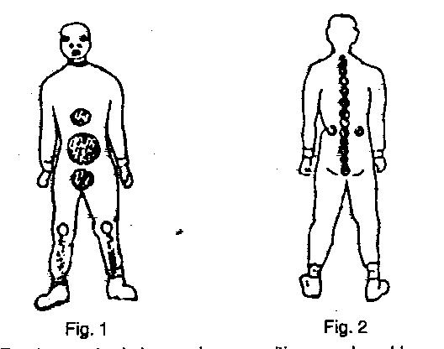

3. The human body has various sensitive or vulnerable spots, which in unarmed combat are considered as vital spots. These spots, such as solar plexus, temple and fork are very difficult to toughen, consequently, the degree of pain or injury from a blow to these spots will be graver and more serious than to the other parts of the body.

4. A soldier therefore must familiarize himself with the various degrees of vulnerability of vital spots and the body weapons, which would enable him to select the proper target to achieve the aimed injury and also to be able to defend against a seasoned blow effectively.

Vital Spots of the Body

5. The front and the rear view spots of the body are given in Fig-3 and Fig-4 respectively:-

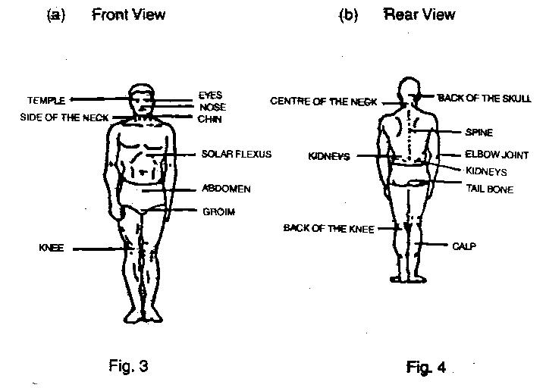

SECTION-4

PHYSICAL SELF DEFENCE/UAC

Introduction

1. The form of self defence which an individual has to employ against an armed or unarmed enemy, has always been the cause of concern for a soldier through the ages. Whenever a man faced a wild animal or an enemy, his concern has been to render his adversary ineffective by any available means.

2. Necessity is the mother of invention and it is with the aim of ensuring self preservation that most of the modern day martial arts and arts o self defence were invented through the ages.

3. The unarmed combat is a collection of offensive as well as defensive techniques derived from martial arts and combat sports which are ideally suited to the requirement of warfare where surprise is of paramount importance. The need to fight in built up areas, where even the most innocent of persons may turn out to be an enemy, makes unarmed combat, an essential part of every soldier’s training.

4. The thorough knowledge of unarmed combat in the hands of a self trained and highly motivated solider, is a formidable weapon which in many circumstances, is a more effective weapon, against an armed enemy. The usefulness of unarmed combat during an ambush, sentry silencing etc, has been adequately demonstrated in various wars fought all over the world.

5. Training in unarmed combat aims at installing the idea into a soldier that the fight is not over, even though he has been disarmed and, that a seemingly hopeless and unarmed defensive situation can be changed into an aggressive and attacking position.

Principles

6. In order to enable the solider to derive maximum benefit from a given situation by the use of unarmed combat. It is essential that he is aware of the various principles of unarmed combat. It is only by rigid adherence and implicit application of these principles that success can be ensured. The various principle are enlisted below:-

(a) Ruthlessness. War is a matter of life and death, especially where unarmed combat is concerned, hence there must be no scruples or compunction over the methods employed. ‘RUTHLESSNESS’ is necessary in order to gain mastery over the enemy, and it must be used without any mercy. The brutal method of attack, such as, kicking, gouging the eyes, blow etc, must be used without any hesitation. Emphasis must be laid on this from the very first lesson and a note made of the occasion, when such attacks should be employed.

(b) Determined Effort. All attacks must be aimed and carried out in a fierce, ruthless and determined manner. A “half hearted” attack will always be futile and loses half its effectiveness.

(c) Attack Vulnerable Points. The solider must be taught to close in with the enemy, whether the latter be armed or otherwise and immediately attack the most vulnerable points open to him, to achieve the aim. The location of these will depend upon the enemy’s dress, equipment and his position i.e., standing, kneeling, facing or with back to the attacker.

(d) Efficiency of Initial Attack. The vigour and suddenness of attack will probably catch even an armed opponent at a disadvantage, for it is unlikely that he will anticipate an attack from an unarmed man. The initial attack must be aimed at killing or disabling. However, if only a knock down or stunning blow can be delivered, it must be followed quickly by a hold, lock or throw which should succeed in giving the attacker, complete mastery over his enemy, even to the point of killing him.

(e) Surprise and Speed of Attack. Any defensive movement followed by speedy counter attack, must be aimed to catch the enemy by surprise. The surprise gained would diminish the chances of effective counter attack by the enemy.
(f) Retaining Initiative. Surprise, speed, strength, smoothness of execution and perhaps the most important of all, the gaining and retention of initiative, are essential if success is to be achieved. However, no two enemies will attack in precisely the same manner, but the skilled opponent of unarmed combat, by virtue of his knowledge gained, combined with constant practice with varied partners, under different conditions, will have variety of move at his commander to overpower his enemy.

Precautions

7. The following safety precautions must be strictly adhered to, when conducting the unarmed combat training to avoid any injury or accidents:-

(a) All practical work to be supervised closely and constantly. A class must never be left unsupervised.

(b) A soldier must be familiarized with each movement, theoretically and with practical demonstration, before attempting any practical work.

(c) During learning stages to prevent accident, do not permit a soldier to go ahead of your instruction.

(d) During learning and perfection of technique stages, ensure that the training partner offers no resistance. He should allow the movements to be executed freely.

(e) Ensure adequate space for practical work.

(f) Establish a signal for stopping the application of pressure when executing holds.

(g) Proper warming up is a must before carrying out any practical work

(h) Caution the men to apply very light pressure, until they become familiar with the holds.

Preliminaries

8. Dress. Initially start with denims and boots and progressively wear equipment and battle order.

(a) Ambidexterity. All attacks and defences must be taught using both left and right handed methods.

(b) Realism. Training should be realistic within safety limits.

(c) Blows. Practice these on punching bags, medicine balls or on a plank of thin wood.

(d) Attacks. These must be all out, followed up and doubled up whenever possible without losing the effect on the main attack.

(e) Knowledge and Practice. Understand, master and practice each move for speed and coordination.

(f) Defence. Follow all defensive moves or parries with attack.

(g) Initiative. Seize initiative at first opportunity.

(h) Bluff. The opponent should be bluffed into thinking that the individual is submissive and is not going to attack or that he is injured.

(j) Balance. Practice in pulling and tripping enemy off balance.

(k) Surprise. Surprise and unexpected attacks are important factors.

(l) Strength. It has an important part in unarmed combat.

Basic Throws

9. The throwing techniques are important for meeting situation that may arise during a combat either as form of defence or attack. It is therefore essential that a soldier is well versed with the throwing techniques, which requires a great deal of coordination of the mind, the body muscles, the body weight and also the quick reflexes which are of utmost importance, for imbalancing the enemy and achieving the required goal.

10. The under mentioned throwing techniques must only be practiced on soft mat/ground, to your sparring partner:-

(a) Right Hip Throw. Place the left foot in front of land slightly inside of your opponent’s left foot. At the same time, strike your opponent vigorously on his right shoulder with the heel of your left hand and grasp his clothing. This blow knocks him off balance (Fig-4) and then pivot on to your left 180 degrees on the ball of your left foot. During the pivot, place your right arm around your opponent’s waist and jerk him forward forcefully with both arms driving his mid section into your buttocks. This bends your opponent over your right hip at his waist and leaves him partially suspended in this position. Straighten your legs quickly thrusting your buttocks forcefully into your opponent’s mid section. At the same time, bend forward at the waist and pull forward and down with both arms driving your opponent to the ground (Fig-5 ) (a) & 5 (b).

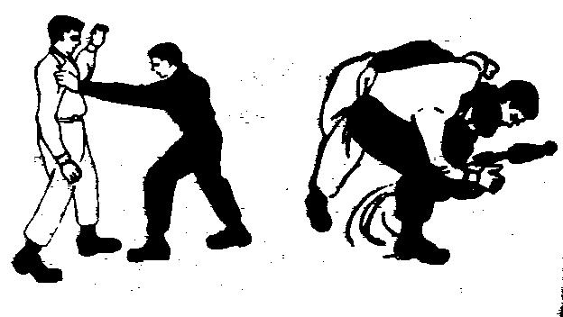

Fig.5
(b) The Ankle and Shoulder Throw. To attack an opponent from behind when silence is not essential, grasp his ankles with cupped hands and simultaneously force your shoulders into his buttocks. Pull his legs outward and backward as you come to the standing position. This will throw him forward on to his face and you should then follow through with a disabling kick to the fork Fig-6.

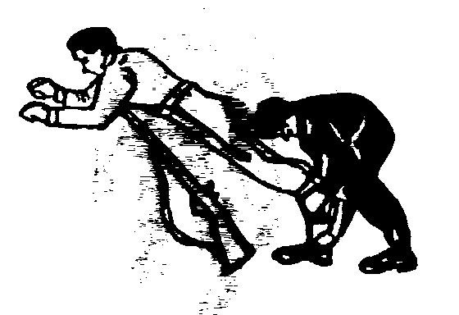
Fig.6

(c) Over Shoulder Throw. The first movement is identical to the right hip throw. Pivot to the left 180 degrees on the ball of your left foot. Keep your right arm in position to protect your head and neck region until you near the completion of the pivot. Then reach up and grasp your opponent’s clothing at his right shoulder with your right hand, gripping him with a double hand hold. As you complete your pivot. Pull your opponent forward and drive his mid section into your buttocks. Your buttocks are directly in front of your opponent’s hips. Your right foot is in front of and slightly outside of your opponent’s right foot, your elbows are as close to your body as possible. And your knees are bent. Straighten your legs, bend at the waist and pull downward with both hands. This action will catapult him over your shoulder (Fig-7).
(d) The Rugby Tackle. A rugby tackle from the rear consists of a swift dive at on opponents legs. As he starts to fall you must be prepared to deal with a disabling blow. This movement can be practiced either on a dummy, e.g. a weight sack suspended just clear of the ground or on a stationary / running man who has been taught how to fall (Fig- 8).
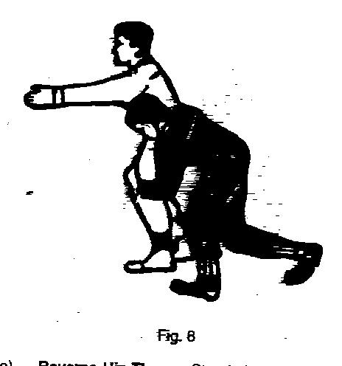

(e) Reverse Hip Throw. Stand closer to your opponent than in the previous throws. Take a long step forward with your left foot and place it slightly outside of and a few inches beyond your opponent’s right foot. Most of your weight is supported on your foot. At the same time, strike your opponent forcefully on his right upper arm and with your left hand grasp his arm at this point with that hand. This blow causes him to lose his balance to the rear Fig 5 (a) immediately step around your opponent with your right foot and place it directly behind him. At the same time encircle his waist with your right arm. Push your hips to your right as far as possible to gain buttock to buttock contact and pull your opponent in position on your right hip. At this time lock your opponents right arm into your left elbow. Straighten your legs, use your right hip as lever and throw your opponent over your hip, not over the side of your right leg (Fig-9).

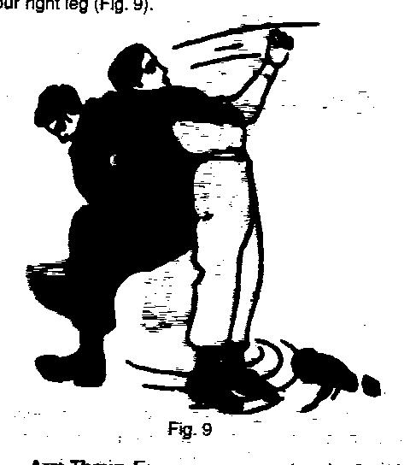

(f) Arm Throw. Face your opponent and seize his right wrist with both hands, right above left, swing his arm up quickly forward and pass under it by turning right-about maintaining a firm grip with your hands, and thus twisting his arm. Bend slightly forward over your left knee straightening and bracing your leg. Pull sharply down on your opponent’s arm by bending your leg. Pull sharply down on your opponent’s arm by bending forward at the waist and throw him on to his back. In practice, after you have secured you grip and turned, the

remaining movements must be done gradually, otherwise you will dislocate your opponent’s shoulder or cause him to strike the back of his head on the ground (Fig-10).
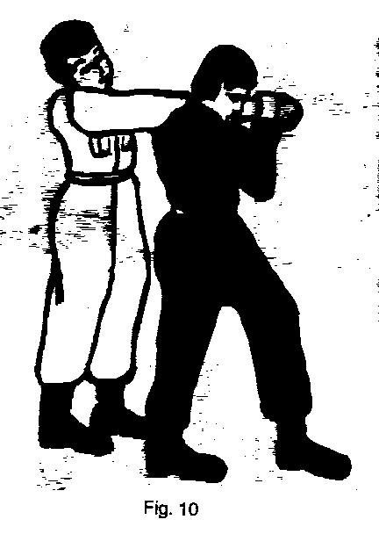

(g ) Stomach Throw. Grasp opponent’s right and left side collars, disturb his balance by pushing him to his direct rear, In return when the opponent pushes you, place your right foot on his lower abdomen and retaining your firm hand grip on your opponent’s lapel, side to the ground with your buttocks enabling your opponent’s lapel, slide to the ground with you buttocks enabling your opponent to fly over your head to the ground beyond, describing an arc in light through space. Sit on his chest and press his neck with both hands (Fig-11 (a), (b) & (c).
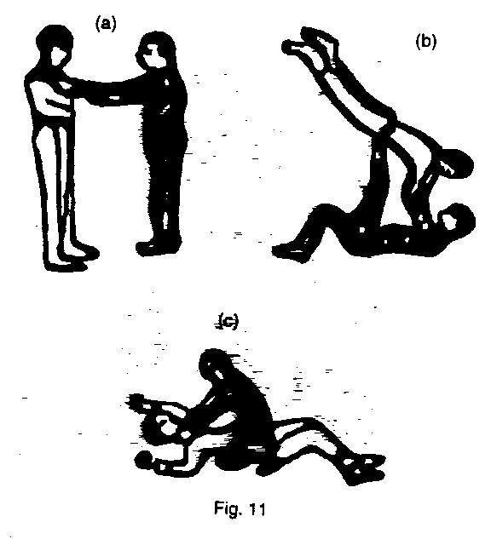
Attacking

11. Chin Jab. Sharp forward and upward blow delivered with the heel of the hand bent arm under an opponents chin. The weight of the body behind the blow (Fig-12).

12. The Knee Blow. A various blow with the bent knee to opponents fork/solar plexus or face (Fig- 13).
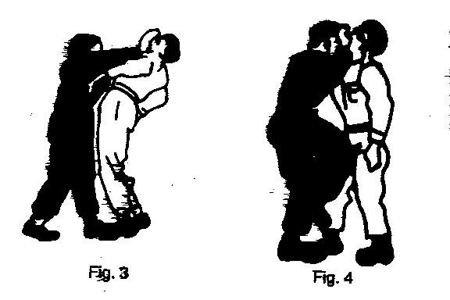
12
13

13. The Kick. (Fig-14 and 15 defence against the kick).
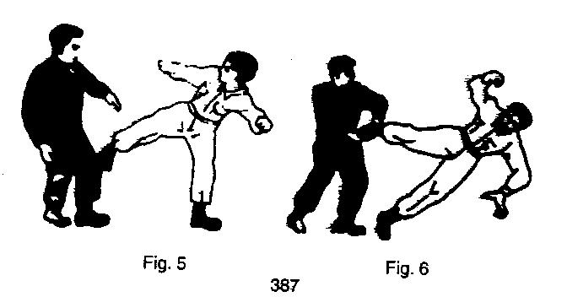
14
15

14. The Stamp. When seized from behind or front use your boot sharply on the opponents shin followed by more disabling blow (Fig-16)

15. Full Nelson. With both arms under the opponents armpit place your hands at the back of his head. Apply downward pressure on his head and upward pressing under his arms (Fig-17) .

16
17

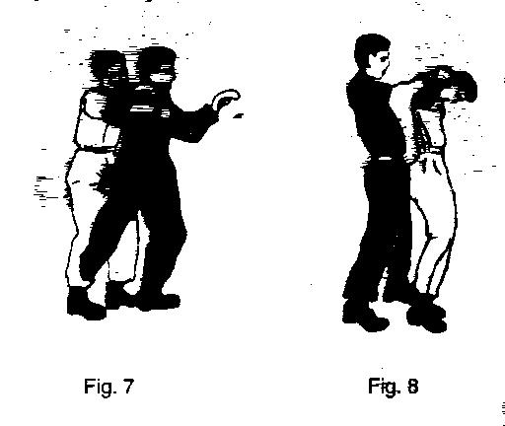
16. The Wrist Locks. Bending the wrist in any direction causes extreme pain. Fingers of the hand are also vulnerable . See double wrist lock . (Fig-18).

17. Strangle Holds

(a) Front Strangle Hold. Good for low frontal attack (Fig-19).

(b) Rear Strangle Hold. From behind stike him across his throat (Fig-20).

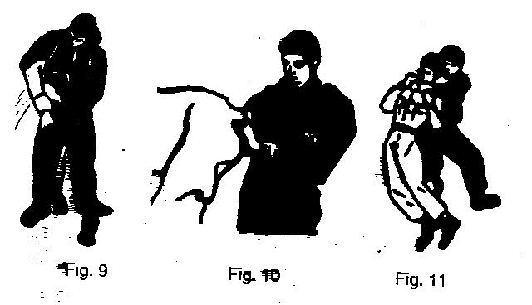
18
19
20

(c) Cross Collar Strangle Hold (Fig-21)

(d) Japanese Strangle Hold (Fig-22).

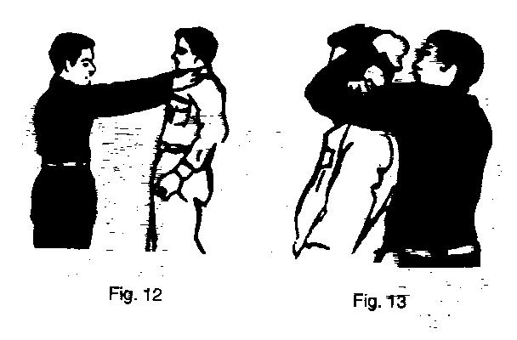

21
22
Release and Counter Attack

18. Counter attacks to front strangle hold (Fig 23 and 24)
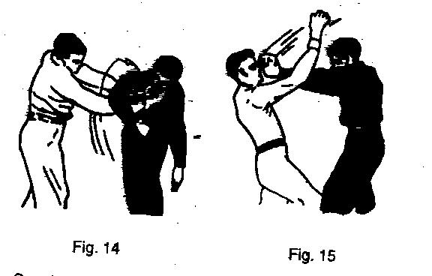
23
24

19. Counter attacks to rear strangle holds (Fig- 25 and 26).

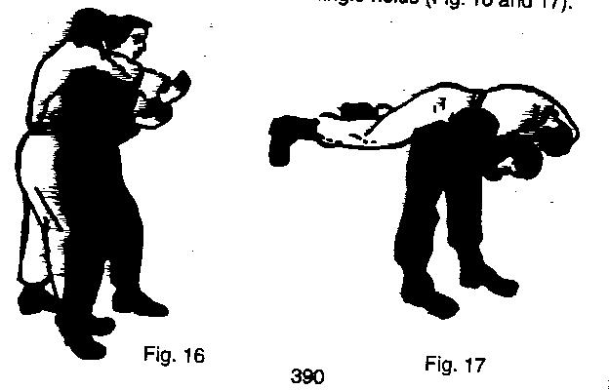

25
26

CHAPTER-XII

POSTURE TRAINING

INDEX

CHAPTER-XII POSTURE TRAINING
(ONLY FOR SD/SW)

SECTION-1 | Aim and Principles of Posture  Training and its Importance
SECTION-2 | Anatomy and Relationship of Body Segments
SECTION-3 | Analysis of Good Posture
SECTION-4 | Causes of Bad Posture, Remedial  and Preventive Measures
SECTION-5 | Balanced Alignment and Exercise
SECTION-6 | Balanced Diet
SECTION-7 | Correct Standing and Exercises
SECTION-8 | Correct Walking and Exercises
SECTION-9 | Correct Use of Body in Motion

SECTION-1

AIM AND PRINCIPLES OF POSTURE
TRAINING AND ITS IMPORTANCE

Introduction

1. A well poised body means better health through improved organic functions. The resultant, better work and increased physical and mental powers give greater strength and endurance which are helpful towards the building up of self-reliance, necessary for initiative in any field. Suffice to say that considering the objectives of NCC and the bearing of correct physique and self-confidence, posture training has taken an added significance.

Object

2. The main objects are to:-

- Develop the personality of cadets.
- Build their physique and teach them correct postures.
- Make them more self-reliant.
- Coordinate body movements.

3. A study of these objects shows that a great deal of emphasis is laid on development of personality, physique and self-reliance. It, therefore, follows that the training programme for cadets should be so designed that these objectives are achieved to the maximum limit possible. Good posture and deportment being essential in the development of personality and physique, it becomes necessary that elementary training in these is imparted to the cadets. Correct posture not only gives a distinctive touch to deportment, but also is a basic requisite to the efficient functioning of the human body both physiologically as well as psychologically. Hence the improvement in physique.

The Need for Good Posture

4. Grace and poise are the hallmark of an individual’s personality which can not be attained without developing a good posture.

5. Poise and graceful carriage may not come naturally to all of us but the smooth coordination of various sections of the body can be cultivated by correct training to acquire these elements of one’s personality.

6. Most of us receive no training in carrying out domestic chores with unstrained postures and body movements. We fail to drift into a room with poise, sit properly or execute a tennis stroke with grace. Incorrect movements are both inefficient and unattractive and leave us tense and fatigued long before the day has run out. They also wear out our organs and tissues faster, very much in the manner of an improperly driven car that soon rattles and collapses.

7. Hence from scientific and aesthetic view points, it is essential that we learn and understand the correct use of the body which would avoid strain and at the same time effect appearance and general bearing. The basic factor to understand is that the human body is a machine and considering it as such, we find it is made up of various segments whose movements should be smoothly co-ordinated.

SECTION-2

ANATOMY AND RELATIONSHIP OF BODY SEGMENTS

1. Posture is a problem to human beings because the skeleton is fundamentally unstable in the upright position. The two legged human body presents a continuous problem in maintaining balance at the feet which provide a very small base of support. To add to this, the trunk, head and arms are supported from the hips upward by a one legged arrangement of the spine. The body is composed of a large number of segments and these must be held together at all joint contacts and must be controlled and moved by many muscles arranged around the joints. Fig. 1.

2. The major joints, their location, direction of their movements and their functions are given below:-

S.No. | Type | Where Joined movements | Directions of | Functions
(a) | Ball & Socket | Hip Shoulder  Trunk  sideways | Forward  Backward  and rotation | Bending, straight-ening, extending
(b) | Condy-loid | Head, Neck Wrist  Fingers, Toes  sideways | Forward  Backward | Bending and straightening
(c) | Hinge | Elbow, Knee  Ankle Fingers | Forward  Backward | Bending and straightening
(d) | Pivot | Fore-arm, Head,  Neck | Around | Rotation, right  left, in and out
(e) | Irregular | Foot Hand | Gliding | In and out  movement

Muscles

3. The force of gravity continuously exerts the force on all parts of the human body. If a person does not unconsciously use muscles, one cannot stand erect against this force of gravity yet one is seldom aware of this muscle contraction under the force of gravity, the body tends to collapse forward, especially if muscle control is inadequate. Since the body is flexible and symmetrical, the job of keeping it erect falls greatly on certain muscle groups which are called antigravity muscles.

4. When muscles are continuously stretched by habitually poor posture, they lengthen and their tone diminishes. General fatigue also diminishes the muscle tone. When the antigravity muscles are fatigued or stretched, desirable postures can no longer be maintained. It is, therefore, essential that the anti-gravity muscles should be strong and well co-ordinated to maintain good body mechanics.

5. It is necessary to understand the vital functions of the antigravity muscles in order to attain and work for better posture. We shall start from the foot muscles and work upward.

Front View Back View
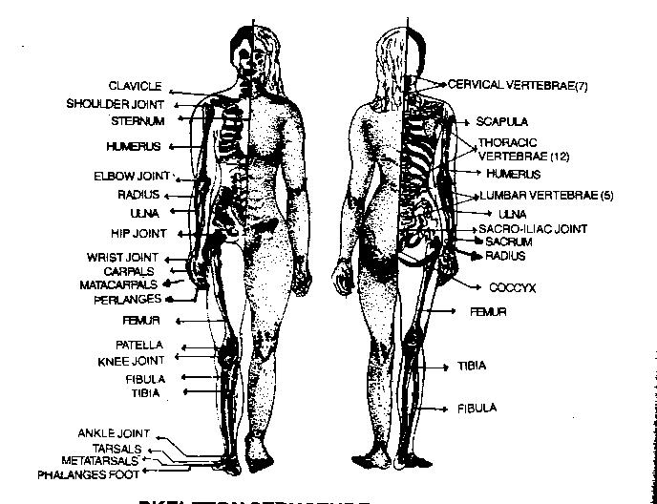

Fig. 1

SKELETON STRUCTURE & BODY FORM

Foot

6. The sole of the foot is heavily supplied with ligaments and muscles which act as buttresses to enable a person withstand the strain. The strain of standing tends to lower the arch of the foot. When the arches drop, one becomes flat footed.

Ankle

7. The body sways forward and backward over the feet, with the movement taking place at the ankle joint. The leg is attached to the ankle joint. The leg is attached to the foot much more towards the heel than the centre of the foot and hence the body must normally be balanced slightly forward of the ankle in order to centre its weight over the length of the feet. This means that the muscles of the calf of the leg, which are attached to the bone of the heel, should be strong.

Knee

8. At the knee position, the leg can be bent only in the backward direction. When the body weight sways backwards, gravity causes the knee to bend, unless the muscles of the thighs are contracted. These muscles are essential for keeping the legs straight.

Hip

9. The hip muscles are called into play to hold the trunk and the upper legs erect against the forward bending force of gravity without leaning on the ligaments.

The Trunk and the Pelvis

10. The spine acts as support for the trunk, head and arms. Because of its location more towards the back, the entire trunk has a tendency to fall forward. This becomes all the more increased by the fact that most of our daily activity is concentrated in front of the body under focus of the eyes. To control this forward drooping of the trunk the entire back muscles are called in to play. But some of the muscles are seldom required to work very hard and thus are poorly developed, as such they do the job of supporting the trunk indifferently.

11. Muscles are further weakened by prolonged stretching. Habitually poor postures expose the antigravity muscles of the back, abdomen and shoulders to prolonged stretch as the upper back is rounded, the chest sinks, the muscles of the back are stretched around the out side of the increased back curve. This rounding of the back is accompanied by a forward droop of the shoulders which in turn stretches the muscle fibres from the spine out to the shoulder blades. As the chest sinks, it carries the heart, lungs and the blood vessels downward pressing on the contents of the abdominal cavity. These then are pressed down and forward against the abdominal muscles. This places a stretch on the entire abdominal muscle walls, weakening it and causing bad body mechanics.

SECTION - 3

ANALYSIS OF GOOD POSTURE

1. We constantly adjust ourselves to eight segments of the body which are as under :-

(a) The bones of feet acting as means of locomotion and a base for supporting the entire super imposed weight of the body.

(b) The bones of lower legs, jointed for freer movement.

(c) The bones of upper legs, offering full and varied movement at the hips.

(d) The pelvic or hip girdle, the position of which is fundamental to the support of the upper body.

(e) The bones of the trunk, the spine with its normal curves, with chest and abdomen providing ample room for vital organs.

(f) The bones of the shoulder girdle.

(g) The bones of the neck.

(h) The head with eyes level-crowns the highest part.

2. When these segments are held one upon another in the best possible manner, that posture is good. When they are moved in poised and unstrained manner, the body moves efficiently. This may need more clarification. Take five boxes of the same size or different sizes and place them all on top of each other as shown – Fig. 2. Take another set of five boxes and place them on top of each other as shown in Fig.3. The results are obvious.

3. Likewise the segments of the body act, if held in one line. They ensure economy of effort, strength, balance and proper support. In case where these segments get out of alignment they involve more strain and convey an unaesthetic and weak position.

4. Fig. 2 shows head straight, chest up forward, abdomen in and back with

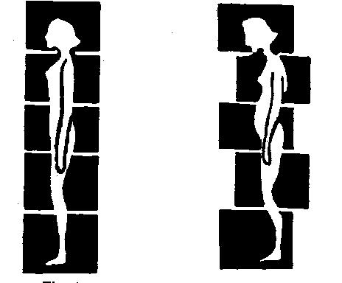
Fig. 3
Fig. 2
Fig. 1

the usual curves. It also shows that all the segments are placed in one line and therefore convey correct position of the body. Fig. 3 shows head forward, abdomen protruding, back with curves exaggerated. It shows that segments of the body are placed in a zigzag manner and therefore the body is held in an incorrect position. The correct posture would mean:-

(a) The body is held as tall as possible without strain.

(b) The head held correct and the chin slightly drawn in (vertical line-chin to sternum).

(c) The shoulders are slightly posterior to the centre of gravity (Straight line from shoulder to sternum).

(d) The chest is high (Sub-costal angle of the ribs at least at right angle).

(e) The abdomen is in (Abdomen flat).

(f) The spinal curves are not exaggerated (Gentle curves).

(g) The pelvis is tilted slightly upward in front and downward in back (55 degrees).

(h) The knees are straight but not still.

(j) The weight of the body falls back of the middle of the foot on the longitudinal arches. The plumb line through the middle of the patella should fall between the bases of the second and third toes.

(k) The body is free for movement without strain and with the least expenditure of energy.

(l) The entire body is in the true anatomical position.

(m) The vital organs are free for most efficient function.

5. The above position is maintained with relative ease if :-

(a) The individual possesses sufficient strength and tone of the opposing muscle groups.

(b) There is adequate organic vigour and the body is free from infection.

(c) There is sufficient strength of ligaments and muscles to permit correct body position without undue strain on these ligaments or muscles. That is, there must be sufficient flexibility and normal range of movements. It must be possible to stretch to proper position the shortened parts and shorten the over stretched parts.

(d) The individual knows what correct body mechanics is.

(e) The individual has had sufficient practice in the correct position. The muscle sense of the correct position must be fully developed.

(f) The external conditions for maintaining correct body mechanics are conducive to correct posture i.e. chairs must fit the body.

6. An incorrect body posture is more fatiguing as more energy is required to maintain the physical equilibrium. There is generally a very wrong notion about changing a habitually defective posture to a correct one. People think that changing to the correct posture would make one more tired. However as per the principles of correct body mechanics the various parts of the body are so aligned that they do not require much muscular support and can very easily fall into the correct position.

7. An improperly aligned body structure is generally due to a wrong postural habit. Establishing a new habit is at first fatiguing and it becomes difficult to get rid of a wrong- ly formed physical posture. However, once efforts are made to correct it, the alignment is set automatically.

SECTION-4

CAUSES OF BAD POSTURE REMEDIAL AND
PREVENTIVE MEASURES

1. The following are the causes of bad posture:-

- Due to Muscular and Organic Defects. Sometimes bad posture is due to poor development of muscles. The back muscles are weak and the abdominal muscles get relaxed. Hence the whole muscular system becomes loose and sagging. All efforts to balance the body correctly fail because of a defective body framework.

- Lack of Nourishment. Children who do not get proper nourishment develop defective body mechanics.

- Fatigue Due to Over Work. Bodies get deshaped due to overwork. Under nourished children struggling under heavy school schedules develop poor body movements.

- Due to Illness and Infections. Illness and infections result in fatigue and the body slumps out of shape. Wariness leads to overstrained muscles and ligaments and the consequent body deformity. Due to the warping of the body framework there is a deformed posture. Sometimes faulty body mechanics are due to injuries also.
- Due to Bad Habits. Bad habits of sitting, standing and walking in wrong postures due to shyness or inferiority complex result in a deformed posture unless persistent efforts are made to improve them.

- Due to Poor Hygiene. Neglect of the principles of hygiene such as proper bathing, eating, sleeping and relaxing and taking of exercises result in poor body mechanics.

SECTION-5

BALANCED ALIGNMENT AND EXERCISE

General

1. These techniques are designed for the primary purpose of improving your muscle sense or keen aesthetic perception of the balanced position of the total body. The goal is to consciously achieve a balanced position so that when you assume any other position, you will be uncomfortable. A description of balanced position when standing seems in order at this time. They are as under:-

- Your knees will be free and easy, neither bent nor thrust back.

- Your hips will be under you neither leading nor thrust back.

- Your abdomen will be up and in, neither relaxed nor protruding.

- Your chest will be held up and easy, neither sagging nor too high and leading.

- Your shoulder blades will be drawn down and flat on your back.

- Your arms will hang naturally and relaxed at your sides, neither rigid nor too relaxed.

- Your trunk will be with in normal limits of curves, neither too straight and flat nor too rounded and hollow and you will stretch your back straight upward towards the crown of your head. Your head and chin will be easy and centre over your trunk with chin held at right angles to front of your neck.

2. Specific techniques to aid you in attaining balanced alignment are prescribed in following paragraphs.

3. Try to find your position of balance by feeling it, seeing it, and holding it for a few seconds. Relax, then see if you can find this position. Again repeat.

4. See it, work in front of a mirror and try to visualize the balanced position of your body segments, the total line running through the centre of weight of each body segment and falling slightly in front of the outer ankle bone. Feel it.

5. When you find this position, become aware of the position of the body parts, the sense of weight on the feet, the free and easy position of the knees, the balance of the pelvis, the position of the trunk and the chest, the free and easy balance of the shoulder, and the feeling of the head and chin.

6. If you have difficulty in finding the balance of your body parts, test yourself against a wall or door, stand with the back against the wall or door. Heels, hips and head touching the wall. Stretch tall and easily, keep waistline in, shoulders balanced and easy, arms relaxed at the side, head straight, chin horizontal and chest held in mid position. The space between your lower back and the wall should be at a minimum, just enough to feel the pressure on your fingertips, if you tried to slide your hand through.

7. If you are still having difficulty in developing the balanced feeling by this exercise then stand with the hips supported against the wall, several inches from the wall, body bent forward at the waist. Gradually bring the body to an extended position by first pressing the lumbar region of the spine to the wall and then attempting to touch each segment of the spinal column to the wall.

8. One good exercise that brings about the feeling of the balanced position and at the same time, assists in developing the muscles necessary to maintain this balanced position is to stand with the back against a wall. Heels about 3 or 4 inches from the wall, feet straight ahead and 2 inches apart, knees easy. Place the hands up beside the head will elbows touching the wall by pulling up and in, with the power of abdominal muscles. Hold head straight and the chin level, stretch tall in this position. Tighten muscles on inner side of feet, rolling weight, slightly towards outer borders of the feet and rotate legs slightly out ward with knee caps facing straight ahead by tightening the buttock muscles. Hold this position about 3 counts. Relax, repeat exercise 3 times per day. You may occasionally stretch the arms up over head, keeping them in contact with wall.

9. If this exercise is difficult for you, try it on the floor, then try it up on a stool with the knees bent at right angle and feet flat on the floor. Then proceed to stand position.

10. Once you achieve the sense of balance in the standing position with concentration, your next step is to practice. Relax, balance, relax. Repeat the procedure about 3 times per day. Continue as long as necessary so that during the day without a mirror, you can check yourself.

11. To become more consciously aware of your balanced position in the upright position, utilize the following procedure:-

(a) Balance yourself in front of a mirror. Walk away from the mirror and then return. Are you in balanced position? If not find your balanced position and repeat the exercise. Repeat until you can come back and be in a balance position.

(b) After you can do this, increase the frequency of the exercise. Don’t just walk, but stoop, lift, carry objects, climb stairs and change the height of your heels. When you can achieve the balanced position with concentration then you are ready for the next step.

Balanced Exercise

12. Keeping the correct balance is important in posture training. All remedial exercises should be carried on from basically correct positions due to the prevalence of faulty foot and leg position. Walking on a straight line, narrow beam or even on the flat floor places undue stress on groups of balance muscles that are not developed symmetrically. For this reason a tilted board balance is devised in which the treads are started outwards at about 15 degrees. Standing on these treads, the leg is rotated outwards and the feet are thrown into a wild universion state which corrects the position. In this position there is a taking up of a slack of the stretched muscles and a lengthening of the shortened muscles every time one foot is raised.

13. The effort to keep the balance, or to maintain stability is being done by the opposite leg body or arm. Something else, gives a powerful stimulus to all the muscles.

Equipment

14. The suggested equipment for these exercises is given below:-

  - Full length mirror – located in conveniently accessible place.

  - Hanging apparatus/Beam/Bar.

  - Visual aid – postures and charts.

  - Balance boards, raised brick bund approx 40 feet length.

  - Sand bags – varying in weight from one to five Lbs. Use these for balancing on the head.

SECTION-6

BALANCED DIET

General

1. The major components of food are Carbohydrates, Proteins, Fats, Vitmins and Minerals. These are called Nutrients. Besides these, water is an important constituent of our food and makes up for two - thirds of our body weight. Our diet usually contains all the nutrients in varying amounts. Rice or roti gives us energy. Dal, eggs and meat give us protein, and so on. A diet is Balanced if it contains all the nutrients in the correct amount. Carbohydrates and fats provide energy for the body. Proteins provide materials for growth and repair of cellular constituents. Minerals and vitamins are needed to aid vital reactions in cells and tissues and also to regulate body functions. Water plays an important role in cellular reactions, and other life processes such as digestion, excretion and transport. Alongwith all these, a certain amount of Roughage is needed for proper digestion. Roughage largely consists of the indigestible plant Cellulose which helps retain water, adds bulk to the food and prevents constipation.

Individual Body Need

2. Again, a balanced diet is related to the state of one’s age, health and occupation. For example, a 12-15 years old girl needs daily about 10300 kilojoule of energy from oxidation of carbohydrates and fats and 50 grams of vegetable protein. The requirement of protein is not the same for all adults, for example, some need only about one gram per kilogram of body weight. It is high for growing children and pregnant women. Can you reason why? A man doing hard work may not need large amounts of protein in his food, but he does require food of high calorific value, i.e., high content of carbohydrates and fats. The body also needs small amounts of vitamins and minerals. So , in order to design a diet which will take care of your body’s requirement and satisfy your food habit, you will have to know the nutritive value of various items in your food. Inaccurate and misconceived information about the nutritive value of certain food items(such as, ‘grapes are best for health’, or ‘an apple a day keeps the doctor away’) can lead to wasteful expenditure without ensuring good food value.

Recommended Diet

3. Almost all foods contain all the nutrients in varying amounts-some more, others less. A meal can be carefully chosen so that all the requirements of the body are met. The recommended dietary requirements are given in the chart.

Recommended Dietary Requirements in Gram

Food items | Adult man |  |  | Adult woman |  |  | Children |  | Boys | Girls
 | Sedent  ary | Moder  ate | Heavy work | Sedent  ary | Moder  ate | Heavy work | 1-3 yrs | 4-6 yrs | 10-12 yrs | 10-12 yrs
Cereals | 460 | 520 | 670 | 410 | 440 | 575 | 175 | 270 | 420 | 380
Pulses | 40 | 50 | 60 | 40 | 45 | 50 | 35 | 35 | 45 | 45
Leafy  Vegetables | 40 | 40 | 40 | 100 | 100 | 50 | 40 | 50 | 50 | 50
Other Vegetables | 60 | 70 | 80 | 40 | 40 | 100 | 20 | 30 | 50 | 50
Roots and Tubers | 50 | 60 | 80 | 50 | 50 | 60 | 10 | 20 | 30 | 30
Milk | 150 | 200 | 250 | 100 | 150 | 200 | 300 | 250 | 250 | 250
Oil and fat | 40 | 45 | 65 | 20 | 25 | 40 | 15 | 25 | 40 | 35
Sugar and Jaggery | 30 | 35 | 55 | 20 | 20 | 40 | 30 | 40 | 45 | 45

SECTION-7

CORRECT STANDING AND EXERCISES

Correct Standing

1. Correct Standing means that the weight of the body should be on both feet; knees should be relaxed. Line of abdomen should be almost straight; pelvis should be held squarely over the base of support, chest over pelvis, shoulders resting easily over rib cage, head over shoulder and chin should be parallel to feet.

Exercises

2. Following exercises help in gaining muscle control and in correct standing:-

(a) Walk, run, walk run - - -
repeat.

(b) Skip - - -
repeat.

(c) Review your standing position and find out and correct fault such as :-

(i) Forward head.

(ii) Tilted shoulders.

(iii) Round back.

(iv) Round shoulder.

(v) Protruding abdomen.

(d) Short stride standing position and find out and correct fault such as arms over head, shoulders relaxed :-

(i) Start slow ‘pinwheeling’ over left foot.

(ii) Continue slow ‘pinwheeling’ over right foot.

(iii) Lift trunk, twist to left, bend with a strong trunk extension with shoulders relaxed.

(iv) Begin ‘pinwheeling’ over left foot.
Repeat

(For flexibility of trunk and shoulder girdle and strong spinal extension).

(e) Back lying arms relaxed at side:-

(i) Lift trunk and legs forming ‘V’ with the ankles. Forward reach of both arms will help balance pull up.

(ii) Touch outside of knees but do not hold on or hold breath.

(iii) Return, bend knees and slide down.
Repeat.
(For strengthening of abdominal and spinal muscles).

(f) Standing – Easy knee and arm swings keeping trunk erect over the base as the knees dip easily. Heels slightly off the floor, begin with a slight bend, ncrease the depth from one swing to four swings.

Repeat
(For flexibility and strengthening of knee and hip joints).

(g) Back lying, knee pulled to chest and held : Roll forward and back and from side to side.

Repeat
(For strengthening of lower back).

(h) Back lying:

(i) Inhale as fully as possible.

(ii) Exhale.

(iii) Relax.
Repeat
(For relaxation).

SECTION - 8

CORRECT WALKING AND EXERCISES

Walking

1. While walking, heel should be in contact with the ground, weight of the body should be transferred to the balls of feet, inner line of feet should be straight, there should be no body bulge in front, heel cord seen in rear view is straight, not bent inward at ankle level, relaxed arm swing, feet swing forward parallel and body alignment is good.

Exercise

2. Following exercises will help in improving use of legs and in correct walking :-

(a) Skip high , skip low.

Repeat.

(b) Practice correct walking as explained below:-

(i) Heels in contact with the ground first.

(ii) Weight of body transferred to the ball of feet.

(iii) Toes used in definite push off action at each step.

(iv) Legs swinging forward and parallel.

(v) Feet swing forward parallel.

(vi) Relaxed arm swing.

(vii) Good body alignment.

(c) Walk run, walk run : Repeat until you feel difference in the push off.

(d) Run in slow long stride, run with arms swinging strongly forward and back in opposition.

Repeat.
(e) Standing Arms Relaxed at Sides. Pedal weight on right foot and left toes, change weight distribution with tall push up through spine, up toes of both feet before alternate heel is dropped.

Repeat
(For improving the use of legs and feet in motion)

(f) Standing with Hands on Hips. Alternate leg swing forward and backward first with heel on floor then with lifted heel. Once the movement is started continue with complete swing with little effort. Swing sixteen times on each side before changing.

(i) Repeat running and walking with emphasis on relaxed easy legs drive and arm swing forward and backward.

(For improving the use of legs and feet in motion).

SECTION - 9

CORRECT USE OF BODY IN MOTION

1. The body goes through innumerable motions all the time. But the most vital ones which we must learn to execute correctly are as under:-

(a) Sitting. Back should be straight, weight of the upper portion of the body should be over pelvis, feet and legs should be in easy relaxed position.

(b) Lifting Objects with One Hand. In order to pick up an object, place one foot nearest to the objects close to it and as near its centre of weight as possible, with the other foot slightly ahead. Then, bending knees, with the trunk leaning slightly forward, grasp object and lift it in line with the body as the trunk, hips, and knees extend back to normal erect alignment. This method is correct for lifting light and heavy objects which can be moved with one hand, such as objects with handle, suit cases, packages, a book etc.

(c) Lifting Objects Requiring Use of Both Arms and Hands. A tray of dishes, a bag of groceries a baby from the floor etc. stand close to the objects, with feet slightly apart, bend knees to required depth keeping pelvis and weight of trunk over the feet. When contact is established with arms or hands lift the object to desired carrying position. This position should be as nearly over the body’s centre of gravity as possible or parallel to its line of gravity.

(d) Pushing or Pulling Heavy Objects. In pushing, stand as close to the object as necessary. (The heavier is the object, the closer one should stand). Apply the push in the desired direction and through the object’s weight centre. Lean forward bracing your hands against the object to bemoved. In pulling, lean in the direction of the pull to increase the horizontal component of the leg thrust.

(e) Lowering Weight with One Hand. Bend the trunk slightly forward with knees and hips flexed. Place the foot nearest to the object slightly back to receive the weight of the body. Place the opposite foot forward to balance, increase knee and hip bend to required level. Slowly lower the object to the receiving surface.

(f) Lowering Weight with the Use of Both Arms and Hands on a Table or Raised Surface. Place the foot nearest to the object as far under receiving surface as possible or close to it and parallel to its edge. With a slight bend of the trunk forward, bend knees slowly at the same time as the lowering of the weight.

(g) Lowering Weight to the Floor. Place one foot slightly forward. Bend knees as far as necessary and trunk slightly forward as object makes contact with the floor.

(h) Lifting and Carrying Objects from Floors in Pairs. Bend knees and hips as deeply as possible. Each cadet should grasp an object at an end with strong extension of the legs. Lift together and carry to the new position. (Lowering to its new location involves the reverse of lifting.)

(j) Skipping and Running. End with skipping and running.

MISCELLANEOUS

CHAPTER-XIII

INDEX

CHAPTER-XIII MISCELLANEOUS

SECTION-1 | Career Options in Services: Army, Navy & Air Force
SECTION-2 | Selection Process : WTLOs
SECTION-3 | Traffic Rules and Road Signs

SECTION-1

CAREER OPTION IN SERVICES: ARMY, NAVY & AIR FORCE

ARMY

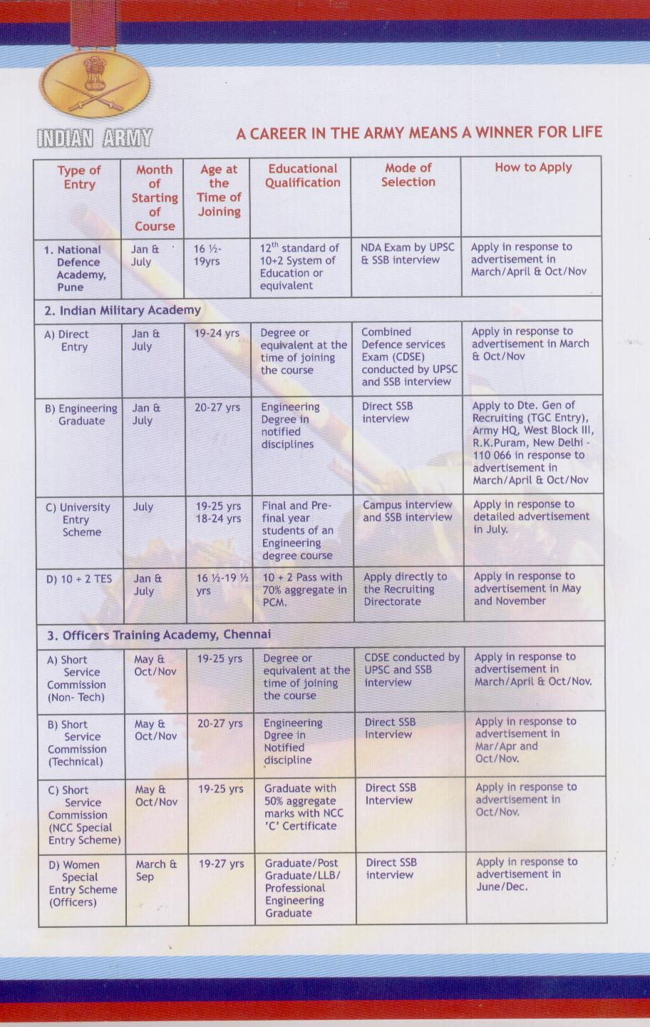

NAVY

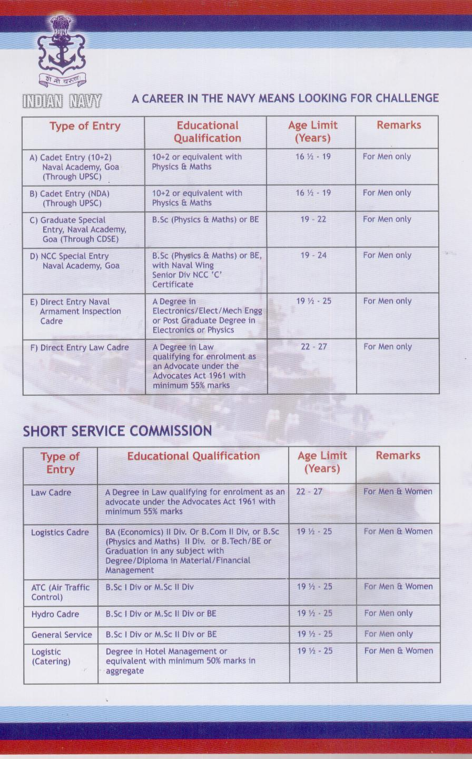
AIR FORCE

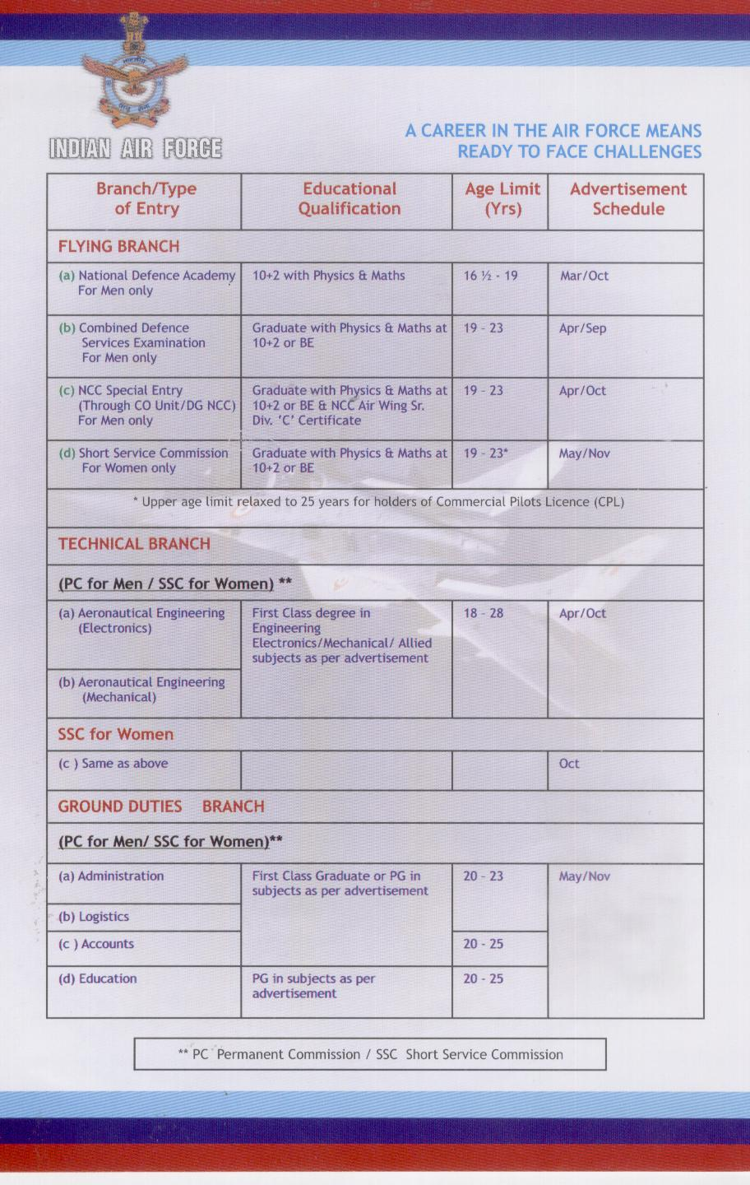

SECTION-2

SELECTION PROCESS : WTLOs

1. Selection process for the Whole Time Lady Officers is given in the succeeding paragraphs.

2. WTLOs. The Direct Entry Whole Time Lady Officers are selected through an open competition by the Union Public Service Commission as and when vacancies arise . A limited percentage of vacancies is also reserved for ‘C’ Certificate holders of NCC , subject to fulfilling other conditions .

(a) Eligibility Conditions – Direct Entry

(i) Age - 21 -25 Years

(ii) Qualification - Degree of a University or equivalent

(iii) Must be medically fit for active service.

(iv) Must fulfil the following physical standards:-

(aa) Heights - 145 Cms

Relaxation in - For Gorkha/ Garhwali/
Height Standards Kumaoni/ Dogra /Maratha
ladies -2 cms, Adivasis – 3 cms

(ab) Weight - According to height but not less
than 42 Kgs

(ac) Should not have knock –knee or or flat foot.

(ad) Eyesight (with or with out glasses)

Distant Vision - 6/6 in one eye and 0.8 in other eye.

Near Vision - 0.6 in one eye and 0.8 in other eye.

(v) Desirable

(aa) 2 years experience as ANO or GCI in NCC or equivalent rank in Police Force.

(ab) NCC ‘C’ Certificate holder.

SECTION-3

TRAFFIC RULES AND ROAD SIGNS

General

1. Roads are made for human-beings and all types of transportation but to avoid chaos on the roads, there are certain traffic rules and laid down set road signals. These have to be followed strictly for safety of everyone. Certain important points are discussed in detail in succeeding paragraph.

Crossing of Roads

2. Pedestrians are the high–risk group on roads. Most of the accidents and accidental deaths involving pedestrians are the direct result of their errant behaviour, specially while crossing roads. They are least bothered about the right of vehicles on roads and scuttle across roads amidst heavy traffic without giving due respects to road safety norms. The first right on the roads is that of vehicles, hence give way to them. Utilise zebra crossings, subways and foot over bridges to cross roads instead of cutting it in the middle. Pedestrians should keep the following in mind :-

(a) Zebra Crossings. Every pedestrian must have seen a group of white lines as those on a zebra near intersections where vehicles stop at red light. These are exclusively meant for pedestrians for their safe crossover. They should cross the road by walking over it. Only when the traffic signal for vehicles is green do vehicles drive over zebra crossing.

(b) Subways. Technology tunnels involving great engineering skills and expenditure are built underneath roads to enable pedestrians cross busy roads safely without confronting heavy onrush of traffic on roads. It is not only safe to cross roads using a subway it is fun too. For you can have a leisure walk without any botheration for traffic.

(c) Overhead Bridges. On certain busy roads wherein construction of subway is not feasible overhead bridges are built across road edges to enable pedestrians’ safe crossover. Again, using these bridges to cross roads would be safe as well as fun. For you are quite above from the realities on roads.

2. Safety Rules to be Followed, While Walking to School

(a) Always walk on the footpath only. On roads without footpath, walk on the extreme right hand side of the roads. Do not be impatient on the road. Do not rush or run on the road.

(b) Cross only at zebra crossings, traffic signals, subways, foot over-bridges. Where such facilities do not exist, look for a safe place to cross.

(c) At the signal lights, cross only on a clear green signal. If an intersection is controlled by a policeman, traffic warden or RSP cadets, cross only when he signals you to do so.

(d) When crossing between vehicles parked on the side of the road, remember that you are not visible to the moving traffic (because the parked vehicles may be higher than you). Stop as you appear from behind the vehicle and look for a safe gap before crossing. Remember, drivers need plenty of time to see you and to slow down and stop.

(e) While crossing wide road that have central islands, always cross in two stages. Cross to the Central Island, stop, and cross when the next section is clear.

(f) While crossing one-way streets, remember that the traffic will usually be moving in a number of lanes and at higher speeds. Do not cross unless all lanes are clear.

(g) Never cross a road at a corner, as the motorist taking the turn will not be able to see you on time.

(h) Running across the road is a bad idea, as you may slip and fall.

3. Safety Rules to be Followed, While Going by Bus

(a) Leave home well in time, so that you won’t have to run to catch the bus.

(b) At the bus stand, always follow the queue. Board the bus only after it has come to the proper stop, without rushing in or pushing others.

(c) While in the bus, shouting or marking a noise is definitely bad manners. Such behaviour can also distract the driver.

(d) Do not board or alright at a bus stop other than the one decided by the school. Never board and alight at a red light crossing or unauthorized bus stop.

(e) Always hold onto the hand-rail if standing in a moving bus, especially on sharp turns.

(f) Do not sit, stand or travel on the footboard of the bus.

(g) Do not put any part of their body outside a moving or stationary bus.

(h) Always adhere to the bus safety rules.

Use of Helmets

4. It is necessary to wear helmet while driving for ones own safety. Helmet save us from brain-injury if accident occurs. As brain is the most important part of our body, in case injury occurs in brain one can die or lose his memory or may become paralysed. So to avoid this, simply ‘WEAR HELMET WHILE DRIVING’. Main points to be taken into consideration, regarding helmet:-

(a) Wear only driving-helmet.

(b) Helmet string should not be of poor quality.

(c) Helmet string should be tied properly.

(d) Helmet should have I.S.I Mark.

Use of Mobiles

5. While driving / riding switch off your mobile and put it on voice mail. If you talk while steering you can be fined or face imprisonment. If you talk while driving your concentration gets reduced and can cause an accident..

Effects of Alcohol

6. Alcohol reduces the ability to drive in a proper and sane manner, which may result in disaster on roads. Alcohol has following effects:-

(a) Slows down the mental process.

(b) Incapacitates the brain to take a rational decision.

(c) Gives strong but false sense of confidence, which in turn affects performance.

(d) Renders the brain incapable of controlling and coordinating body movement.

(e) Impairs the ability to judge speed and distance.

(f) Impairs the ability to judge speed and distance.

(g) Impairs vision and hearing.

Punishment

7. If any of the above happens while you are driving, accident is sure to follow. Further you will fall prey to end number of legal complications. Driving with an alcohol content of more than 30 mg per 100 ml of blood is a punishable offence and a court challan is issued to the offender.

(a) Punishment for the First Offence. Imprisonment for a term which may extend up 6 months or a fine of Rs 2000/- or both.

(b) Punishment for the Subsequent Offence. For an offence committed within 3 years of the previous offence, the offender may be imprisoned for a maximum period of 2 years or charged a fine of Rs 3000/- or both.

8. Precaution to be Taken . After a drink party the host should make his inebriated guest stay at his place or else hire a driver to ensure safe transportation of his guest back home. Also the youngsters must be told that it is not smart to drink and drive. It is essential for the parents to instill in the minds of their children a sense of responsibility towards the society.
Road Signs

9. These are of three types i.e. Mandatory, Warning and Informatory signals

