**CHAPTER-I**

**ARMED FORCES**

|  |  |  |  |
| --- | --- | --- | --- |
| **INDEX** | | | |
| **CHAPTER-I ARMED FORCES** | | **JD/JW** | **SD/SW** |
| SECTION-1 | Basic Organisation of Armed Forces  (Army, Navy & Air Force) | √ | √ |
| SECTION-2 | Badges and Ranks | √ | √ |
| SECTION-3 | Honours and Awards | √ | √ |
| SECTION-4 | Concept of Combined Defence Services | - | √ |

**SECTION -1**

**BASIC ORGANISATION OF ARMED FORCES**

**ARMY**

**Introduction**

1. The present day Indian Army owes its origin to British days. It was then used as an instrument for the expansion and preservation of the British Empire.

2. At the time of independence in 1947, due to partition of the sub-continent, the old Indian Army was also divided. Since then the Army has continued to be re-organised and modernised.

3. The Army since independence has taken part in the following major operations in defence of our borders :-

(a) Kashmir Operations against Pakistan 1947-48.

(b) Sino- Indian Operations in NEFA (Arunanchal) and Laddakh 1962.

(c) Indo-Pak war 1965.

(d) Indo – Pak war 1971.

(e) Kargil conflict 1999.

4. In addition, Army has taken part in peace keeping missions under United Nations in various parts of the world.

5. Services of the Army and Air Force have been extensively utilized in aid of civil authorities during natural calamities like floods, cyclones and earthquakes.

6. The Army today is self–reliant in respect of its requirements of conventional weapons and is fully geared to meet any external aggression on our borders.

**Command and Control**

7. **Command.** The President of India is the Supreme Commander of all the Armed Forces of the country. The Chief of Army staff is the head of the Indian Army and is responsible for its command, training, operations and administration. He carries out these functions through Army Headquarters (Army HQ).

8. **Command Headquarters.** The whole country is divided into seven commands. These are Northern, Western, Central, Southern, South Western, Eastern and Training Command. The Command HQ exercises operational responsibility. It is commanded by an officer of the rank of Lt General.

9. **Field Formations.**  Corps, Divisions and Brigades. These are commanded by an officer of the rank of Lt General, Maj General and Brigadier respectively.

10. **Static Formations.** Area and Sub Area Headquarters. These are commanded by an officer of the rank of Maj General and Brigadier respectively.

**Fighting Arms**

11. **Armour.** Armour by virtue of its mobility, fire power, protection and shock action is most aptly suited for present day battle field environment. The basic role of armour is to destroy the enemy by relentless, mobile offensive action, both in offensive and defensive operations.

12. **Infantry**. Infantry is essentially an arm of close combat. Its role in attack is to close in with the enemy and destroy or capture him and capture and hold ground. In defence it is to hold ground against all forms of enemy’s attack. It is also employed in counter insurgency and counter terrorism operations.

13. **Mechanised Infantry**. It is just like infantry with enhanced mobility and fire power. Mechanised Infantry moves in armoured personnel carrier (APC) which has adequate protection against small arms fire. Their mobility in conjunction with Armour enables own troops to obtain most favourable decision in battle. The emphasis is on mobility, fire power and manoeuvre rather than manpower.

**Supporting Arms**

14. **Artillery**. Artillery provides heavy volume of fire at long ranges to damage and destroy enemy positions before it can be physically captured and occupied by own ground forces.

15. **Engineers.** The role of Engineers in war is to provide support for offensive and defensive operations in mine warfare, bridging, demolitions, construction of field fortifications and operational roads/tracks.

16. **Army Air Defence**. Army Air Defence is equipped with air defence guns and short and medium range surface to air missile systems. Along with Air Force it provides air defence to Mobile Forces, Vulnerable Areas and Vulnerable Points.

17. **Army Aviation Corps.** The role of Army Aviation Corps is reconnaissance and observation by controlling artillery and infantry mortar fire from air. It provides commanders and staff rapid means for liaison visits. It is ideally suited for evacuation of battle casualties.

18. **Signals**. The role of Signals is to provide radio, radio relay and line communication and establish signal centre during war and peace. It also monitors enemy’s communication systems.

**Supporting Services**

19. These elements provide administrative cover to the Fighting and Supporting Arms thus enabling them to carry out their tasks. The services and the functions of some of them in brief are :-

(a) Army Service Corps - Supply of rations, POL and transport.

(b) Army Medical Corps - Provision of medical cover.

(c) Army Ordnance Corps -Supply of armament, ammunition,

vehicles, clothing, tentage and all equipment.

(d) Corps of Electronics and - Repair, recovery and maintenance of

Mechanical Engineers all vehicles, arms, electrical, electronic

and mechanical equipment.

(e) Remount and Veterinary - Maintain and train animals utilized by

Corps. the army like mules for carrying loads,

dogs for tracking and sniffing, horses for

equestrian activities

(f) Army Education Corps - Impart military and civilian education to

troops.

(g) The Intelligence Corps - Gather intelligence of the enemy and

prevent leakage of own information to the

enemy.

1. The Corps of Military Police - Help in maintaining discipline relating to

army personnel

1. Judge Advocate General -Deals with legal matters relating to the

Branch Armed Forces

(k) Army Physical Training -Deals with physical education and sports

Corps in the Armed Forces

(l) The Pioneer Corps -Deals with provision and looking after

manpower for load carriage in the Armed Forces.

1. Defence Security Corps - Provide security to VAs ,VPs and other

important installations.

**NAVY**

**Introduction**

20. Enveloping the country from almost three sides and stretching over 6000 Kms of our coast line, the sea has always exerted a decisive influence on India’s freedom , trade, commerce, and culture.

**Constituents of the Navy**

21. The Indian Navy is equipped with several ships of different types and naval aircrafts. Shore facilities have been provided at various places in the country to train personnel for the Navy, repair ships and aircrafts, and provide the fleets with logistic support.

**Organisation and Administration**

22.The Naval Headquartersat New Delhi exercises administrative and operational control over the Navy through various “ Administrative Authorities”. For this purpose the Navy is divided into three commands. These are:-

(a) Western Naval Command with HQ at Mumbai.

(b) Eastern Naval Command with HQ at Vishakhapatnam.

(c) Southern Naval Command with HQ at Cochin.

23. The Navy has at present two fleets, viz the Western Fleet and the Eastern Fleet, each commanded by Flag Officer of the rank of a Rear Admiral. The Southern Naval Command is basically a Training Command governing the Training Establishments in the Indian Navy. It has under its command an afloat Training Squadron. It is also allotted operational ships or aircraft from time to time as the situation warrants.

24. 04 December 1971 was the finest hour of the Indian Navy when its valiant missile boats daringly attacked Karachi Harbour and caused havoc to Pakistani ships and shore installations.

**AIR FORCE**

**Introduction**

25. Indian Air Force is the youngest of the three Services. It was in 1932 that an Act was passed in Indian Legislature for establishing the Indian Air Force on the recommendations of Skeen Committee.

**Organisation**

26. **Air Headquarters**

(a) Air Headquarters comprises the Chief of the Air Staff and his principal staff officers.

(b) The staff of Air Headquarters consists of three branches, viz the Air Staff, Administrative and Maintenance branches, each being organized into Directorates.

**Commands**

27. The Air Force is organized into seven commands which are functionally and administratively controlled by Air HQ. Each Command is placed under the command of an Air Officer Commanding-in-Chief. The Commands are :-

(a) Western Air Command.

(b) Central Air Command

( c) Eastern Air Command.

(d) South Western Air Command.

(e) Southern Air Command.

(f) Training Command.

(g) Maintenance Command.

28. These commands have a number of formations under them.

29. Since independence the IAF has taken part in all the major operations in defence of our country’s borders e.g. Kashmir operations in 1947-48, Sino-Indian Conflict 1962, Indo Pak War 1965, 1971 and Kargil Conflict 1999.

30. IAF has always been called upon to render assistance to civil authorities in cases of various natural calamities like floods, earthquakes and tsunami.

31. IAF contingents have also taken part in the peace keeping missions of United Nations.

**SECTION-2**

**BADGES AND RANKS**

**ARMY**

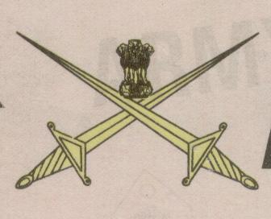

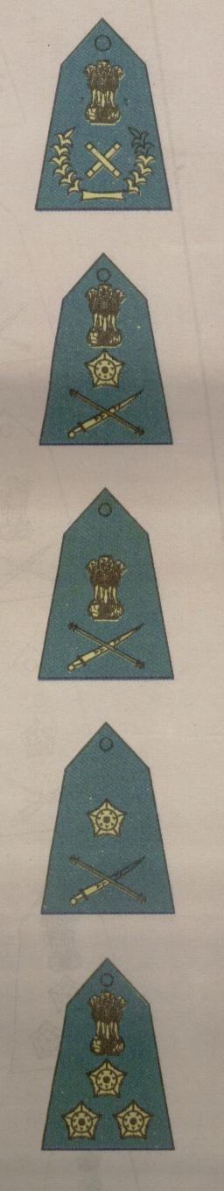

**Lieutenant General**

**General**

**Brigadier**

**Major General**

**Field Marshal**

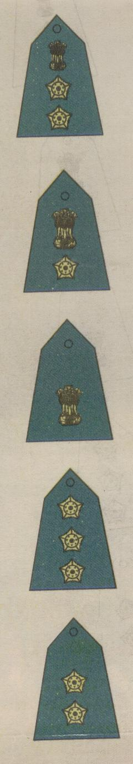

**Lieutenant**

**Captain**

**Major**

**Lieutenant Colonel**

**Colonel**

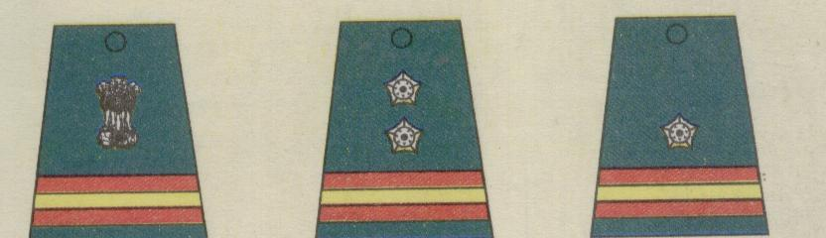

**Naib Subedar**

**Naib Risaldar**

**Subedar**

**Risaldar**

**Subedar Major**

**Risaldar Major**

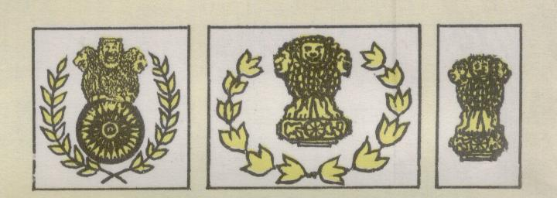

**Coy. Hav. Major**

**Bn . QM. Hav**

**Bn . Hav. Major**

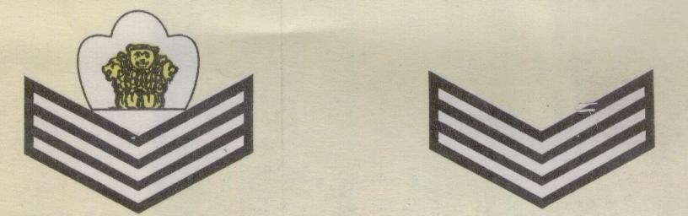

**Havildar**

**Coy. QM. Hav**

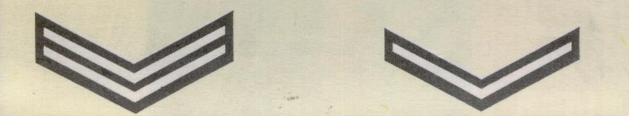

**Lance Naik**

**Naik**

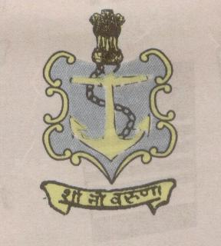

**NAVY**

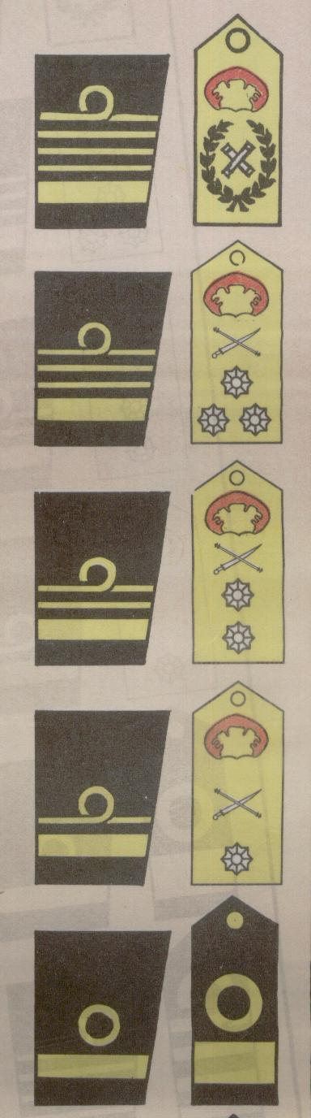

**Commodore**

**Rear Admiral**

**Vice Admiral**

**Admiral**

**Admiral of the Fleet**

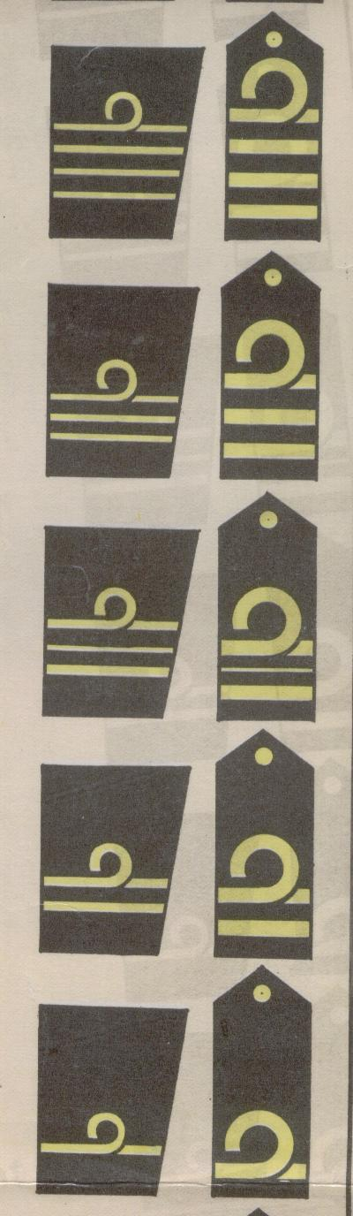

**Sub Lieutenant**

**Lieutenant**

**Lieutenant Commander**

**Commander**

**Captain**

**CAP BADGES**

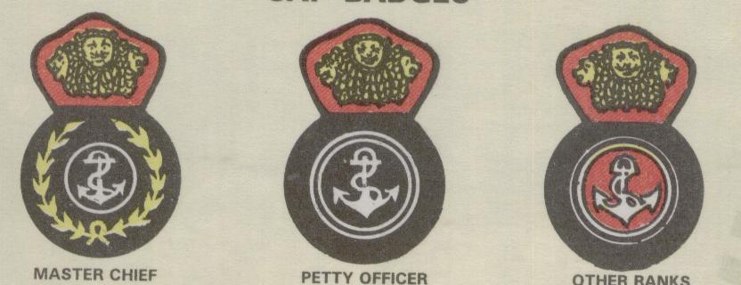

**Master Chief Petty Officer Other Ranks**

**SHOULDER BADGES**

**GOOD CONDUCT**

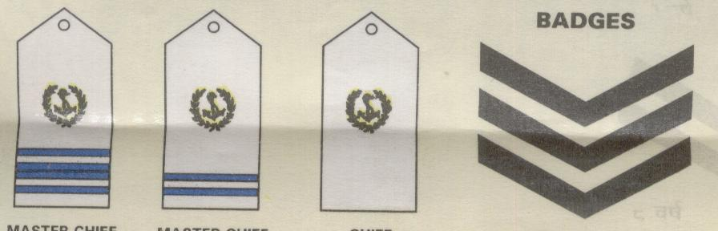

**12 Years**

**Master Chief**

**Petty Officer(ii)**

**Master Chief**

**Petty Officer(i)**

**Chief**

**Petty Officer**

**ARM BADGES**

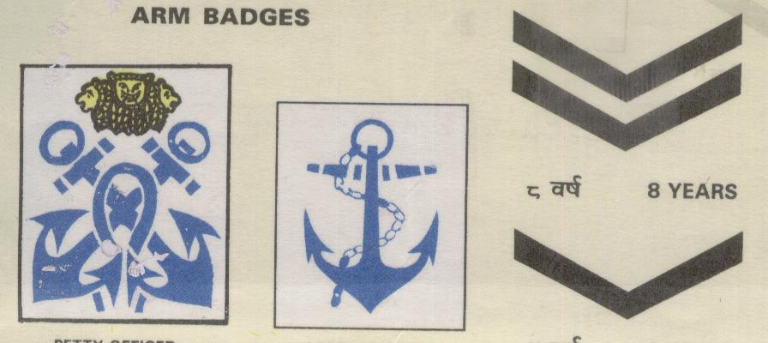

**Leading Ranks**

**Petty Officer**

**4 Years**

**8 Years**

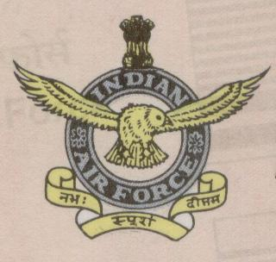

**AIR FORCE**

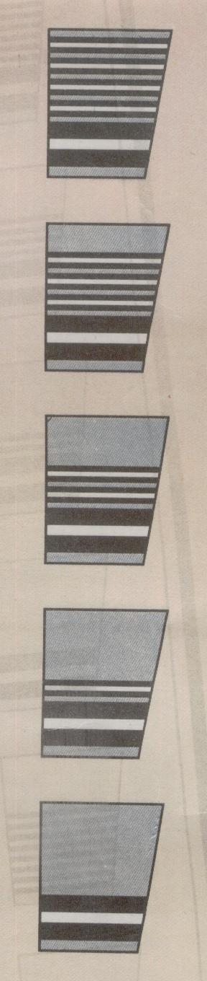

**Air Commodore**

**Air Vice Marshal**

**Air Marshal**

**Air Chief Marshal**

**Marshal of the Air Force**

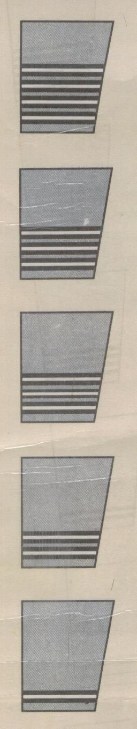

**Flying Officer**

**Flight Lieutenant**

**Squadron Leader**

**Wing Commander**

**Group Captain**

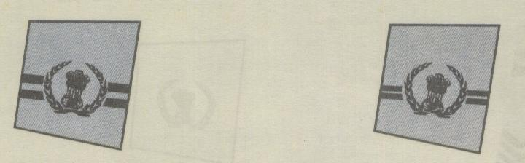

**Warrant Officer**

**Master**

**Warrant Officer**

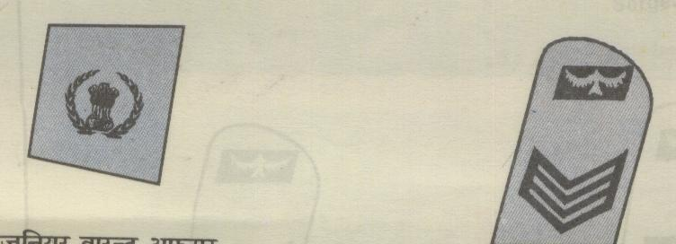

**Sergeant**

**Junior Warrant Officer**

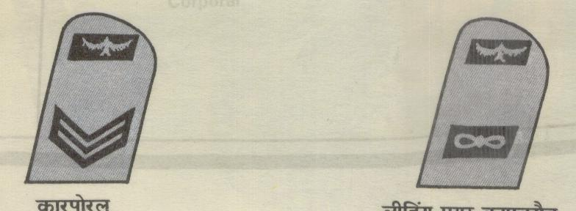

**Corporal Leading Aircraftman**

**SECTION-3**

**HONOURS AND AWARDS**

**Indian Armed Forces Awards**

1. For the purpose of classification, Indian Armed Forces Honours and Awards can be divided in to two categories:-

(a) Gallantry Awards.

(b) Non-Gallantry Awards.

2. **Gallantry Awards**. Gallantry awards are again divided into two categories:-

(a) **Gallantry in the Face of Enemy**

(i) Param Vir Chakra.

(ii) Maha Vir Chakra.

(iii) Vir Chakra.

(iv) Sena, Nao Sena and Vayu Sena Medal.

(v) Mention in Dispatches.

(vi) Chiefs of Staff Commendation Card.

(b) **Gallantry other than in the face of the enemy**

(i) Ashoka Chakra.

(ii) Kirti Chakra.

(iii) Shaurya Chakra.

Note:- These were originally named Ashoka Chakra Class I, Class II, Class III

3. **Non-Gallantry Awards** are as follows:-

(a) Bharat Ratna.

(b) Padma Vibhushan.

(c) Padma Bhushan.

(d) Sarvottam Yudh Seva Medal.

(e) Param Vishisht Seva Medal.

(f) Padma Shri.

(g) Sarvottam Jeevan Raksha Padak.

(h) Uttam Yudh Seva Medal.

(j) Ati Vishisht Seva Medal.

(k) President’s Police and Fire Service Medal for Gallantry.

(l) President’s Police Medal For Gallantry.

(m) President’s Fire Service Medal For Gallantry.

(n) President’s Correctional Service Medal For Gallantry.

(o) President’s Home Guards and Civil Defence Medal For Gallantry.

(q) Yuddh Seva Medal.

(r) Vishisht Seva medal.

4. Correct ‘**Order of Precedence**’ of wearing of various medals and decoration is given in Appendix.

**Conditions of Eligibility and Eligible Categories**

5. Conditions of Eligibility and Eligible Categories for some of the awards are given in succeeding paras.

6. **Param Vir Chakra**

(a) **Conditions of Eligibility**. Awarded for most conspicuous bravery or some daring or pre-eminent act of valour or self sacrifice, in the presence of the enemy, whether on land, at sea, or in the air. The decoration may be awarded posthumously.

(b) **Eligible Categories**. Officers, men and women of all ranks of the Army, the Navy and the Air Force, of any of the Reserve Forces, of the Territorial Army, Militia and of any other lawfully constituted Armed Forces. Matrons, Sisters, Nurses and staff of the Nursing Services and other Services pertaining to Hospital and Nursing and Civilians of either sex serving regularly or temporarily under the orders, directions or supervision of any of the above-mentioned Forces.

(c) **Monetary Allowances.** Rs 1500/-pm and each bar to the decoration another Rs 1500/-pm to all recipients.

7. **Ashok Chakra**

(a) **Conditions of Eligibility**. Awarded for most conspicuous bravery, or some act of daring or pre-eminent act of valour or self-sacrifice otherwise than in the face of the enemy. The decoration may be awarded posthumously.

(b) **Eligible Categories**. Officers, men and women of all ranks of the Army, the Navy and the Air Force, of any of the Reserve Forces, Territorial Army, Militia and of any other lawfully constituted Forces. Members of the Nursing Services of the Armed Forces. Civilian citizens of either sex in all walks of life, other than members of Police Force and of recognized Fire Services.

(c) **Monetary Allowances**. Rs 1400/-pm and each bar to the decoration Rs 1400/-pm to all recipients.

8.  **Param Vishisht Seva Medal**

(a) **Conditions of Eligibility**. For distinguished service of the most exceptional order.

(b) **Eligible Categories**. All ranks of the Armed Forces including Territorial Army units, Auxiliary and Reserve Forces (when embodied) and other lawfully constituted Armed Forces. Nursing officers and other members of the Nursing Services in the Armed Forces.

9. **Vir Chakra**

(a) **Conditions of Eligibility.** For the acts of gallantry in the presence of enemy, whether on land or at sea or in the air. The decoration may be awarded posthumously.

(b) **Eligible Categories**. Officers, men and women of all ranks of the Army, the Navy and the Air Force, of any of the Reserve Forces, of the Territorial Army, Militia and of any other lawfully constituted Armed Forces. Matrons, Sisters, Nurses and staff of the Nursing Services and other Services pertaining to Hospital and Nursing and Civilians of either sex serving regularly or temporarily under the orders, directions or supervision of any of the above-mentioned Forces.

(c) **Monetary Allowance**. Rs. 850/- pm and each bar to the decoration Rs. 850/- pm to all recipients.

10. **Yuddh Seva Medal**

(a) **Conditions of Eligibility**. Awarded for distinguished service of a high order during war/conflict/hostilities.

(b) **Eligible Categories**. All ranks of the Army, the Navy and the Air Force, including those of Territorial Army units, Auxiliary and Reserve Forces and other lawfully constituted Armed Forces when embodied. Nursing officers and other members of the Nursing Services in the Armed Forces.

11. **Sena Medal**

(a) **Conditions of Eligibility**. Awarded for such individual acts of exceptional devotion to duty or courage as have special significance for the Army, Navy and Air Force. The award may be made posthumously.

(b) **Eligible Categories**. All ranks of the Army, Navy and Air Force.

(c) **Monetary Allowances**. Rs 250/- pm and each bar to the medal Rs 250/- pm to all Sena Medal (Gallantry) awardees.

**NCC Awards**

12.These awards are given to NCC personnel since 1984. It includes NCC Whole Time Lady Officers (WTLO’s), Associate NCC Officers (ANO’s), Girls Cadet Instructors (GCI’s) and NCC cadets.

13. **Raksha Mantri’s Padak**.Raksha Mantri’s Padak is awarded to NCC personnel and cadets since 1989 for performance of any exceptional act involving courage, devotion to duty and contribution of lasting value to the NCC. In addition cash award of Rs 10000/- and a running Veer Trophy is also given to the recipient of this award. Every year only one Raksha Mantri’s Padak is awarded.

14. **Raksha Mantri’s Prashansa Patra**. Raksha Mantri’s Commendation Card with Rs.7500/- cash is awarded to NCC personnel and cadets since 1989 for any outstanding act involving leadership, courage or devotion to duty, which enhances the image of the NCC. Every year maximum three Raksha Mantri’s Commendation Cards are awarded.

15. **Raksha Sachiv’s Prashansa Patra**. The Commendation Card with Rs 5000/- cash, is awarded since 1984 for outstanding act or deed in the field of adventure sports, training or for outstanding contribution in social or cultural activities. Every year maximum ten Raksha Sachiv Commendation Cards are awarded.

16.  **Maha Nideshak’s Prashansa Patra**. This Commendation Card with Rs 1000/- cash, is awarded since 1984 for outstanding act or deed in the field of adventure sports, training or for outstanding contribution in social or cultural activities. There is no limit to the number for award of Maha Nideshak’s Prashansa Patra.

17.  **Maha Nideshak’s Prashansa Patra To Civilian Personnel**. It is awarded to Central Government civilian officers/staff posted at various levels in the NCC, for displaying outstanding and distinguished service, dedication and devotion to work and outstanding contribution for efficient management of various NCC activities including camps.

**Appendix**

(Refer Para 4 of

Section-3 Chapter-1)

**ORDER OF PRECEDENCE : MEDALS AND DECORATION**

1. Bharat Ratna

2. Param Vir Chakra

3. Ashoka Chakra

4. Padma Vibhushan

5. Padma Bhushan

6. Sarvottam Yudh Seva Medal

7. Param Vishisht Seva Medal

8. Maha Vir Chakra

9. Kirti Chakra

10. Padma Shri

11. Sarvottam Jeevan Raksha Padak

12. Uttam Yudh Seva Medal

13. Ati Vishisht Seva Medal

14. Vir Chakra

15. Shaurya Chakra

16. President’s Police and Fire Service Medal for Gallantry

17. President’s Police Medal for Gallantry

18. President’s Fire Service Medal for Gallantry

19. President’s Correctional Service Medal for Gallantry

20. President’s Home Guards and Civil Defence Medal for Gallantry

21. Yuddh Seva Medal

22. Sena, Nao Sena and Vayu Sena Medal

23. Vishisht Seva Medal

24. Police Medal for Gallantry

25. Fire Service Medal for Gallantry

26. Correctional Service Medal for Gallantry

27. Home Guard and Civil Defence Medal for Gallantry

28. Uttam Jeevan Raksha Padak

29. Parakram Padak

30. General Service Medal-1947

31. Samanya Seva Medal-1965

32. Special Service Medal

33. Samar Seva Star-1965

34. Poorvi Star

35. Paschmi Star

36. Op Vijay Star

37. Siachin Glacier Medal

38. Raksha Medal-1965

39. Sangram Medal

40. Op Vijay Medal

41. Op Parakram Medal

42. Sainya Seva Medal

43. High Attitude Medal

44. Police (Special Duty) Medal-1962

45. Videsh Seva Medal

46. President’s Police and Fire Service Medal for Distinguished Service

47. President’s Police Medal for Distinguished Service

48. President’s Fire Service Medal for Distinguished Service

49. President’s Correctional Service Medal for Distinguished Service

50. President’s Home Guards and Civil Defence Medal for Distinguished Service

51. Meritorious Service Medal

52. Long Service and Good Conduct Medal

53. Police Medal for Meritorious Service

54. Fire Service Medal for Meritorious Service

55. Correctional Service Medal for Meritorious Service

56. Home Guard and Civil Defence Medal for Meritorious Service

57. Jeevan Raksha Padak

58. Teritorial Army Decoration

59. Teritorial Army Medal

60. Indian Independence Medal-1947

61. Independance Medal-1950

62. 50th Anniversary of Independence Medal

63. 25th Independence Anniversary Medal

64. 30 Years Long Service Medal

65. 20 Years Long Service Medal

66. 9 Years Long Service Medal

67. Commonwealth Awards

68. Other Awards

**SECTION-4**

**CONCEPT OF COMBINED DEFENCE SERVICES**

**Introduction**

1. The nature of modern warfare is characterised by technological complexities that demand that our armed forces fight as a team. A country like India endowed with a geostrategic location in the Asian sub continent must have basic structures and systems to manage its national security. Modern wars have become total, complex and highly specialised requiring suitable organizations to wage wars. The fast changing scenarios have overtaken the present Indian system making it redundant. The times when each Service could fight its own war in isolation and without integration of the other two services is a legacy of the past. Military thinking throughout the world accepts as a truism that modern war must be fought by all three services under a single commander and unless done, the chances of success will be small.

**Concept**

2. The concept of three dimensional warfare or combined operations wherein the three wings of the armed forces i.e. Army, Navy and Air Force, have to operate as a single cohesive force against the enemy is the norm of the day.

3. Efforts have been made in this direction in our country also. Exchange of officers among the three services during various training course, sand model discussion and exercises at various levels is very useful in understanding the working ethos of other services. It ultimately leads to cohesiveness at ground level. A very good example of inter services co-operation is Indo Pak war 1971 and recently Kargil war 1999 where in Army and Air Force worked in unison achieved remarkable results.

4. Currently Integrated Command having all the three services under its wing is established at Port Blair to institutionalize the concept of three dimensional warfare and same is working very efficiently.

**Conclusion**

5. National defence is not a concern of either military forces or the national government but of the nation as a whole. A nation’s security rests on many resources: human, economic, natural, technological, political to name but a few. The national aim during any war would be to win, for which all the national resources will be employed. The defence services are the most important tool available with the government to achieve its aim. However, individually no single service on its own can achieve this aim. Therefore there is a need to adopt a joint/common approach towards attainment of the national aim and this is only possible when the three services work and operate together, both during peace and war.

**CHAPTER-II**

**MAP READING**

|  |  |  |  |
| --- | --- | --- | --- |
| **INDEX** | | | |
| **CHAPTER-II MAP READING** | | **JD/JW** | **SD/SW** |
| SECTION-1 | Introduction to Map and Conventional Signs | √ | √ |
| SECTION-2 | Scales | √ | √ |
| SECTION-3 | Topographical Forms and Technical Terms | √ | √ |
| SECTION-4 | The Grid System | √ | √ |
| SECTION-5 | Relief Contours and Gradients | √ | √ |
| SECTION-6 | Cardinal Points and Finding North | - | √ |
| SECTION-7 | Type of Bearings and use of Service Protractor | √ | √ |
| SECTION-8 | Prismatic Compass, Its Use and  Introduction to GPS | √ | √ |
| SECTION-9 | Setting a Map, Finding Own Position and North | √ | √ |
| SECTION-10 | Map to Ground | - | √ |
| SECTION-11 | Ground to Map | - | √ |
| SECTION-12 | Point to Point March | - | √ |

**SECTION-1**

**INTRODUCTION TO MAP AND**

**CONVENTIONAL SIGNS**

**Introduction**

1. A map is representation of selected natural and man made features of the whole or part of the earth’s surface on a flat sheet of paper on a definite scale and in their correct relative geographic positions and elevations. Symbols, colour differentiations and contours help to show the physical features- mountains , valleys and plains- in their true relationship to the land and man made features. In a way they are an inventory of the physical features of and on the surface of earth and a blue print for Commanders for planning campaigns. Map reading thus helps a peron to get a clear and accurate picture of the ground without actually seeing it. A map however has the following limitations:-

(a) It is seldom, if ever, upto date.

(b) It cannot show every thing that exists on the ground.

**Information**

3. Every map carries a variety of information printed on its margin and since these pieces of information usually appear in approximately the same position, it is useful to know where to look for them. Fig 1 shows the information which is given in the margins of the 1 inch Survey of India Map in a diagrammatic form.

**Conventional Signs**

4. Conventional signs are symbols used to represent certain artificial or natural features/objects on the map. They are seldom drawn to scale.

5. The exact position of the object represented is the centre of the symbol if it is drawn in plan or the centre of the base of the symbol in elevation.

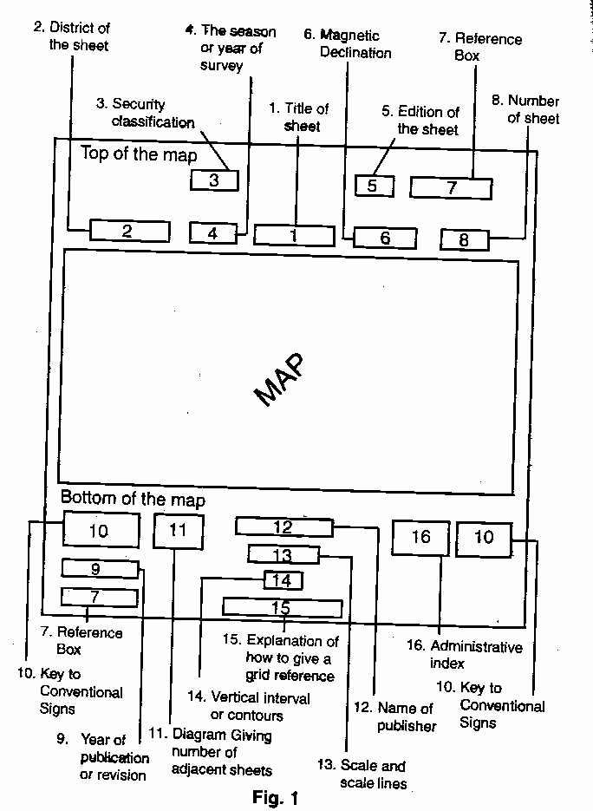

**Common Types**

6. A selection of the more common conventional signs is given as below.

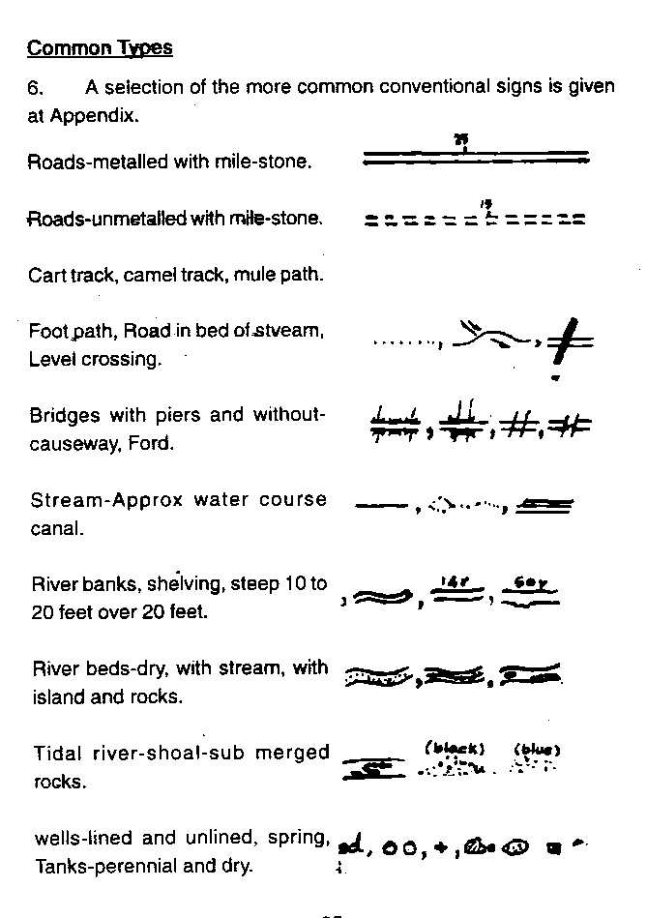

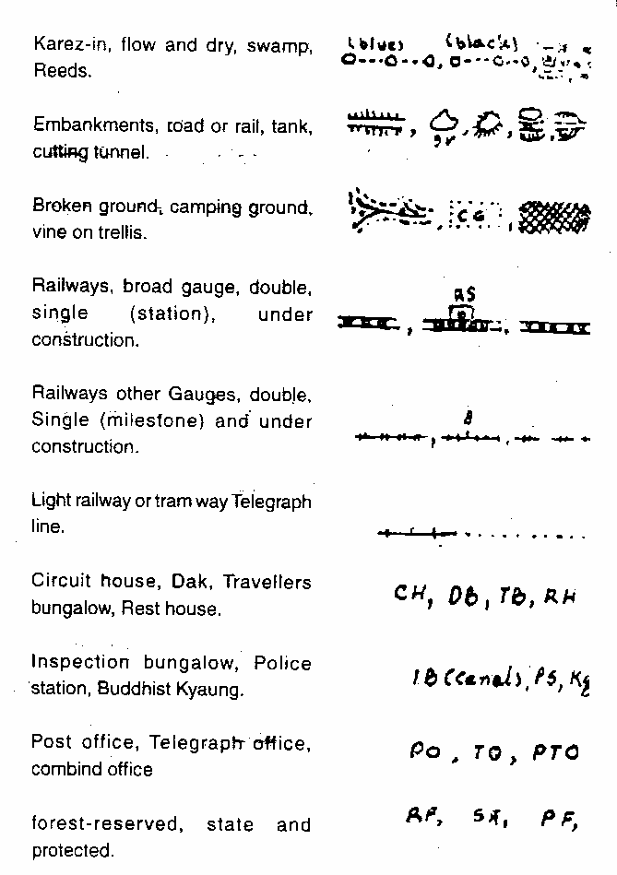

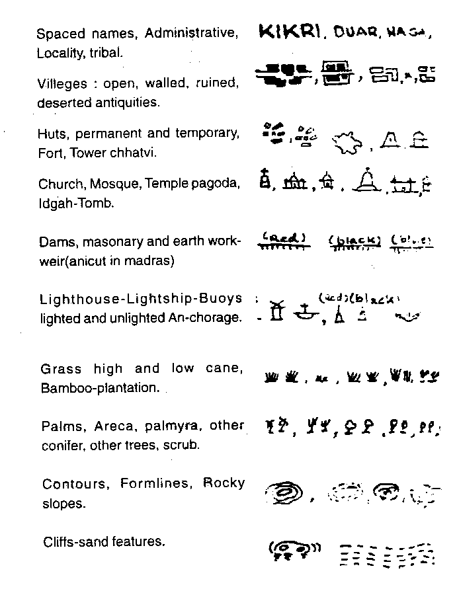

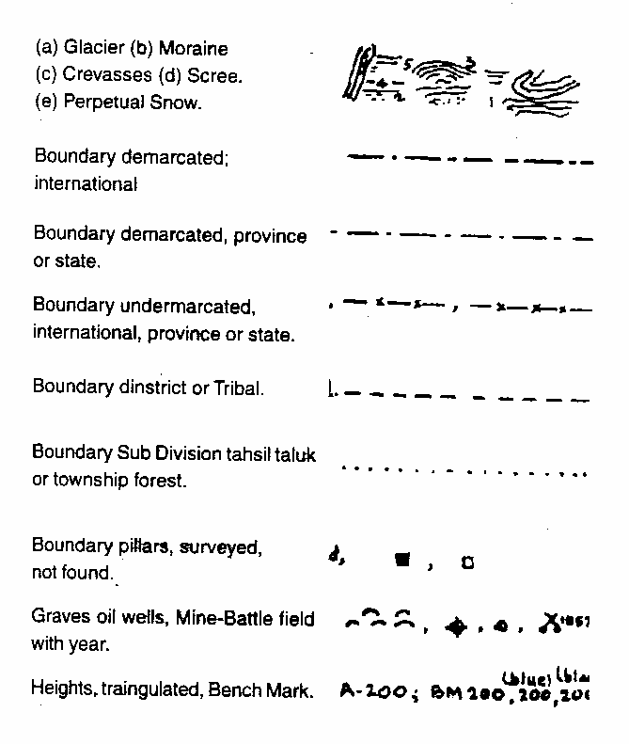

7. The conventional signs shown are those of the Survey of India 1 inch Map.

8. The signs may vary a little with different scale maps and with different editions but not to any great degree and even on foreign maps the conventional signs are sufficiently similar to be easily recognisable.

**MILITARY SYMBOLS**

**INF MECH INF ARMD ARTY**

•

•

•

**BTY**

**REGT**

**SQN**

**REGT**

**TP**

**BASIC**

• • •

**SEC**

••• ••• •••

**PL**

**COY**

**BN**

**HQ**

**WPNS MSL**

**LMG**

**MOR**

**MMG**

**RL ARTY GUN**

**SECTION-2**

**SCALES**

**Definition**

1. By scale it means the proportion which the distance between two points on the map bears to the distance between the same two points on the ground. It is obvious that it would be impossible to make a map the same size as the country which it represents. Everything on the map must be reduced and the extent to which the size is reduced constitutes the scale of the map. The essence of a map is that it is a drawing to scale and it bears a definite ratio to the size of the actual country which it portrays. If you imagine two maps, each measuring 3 feet x 2 feet, one might show the whole of Bihar and Orissa, while the other might show only a small district. The scale of these two maps are obviously not the same.

**Methods**

2. There are two methods of expressing a scale:-

(a) **In Words.** 1 inch to 1 mile, it means that 1 inch on the map represents 1 mile on the ground. If your were to measure on a map of this scale the distance from your house to the nearest railway station and you found that it was two inches you would know that the distance in actual fact was 2 miles.

(b) **As a Representative Fraction (RF)**. This is the scale expressed in the form of a fraction, if the scale of a map is given as 1/100000 this means that one unit of the map represents 100000 of the same unit on the ground. It could mean that one centimeter on the map represents 100000 on the ground. Thus 1/63360 means that 1 inch on the map represents 63360 inches on the ground and that is the number of inch in one mile. This is the representative fraction for a scale of 1 inch to 1 mile. The advantage of expressing a scale as a RF is that it can be applied to any type of map of whatever nationality. The scale is always written in the centre of the bottom margin of the map.

**Scale Line**

3. Underneath this is the scale line which is drawn in two ways and by means of this, distance on the map can be measured. On the 1 inch to 1 mile map one shows miles along its length, and is similarly divided into yards, with sub divisions in the left hand section.

4. The large divisions on these scale lines are called primaries and the small divisions on the left secondaries. An example of the scale lines for a scale 1 inch to 1 mile is at Fig.1

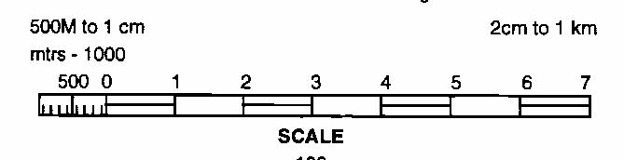

**Fig-1**

**Common Scales**

5. The following is a short list of the more common scales used on Survey of India Maps:-

* 1. 16 inches to 1 Mile 1/3960
  2. 4 inches to 1 mile 1/15840
  3. 2.53 inches to 1 mile 1/25000
  4. 1 inch to 1 mile 1/63360
  5. ½ inch to 1 mile 1/126720
  6. ¼ inch to 1 mile 1/253440
  7. 16 miles to 1 inch (Approx) 1/1000000
  8. 32 miles to 1 inch (Approx) 1/2000000

6. The 16 inches and 4 inches maps are called large scale maps or “Plans” and they show a very great amount of detail.

7. The most common scale of military maps is 1 inch to 1 mile, which shows most of the detail on the ground and is the scale normally used for the tactical purposes. The ¼ inch to 1 mile being more of an out-line map and one which shows a large area of country on one sheet is more commonly used by mechanized troops and transport columns. A scale which may sometimes be required for small tactical exercises is the 1/25000 (approx 2.5 inches to 1 mile). This shows a great amount of detail. The 1/M (million) map and ½ M map are purely routine maps normally used by the Air Force.

8. Abroad, scale are referred to purely by their representative fraction and the French army uses three main scales, which are given below with their English equivalent:-

* 1. 1/20000 : 3.16 miles to 1 inch (approx)
  2. 1/80000 : 0.8 inches to 1 mile (approx)
  3. 1/50000 : 1.27 inches to 1 mile (approx)
  4. 1/25000 : 2.25 inches to 1 mile (approx)

9. The first is used for strategic purposes, the last is an artillery and French map.

10. The 1/50000 map which is used over considerable portions of France has not been completed, therefore old topographical maps of the scale 1/80000 are still being employed commonly.

11. In our army we employ mostly the 1:50000 maps and 1:250000 maps. The Air Force uses the ‘million map’ since pilots have to overfly vast area and need continuous update from much larger landmarks, than used by the ground forces.

**SECTION 3**

**TOPOGRAPHICAL FORMS AND TECHNICAL TERMS**

**General**

1. The following list of technical terms and topographical forms is by no means exhaustive and is meant to include only those which are more commonly used. Topographical forms is a name used to describe geographical features which occur on the ground.

**Technical Terms**

2. (a) **Bearing** - The angle formed by a line joining two points and the North and South line. Bearings are always measured clockwise.

(b) **Bench Mark** - A permanent mark usually cut into a wall recording exact height for future reference, marked BM with the height on Ordnance Survey Maps.

(c) **Contours** - A line drawn on the map joining up all points of equal height above sea level.

(d) **Detail** - All the Topographical information on a map.

(e) **Gradient** - The slope of a hill expressed as a fraction.

(f) **Grid Lines** - Lines running parallel to and at right angles to a North and South line through approximately the centre of the area covered by the grid system.

(g) **Grid North** - Except through the origin, grid lines do not lie true North and South or East and West, Grid North is the direction of the North South grid lines on a map.

(h) **Horizontal** - The distance measured on the map between **Equivalent (HE)** adjacent contour lines. It varies according to the

nature of the relief.

(j) **Magnetic** - The difference between true North & Magnetic **Variation** North.

(k) **Setting** - Placing a map so that North on the map points toward the North so that the objects on the map are placed in relationship to the same objects on the ground.

(l) **Spot Height** - A point on a map whose height has been determined by Survey methods. This height is printed alongside the point.

(m) **Trig Point** - A point fixed during the triangulation at the b beginning of a survey, marked on Ordance Survey Maps by a small triangle with the height.

(n) **True North** - The direction of the North Pole from the point.

(o) **Vertical** - Successive controur lines. The VI is generally **Interval (VI)** the same for any given scale.

**Topographical Forms**

3. (a) **Basin** - An area of fairly level ground surrounded by hills or the area drained by a river and its distributaries.

(b) **Col or Saddle** - A narrow ridge of high land joining up to higher

hills.

(c) **Crest** - The highest part of a hill or mountain range. It is that line on a range of hills or mountains from which the ground slopes down in opposite

directions.

(d) **Dead Ground** - Ground which by reason of undulations or hills is not visible to the observer.

(e) **Defile** - Any feature whether natural or artificial which could cause a body of troops to contract its front. An example of a natural defile is mountain pass while a bridge is an example of an artificial defile.

(f) **Escarpment** - The steep hill side formed by a sudden drop in the general ground level usually from a plateau.

(g) **Knoll** - A small isolated hill.

(h) **Plateau** - A table land, an elevated region of considerable extent generally fairly level.

(j) **Ravine** - A long deep valley closed at one end separating two

spurs.

(k) **Ridge**  - The line along a hill or range of hills or mountains from which water flows in opposite directions, a divide,sometimes the crest of a line of hills as it appears along the horizon.

(l) **Spur**  - A piece of high ground jutting out from a range of hills into lower ground.

(m) **Watershed** - The line separating the water flowing into two different river systems, the edge of a river basin.

**SECTION-4**

**THE GRID SYSTEM**

**Definition of Grid**

1. A map is covered with a net work of purple lines, some running North and South and other West and East. These form a series of small squares all over the map. These lines are known as “Grid Lines”.

**Purpose**

2. The purpose of grid lines is to make possible giving and reading grid references and to facilitate measurement of bearings. They make no difference to the construction of the map and if they are removed, the accuracy of the map would not be affected. These lines are super-imposed in order that it may be possible to give a reference to a desired point.

**Division**

3. The whole country is divided into large lettered square each measuring 1000000 yards squares. The lettered squares are subdivided into 100 similar squares each measuring 10000 yards squares.The side of 10,000 yards are thickened and they are further divided into smaller square/measuring 1000 yards squares. A 1,000,000 yards lettered square is much larger than the whole of a normal one inch map sheet and for practical purposes they are ignored. You use these letters when giving reference on smaller maps (e.g. Quarter inch).

**Need for Reference**

4. It is difficult to describe an exact position without pointing it out on the map which is not always possible and to describe the position in ordinary terms is lengthy and ambiguous. The key-note of a reference is that the method should be accurate, quick and simple. In the army maps, we make use of the Grid system to achieve this.

**Method of Grid Reference**

5. In giving a grid reference, there are four rules to remember:-

(a) A reference must always contain an even number of figures. In the normal method, it will contain six figures.

(b) Always count along the EASTING lines first from WEST to EAST and then from SOUTH to NORTH, along NORTHINGS.

(c) For the six figures reference, the third and the sixth figure represent the divisions of 1000 yards square to the nearest 10th part, so they have to be estimated and for these figures a slight latitude is allowed.

(d) If a general grid reference is to be given or there is only one such object in one square e.g. bridge, temple, road, junction, then a four figure grid reference would suffice.

**SECTION 5**

**RELIEF CONTOURS AND GRADIENTS**

**General**

1. The word relief is a name used to describe the rise and fall of the ground or in other words the hills and valleys. The most common way in army to do so is by contour lines. These are thus lines drawn on the map (usually drawn) each line joining up points of equal heights above sea level. Against these lines is written the height.

**Slopes**

2. The closer together the contour lines are, the steeper is the slope of the hill which they show, where they are far apart, the slope down is gradual. Remembering this, it is possible to see at a glance where the steeper hills are.

**Type of Slopes**

3. There are two type of slopes, convex and concave. A convex slope is the one which bulges outwards and concave slope is the one which curves inwards.

**Vertical Interval(VI)**

4. The rise between successive contour lines is known as the vertical interval. On map scale 1 inch to 1 mile, the VI of each contour line is 50 feet while on the ¼ inch to a mile it is 250 feet.

**Horizontal Equivalent**

5. The distance measured flat on the map between adjacent contour lines is horizontal equivalent (HE).

**Gradient**

6. A gradient is a slope expressed as a fraction. If we say that a slope has a gradient of 1 inch to 7 we mean for every 7 feet of horizontal distance the slope rises or falls 1 foot vertically. Simple Formula is VI/HE = Gradient.

7. The horizontal equivalent is obtained by measuring on the map and vertical interval by subtracting the contour heights.

**SECTION 6**

**CARDINAL POINTS AND FINDING NORTH**

**General**

1. This figure shows the main points of compass. North, South, East and West are known as the cardinal points.

2. If the North point is taken as 0 Degrees the angle which East forms with it is 90 degrees, or a right angle. The angle formed by the South point, being twice as large, is 180 degrees, and the West point forms an angle of 270 degrees. If the angle is measured all the way round the circle back again to North, it will be found to be 360 degrees.

**Types of North**

3. There are three type of North points:-

(a) **True North -** The direction of North pole from the observer.

(b) **Magnetic North-** It is the point to which an accurate compass needle points, when freely suspended.

(c) **Grid North** - It is the direction to which the North South grid lines on a map point.

**Magnetic Variation**

4. **True North is Constant** Magnetic North is the point to which the compass needle points. The needle does not point directly to True North, but a little West or East of True North. The point towards which the needle swings is known as Magnetic North

and the difference between True North and Magnetic North is called magnetic variation. The amount of the magnetic variation depends upon two factors, time and place. See Fig.3

**True North**

**Magnetic**

**Variation**

**Magnetic North**

**Fig.3 Magnetic Variation**

5. **Time**. The Variation is not constant but is, gradually changing and even the change each year is not constant but the difference being negligible it is taken to be constant. On the top margin of a map will be found a statement giving the magnetic variation. To bring this up-to-date, the year of issue of the map must be noted and for every year that has passed since then the applicable change annually subtracted or added from the figure given as applicable.

6. **Place**. The amount of the magnetic variation also changes in different parts of the world and indeed in different parts of the country.

**Grid Convergence**

7. The angular difference between Grid and True NORTH is called the ‘Angle of Convergence or the grid convergence’.

**SECTION-7**

**TYPE OF BEARINGS AND USE OF SERVICE PROTRACTOR**

1. The clock wise angle formed by a straight line joining two points and direction of NORTH, is called the bearing between the two points. A bearing is always measured clockwise. They are of three types as given below:-

(a) **Grid Bearing**.Measured on the map from the Grid North by the help of a protractor.

(b) **Magnetic Bearing**. Measured from Magnetic North by the compass.

(c) **True Bearing.** Calculated by finding out the relation of true NORTH and Grid NORTH or Magnetic NORTH.

**Conversion of Bearings**

2. The methods are explained in the succeeding paras.

**To Convert a Magnetic Bearing to a True Bearing**

3. Suppose the bearing of a certain point P is measured with a compass and is found to be 160 Degrees. To convert this magnetic bearing to a true bearing, draw a diagram as given in Fig.4.

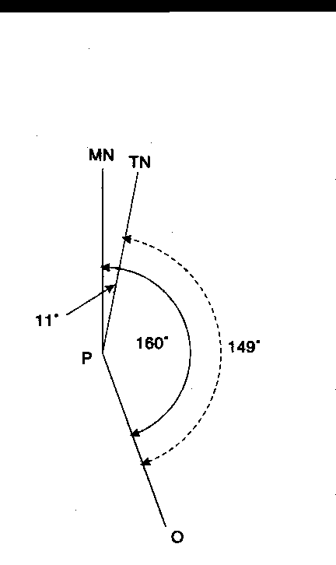

Fig. 4

4. First draw a vertical line to represent Magnetic North (because it is a magnetic bearing which is being considered). Next draw a line to P at an angle of 160 degrees. It is only a rough diagram, and the angle can be judged by eye. Thirdly, draw in the true North line approximately 11 degrees East of Magnetic North, with this diagram it becomes clear that true bearing (marked with a dotted line) is smaller by 11 degrees. Therefore, the true bearing of P is 149 degrees.

**To Convert Grid Bearing to Magnetic Bearing**

5. Measuring with a protractor on the map, the bearing of a Wind Mill at Y from a Church at X is found to be 120 degrees. To convert this grid bearing to a magnetic bearing, draw a diagram as before this time starting with the Grid North line. The magnetic bearing is larger than the grid bearing by 11 degrees and is therefore, 131 degrees.

6. In converting bearing it is always wise to draw a diagram in order to see whether the magnetic variation should be added or sustracted and this is an easier way than remembering sets of rules.

**Back Bearing**

7. It is the bearing taken from the observation point back on to the original position. In practice it is not necessary to move to the observation point as it can be calculated. The rule is that if the bearing is large enough to have 180 degrees substracted from it this should be done. If it is smaller this figure should be added.

**Use of Service Protractor**

8. **General** The service protractors “A” Mark IV is an instrument used for plotting and measuring bearing on the map. It is the essential link between the compass and the map, for it is by means of the protractor that magnetic bearings have been converted to grid bearing and transferred to the map.

**Desrcription**

9. The protractor is made of cardboard or ivorine and it measures 6 inches long by 2 inches wide.

10. The front face of the protractor has 3600 of a circle marked around the edges of the three sides. The degrees are marked in a clockwise direction starting from the left hand bottom corner in two tiers, outer set of figures shows gradration from zero degrees to 1800 and the inner set from 1800 to 3600. The zero is denoted by a small arrow at the centre of the fourth side of the protactor (Fig-5).





**Fig-5**

**Scale of Protractors**

11. The main purpose of the protractor is to measure angles and bearings as described in the preceding paragraphs.

12. The protractor also shows on both its faces a number of the more common map scales. The respective scale lines are drawn out and divided into primary and secondary divisions in exactly the same way as at the bottom of the map. Six different scales are shown on the faces each with a variety of sub-divisions so that there is unlikely to be a map on which distance cannot be measured by means of the service protractor.

**Measuring a Bearing**

1. The angle can be measured by drawing a line from the gradation to the point zero on the protractor. The required angle will be the gap between this line and the line joining the zero ( Fig – 5A).

Angle

**Fig-5A**

**Usage of Protractors**

14. The service protractor is an essential item of equipment. With its help one can:-

(a) Plot and measure bearing on paper or on a map. For bearing between 0 and 180 degrees their Zero edge must be on the LEFT and for 180 degrees -360 degrees it must be on the RIGHT.

(b) Measure distance in inches correct upto 1/100th.

(c) Measure distance in yards, metres or miles on a map by using the appropriate scale.

(d) For using the diagonal scale one must use an intermediate agent. Mark off the distance to be measured on the straight edge of a paper or by means of a divider and then put the paper or divider on the diagonal scale and measure.

**SECTION-8**

**PRISMATIC COMPASS , ITS USE AND**

**INTRODUCTION TO GPS**

1. **General**. The magnetic compass has been and is being used extensively in ships, aircraft and the various branches of the army to find and maintain direction. The prismatic compass is an accurate and reliable instrument of great value except during a “magnetic storm” or when subject to strong local magnetic field e.g. in polar regions. With the prismatic compass one can measure magnetic bearing on the ground.

**Types**

2. There are two types of prismatic compass, the dry and liquid type. Liquid type is easier to use though it is less sensitive.

**Description**

3. The names of various parts are shown in figure 6 and 7.

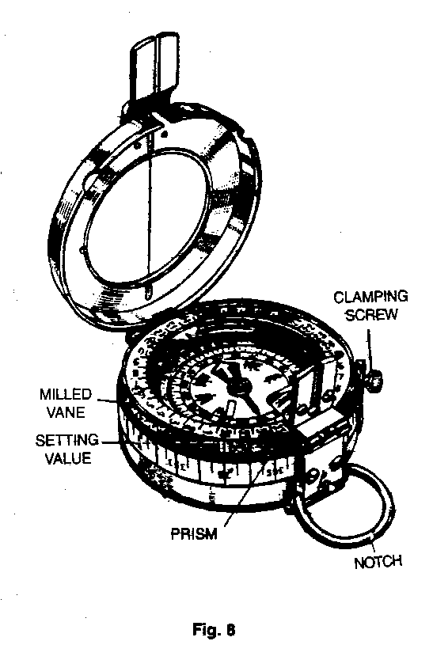

**6**

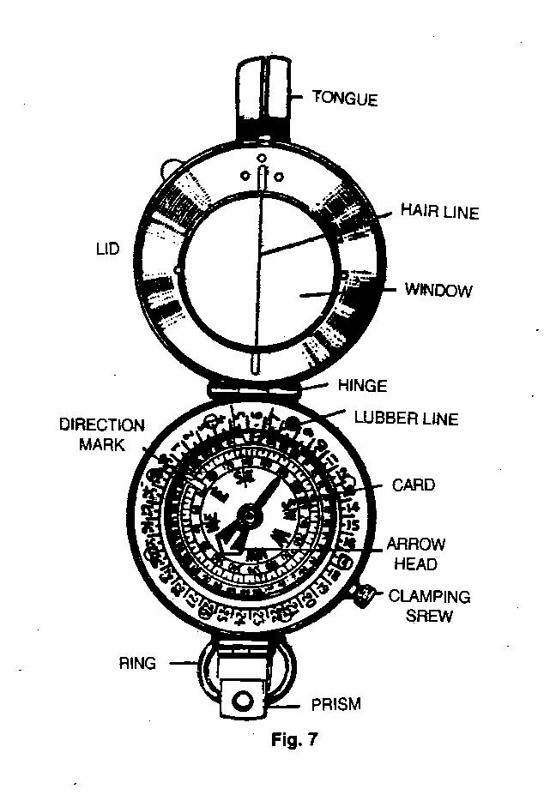

**How to Take a Bearing**

4. Open the lid so that it is roughly at right angle to the body of the compass.

5. Turn the prism casing over so that it lies flat on the face of the compass. Put your thumb through the ring and your forefinger underneath the compass and hold it so that it attains horizontal level.

6. Bring the prism upto the eye and you will see two things:-

* 1. Above the prism, through the slot on the case, the hair line on the window.
  2. Through the prism itself, a set of figures.

7. The compass must be held so that the hair line is vertical and so that it cuts the object on to which the bearing is being taken. The reading is determined by noting where the bottom of the hair line cuts the set of figures beneath it.

**Compass Error**

8. Sometimes due to the presence of impurities in the material of which a compass is made or other reasons, the magnetic needle may not point toward the magnetic NORTH but a little to the EAST or WEST of it. This deviation of the magnetic needle in the compass from the magnetic NORTH is termed compass error:-

(a) The compass error is said to be 2 degrees EAST if the compass needle points 2 degrees EAST of magnetic NORTH. The compass error is 5 degrees WEST if the compass needle points 5 degrees WEST of magnetic NORTH.

(b) Always draw a rough diagram showing the magnetic NORTH and the compass NORTH with the error, you will then see whether you have to subtract or add when converting compass bearing into magnetic bearing and vice versa.

**Global Positioning System**

9. Global Positioning System (GPS) refers to a system of satellites and receivers that allows people and devices to pin point their precise location on the earth. The normal GPS operational constellation consists of 24 satellites that orbit the earth in 12 hours. The satellite orbits repeat almost the same ground track each day. The orbit altitude is such that the satellites repeat the same track and configuration over any point. There are six orbital planes with four space vehicles in each, equally spaced 60 degree apart and inclined about 55 degree with respect to equatorial plane. The constellation provides the user with 5-8 space vehicles visible from any point on the earth. Devices that are equipped with GPS equipment receive transmission from at least a few of the satellites and are able to discern very precise positioning data.

10. The first GPS satellite was launched in1974 and the 24th was launched in1994. The new satellites are periodically launched to replace the ageing ones. GPS in funded by and controlled by the United States, Department of Defence.

11. The application of GPS is very broad and number of users is increasing dramatically. With improved technology, small portable GPS receivers have become very handy and accuracy is remarkable. These devices are used by fishermen and hikers to navigate. Today, many vehicles are equipped with GPS to help the drivers to navigate. In the Armed Forces, GPS has made navigation very easy. All aircraft, ships and specialist vehicles are equipped with GPS. In the Army, GPS is commonly used in battle fields and insurgency-affected areas. It assists troops to navigate in thick jungles, mountains and deserts. GPS is also used to guide missiles to pre specified targets.

**SECTION-9**

**SETTING A MAP, FINDING OWN POSITION AND NORTH**

**Definition**

1. A map is said to be set or oriented when it is placed such that it corresponds directly with the ground i.e. when true NORTH on the map points to true NORTH on the ground. Obviously it is easier to read a map when the objects on it are pointing in the same direction as the objects on the ground.

**Methods of Setting**

2. There are two methods of setting a map - By compass and by objects on the ground.

3. **Setting by Compass** Draw a line showing magnetic NORTH from a point on a grid line. Open the compass and lay it flat on the map over the above drawn diagram which will show the magnetic variation so that the hair line on the window lies along the magnetic NORTH line on the diagram. Then turn both the map and the compass till the needle points along the hair line. The map is now set, since the magnetic NORTH line on the map is pointing in the direction of magnetic NORTH as indicated by the compass needle.

4. (a) **Without a Compass when Own Position is Known**

1. Using a straight edge, for instance railway line.
2. Recognise one object on the ground and on the map and join own

position to that object. Hold the map so that when looking along the line you see the object on the ground in the same straight line.

1. **Without a Compass when Own Position is not Known**

(i) **Parallel Method**. Select two landmarks such as road, railway line and so on which are easily recognizable on the map. If continuous landmarks are not visible, choose two objects and imagine a line joining them. With each landmark, make the corresponding landmark on the map parallel and the map will roughly be set.

(ii) **On Near Line Joining Two Points.** Identify two nearby objects on the map and the ground. Stand on an imaginary line joining them and set the map.

**Finding North**

5. **Without Compass**.The position of NORTH can be discovered by one of the following methods:-

(a) **Watch Method**.Point the hour hand of your watch toward the sun. A line bisecting the angle between the hour hand and the direction of the 12 O’clock will then point due SOUTH. It must be ensured the the angle bisected must always be that which is less than 180 degrees. It is a rough method and applies only in the northern hemisphere.

(b) **Equal Altitude Method**

1. Take a fairly large piece of paper or card board and spread it flat on the ground. In the centre fix a pencil or piece of wood perpendicular to the ground. It can be done with the help of a coin fixed at the base of pencil or wood with sealing wax or by directly pushing it in the ground.

(ii) The pencil will throw on the paper a shadow as shown by the dotted line AB of Fig 8. Where the shadow ends make a mark B, and then from the base of the pencil draw a circle of radius AB.

1. Wait till after mid day until the sun has moved around sufficiently to throw another shadow as indicated by the dotted line AD i.e. of the same length as the original shadow AB.

A

N

B

D

**Fig-8**

(iv) When this is so, draw a line A N bisecting the angle formed by the two shadow lines. This will point to TRUE NORTH.

(v) This is extremely accurate way of finding north but it is of no use on cloudy or dull day. It is also a very time consuming process as the work should start earlier than mid day.

(c) **By Stars**. In the Northern hemisphere, the Pole star indicates the position of True North to within 2 degree. It is a bright star and it can be found by protruding a line from Great Bear. The pole star will be found slightly off this line on the side remote from the remaining stars of the Great Bear.

*

*

*

*

*

*

*

*

**POLE STAR**

**POINTERS**

**GREAT BEAR**

*

**SECTION-10**

**MAP TO GROUND**

**Introduction**

1. To find out the details of map on ground is known as map to ground. Following methods are used to identify objects from map to ground:-

(a) **Bearing and Distance Method.** With the help of bearing and distance, find out own position. Find out the distance of the object to be identified on ground with the help of a scale on the map. Using service protractor, find out the bearing of the object and convert it into magnetic bearing. Set the magnetic bearing on compass and look for the object in the given bearing. Estimating the distance on ground, the object will be identified.

(b)  **Direction and Distance Method.**  Draw a line on the map between own position and object to be identified. Calculate its distance and using any of the following methods find the direction of the object:-

(i) With the help of a sight rule find the ground direction of the object.

(ii) With the help of two points on the map estimate the ground direction.

(iii) Place a foot ruler /pencil at own position and align it with line of the map.

(iv) Place a pin each at own position and at the object on the map. Align both pins and find general direction.

(c)  **By Estimation Method**. In this method measuring bearing, distance and direction, object is identified with the help of other details in the proximity of the object.

**SECTION-11**

**GROUND TO MAP**

1. To find out an object indicated on ground on the map is called ground to map. Method used to identify objects from ground to map arediscussed in succeeding paras.

2.  **Simple Method**

(a)  **Using Bearing**. Find out the distance and the magnetic bearing of the object. Translate magnetic bearing to grid bearing. Set the map and find own position. From own position draw a line at the given grid bearing. Measure distance with service protractor and mark the given distance on the line. The object will be in the proximity of the given mark.

(b) **Intersection Method**. To find out the objects which are at a larger distance or in hilly terrain, intersection method is used. In this method help of minimum two prominent objects are taken which can be easily identified on the ground. Lines are drawn from the prominent objects to the object to be identified on map. This method is used when we cannot estimate exact distance. Intersection is done in two ways:-

(i)  **By Compass Bearing.**  Take the bearing of the object from two known prominent objects. Draw the lines on the map. The object will be in the proximity of the intersection of the two lines. Magnetic bearing is found by two methods:-

(aa) **By Compass.** Take the forward bearing from known object.

(ab) **By Back Bearing**. In war, in case we intercept the enemy’s transmission, with the help of the fall of the shot we can find out the location by working out back bearing.

(c)  **By Direction Method**. In this method set the map and mark own position. With the help of any of the following methods find the direction of object on the map. Draw a line from own position in that direction. Put a mark on the line at the estimated distance of the object. The object will be in the proximity of the marked point:-

(i) Place a foot ruler /pencil at own position and align it in the direction of the object.

(ii) Place a pin at own position on the map. Place the second pin in the direction of the object.

(iii) With the help of details around the object, find direction and mark the object on the map.

(iv) With the help of sight rule find exact direction of the object.

(d) **By Estimation Method.**  By knowing the bearing and distance of the object on ground it can be identified on map by estimation.

**SECTION-12**

**POINT TO POINT MARCH**

**Day Time**

1. **Methods used during Day March**

(a) **With Map Only**. In this method set the map and find your own position. Then, find out the position of the object. Note important landmarks in the vicinity of the object. Also find out the distance of the object. Finally find out the best route to reach the object. While marching, keep comparing the major landmarks enroute. Distance can be measured with the help of steps. 100 meter corresponds to 120 steps approximately. On reaching the object, confirm its correctness with help of other details in the proximity.

(b) **Marching without Map**. There are two methods of marching without map:-

(i) **With Compass**.

(aa) **First Method**. If you know the bearing and distance of the object, take a compass and select two important landmarks in one line where you can march easily. If there is difficulty in selecting landmarks at a large distance due to forest cover or undulating land, then closer landmarks can be selected. This could be repeated till you reach the object. If there is a major obstacle like river or nala which require deviation from the given bearing, one must come to the same line after crossing the obstacle and move on initial bearing.

(ab) **Second Method**. This method is used when bearing and distance of important landmarks enroute are given. Set the bearing of the first landmark from start point and repeat this after reaching every intermediate landmark till you reach the object. In this method one is more confident while marching.

(ii) **Without Compass**. In this method you are required to march based on your memory power. Points to be kept in mind are:-

(aa) Before marching, recognize the object carefully and take note of other landmarks in the proximity.

(ab) Choose best route to the object and convert distance into steps / paces.

(ac) Take note of all the intermediate landmarks and their distances.

(ad) Enroute, ensure you are marching correctly.

(ae) Be careful while measuring distance in steps.

(af) If you deviate while crossing an obstacle, choose a mark across the obstacle. After crossing the obstacle come in line of the mark and recommence marching.

(ag) If you reach a wrong place, come back to the start point.

**Night March**

2. When a navigation party moves at night with the help of compass and night march chart, this is called night march.

(a) **During Moonlit Night**. If you have a compass, you can select two important land marks on the given bearing in a line and march on the same bearing and line. Repeat this till you reach the object.

(b) **Starlit Night**. Select a prominent star at 30 degree on the horizon on the given bearing. Select a landmark in line of the star. March in line of the star and the land mark for approximately 15 minutes. Then select another star in the same bearing and repeat till you reach the object.

(c) **Cloudy Night**. Make a person march on the given bearing to a distance where he can be seen. Then the person holding compass marches, measuring the distance. First person is made to march again in the given bearing and the process is repeated till he reaches the object.

3. **Items Required by Navigation Party**

(a) Set compass as per bounds.

(b) Luminous stick.

(c) White cloth.

(d) Marching chart.

(e) White lime/ chalk.

(f) Stone pebbles for measuring steps.

(g) Frosted torch.

4. **Composition of Navigation Party**

(a) **Guide**. He carries a luminous stick and a compass set to a given bearing.

(b) **Assistant Guide**. He has a white piece of cloth at his back for identification and a stick to measure depth of nala / pits.

(c) **Recorder**. He carries additional compass already set on given bearing, night march chart and stone pebbles. He measures the distance.

(d) **Scouts**. Number of scouts could be from 2 to 4 depending upon the route and tasks.

5. **Night March Parade**

(a) **Assistant Guide**. He moves in front between left and right scouts. He walks for 20 steps and stops. Guide moves up to him and then indicates him to march ahead. Following actions will be taken while crossing an obstacle.

(i) Assistant guide and scouts will negotiate the obstacle from left / right. Guide and balance party will keep waiting. After crossing the obstacle assistant guide and scouts will come in the line of march.

(ii) Then guide and balance party will cross the obstacle and move behind assistant guide.

(b) **Guide**. Guide marches behind assistant guide so that required instructions can be given to him. He also carries a compass with set bearing so that he can correct the line of march of assistant guide.

(c) **Recorder**. Recorder marches behind the guide and measures the distance by steps / measuring tape.

5. **Points to be Kept in Mind**

(a) While marching do not cough, talk or make any noise.

(b) While marching keep inter person distance in mind.

(c) Party must ensure safety and security.

(d) Smoking / using any kind of light is strictly prohibited.

(e) To read night march chart use frosted torch.

**NIGHT MARCH CHART**

|  |  |  |
| --- | --- | --- |
| **(Object)** | **Distance** | **Degree** |
| **Temple**  **Picture 057** |  |  |
|  | **450 M** |  |
| **Well**  **ס** |  | **500** |
|  | **200 M** |  |
| **Bridge** |  | **400** |
|  | **350 M** |  |
| **Track Junction** |  | **200** |
|  | **300 M** |  |
| **Start Point**  **(Survey Tree)**  **Picture 061** |  | **700** |