**CHAPTER-I**

**ARMED FORCES**

|  |  |  |  |
| --- | --- | --- | --- |
| **INDEX** | | | |
| **CHAPTER-I ARMED FORCES** | | **JD/JW** | **SD/SW** |
| SECTION-1 | Basic Organisation of Armed Forces  (Army, Navy & Air Force) | √ | √ |
| SECTION-2 | Badges and Ranks | √ | √ |
| SECTION-3 | Honours and Awards | √ | √ |
| SECTION-4 | Concept of Combined Defence Services | - | √ |

**SECTION -1**

**BASIC ORGANISATION OF ARMED FORCES**

**ARMY**

**Introduction**

1. The present day Indian Army owes its origin to British days. It was then used as an instrument for the expansion and preservation of the British Empire.

2. At the time of independence in 1947, due to partition of the sub-continent, the old Indian Army was also divided. Since then the Army has continued to be re-organised and modernised.

3. The Army since independence has taken part in the following major operations in defence of our borders :-

(a) Kashmir Operations against Pakistan 1947-48.

(b) Sino- Indian Operations in NEFA (Arunanchal) and Laddakh 1962.

(c) Indo-Pak war 1965.

(d) Indo – Pak war 1971.

(e) Kargil conflict 1999.

4. In addition, Army has taken part in peace keeping missions under United Nations in various parts of the world.

5. Services of the Army and Air Force have been extensively utilized in aid of civil authorities during natural calamities like floods, cyclones and earthquakes.

6. The Army today is self–reliant in respect of its requirements of conventional weapons and is fully geared to meet any external aggression on our borders.

**Command and Control**

7. **Command.** The President of India is the Supreme Commander of all the Armed Forces of the country. The Chief of Army staff is the head of the Indian Army and is responsible for its command, training, operations and administration. He carries out these functions through Army Headquarters (Army HQ).

8. **Command Headquarters.** The whole country is divided into seven commands. These are Northern, Western, Central, Southern, South Western, Eastern and Training Command. The Command HQ exercises operational responsibility. It is commanded by an officer of the rank of Lt General.

9. **Field Formations.**  Corps, Divisions and Brigades. These are commanded by an officer of the rank of Lt General, Maj General and Brigadier respectively.

10. **Static Formations.** Area and Sub Area Headquarters. These are commanded by an officer of the rank of Maj General and Brigadier respectively.

**Fighting Arms**

11. **Armour.** Armour by virtue of its mobility, fire power, protection and shock action is most aptly suited for present day battle field environment. The basic role of armour is to destroy the enemy by relentless, mobile offensive action, both in offensive and defensive operations.

12. **Infantry**. Infantry is essentially an arm of close combat. Its role in attack is to close in with the enemy and destroy or capture him and capture and hold ground. In defence it is to hold ground against all forms of enemy’s attack. It is also employed in counter insurgency and counter terrorism operations.

13. **Mechanised Infantry**. It is just like infantry with enhanced mobility and fire power. Mechanised Infantry moves in armoured personnel carrier (APC) which has adequate protection against small arms fire. Their mobility in conjunction with Armour enables own troops to obtain most favourable decision in battle. The emphasis is on mobility, fire power and manoeuvre rather than manpower.

**Supporting Arms**

14. **Artillery**. Artillery provides heavy volume of fire at long ranges to damage and destroy enemy positions before it can be physically captured and occupied by own ground forces.

15. **Engineers.** The role of Engineers in war is to provide support for offensive and defensive operations in mine warfare, bridging, demolitions, construction of field fortifications and operational roads/tracks.

16. **Army Air Defence**. Army Air Defence is equipped with air defence guns and short and medium range surface to air missile systems. Along with Air Force it provides air defence to Mobile Forces, Vulnerable Areas and Vulnerable Points.

17. **Army Aviation Corps.** The role of Army Aviation Corps is reconnaissance and observation by controlling artillery and infantry mortar fire from air. It provides commanders and staff rapid means for liaison visits. It is ideally suited for evacuation of battle casualties.

18. **Signals**. The role of Signals is to provide radio, radio relay and line communication and establish signal centre during war and peace. It also monitors enemy’s communication systems.

**Supporting Services**

19. These elements provide administrative cover to the Fighting and Supporting Arms thus enabling them to carry out their tasks. The services and the functions of some of them in brief are :-

(a) Army Service Corps - Supply of rations, POL and transport.

(b) Army Medical Corps - Provision of medical cover.

(c) Army Ordnance Corps -Supply of armament, ammunition,

vehicles, clothing, tentage and all equipment.

(d) Corps of Electronics and - Repair, recovery and maintenance of

Mechanical Engineers all vehicles, arms, electrical, electronic

and mechanical equipment.

(e) Remount and Veterinary - Maintain and train animals utilized by

Corps. the army like mules for carrying loads,

dogs for tracking and sniffing, horses for

equestrian activities

(f) Army Education Corps - Impart military and civilian education to

troops.

(g) The Intelligence Corps - Gather intelligence of the enemy and

prevent leakage of own information to the

enemy.

1. The Corps of Military Police - Help in maintaining discipline relating to

army personnel

1. Judge Advocate General -Deals with legal matters relating to the

Branch Armed Forces

(k) Army Physical Training -Deals with physical education and sports

Corps in the Armed Forces

(l) The Pioneer Corps -Deals with provision and looking after

manpower for load carriage in the Armed Forces.

1. Defence Security Corps - Provide security to VAs ,VPs and other

important installations.

**NAVY**

**Introduction**

20. Enveloping the country from almost three sides and stretching over 6000 Kms of our coast line, the sea has always exerted a decisive influence on India’s freedom , trade, commerce, and culture.

**Constituents of the Navy**

21. The Indian Navy is equipped with several ships of different types and naval aircrafts. Shore facilities have been provided at various places in the country to train personnel for the Navy, repair ships and aircrafts, and provide the fleets with logistic support.

**Organisation and Administration**

22.The Naval Headquartersat New Delhi exercises administrative and operational control over the Navy through various “ Administrative Authorities”. For this purpose the Navy is divided into three commands. These are:-

(a) Western Naval Command with HQ at Mumbai.

(b) Eastern Naval Command with HQ at Vishakhapatnam.

(c) Southern Naval Command with HQ at Cochin.

23. The Navy has at present two fleets, viz the Western Fleet and the Eastern Fleet, each commanded by Flag Officer of the rank of a Rear Admiral. The Southern Naval Command is basically a Training Command governing the Training Establishments in the Indian Navy. It has under its command an afloat Training Squadron. It is also allotted operational ships or aircraft from time to time as the situation warrants.

24. 04 December 1971 was the finest hour of the Indian Navy when its valiant missile boats daringly attacked Karachi Harbour and caused havoc to Pakistani ships and shore installations.

**AIR FORCE**

**Introduction**

25. Indian Air Force is the youngest of the three Services. It was in 1932 that an Act was passed in Indian Legislature for establishing the Indian Air Force on the recommendations of Skeen Committee.

**Organisation**

26. **Air Headquarters**

(a) Air Headquarters comprises the Chief of the Air Staff and his principal staff officers.

(b) The staff of Air Headquarters consists of three branches, viz the Air Staff, Administrative and Maintenance branches, each being organized into Directorates.

**Commands**

27. The Air Force is organized into seven commands which are functionally and administratively controlled by Air HQ. Each Command is placed under the command of an Air Officer Commanding-in-Chief. The Commands are :-

(a) Western Air Command.

(b) Central Air Command

( c) Eastern Air Command.

(d) South Western Air Command.

(e) Southern Air Command.

(f) Training Command.

(g) Maintenance Command.

28. These commands have a number of formations under them.

29. Since independence the IAF has taken part in all the major operations in defence of our country’s borders e.g. Kashmir operations in 1947-48, Sino-Indian Conflict 1962, Indo Pak War 1965, 1971 and Kargil Conflict 1999.

30. IAF has always been called upon to render assistance to civil authorities in cases of various natural calamities like floods, earthquakes and tsunami.

31. IAF contingents have also taken part in the peace keeping missions of United Nations.

**SECTION-2**

**BADGES AND RANKS**

**ARMY**

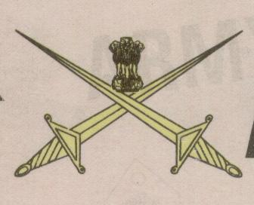

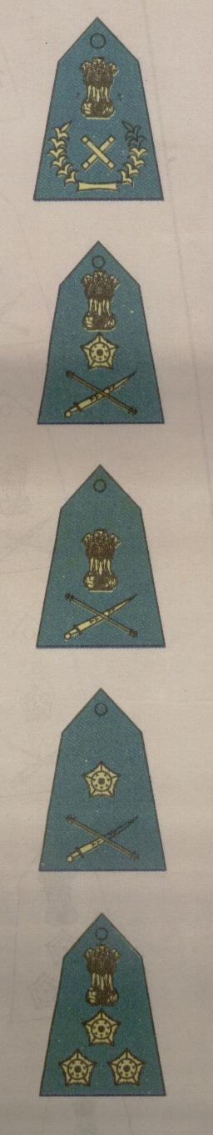

**Lieutenant General**

**General**

**Brigadier**

**Major General**

**Field Marshal**

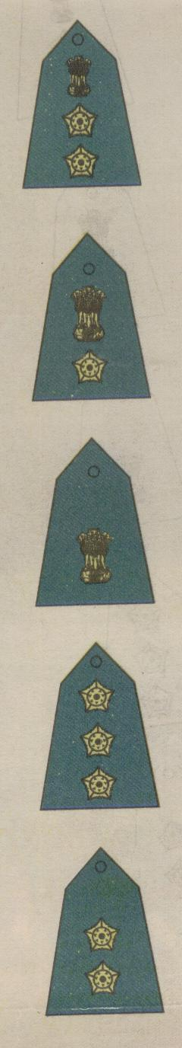

**Lieutenant**

**Captain**

**Major**

**Lieutenant Colonel**

**Colonel**

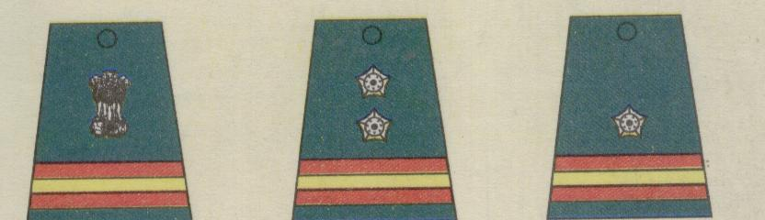

**Naib Subedar**

**Naib Risaldar**

**Subedar**

**Risaldar**

**Subedar Major**

**Risaldar Major**

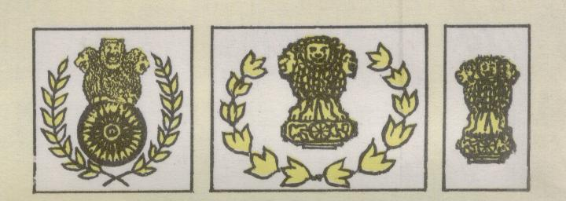

**Coy. Hav. Major**

**Bn . QM. Hav**

**Bn . Hav. Major**

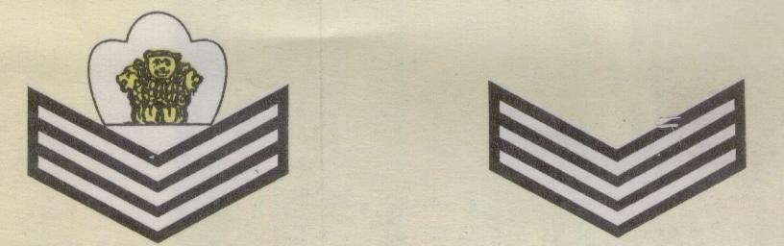

**Havildar**

**Coy. QM. Hav**

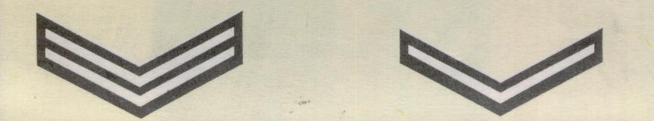

**Lance Naik**

**Naik**

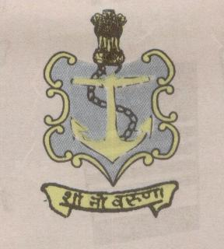

**NAVY**

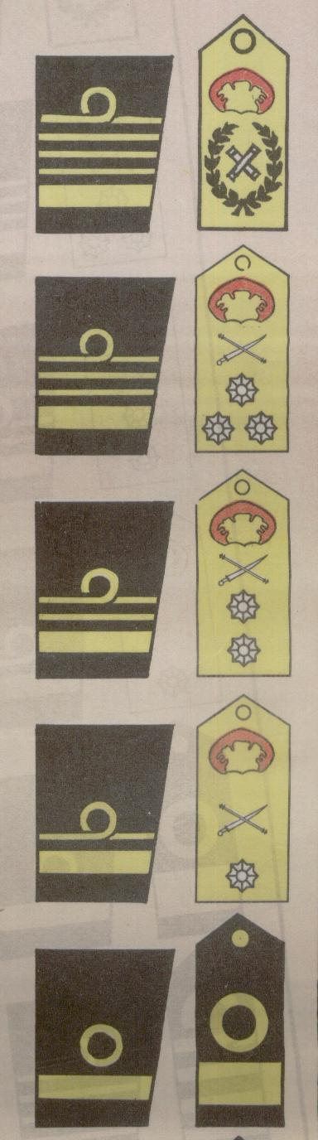

**Commodore**

**Rear Admiral**

**Vice Admiral**

**Admiral**

**Admiral of the Fleet**



**Sub Lieutenant**

**Lieutenant**

**Lieutenant Commander**

**Commander**

**Captain**

**CAP BADGES**



**Master Chief Petty Officer Other Ranks**

**SHOULDER BADGES**

**GOOD CONDUCT**

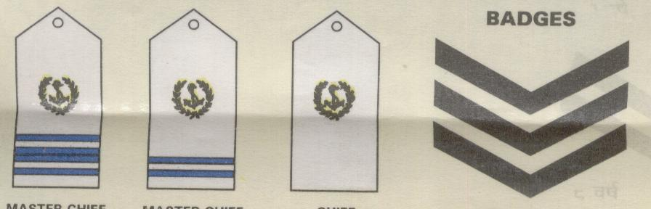

**12 Years**

**Master Chief**

**Petty Officer(ii)**

**Master Chief**

**Petty Officer(i)**

**Chief**

**Petty Officer**

**ARM BADGES**

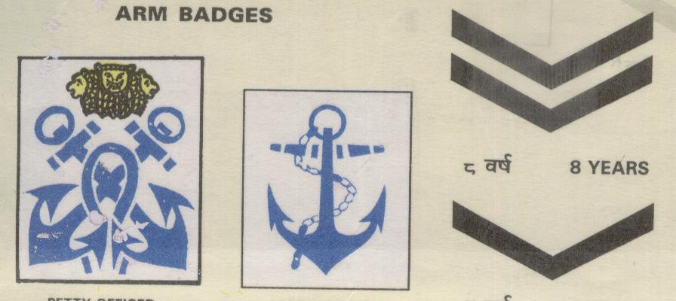

**Leading Ranks**

**Petty Officer**

**4 Years**

**8 Years**

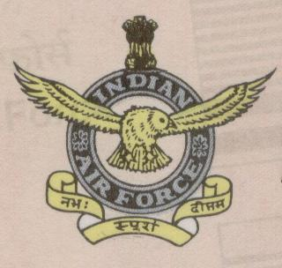

**AIR FORCE**

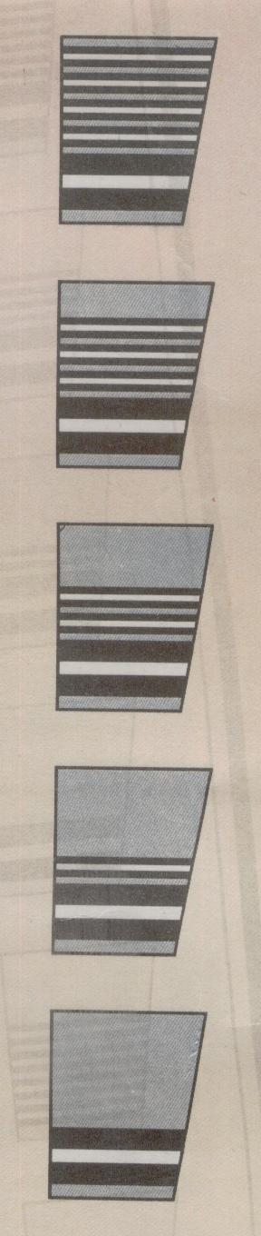

**Air Commodore**

**Air Vice Marshal**

**Air Marshal**

**Air Chief Marshal**

**Marshal of the Air Force**

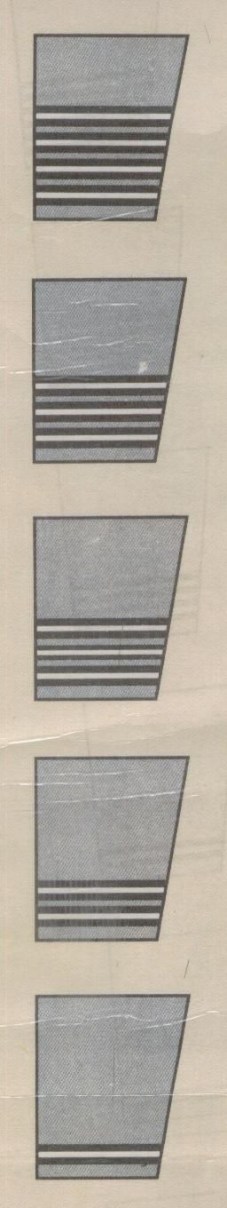

**Flying Officer**

**Flight Lieutenant**

**Squadron Leader**

**Wing Commander**

**Group Captain**



**Warrant Officer**

**Master**

**Warrant Officer**

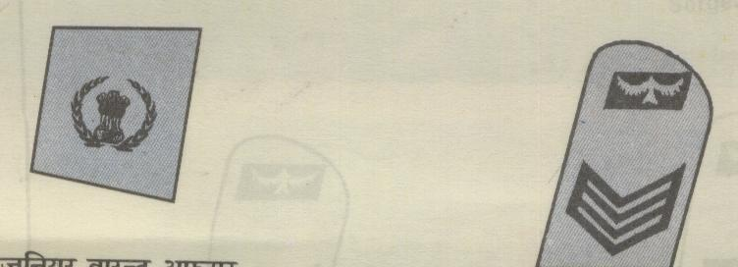

**Sergeant**

**Junior Warrant Officer**

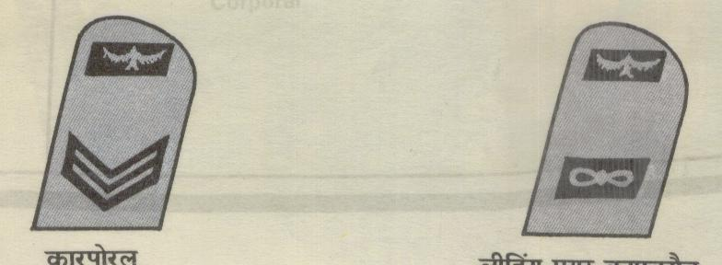

**Corporal Leading Aircraftman**

**SECTION-3**

**HONOURS AND AWARDS**

**Indian Armed Forces Awards**

1. For the purpose of classification, Indian Armed Forces Honours and Awards can be divided in to two categories:-

(a) Gallantry Awards.

(b) Non-Gallantry Awards.

2. **Gallantry Awards**. Gallantry awards are again divided into two categories:-

(a) **Gallantry in the Face of Enemy**

(i) Param Vir Chakra.

(ii) Maha Vir Chakra.

(iii) Vir Chakra.

(iv) Sena, Nao Sena and Vayu Sena Medal.

(v) Mention in Dispatches.

(vi) Chiefs of Staff Commendation Card.

(b) **Gallantry other than in the face of the enemy**

(i) Ashoka Chakra.

(ii) Kirti Chakra.

(iii) Shaurya Chakra.

Note:- These were originally named Ashoka Chakra Class I, Class II, Class III

3. **Non-Gallantry Awards** are as follows:-

(a) Bharat Ratna.

(b) Padma Vibhushan.

(c) Padma Bhushan.

(d) Sarvottam Yudh Seva Medal.

(e) Param Vishisht Seva Medal.

(f) Padma Shri.

(g) Sarvottam Jeevan Raksha Padak.

(h) Uttam Yudh Seva Medal.

(j) Ati Vishisht Seva Medal.

(k) President’s Police and Fire Service Medal for Gallantry.

(l) President’s Police Medal For Gallantry.

(m) President’s Fire Service Medal For Gallantry.

(n) President’s Correctional Service Medal For Gallantry.

(o) President’s Home Guards and Civil Defence Medal For Gallantry.

(q) Yuddh Seva Medal.

(r) Vishisht Seva medal.

4. Correct ‘**Order of Precedence**’ of wearing of various medals and decoration is given in Appendix.

**Conditions of Eligibility and Eligible Categories**

5. Conditions of Eligibility and Eligible Categories for some of the awards are given in succeeding paras.

6. **Param Vir Chakra**

(a) **Conditions of Eligibility**. Awarded for most conspicuous bravery or some daring or pre-eminent act of valour or self sacrifice, in the presence of the enemy, whether on land, at sea, or in the air. The decoration may be awarded posthumously.

(b) **Eligible Categories**. Officers, men and women of all ranks of the Army, the Navy and the Air Force, of any of the Reserve Forces, of the Territorial Army, Militia and of any other lawfully constituted Armed Forces. Matrons, Sisters, Nurses and staff of the Nursing Services and other Services pertaining to Hospital and Nursing and Civilians of either sex serving regularly or temporarily under the orders, directions or supervision of any of the above-mentioned Forces.

(c) **Monetary Allowances.** Rs 1500/-pm and each bar to the decoration another Rs 1500/-pm to all recipients.

7. **Ashok Chakra**

(a) **Conditions of Eligibility**. Awarded for most conspicuous bravery, or some act of daring or pre-eminent act of valour or self-sacrifice otherwise than in the face of the enemy. The decoration may be awarded posthumously.

(b) **Eligible Categories**. Officers, men and women of all ranks of the Army, the Navy and the Air Force, of any of the Reserve Forces, Territorial Army, Militia and of any other lawfully constituted Forces. Members of the Nursing Services of the Armed Forces. Civilian citizens of either sex in all walks of life, other than members of Police Force and of recognized Fire Services.

(c) **Monetary Allowances**. Rs 1400/-pm and each bar to the decoration Rs 1400/-pm to all recipients.

8.  **Param Vishisht Seva Medal**

(a) **Conditions of Eligibility**. For distinguished service of the most exceptional order.

(b) **Eligible Categories**. All ranks of the Armed Forces including Territorial Army units, Auxiliary and Reserve Forces (when embodied) and other lawfully constituted Armed Forces. Nursing officers and other members of the Nursing Services in the Armed Forces.

9. **Vir Chakra**

(a) **Conditions of Eligibility.** For the acts of gallantry in the presence of enemy, whether on land or at sea or in the air. The decoration may be awarded posthumously.

(b) **Eligible Categories**. Officers, men and women of all ranks of the Army, the Navy and the Air Force, of any of the Reserve Forces, of the Territorial Army, Militia and of any other lawfully constituted Armed Forces. Matrons, Sisters, Nurses and staff of the Nursing Services and other Services pertaining to Hospital and Nursing and Civilians of either sex serving regularly or temporarily under the orders, directions or supervision of any of the above-mentioned Forces.

(c) **Monetary Allowance**. Rs. 850/- pm and each bar to the decoration Rs. 850/- pm to all recipients.

10. **Yuddh Seva Medal**

(a) **Conditions of Eligibility**. Awarded for distinguished service of a high order during war/conflict/hostilities.

(b) **Eligible Categories**. All ranks of the Army, the Navy and the Air Force, including those of Territorial Army units, Auxiliary and Reserve Forces and other lawfully constituted Armed Forces when embodied. Nursing officers and other members of the Nursing Services in the Armed Forces.

11. **Sena Medal**

(a) **Conditions of Eligibility**. Awarded for such individual acts of exceptional devotion to duty or courage as have special significance for the Army, Navy and Air Force. The award may be made posthumously.

(b) **Eligible Categories**. All ranks of the Army, Navy and Air Force.

(c) **Monetary Allowances**. Rs 250/- pm and each bar to the medal Rs 250/- pm to all Sena Medal (Gallantry) awardees.

**NCC Awards**

12.These awards are given to NCC personnel since 1984. It includes NCC Whole Time Lady Officers (WTLO’s), Associate NCC Officers (ANO’s), Girls Cadet Instructors (GCI’s) and NCC cadets.

13. **Raksha Mantri’s Padak**.Raksha Mantri’s Padak is awarded to NCC personnel and cadets since 1989 for performance of any exceptional act involving courage, devotion to duty and contribution of lasting value to the NCC. In addition cash award of Rs 10000/- and a running Veer Trophy is also given to the recipient of this award. Every year only one Raksha Mantri’s Padak is awarded.

14. **Raksha Mantri’s Prashansa Patra**. Raksha Mantri’s Commendation Card with Rs.7500/- cash is awarded to NCC personnel and cadets since 1989 for any outstanding act involving leadership, courage or devotion to duty, which enhances the image of the NCC. Every year maximum three Raksha Mantri’s Commendation Cards are awarded.

15. **Raksha Sachiv’s Prashansa Patra**. The Commendation Card with Rs 5000/- cash, is awarded since 1984 for outstanding act or deed in the field of adventure sports, training or for outstanding contribution in social or cultural activities. Every year maximum ten Raksha Sachiv Commendation Cards are awarded.

16.  **Maha Nideshak’s Prashansa Patra**. This Commendation Card with Rs 1000/- cash, is awarded since 1984 for outstanding act or deed in the field of adventure sports, training or for outstanding contribution in social or cultural activities. There is no limit to the number for award of Maha Nideshak’s Prashansa Patra.

17.  **Maha Nideshak’s Prashansa Patra To Civilian Personnel**. It is awarded to Central Government civilian officers/staff posted at various levels in the NCC, for displaying outstanding and distinguished service, dedication and devotion to work and outstanding contribution for efficient management of various NCC activities including camps.

**Appendix**

(Refer Para 4 of

Section-3 Chapter-1)

**ORDER OF PRECEDENCE : MEDALS AND DECORATION**

1. Bharat Ratna

2. Param Vir Chakra

3. Ashoka Chakra

4. Padma Vibhushan

5. Padma Bhushan

6. Sarvottam Yudh Seva Medal

7. Param Vishisht Seva Medal

8. Maha Vir Chakra

9. Kirti Chakra

10. Padma Shri

11. Sarvottam Jeevan Raksha Padak

12. Uttam Yudh Seva Medal

13. Ati Vishisht Seva Medal

14. Vir Chakra

15. Shaurya Chakra

16. President’s Police and Fire Service Medal for Gallantry

17. President’s Police Medal for Gallantry

18. President’s Fire Service Medal for Gallantry

19. President’s Correctional Service Medal for Gallantry

20. President’s Home Guards and Civil Defence Medal for Gallantry

21. Yuddh Seva Medal

22. Sena, Nao Sena and Vayu Sena Medal

23. Vishisht Seva Medal

24. Police Medal for Gallantry

25. Fire Service Medal for Gallantry

26. Correctional Service Medal for Gallantry

27. Home Guard and Civil Defence Medal for Gallantry

28. Uttam Jeevan Raksha Padak

29. Parakram Padak

30. General Service Medal-1947

31. Samanya Seva Medal-1965

32. Special Service Medal

33. Samar Seva Star-1965

34. Poorvi Star

35. Paschmi Star

36. Op Vijay Star

37. Siachin Glacier Medal

38. Raksha Medal-1965

39. Sangram Medal

40. Op Vijay Medal

41. Op Parakram Medal

42. Sainya Seva Medal

43. High Attitude Medal

44. Police (Special Duty) Medal-1962

45. Videsh Seva Medal

46. President’s Police and Fire Service Medal for Distinguished Service

47. President’s Police Medal for Distinguished Service

48. President’s Fire Service Medal for Distinguished Service

49. President’s Correctional Service Medal for Distinguished Service

50. President’s Home Guards and Civil Defence Medal for Distinguished Service

51. Meritorious Service Medal

52. Long Service and Good Conduct Medal

53. Police Medal for Meritorious Service

54. Fire Service Medal for Meritorious Service

55. Correctional Service Medal for Meritorious Service

56. Home Guard and Civil Defence Medal for Meritorious Service

57. Jeevan Raksha Padak

58. Teritorial Army Decoration

59. Teritorial Army Medal

60. Indian Independence Medal-1947

61. Independance Medal-1950

62. 50th Anniversary of Independence Medal

63. 25th Independence Anniversary Medal

64. 30 Years Long Service Medal

65. 20 Years Long Service Medal

66. 9 Years Long Service Medal

67. Commonwealth Awards

68. Other Awards

**SECTION-4**

**CONCEPT OF COMBINED DEFENCE SERVICES**

**Introduction**

1. The nature of modern warfare is characterised by technological complexities that demand that our armed forces fight as a team. A country like India endowed with a geostrategic location in the Asian sub continent must have basic structures and systems to manage its national security. Modern wars have become total, complex and highly specialised requiring suitable organizations to wage wars. The fast changing scenarios have overtaken the present Indian system making it redundant. The times when each Service could fight its own war in isolation and without integration of the other two services is a legacy of the past. Military thinking throughout the world accepts as a truism that modern war must be fought by all three services under a single commander and unless done, the chances of success will be small.

**Concept**

2. The concept of three dimensional warfare or combined operations wherein the three wings of the armed forces i.e. Army, Navy and Air Force, have to operate as a single cohesive force against the enemy is the norm of the day.

3. Efforts have been made in this direction in our country also. Exchange of officers among the three services during various training course, sand model discussion and exercises at various levels is very useful in understanding the working ethos of other services. It ultimately leads to cohesiveness at ground level. A very good example of inter services co-operation is Indo Pak war 1971 and recently Kargil war 1999 where in Army and Air Force worked in unison achieved remarkable results.

4. Currently Integrated Command having all the three services under its wing is established at Port Blair to institutionalize the concept of three dimensional warfare and same is working very efficiently.

**Conclusion**

5. National defence is not a concern of either military forces or the national government but of the nation as a whole. A nation’s security rests on many resources: human, economic, natural, technological, political to name but a few. The national aim during any war would be to win, for which all the national resources will be employed. The defence services are the most important tool available with the government to achieve its aim. However, individually no single service on its own can achieve this aim. Therefore there is a need to adopt a joint/common approach towards attainment of the national aim and this is only possible when the three services work and operate together, both during peace and war.

**CHAPTER-II**

**MAP READING**

|  |  |  |  |
| --- | --- | --- | --- |
| **INDEX** | | | |
| **CHAPTER-II MAP READING** | | **JD/JW** | **SD/SW** |
| SECTION-1 | Introduction to Map and Conventional Signs | √ | √ |
| SECTION-2 | Scales | √ | √ |
| SECTION-3 | Topographical Forms and Technical Terms | √ | √ |
| SECTION-4 | The Grid System | √ | √ |
| SECTION-5 | Relief Contours and Gradients | √ | √ |
| SECTION-6 | Cardinal Points and Finding North | - | √ |
| SECTION-7 | Type of Bearings and use of Service Protractor | √ | √ |
| SECTION-8 | Prismatic Compass, Its Use and  Introduction to GPS | √ | √ |
| SECTION-9 | Setting a Map, Finding Own Position and North | √ | √ |
| SECTION-10 | Map to Ground | - | √ |
| SECTION-11 | Ground to Map | - | √ |
| SECTION-12 | Point to Point March | - | √ |

**SECTION-1**

**INTRODUCTION TO MAP AND**

**CONVENTIONAL SIGNS**

**Introduction**

1. A map is representation of selected natural and man made features of the whole or part of the earth’s surface on a flat sheet of paper on a definite scale and in their correct relative geographic positions and elevations. Symbols, colour differentiations and contours help to show the physical features- mountains , valleys and plains- in their true relationship to the land and man made features. In a way they are an inventory of the physical features of and on the surface of earth and a blue print for Commanders for planning campaigns. Map reading thus helps a peron to get a clear and accurate picture of the ground without actually seeing it. A map however has the following limitations:-

(a) It is seldom, if ever, upto date.

(b) It cannot show every thing that exists on the ground.

**Information**

3. Every map carries a variety of information printed on its margin and since these pieces of information usually appear in approximately the same position, it is useful to know where to look for them. Fig 1 shows the information which is given in the margins of the 1 inch Survey of India Map in a diagrammatic form.

**Conventional Signs**

4. Conventional signs are symbols used to represent certain artificial or natural features/objects on the map. They are seldom drawn to scale.

5. The exact position of the object represented is the centre of the symbol if it is drawn in plan or the centre of the base of the symbol in elevation.

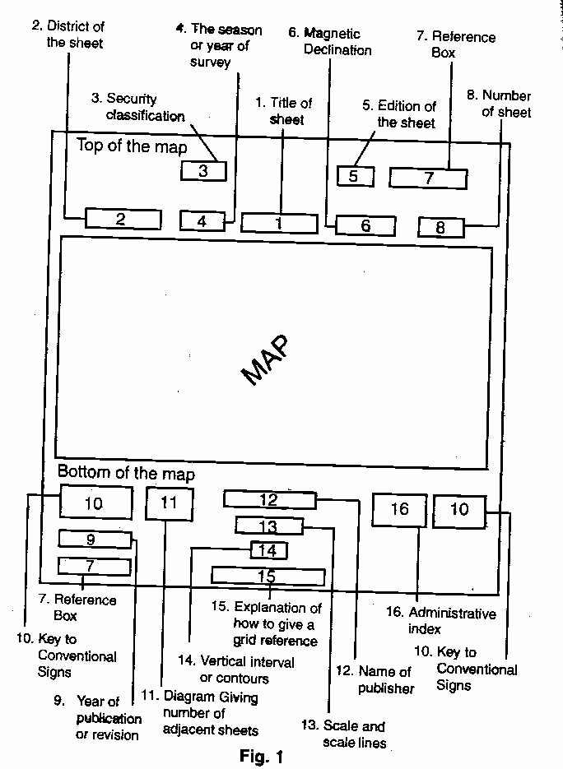

**Common Types**

6. A selection of the more common conventional signs is given as below.

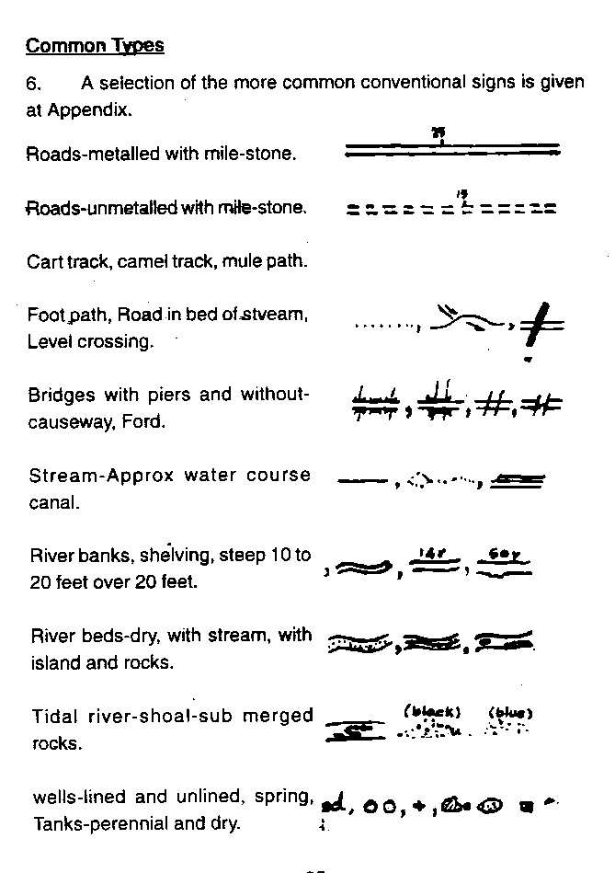

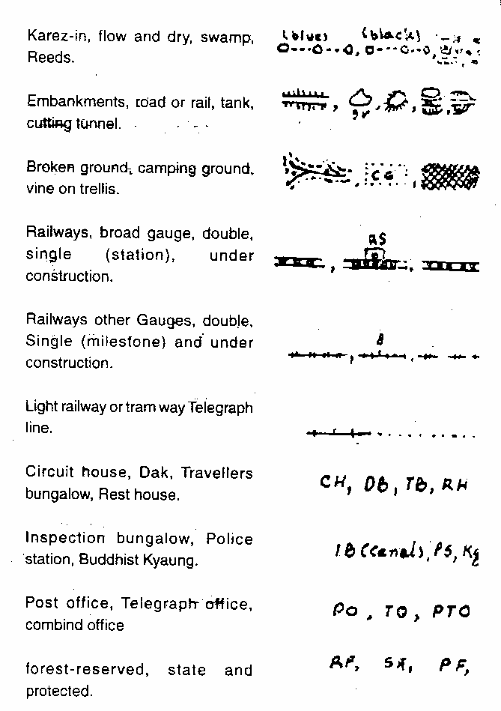

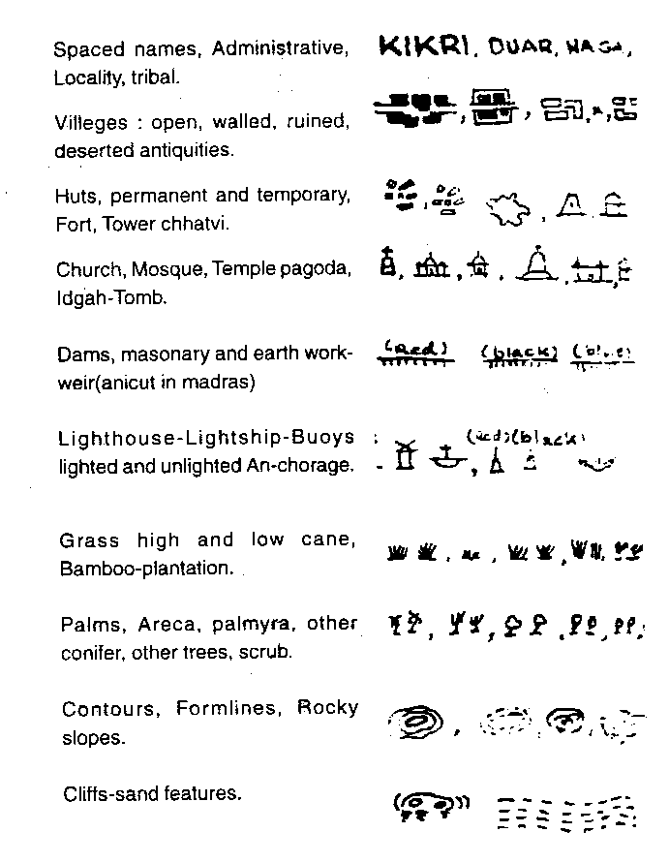

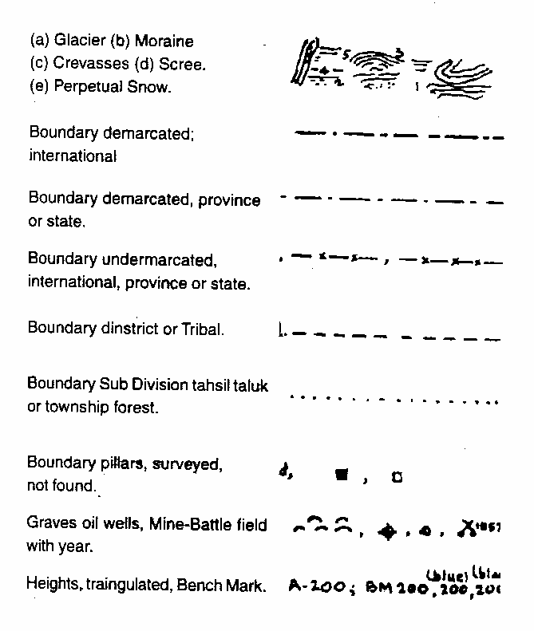

7. The conventional signs shown are those of the Survey of India 1 inch Map.

8. The signs may vary a little with different scale maps and with different editions but not to any great degree and even on foreign maps the conventional signs are sufficiently similar to be easily recognisable.

**MILITARY SYMBOLS**

**INF MECH INF ARMD ARTY**

•

•

•

**BTY**

**REGT**

**SQN**

**REGT**

**TP**

**BASIC**

• • •

**SEC**

••• ••• •••

**PL**

**COY**

**BN**

**HQ**

**WPNS MSL**

**LMG**

**MOR**

**MMG**

**RL ARTY GUN**

**SECTION-2**

**SCALES**

**Definition**

1. By scale it means the proportion which the distance between two points on the map bears to the distance between the same two points on the ground. It is obvious that it would be impossible to make a map the same size as the country which it represents. Everything on the map must be reduced and the extent to which the size is reduced constitutes the scale of the map. The essence of a map is that it is a drawing to scale and it bears a definite ratio to the size of the actual country which it portrays. If you imagine two maps, each measuring 3 feet x 2 feet, one might show the whole of Bihar and Orissa, while the other might show only a small district. The scale of these two maps are obviously not the same.

**Methods**

2. There are two methods of expressing a scale:-

(a) **In Words.** 1 inch to 1 mile, it means that 1 inch on the map represents 1 mile on the ground. If your were to measure on a map of this scale the distance from your house to the nearest railway station and you found that it was two inches you would know that the distance in actual fact was 2 miles.

(b) **As a Representative Fraction (RF)**. This is the scale expressed in the form of a fraction, if the scale of a map is given as 1/100000 this means that one unit of the map represents 100000 of the same unit on the ground. It could mean that one centimeter on the map represents 100000 on the ground. Thus 1/63360 means that 1 inch on the map represents 63360 inches on the ground and that is the number of inch in one mile. This is the representative fraction for a scale of 1 inch to 1 mile. The advantage of expressing a scale as a RF is that it can be applied to any type of map of whatever nationality. The scale is always written in the centre of the bottom margin of the map.

**Scale Line**

3. Underneath this is the scale line which is drawn in two ways and by means of this, distance on the map can be measured. On the 1 inch to 1 mile map one shows miles along its length, and is similarly divided into yards, with sub divisions in the left hand section.

4. The large divisions on these scale lines are called primaries and the small divisions on the left secondaries. An example of the scale lines for a scale 1 inch to 1 mile is at Fig.1

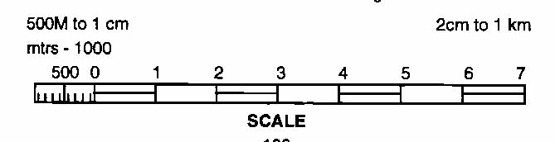

**Fig-1**

**Common Scales**

5. The following is a short list of the more common scales used on Survey of India Maps:-

* 1. 16 inches to 1 Mile 1/3960
  2. 4 inches to 1 mile 1/15840
  3. 2.53 inches to 1 mile 1/25000
  4. 1 inch to 1 mile 1/63360
  5. ½ inch to 1 mile 1/126720
  6. ¼ inch to 1 mile 1/253440
  7. 16 miles to 1 inch (Approx) 1/1000000
  8. 32 miles to 1 inch (Approx) 1/2000000

6. The 16 inches and 4 inches maps are called large scale maps or “Plans” and they show a very great amount of detail.

7. The most common scale of military maps is 1 inch to 1 mile, which shows most of the detail on the ground and is the scale normally used for the tactical purposes. The ¼ inch to 1 mile being more of an out-line map and one which shows a large area of country on one sheet is more commonly used by mechanized troops and transport columns. A scale which may sometimes be required for small tactical exercises is the 1/25000 (approx 2.5 inches to 1 mile). This shows a great amount of detail. The 1/M (million) map and ½ M map are purely routine maps normally used by the Air Force.

8. Abroad, scale are referred to purely by their representative fraction and the French army uses three main scales, which are given below with their English equivalent:-

* 1. 1/20000 : 3.16 miles to 1 inch (approx)
  2. 1/80000 : 0.8 inches to 1 mile (approx)
  3. 1/50000 : 1.27 inches to 1 mile (approx)
  4. 1/25000 : 2.25 inches to 1 mile (approx)

9. The first is used for strategic purposes, the last is an artillery and French map.

10. The 1/50000 map which is used over considerable portions of France has not been completed, therefore old topographical maps of the scale 1/80000 are still being employed commonly.

11. In our army we employ mostly the 1:50000 maps and 1:250000 maps. The Air Force uses the ‘million map’ since pilots have to overfly vast area and need continuous update from much larger landmarks, than used by the ground forces.

**SECTION 3**

**TOPOGRAPHICAL FORMS AND TECHNICAL TERMS**

**General**

1. The following list of technical terms and topographical forms is by no means exhaustive and is meant to include only those which are more commonly used. Topographical forms is a name used to describe geographical features which occur on the ground.

**Technical Terms**

2. (a) **Bearing** - The angle formed by a line joining two points and the North and South line. Bearings are always measured clockwise.

(b) **Bench Mark** - A permanent mark usually cut into a wall recording exact height for future reference, marked BM with the height on Ordnance Survey Maps.

(c) **Contours** - A line drawn on the map joining up all points of equal height above sea level.

(d) **Detail** - All the Topographical information on a map.

(e) **Gradient** - The slope of a hill expressed as a fraction.

(f) **Grid Lines** - Lines running parallel to and at right angles to a North and South line through approximately the centre of the area covered by the grid system.

(g) **Grid North** - Except through the origin, grid lines do not lie true North and South or East and West, Grid North is the direction of the North South grid lines on a map.

(h) **Horizontal** - The distance measured on the map between **Equivalent (HE)** adjacent contour lines. It varies according to the

nature of the relief.

(j) **Magnetic** - The difference between true North & Magnetic **Variation** North.

(k) **Setting** - Placing a map so that North on the map points toward the North so that the objects on the map are placed in relationship to the same objects on the ground.

(l) **Spot Height** - A point on a map whose height has been determined by Survey methods. This height is printed alongside the point.

(m) **Trig Point** - A point fixed during the triangulation at the b beginning of a survey, marked on Ordance Survey Maps by a small triangle with the height.

(n) **True North** - The direction of the North Pole from the point.

(o) **Vertical** - Successive controur lines. The VI is generally **Interval (VI)** the same for any given scale.

**Topographical Forms**

3. (a) **Basin** - An area of fairly level ground surrounded by hills or the area drained by a river and its distributaries.

(b) **Col or Saddle** - A narrow ridge of high land joining up to higher

hills.

(c) **Crest** - The highest part of a hill or mountain range. It is that line on a range of hills or mountains from which the ground slopes down in opposite

directions.

(d) **Dead Ground** - Ground which by reason of undulations or hills is not visible to the observer.

(e) **Defile** - Any feature whether natural or artificial which could cause a body of troops to contract its front. An example of a natural defile is mountain pass while a bridge is an example of an artificial defile.

(f) **Escarpment** - The steep hill side formed by a sudden drop in the general ground level usually from a plateau.

(g) **Knoll** - A small isolated hill.

(h) **Plateau** - A table land, an elevated region of considerable extent generally fairly level.

(j) **Ravine** - A long deep valley closed at one end separating two

spurs.

(k) **Ridge**  - The line along a hill or range of hills or mountains from which water flows in opposite directions, a divide,sometimes the crest of a line of hills as it appears along the horizon.

(l) **Spur**  - A piece of high ground jutting out from a range of hills into lower ground.

(m) **Watershed** - The line separating the water flowing into two different river systems, the edge of a river basin.

**SECTION-4**

**THE GRID SYSTEM**

**Definition of Grid**

1. A map is covered with a net work of purple lines, some running North and South and other West and East. These form a series of small squares all over the map. These lines are known as “Grid Lines”.

**Purpose**

2. The purpose of grid lines is to make possible giving and reading grid references and to facilitate measurement of bearings. They make no difference to the construction of the map and if they are removed, the accuracy of the map would not be affected. These lines are super-imposed in order that it may be possible to give a reference to a desired point.

**Division**

3. The whole country is divided into large lettered square each measuring 1000000 yards squares. The lettered squares are subdivided into 100 similar squares each measuring 10000 yards squares.The side of 10,000 yards are thickened and they are further divided into smaller square/measuring 1000 yards squares. A 1,000,000 yards lettered square is much larger than the whole of a normal one inch map sheet and for practical purposes they are ignored. You use these letters when giving reference on smaller maps (e.g. Quarter inch).

**Need for Reference**

4. It is difficult to describe an exact position without pointing it out on the map which is not always possible and to describe the position in ordinary terms is lengthy and ambiguous. The key-note of a reference is that the method should be accurate, quick and simple. In the army maps, we make use of the Grid system to achieve this.

**Method of Grid Reference**

5. In giving a grid reference, there are four rules to remember:-

(a) A reference must always contain an even number of figures. In the normal method, it will contain six figures.

(b) Always count along the EASTING lines first from WEST to EAST and then from SOUTH to NORTH, along NORTHINGS.

(c) For the six figures reference, the third and the sixth figure represent the divisions of 1000 yards square to the nearest 10th part, so they have to be estimated and for these figures a slight latitude is allowed.

(d) If a general grid reference is to be given or there is only one such object in one square e.g. bridge, temple, road, junction, then a four figure grid reference would suffice.

**SECTION 5**

**RELIEF CONTOURS AND GRADIENTS**

**General**

1. The word relief is a name used to describe the rise and fall of the ground or in other words the hills and valleys. The most common way in army to do so is by contour lines. These are thus lines drawn on the map (usually drawn) each line joining up points of equal heights above sea level. Against these lines is written the height.

**Slopes**

2. The closer together the contour lines are, the steeper is the slope of the hill which they show, where they are far apart, the slope down is gradual. Remembering this, it is possible to see at a glance where the steeper hills are.

**Type of Slopes**

3. There are two type of slopes, convex and concave. A convex slope is the one which bulges outwards and concave slope is the one which curves inwards.

**Vertical Interval(VI)**

4. The rise between successive contour lines is known as the vertical interval. On map scale 1 inch to 1 mile, the VI of each contour line is 50 feet while on the ¼ inch to a mile it is 250 feet.

**Horizontal Equivalent**

5. The distance measured flat on the map between adjacent contour lines is horizontal equivalent (HE).

**Gradient**

6. A gradient is a slope expressed as a fraction. If we say that a slope has a gradient of 1 inch to 7 we mean for every 7 feet of horizontal distance the slope rises or falls 1 foot vertically. Simple Formula is VI/HE = Gradient.

7. The horizontal equivalent is obtained by measuring on the map and vertical interval by subtracting the contour heights.

**SECTION 6**

**CARDINAL POINTS AND FINDING NORTH**

**General**

1. This figure shows the main points of compass. North, South, East and West are known as the cardinal points.

2. If the North point is taken as 0 Degrees the angle which East forms with it is 90 degrees, or a right angle. The angle formed by the South point, being twice as large, is 180 degrees, and the West point forms an angle of 270 degrees. If the angle is measured all the way round the circle back again to North, it will be found to be 360 degrees.

**Types of North**

3. There are three type of North points:-

(a) **True North -** The direction of North pole from the observer.

(b) **Magnetic North-** It is the point to which an accurate compass needle points, when freely suspended.

(c) **Grid North** - It is the direction to which the North South grid lines on a map point.

**Magnetic Variation**

4. **True North is Constant** Magnetic North is the point to which the compass needle points. The needle does not point directly to True North, but a little West or East of True North. The point towards which the needle swings is known as Magnetic North

and the difference between True North and Magnetic North is called magnetic variation. The amount of the magnetic variation depends upon two factors, time and place. See Fig.3

**True North**

**Magnetic**

**Variation**

**Magnetic North**

**Fig.3 Magnetic Variation**

5. **Time**. The Variation is not constant but is, gradually changing and even the change each year is not constant but the difference being negligible it is taken to be constant. On the top margin of a map will be found a statement giving the magnetic variation. To bring this up-to-date, the year of issue of the map must be noted and for every year that has passed since then the applicable change annually subtracted or added from the figure given as applicable.

6. **Place**. The amount of the magnetic variation also changes in different parts of the world and indeed in different parts of the country.

**Grid Convergence**

7. The angular difference between Grid and True NORTH is called the ‘Angle of Convergence or the grid convergence’.

**SECTION-7**

**TYPE OF BEARINGS AND USE OF SERVICE PROTRACTOR**

1. The clock wise angle formed by a straight line joining two points and direction of NORTH, is called the bearing between the two points. A bearing is always measured clockwise. They are of three types as given below:-

(a) **Grid Bearing**.Measured on the map from the Grid North by the help of a protractor.

(b) **Magnetic Bearing**. Measured from Magnetic North by the compass.

(c) **True Bearing.** Calculated by finding out the relation of true NORTH and Grid NORTH or Magnetic NORTH.

**Conversion of Bearings**

2. The methods are explained in the succeeding paras.

**To Convert a Magnetic Bearing to a True Bearing**

3. Suppose the bearing of a certain point P is measured with a compass and is found to be 160 Degrees. To convert this magnetic bearing to a true bearing, draw a diagram as given in Fig.4.

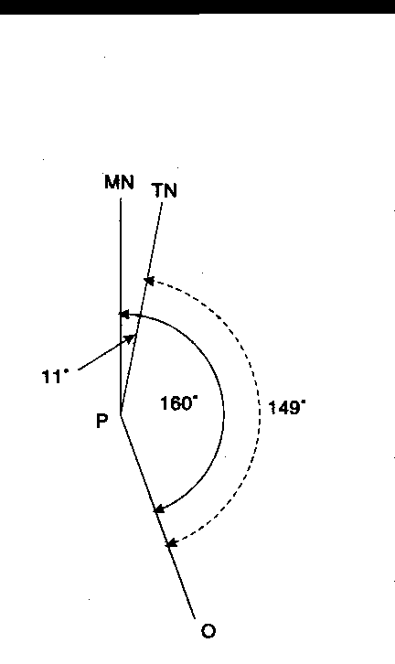

Fig. 4

4. First draw a vertical line to represent Magnetic North (because it is a magnetic bearing which is being considered). Next draw a line to P at an angle of 160 degrees. It is only a rough diagram, and the angle can be judged by eye. Thirdly, draw in the true North line approximately 11 degrees East of Magnetic North, with this diagram it becomes clear that true bearing (marked with a dotted line) is smaller by 11 degrees. Therefore, the true bearing of P is 149 degrees.

**To Convert Grid Bearing to Magnetic Bearing**

5. Measuring with a protractor on the map, the bearing of a Wind Mill at Y from a Church at X is found to be 120 degrees. To convert this grid bearing to a magnetic bearing, draw a diagram as before this time starting with the Grid North line. The magnetic bearing is larger than the grid bearing by 11 degrees and is therefore, 131 degrees.

6. In converting bearing it is always wise to draw a diagram in order to see whether the magnetic variation should be added or sustracted and this is an easier way than remembering sets of rules.

**Back Bearing**

7. It is the bearing taken from the observation point back on to the original position. In practice it is not necessary to move to the observation point as it can be calculated. The rule is that if the bearing is large enough to have 180 degrees substracted from it this should be done. If it is smaller this figure should be added.

**Use of Service Protractor**

8. **General** The service protractors “A” Mark IV is an instrument used for plotting and measuring bearing on the map. It is the essential link between the compass and the map, for it is by means of the protractor that magnetic bearings have been converted to grid bearing and transferred to the map.

**Desrcription**

9. The protractor is made of cardboard or ivorine and it measures 6 inches long by 2 inches wide.

10. The front face of the protractor has 3600 of a circle marked around the edges of the three sides. The degrees are marked in a clockwise direction starting from the left hand bottom corner in two tiers, outer set of figures shows gradration from zero degrees to 1800 and the inner set from 1800 to 3600. The zero is denoted by a small arrow at the centre of the fourth side of the protactor (Fig-5).





**Fig-5**

**Scale of Protractors**

11. The main purpose of the protractor is to measure angles and bearings as described in the preceding paragraphs.

12. The protractor also shows on both its faces a number of the more common map scales. The respective scale lines are drawn out and divided into primary and secondary divisions in exactly the same way as at the bottom of the map. Six different scales are shown on the faces each with a variety of sub-divisions so that there is unlikely to be a map on which distance cannot be measured by means of the service protractor.

**Measuring a Bearing**

1. The angle can be measured by drawing a line from the gradation to the point zero on the protractor. The required angle will be the gap between this line and the line joining the zero ( Fig – 5A).

Angle

**Fig-5A**

**Usage of Protractors**

14. The service protractor is an essential item of equipment. With its help one can:-

(a) Plot and measure bearing on paper or on a map. For bearing between 0 and 180 degrees their Zero edge must be on the LEFT and for 180 degrees -360 degrees it must be on the RIGHT.

(b) Measure distance in inches correct upto 1/100th.

(c) Measure distance in yards, metres or miles on a map by using the appropriate scale.

(d) For using the diagonal scale one must use an intermediate agent. Mark off the distance to be measured on the straight edge of a paper or by means of a divider and then put the paper or divider on the diagonal scale and measure.

**SECTION-8**

**PRISMATIC COMPASS , ITS USE AND**

**INTRODUCTION TO GPS**

1. **General**. The magnetic compass has been and is being used extensively in ships, aircraft and the various branches of the army to find and maintain direction. The prismatic compass is an accurate and reliable instrument of great value except during a “magnetic storm” or when subject to strong local magnetic field e.g. in polar regions. With the prismatic compass one can measure magnetic bearing on the ground.

**Types**

2. There are two types of prismatic compass, the dry and liquid type. Liquid type is easier to use though it is less sensitive.

**Description**

3. The names of various parts are shown in figure 6 and 7.

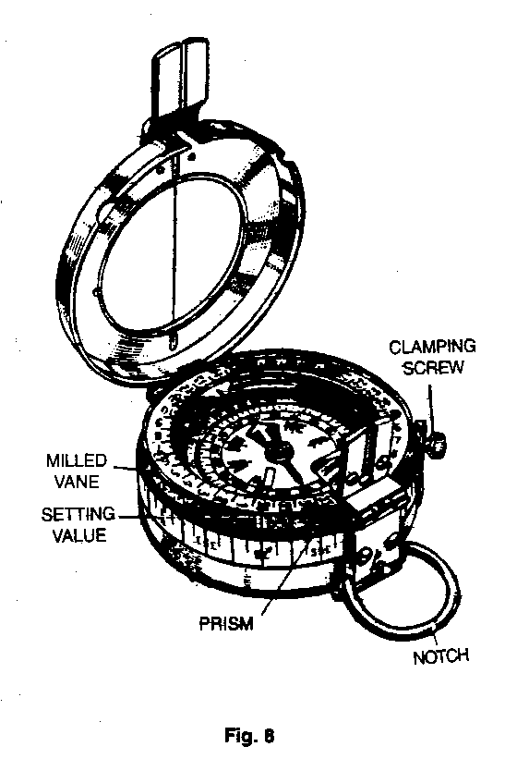

**6**

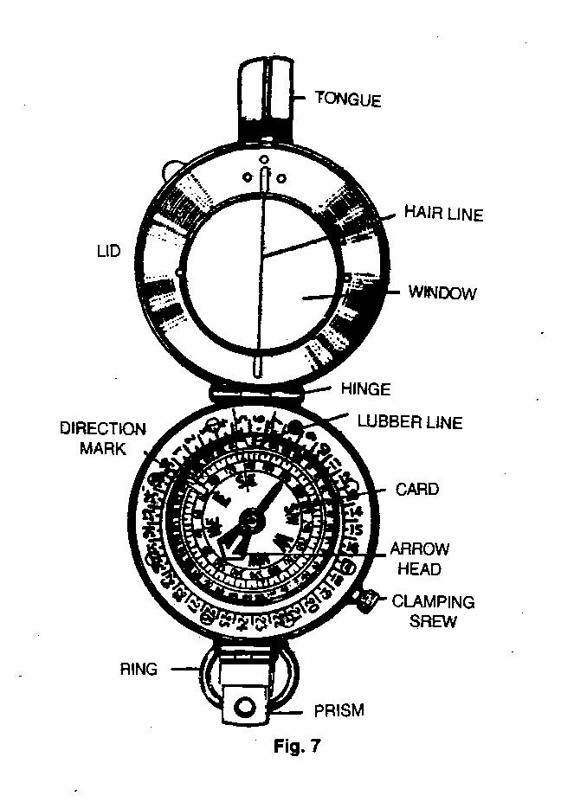

**How to Take a Bearing**

4. Open the lid so that it is roughly at right angle to the body of the compass.

5. Turn the prism casing over so that it lies flat on the face of the compass. Put your thumb through the ring and your forefinger underneath the compass and hold it so that it attains horizontal level.

6. Bring the prism upto the eye and you will see two things:-

* 1. Above the prism, through the slot on the case, the hair line on the window.
  2. Through the prism itself, a set of figures.

7. The compass must be held so that the hair line is vertical and so that it cuts the object on to which the bearing is being taken. The reading is determined by noting where the bottom of the hair line cuts the set of figures beneath it.

**Compass Error**

8. Sometimes due to the presence of impurities in the material of which a compass is made or other reasons, the magnetic needle may not point toward the magnetic NORTH but a little to the EAST or WEST of it. This deviation of the magnetic needle in the compass from the magnetic NORTH is termed compass error:-

(a) The compass error is said to be 2 degrees EAST if the compass needle points 2 degrees EAST of magnetic NORTH. The compass error is 5 degrees WEST if the compass needle points 5 degrees WEST of magnetic NORTH.

(b) Always draw a rough diagram showing the magnetic NORTH and the compass NORTH with the error, you will then see whether you have to subtract or add when converting compass bearing into magnetic bearing and vice versa.

**Global Positioning System**

9. Global Positioning System (GPS) refers to a system of satellites and receivers that allows people and devices to pin point their precise location on the earth. The normal GPS operational constellation consists of 24 satellites that orbit the earth in 12 hours. The satellite orbits repeat almost the same ground track each day. The orbit altitude is such that the satellites repeat the same track and configuration over any point. There are six orbital planes with four space vehicles in each, equally spaced 60 degree apart and inclined about 55 degree with respect to equatorial plane. The constellation provides the user with 5-8 space vehicles visible from any point on the earth. Devices that are equipped with GPS equipment receive transmission from at least a few of the satellites and are able to discern very precise positioning data.

10. The first GPS satellite was launched in1974 and the 24th was launched in1994. The new satellites are periodically launched to replace the ageing ones. GPS in funded by and controlled by the United States, Department of Defence.

11. The application of GPS is very broad and number of users is increasing dramatically. With improved technology, small portable GPS receivers have become very handy and accuracy is remarkable. These devices are used by fishermen and hikers to navigate. Today, many vehicles are equipped with GPS to help the drivers to navigate. In the Armed Forces, GPS has made navigation very easy. All aircraft, ships and specialist vehicles are equipped with GPS. In the Army, GPS is commonly used in battle fields and insurgency-affected areas. It assists troops to navigate in thick jungles, mountains and deserts. GPS is also used to guide missiles to pre specified targets.

**SECTION-9**

**SETTING A MAP, FINDING OWN POSITION AND NORTH**

**Definition**

1. A map is said to be set or oriented when it is placed such that it corresponds directly with the ground i.e. when true NORTH on the map points to true NORTH on the ground. Obviously it is easier to read a map when the objects on it are pointing in the same direction as the objects on the ground.

**Methods of Setting**

2. There are two methods of setting a map - By compass and by objects on the ground.

3. **Setting by Compass** Draw a line showing magnetic NORTH from a point on a grid line. Open the compass and lay it flat on the map over the above drawn diagram which will show the magnetic variation so that the hair line on the window lies along the magnetic NORTH line on the diagram. Then turn both the map and the compass till the needle points along the hair line. The map is now set, since the magnetic NORTH line on the map is pointing in the direction of magnetic NORTH as indicated by the compass needle.

4. (a) **Without a Compass when Own Position is Known**

1. Using a straight edge, for instance railway line.
2. Recognise one object on the ground and on the map and join own

position to that object. Hold the map so that when looking along the line you see the object on the ground in the same straight line.

1. **Without a Compass when Own Position is not Known**

(i) **Parallel Method**. Select two landmarks such as road, railway line and so on which are easily recognizable on the map. If continuous landmarks are not visible, choose two objects and imagine a line joining them. With each landmark, make the corresponding landmark on the map parallel and the map will roughly be set.

(ii) **On Near Line Joining Two Points.** Identify two nearby objects on the map and the ground. Stand on an imaginary line joining them and set the map.

**Finding North**

5. **Without Compass**.The position of NORTH can be discovered by one of the following methods:-

(a) **Watch Method**.Point the hour hand of your watch toward the sun. A line bisecting the angle between the hour hand and the direction of the 12 O’clock will then point due SOUTH. It must be ensured the the angle bisected must always be that which is less than 180 degrees. It is a rough method and applies only in the northern hemisphere.

(b) **Equal Altitude Method**

1. Take a fairly large piece of paper or card board and spread it flat on the ground. In the centre fix a pencil or piece of wood perpendicular to the ground. It can be done with the help of a coin fixed at the base of pencil or wood with sealing wax or by directly pushing it in the ground.

(ii) The pencil will throw on the paper a shadow as shown by the dotted line AB of Fig 8. Where the shadow ends make a mark B, and then from the base of the pencil draw a circle of radius AB.

1. Wait till after mid day until the sun has moved around sufficiently to throw another shadow as indicated by the dotted line AD i.e. of the same length as the original shadow AB.

A

N

B

D

**Fig-8**

(iv) When this is so, draw a line A N bisecting the angle formed by the two shadow lines. This will point to TRUE NORTH.

(v) This is extremely accurate way of finding north but it is of no use on cloudy or dull day. It is also a very time consuming process as the work should start earlier than mid day.

(c) **By Stars**. In the Northern hemisphere, the Pole star indicates the position of True North to within 2 degree. It is a bright star and it can be found by protruding a line from Great Bear. The pole star will be found slightly off this line on the side remote from the remaining stars of the Great Bear.

*

*

*

*

*

*

*

*

**POLE STAR**

**POINTERS**

**GREAT BEAR**

*

**SECTION-10**

**MAP TO GROUND**

**Introduction**

1. To find out the details of map on ground is known as map to ground. Following methods are used to identify objects from map to ground:-

(a) **Bearing and Distance Method.** With the help of bearing and distance, find out own position. Find out the distance of the object to be identified on ground with the help of a scale on the map. Using service protractor, find out the bearing of the object and convert it into magnetic bearing. Set the magnetic bearing on compass and look for the object in the given bearing. Estimating the distance on ground, the object will be identified.

(b)  **Direction and Distance Method.**  Draw a line on the map between own position and object to be identified. Calculate its distance and using any of the following methods find the direction of the object:-

(i) With the help of a sight rule find the ground direction of the object.

(ii) With the help of two points on the map estimate the ground direction.

(iii) Place a foot ruler /pencil at own position and align it with line of the map.

(iv) Place a pin each at own position and at the object on the map. Align both pins and find general direction.

(c)  **By Estimation Method**. In this method measuring bearing, distance and direction, object is identified with the help of other details in the proximity of the object.

**SECTION-11**

**GROUND TO MAP**

1. To find out an object indicated on ground on the map is called ground to map. Method used to identify objects from ground to map arediscussed in succeeding paras.

2.  **Simple Method**

(a)  **Using Bearing**. Find out the distance and the magnetic bearing of the object. Translate magnetic bearing to grid bearing. Set the map and find own position. From own position draw a line at the given grid bearing. Measure distance with service protractor and mark the given distance on the line. The object will be in the proximity of the given mark.

(b) **Intersection Method**. To find out the objects which are at a larger distance or in hilly terrain, intersection method is used. In this method help of minimum two prominent objects are taken which can be easily identified on the ground. Lines are drawn from the prominent objects to the object to be identified on map. This method is used when we cannot estimate exact distance. Intersection is done in two ways:-

(i)  **By Compass Bearing.**  Take the bearing of the object from two known prominent objects. Draw the lines on the map. The object will be in the proximity of the intersection of the two lines. Magnetic bearing is found by two methods:-

(aa) **By Compass.** Take the forward bearing from known object.

(ab) **By Back Bearing**. In war, in case we intercept the enemy’s transmission, with the help of the fall of the shot we can find out the location by working out back bearing.

(c)  **By Direction Method**. In this method set the map and mark own position. With the help of any of the following methods find the direction of object on the map. Draw a line from own position in that direction. Put a mark on the line at the estimated distance of the object. The object will be in the proximity of the marked point:-

(i) Place a foot ruler /pencil at own position and align it in the direction of the object.

(ii) Place a pin at own position on the map. Place the second pin in the direction of the object.

(iii) With the help of details around the object, find direction and mark the object on the map.

(iv) With the help of sight rule find exact direction of the object.

(d) **By Estimation Method.**  By knowing the bearing and distance of the object on ground it can be identified on map by estimation.

**SECTION-12**

**POINT TO POINT MARCH**

**Day Time**

1. **Methods used during Day March**

(a) **With Map Only**. In this method set the map and find your own position. Then, find out the position of the object. Note important landmarks in the vicinity of the object. Also find out the distance of the object. Finally find out the best route to reach the object. While marching, keep comparing the major landmarks enroute. Distance can be measured with the help of steps. 100 meter corresponds to 120 steps approximately. On reaching the object, confirm its correctness with help of other details in the proximity.

(b) **Marching without Map**. There are two methods of marching without map:-

(i) **With Compass**.

(aa) **First Method**. If you know the bearing and distance of the object, take a compass and select two important landmarks in one line where you can march easily. If there is difficulty in selecting landmarks at a large distance due to forest cover or undulating land, then closer landmarks can be selected. This could be repeated till you reach the object. If there is a major obstacle like river or nala which require deviation from the given bearing, one must come to the same line after crossing the obstacle and move on initial bearing.

(ab) **Second Method**. This method is used when bearing and distance of important landmarks enroute are given. Set the bearing of the first landmark from start point and repeat this after reaching every intermediate landmark till you reach the object. In this method one is more confident while marching.

(ii) **Without Compass**. In this method you are required to march based on your memory power. Points to be kept in mind are:-

(aa) Before marching, recognize the object carefully and take note of other landmarks in the proximity.

(ab) Choose best route to the object and convert distance into steps / paces.

(ac) Take note of all the intermediate landmarks and their distances.

(ad) Enroute, ensure you are marching correctly.

(ae) Be careful while measuring distance in steps.

(af) If you deviate while crossing an obstacle, choose a mark across the obstacle. After crossing the obstacle come in line of the mark and recommence marching.

(ag) If you reach a wrong place, come back to the start point.

**Night March**

2. When a navigation party moves at night with the help of compass and night march chart, this is called night march.

(a) **During Moonlit Night**. If you have a compass, you can select two important land marks on the given bearing in a line and march on the same bearing and line. Repeat this till you reach the object.

(b) **Starlit Night**. Select a prominent star at 30 degree on the horizon on the given bearing. Select a landmark in line of the star. March in line of the star and the land mark for approximately 15 minutes. Then select another star in the same bearing and repeat till you reach the object.

(c) **Cloudy Night**. Make a person march on the given bearing to a distance where he can be seen. Then the person holding compass marches, measuring the distance. First person is made to march again in the given bearing and the process is repeated till he reaches the object.

3. **Items Required by Navigation Party**

(a) Set compass as per bounds.

(b) Luminous stick.

(c) White cloth.

(d) Marching chart.

(e) White lime/ chalk.

(f) Stone pebbles for measuring steps.

(g) Frosted torch.

4. **Composition of Navigation Party**

(a) **Guide**. He carries a luminous stick and a compass set to a given bearing.

(b) **Assistant Guide**. He has a white piece of cloth at his back for identification and a stick to measure depth of nala / pits.

(c) **Recorder**. He carries additional compass already set on given bearing, night march chart and stone pebbles. He measures the distance.

(d) **Scouts**. Number of scouts could be from 2 to 4 depending upon the route and tasks.

5. **Night March Parade**

(a) **Assistant Guide**. He moves in front between left and right scouts. He walks for 20 steps and stops. Guide moves up to him and then indicates him to march ahead. Following actions will be taken while crossing an obstacle.

(i) Assistant guide and scouts will negotiate the obstacle from left / right. Guide and balance party will keep waiting. After crossing the obstacle assistant guide and scouts will come in the line of march.

(ii) Then guide and balance party will cross the obstacle and move behind assistant guide.

(b) **Guide**. Guide marches behind assistant guide so that required instructions can be given to him. He also carries a compass with set bearing so that he can correct the line of march of assistant guide.

(c) **Recorder**. Recorder marches behind the guide and measures the distance by steps / measuring tape.

5. **Points to be Kept in Mind**

(a) While marching do not cough, talk or make any noise.

(b) While marching keep inter person distance in mind.

(c) Party must ensure safety and security.

(d) Smoking / using any kind of light is strictly prohibited.

(e) To read night march chart use frosted torch.

**NIGHT MARCH CHART**

|  |  |  |
| --- | --- | --- |
| **(Object)** | **Distance** | **Degree** |
| **Temple**  **Picture 057** |  |  |
|  | **450 M** |  |
| **Well**  **ס** |  | **500** |
|  | **200 M** |  |
| **Bridge** |  | **400** |
|  | **350 M** |  |
| **Track Junction** |  | **200** |
|  | **300 M** |  |
| **Start Point**  **(Survey Tree)**  **Picture 061** |  | **700** |

**CHAPTER-III**

**FIELD ENGINEERING**

|  |  |  |  |
| --- | --- | --- | --- |
| **INDEX** | | | |
| **CHAPTER-III FIELD ENGINEERING** | | **JD/JW** | **SD/SW** |
| SECTION-1 | Introduction to Field Engineering | **√** | **√** |
| SECTION-2 | Knots and Lashings | **√** | **√** |
| SECTION-3 | Types of Mines | **√** | **√** |
| SECTION-4 | Types of Obstacles | **√** | - |
| SECTION-5 | Method of Water Crossing | **√** | - |
| SECTION-6 | Use of Explosives and Improvised  Explosive Device (IED) | **√** | - |
| SECTION-7 | Camouflage and Concealment | **-** | **√** |
| SECTION-8 | Types of Mine Fields | **-** | **√** |
| SECTION-9 | Field Defence | **-** | **√** |

**SECTION-1**

**INTRODUCTION TO FIELD ENGINEERING**

1. **Field Engineering**. Field engineering is the study of field fortification, obstacle planning including minefields, mine warfare, and stores and equipment relating to the same.

2. **Task Performed by Field Engineers**

(a) Laying of mine fields.

(b) Breaching of mine fields.

(c) Construction of field defences.

(d) Construction of tracks in mountains.

(e) Construction / maintenance of border roads.

(f) Water supply to troops in the field, especially in deserts.

(g) Construction of Helipads where-ever required.

(h) In Counter Insurgency Operation:-

(i) Detection, neutralisation and removal of IEDs and explosives.

(ii) Road opening etc for all type of traffic.

(j) Maintenance of essential services.

3. **Equipment Used in Field Engineering**. The following types of equipment is used for various tasks:-

(a) **Laying & Breaching of Mine Fields**.

(i) Explosive ie gunpowder TNT slabs, PEK , Plastic Explosive.

(ii) Various type of charges like cutting, breaching, pressure charge etc.

(iii) Mechanical Mine layers.

(b) **Construction of Field Defences**. Angle Iron pickets, CGI sheets, Binding wire, Ballies, Nails, Barbed wire, Bags, Jar canes, Shovels, Pick axes, Cement, Steel sheets, Bitumen, Paints etc.

(c) **Construction of Tracks**. Duckboards, bulldozers, earthmovers

machines etc.

(d) **Construction of Helipads**. Duckboards, Helipad membranes.

(e) **Watermanship**. Life Jacket, Bridging equipment.

**Commonly Used Tools**

4. Some commonly used tools are given below:-

(a) **Axe Pick GS**. It is used for digging earth; chisel-side for soft ground and pick-side for hard ground.

(b) **Shovels GS**. It is used for lifting the earth and carrying it. Can be used for digging soft earth like sand.

(c) **Entrenching Tool**. It is part of the personal equipment carried by an infantry soldier. It is miniature combination of pick and shovel used for the purpose of digging defences.

(d) **Hammer Sledge**. Used for driving iron pickets into the ground and for breaking big stones/boulders.

(e) **Bar Crow**. Used for pulling out spikes from wood, for removing heavy stones/boulders and logs by making use of the leverage effect.

**SECTION-2**

**KNOTS AND LASHINGS**

1. Knots, bends and hitches are used to join two lashings together, to form a loop in a lashing, to make a stop on a lashing or to secure a lashing to a spar, or to make a hook. Therefore, it is important that cadets are proficient in tying knots. The most useful knots and lashings for general work in the field are classified in the succeeding paragraph.

2. **Characteristics of Knots**

(a) Knot should be strong so that it does not open due to pull and pressure.

(b) Knot should be in conformity to work and simple to use.

(c) Knots should be opened easily.

3. **Types of Knots**

(a) **Thumb Knot**. This knot is used to secure the ends of rope from fraying or opening through a block.

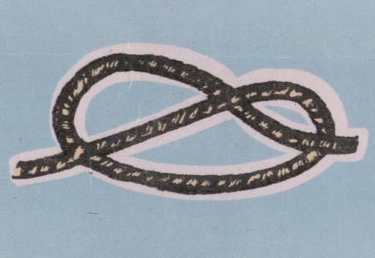 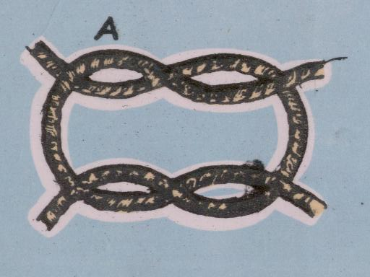

**Thumb Knot**

**Reef Knot**

(b) **Reef Knot**. This knot is used for joining two dry ropes of similar types.

(c) **Figure of Eight Knot**. This is like thumb knot but easier to untie.

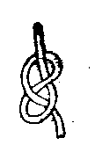 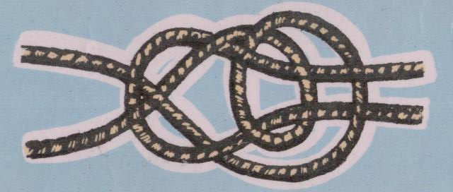

**Double Sheet Bend**

**Figure of Eight Knot**

(d) **Double Sheet Bend**. This knot is used for joining two ropes very securely or two wet ropes of different size strongly.

(e) **Bow Line**. This knot is used to avoid slipping of rope and is used to load or unload heavy materials e.g. rescue a person from a well or from a building on fire.

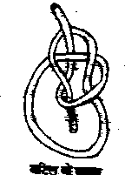 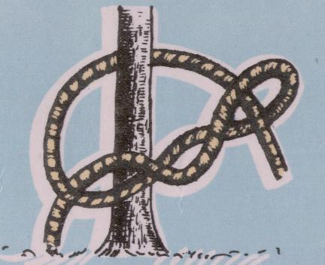

**Bow Line**

**Timber Hitch**

(f) **Timber Hitch**. This knot remains intact only till the time rope is kept taut. The moment rope is left loose, knot automatically become loose. Knot is used to hold timber and securing of logs and planks.

(g) **Clove Hitch**. This knot is used to secure a rope to a spar etc. e.g., tying animals and securing tents etc. To tie this knot force is required.

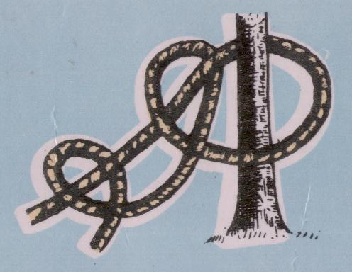 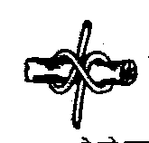

**Clove Hitch**

**Clove Hitch**

(h) **Two Half Hitch**. This knot is used to secure the running end of rope to its standing part.

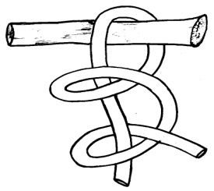

**Two Half Hitch**

(j) **Round Turn and Two Half Hitches**. To make fast a rope to anchorage so that strain on the rope shall not jam the hitches.

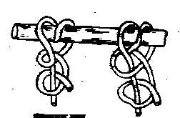

**Round Turn & Two Half Hitches**

**Fisher Man Bend**

(k) **Fisherman Bend**. This knot is used to make fast a rope when there is a give-and-take motion, e.g. anchor cable.

(l) **Running Knot**. This knot is used to form a loop that will draw a taut knot around the object.

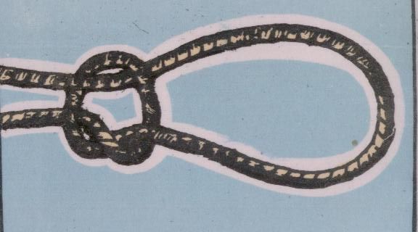

**Running Knot**

4. **Types of Lashes**

(a) **Square Lashes**. This lashing is used to lash one spar at right angle to another. For this put clove hitch on first log then put another log on it and wind the rope 4 – 6 times in one direction only and again close the knot with clove hitch.

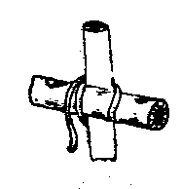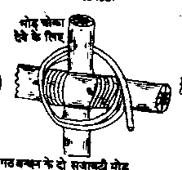 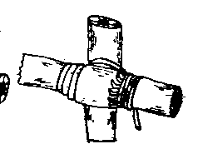

*4 complete turn of the lashing and on extra turn round this spar to bring commencement of trapping turn to the right place.*

*Two trapping turn shown loose for clearness these to be pulled up tight and beaten* in

*Start with a clove Hitch underneath a Transom or above a Ledger*

(b) **Diagonal Lashes**. This is also called multiple knot. This is used to strengthen the square lashes. In this logs are diagonal to each other.

(c) **Parallel Lashes**. This is used for joining two poles/logs to make it longer.

**SECTION-3**

**TYPES OF MINES**

1. **What is Mine.** A mine is a weapon to be used with cunning and with the constant aim of catching the enemy unawares. At the same time it is a weapon which does not distinguish between friend and foe and therefore has to be used with caution.

2. **Types of Mines** . Live mines may be classified according to case, content. purpose. method of firing and ease or difficulty in detection as follows:-

(a) **Case**. Metallic, ceramic, glass, plastic, wood or paper.

(b) **Content**. Explosive, flame, toxic-chemical.

(c) **Use**

(i) **Anti Tank Mines**. Mines designed primarily against tanks are called anti tank mines.

(ii) **Anti Personnel Mines**. Mines designed primarily against personnel are called anti personnel mines. They are further classified as follows:-

(aa) Blast type.

(ab) Fragmentation type.

(iii) **Toxic Chemical Mines.** Mines used to contaminate areas. The toxic agent of each mine is dispersed by burster charges.

(d) **Method of Firing**

(i) **Contact Mines**. Mines which are fired by direct contact with the target.

(ii) **Command Operated Mines**. Mines which are fired by an observer when the target is over or near the mines.

(iii) **Influence Mines**. Mines which are activated by magnetic impulse, vibration or sound waves.

(e) **Ease or Difficulty in Detection**. Mines with metallic cases are easily detected with metal detectors. Mines with glass, plastic, wood, cardboard or other non–metallic cases minimize detection by these metal detectors.

3. Apart from live mines there could be dummy mines drill or practice mines and improvised mines.

**Anti Tank Mines**

4. **Anti Tank Mines**. The anti tank mine contains a large explosive charge weighing from 3-13 kilograms. It is set off by a pressure between 70 to 330 kilograms. The function of an anti tank mine is to disable a tank so that it can be easily and certainly destroyed by the fire of anti tank weapons. An anti tank mine will not be initiated by an armed man stepping over it, but any wheel load in the field will activate it.

**Anti Personnel Mines**

5. **Anti Personnel Mines**. The function of an anti personnel mine is to cause casualties to personnel.

(a) **The Blast Type**. It is small in size and contains just enough explosive to disable one person stepping on it. It can be set off by a pressure upto 18 Kilograms.

(b) **The Fragmentation Type**. This has comparatively more explosive encased in a metal container and has multiple means of actuation ie, pressure and pull. Fragmentation mines are of two types, the air burst and the ground burst. The air burst when actuated throws an explosive shell into the air, which explodes scattering lethal fragments all around. In the ground burst the explosive shell explodes at ground level. The air burst type is more dangerous having a lethal area upto 50 meters radius.

**SECTION-4**

**TYPES OF OBSTACLES**

**General**

1. The purpose of laying obstacles is to impose certain conditions on the enemy’s move, which will put him at a disadvantage and assist us in his destruction by:-

(a) Delaying and disorganizing him under fire.

(b) Restricting his power of manoeuvre thereby canalizing him into a pre-selected killing ground.

(c) Disorganizing his plan of attack.

(d) Making him waste time, labour and equipment in forcing a passage.

(e) Denying him the opportunity of achieving surprise.

(f) Lowering his morale.

**Essential Characteristics**

2. In order to achieve their aim the obstacles must be; strong and of sufficient depth to impose maximum delay; sited to fit in with a coordinated plan; covered by fire; concealed as far as possible so as to assist in achieving a surprise and constructed outside the handgrenade range.

3. Obstacles must not; obscure the fire or observation of the defender, afford cover to enemy , reveal the exact position of the defence, hinder the mobility of the defender and permit the enemy reconnaissance without interference by the defender.

**Planning**.

4. Obstacle belts may be created by construction or destruction. Their creation by means of construction is normally much more expensive in resources than it is by means of destruction of existing crossing facilities on natural obstacles or other means of movement. Two good examples of the above are minefields (construction) and demolition of bridges over a river (destruction).

**Classification**.

5. Obstacles can be classified in various ways: artificial or natural. Anti-personnel or anti-vehicles, and such other modes. Let us confine ourselves to two main type of obstacles. They are as follows:-

(a) Infantry obstacles.

(b) Vehicle and anti-tank obstacles.

**Infantry Obstacles**

6. Infantry obstacles can be classified as under :-

(a) **Artificial Obstacles**.

(i) Wire obstacles.

1. Anti-personnel minefields.

(iii) Thorn fences.

(iv) Panji fields.

(v) Walls.

(vi) Ditches with or without water.

(b) **Natural Obstacles**.

(i) Marshes.

(ii) Rivers, nullahs and canals.

(iii) Unscalabe cliffs, escarpments and steep slopes.

(iv) Dense growth like tea or rhodendrous bushes.

**Vehicle and Anti-tank Obstacles**

7. These are of the following types:-

(a) **Anti-tank Minefields**. These are dealt with in details in section dealing with ‘Types and Laying of Minefields’.

(b) **Physical Obstacles**.

(i) **Steep Slopes**. Slopes of 50 degrees can stop tanks under normal conditions. If the slopes are of loose slippery surface, even lesser angel is sufficient. However the slops must be of sufficient length.

(ii) **Vertical Steps**. A vertical step of 6 feet can be an effective obstacle against all types of tanks.

(iii) **Ditches**. A ditch, which is sufficiently wide and deep to make the nose of the tank tilt down so much that it loses hold on the ground, is an effective obstacle.

(iv) **Water**. For a river or canal to be an obstacle against tanks it must have depth more than tanks heights and length more than ¾ of tanks length.

(v) **Projection**. Projections which raise the fronts of tanks, may be used reducing the grip of the tracks and causing it to turn over. Steel rails or concrete blocks can be utilised.

(c) **Special, Steel and Concrete Obstacles**. These are either prefabricated or constructed on the spot. They consist of individual structures laid on or fixed into the ground in a suitable pattern and to a suitable depth.

(d) **Craters**. These are blown across a road. A crater is normally 10 feet deep and 30 to 40 feet in diameter. A crater by itself is an obstacle only to vehicles. To convert it into a tank obstacle it can be mined or flooded.

**SECTION-5**

**METHOD OF WATER CROSSING**

**General**

1. River and canals are very formidable obstacles which require a great deal of preparation to be crossed over. Standard boats and other engineering equipment help in crossing large bodies of men and loads across these obstacles. Improvised methods, however help smaller number of personnel to go across without getting detected.

**Improvised Equipment**

2. **Groundsheet Water Belt**. It consists of a bundle of grass rolled up tightly inside a ground sheet and supports one man.

3. **Tin Float**. Two jerricans are lashed in a bamboo framework, and support one man.

4. **Two Men’s Equipment and Groundsheet**. All the outer clothing and equipment of two men are wrapped, firstly in caps waterproof, and then in groundsheets and carefully lashed up. This support two men.

5. **Bamboo Pole**. A plain bamboo pole 15 feet in length and 3 inches in diameter is grasped firmly between the feet and the knees and the man propels himself with his hands.

6. **Chattis Water Wings**. The mouths of two chattis (earthen vessels) are sealed with mud and covered with cloth to the necks of the water chattis and then tied together with thick string. This support one man.

7. **Water Bottle Belt.** A number of water bottles are snake lashed together to form a belt, leaving plenty of strap at the end of the lashing to tie the belt round the waist. It supports one man.

8. **Drum Rafts**. A drum raft consists of an improvised deck supported on bearers carried on two sets (Piers) of drums slung between the piers, the raft can support a jeep and a crew of four.

9. **Bundle of Logs**. Several logs lashed together securely make a crude but efficient one man swimming aid.

10. **Bamboo Mat Raft**. The floor consists of a bamboo mat, and walls of sandbags filled with hay; the whole is covered with a tarpaulin; this can carry 30 men.

11. **Hay Bundle Raft**. An ordinary tarpaulin filled with hay and carefully lashed can support four men.

12. **Charpoy Raft**. A charpoy wrapped in tarpaulin makes a good raft for 4 fully armed men.

**SECTION-6**

**USE OF EXPLOSIVES AND IMPROVISED**

**EXPLOSIVE DEVICE (IED)**

1. **Introduction to IED and Main Components**. An explosive generally used by Anti National Elements in order to kill a VIP, civil population and security forces or cause damage to national property, using items of daily use is called an IED.

2. **Main Components of IED**

(a) Explosive.

(b) Detonator.

(c) Initiating Mechanism.

(d) Power Source.

3. **Explosive**. Explosive is the main charge in an IED which on explosion causes maximum damage to the target. The mixture made by combining different chemicals in a particular ratio are called Improvised Explosives.

4. **Detonator**. The agent which is used to give a blast effect in an IED is called a detonator.

5. **Initiating Mechanism**. Initiating mechanism is used to hold the continuity between detonator and power source for sometime and to complete the continuity at a later stage.

6. **Power Source**. The AC or DC current utilised to trigger the detonator is called power source.

7. **Where the IEDs can be Planted**

(a) Public areas (railway stations, bus stands and airports).

(b) Public Transport **(**bus, train, aero plane and ship).

(c) Public Utilities (library, offices and Industries).

(d) Military Installations (ammunition dump, fuel oil and lubrication dump and supply depot).

(e) VIP vehicle.

(f) Along road / tracks, where VIP / security forces are likely to move.

(g) Places where large congregations are likely to take place.

(h) Places of religious worship.

(j) Important buildings e.g. schools, colleges, hospitals and business centre, government offices etc.

(k) Important bridges.

(l) Historical monuments.

8. **Indications for IEDs**

(a) Any unattended item.

(b) Unclaimed attractive items like cell phones, transistor, tape recorder etc.

(c) Any object out of place.

(d) Loose electric wire.

(e) Any antenna wire.

(f) Freshly dug earth.

(g) Dry grass / leaves, cow dung / garbage etc for camouflage.

(h) Broken road or freshly repaired road.

(j) Fresh plaster or painting.

9. **Do’s and Don’ts with IEDs**. IEDs can be found at many places. On detection and identification of IED it should not be handled by untrained personnel.

10. **Do’s**

(a) Remain away from suspected object.

(b) Be aware of booby traps.

(c ) Warn the people about the suspected objects.

(d) Inform police / bomb disposal squad.

(e) Help police in crowd management and traffic control.

(f) Evacuate local population to a safe place.

11. **Don’ts**

(a) Do not believe unattended object to be safe.

(b) Do not handle suspected object.

(c) Do not panic on detection of IED.

(d) Do not think only one IED has been placed.

(e) Do not immerse suspected object in water.

(f) Do not spread rumours.

(g) Do not bunch up near the suspected object.

(h) Do not cut any wire.

(j) Do not make loud sounds near the IED.

(k) Do not light a fire near IED.

(l) Do not be in a hurry and try to become a dead hero.

**SECTION-7**

**CAMOUFLAGE AND CONCEALMENT**

**Introduction**

1. Man has five senses of perception-vision, hearing, smell, speech and touch. Of these, the sense of vision is the most useful in carrying out observation because of its longer range as compared to other senses. It is for this reason that camouflage aims at concealment of man and equipment from enemy’s direct and indirect observation.

**Direct and Indirect Observation**

2. Whenever the observer looks directly at the object either by the naked eye or through binocular or telescope from the ground or from air, it is called direct observation.

3. When the observer looks at the image of the object rather than the object itself through radar, TV or electro optical devices, it is called indirect observation.

**Revealing Signs**

4. Recognition of an object is determined through its appearance, behavior or movement. Concealment aims at preventing recognition. Factor which aid recognition are:-

(a) **Shape**. Many objects are instantly recognizable by reasons of their distinctive shape particularly if they contrast with their surroundings. The smooth round out line of the top of a steel helmet or the straight of its brim and square outline of the pack are shapes which contrast with the natural surrounding. Therefore, if an object is to remain concealed its shape must be disguised and its outline broken.

(b) **Shadow**. The shadow cast by an object in bright sun can reveal its presence. Therefore, a solider whenever possible should keep in the shade, not only because shade in itself affords cover but also by doing so he avoids casting a shadow which is distinctive and conspicuous.

(c) **Silhouette**. Objects silhouette against a contrasting background such as water and worst of all the skyline, is a dangerous background. A soldier should always try to put himself against a rough and uneven background such as a hedge, a bush, a wood or broken ground.

(d) **Surface**. If the colour and the texture of the surface of any object, human or otherwise, contrast with that of the surroundings, that object will be conspicuous. Any object with smooth and light reflecting surface such as shiny helmet, metal parts of equipment and white skin provide a violent contrast to the normal background and must, therefore, be disguised.

(e) **Spacing**. In nature nothing is very regular spaced. Regular spacing of objects such as vehicles, tents or men however, well camouflaged will draw attention to the fact that something other than a natural object is present.

(f) **Movement**. Nothing catches the eye quicker than sudden or violent movement. The best concealed man will give away his position as soon as he makes a sudden movement.

(g) **Shine**. A position however well concealed will be located from the air by reason of the various tracks leading to it. The surface of a road or track contrasts with surroundings and can be easily recognized from the air. Track discipline is, therefore, of vital importance.

(h) **Position**. By position it means the relation of an object to its surrounding.

(j) **Contrast**. An object stands out in its background if it is of a different colours or tone.

(k) **Noise, Sound and Activity**. Certain sounds are associated with certain objects. Tank noise, firing of rifles and sound of vehicles indicate an observer the presence of such object.

**Methods of Camouflage**

5. Three fundamental ways of concealing activities are hiding, blending and deceiving:-

(a) **Hiding**. It is complete concealment of an object by placing a screen between the object and the observers.

(b) **Blending**. It is the arrangement of camouflage materials on, over and around the object so that it appears to be part of the surroundings. The aim is to prevent detection of the object by a change in natural appearance of the position.

(c) **Deceiving**. Deceiving simulates an object or disguises it so that it appears to be different.

**Aids to Camouflage**

6. **Natural Camouflage Materials**. These are locally available materials like foliage, grass, debris and earth which can be used for purpose of camouflage.

7. **Artificial Camouflage Materials**. Artificial camouflage materials are manufactured specially for the purpose of camouflage. This includes colours and paints.

**Individual Camouflage**

8. Individual camouflage is personal concealment that a soldier uses during war to surprise and deceive the enemy. A soldier modifies his dress and weapons to blend with surroundings. Aspects of individual camouflage are :-

(a) **Toning Down of Skin**. The skin on face and hands of a man show off against a natural background due to shine and difference in tone. The areas which shine are forehead, nose, cheek bones, chin and hands. These should be toned down using charcoal, blanco or mud applied in uneven smudges. Camouflage cream and camouflage sticks can also be used for this purpose.

(b) **Helmet**. Helmet is made of metal which shines. Camouflage of helmet therefore involves breaking its outline and removing shine by using paint, foliage, garnish and hesin cloth.

(c) **Web Equipment**. The straight line and shines of the web equipment must be done away with by using blanco, foliage, cloth and mud. All equipment must be properly fitted to avoid sound during movement.

(d) **Clothing**. Uniform must be worn conforming the terrain.

(e) **Position**. Position must be selected to afford maximum concealment without changing natural surroundings. While selecting position silhouette and shadow be kept in mind.

(f) **Silhouette**. A silhouette is formed when a man is seen against the background of the sky and light . In this face is not distinguished but outline is clearly visible.

(g) **Shadow**. An object standing under the sun, throws on the ground or a near by wall a shadow which attracts attention.

(h) **Personal Weapon**. Rifle can be recognized by virtue of their typical out line and the shine from metallic and wooden parts. This can be camouflaged by garnish, hesin cloth and blanco.

9 Besides individual camouflage by a soldier, vehicles, weapons of different types, obstacles, defence installations and buildings near the border, petroleum dumps and air fields are camouflaged to prevent and deceive enemy from aerial, direct and indirect observations.

**SECTION-8**

**TYPES OF MINE FIELDS**

**General**

1. Minefields provide an artificial obstacle and may be composed of anti tank or anti personnel mines or a combination of the two. They have an advantage over natural obstacles in that they can be laid to suit own plan and can be shifted if required. Minefields may be laid along a route of advance or covering the frontage of a defended position. Minefields, like other obstacles, are not impassable barriers but have the merit of causing casualties.

**Function of Minefields**

2. Minefields can have one or more of the following functions:-

(a) Delay and disorganize enemy attack and discourage his entering into our defended positions.

(b) Force the attacker to select certain approaches or routes thereby luring him into a place where he can be killed.

(c) Separate infantry from tanks.

(d) Deny close observation of main defences.

**Technical Classifications**

3. By technical consideration minefields may be classified as under:-

(a) **Anti Personnel**. Containing only anti personnel mines and providing protection only against an infantry attack.

(b) **Anti Tank**. Containing only anti tank mines and providing protection only against an armoured attack.

(c) **Mixed**. Containing both anti tank and anti personnel mines and providing protection against both infantry and armoured attack.

**Tactical Classification**

4. Tactically minefields can be classified into :-

(a) Protective.

(b) Defensive.

(c) Tactical.

(e) Nuisance.

(f) Dummy.

**Laying of Mine Fields**

5. Mines may be laid mechanically or by hand. Hand laying is slow but extremely flexible. It can be employed in any type of terrain and can achieve very good concealment.

6. A particular pattern accepted in any army is known as its standard pattern. One of the standard pattern is the strip method, which envisages laying mines by hand.

**The Strip Method**

7. **General**. The strip method of mine laying consists of mines laid on both sides of a centre line at prescribed distances. Any number of strips may be laid to achieve desired density and depth. The unit of measure in mine laying is the step. One step is 30 inchs.

8. **Type of Strips**. A mine strip consists of two or more parallel mine rows laid simultaneously on both sides of the centre line. Mine strips are of three types:-

(a) Anti personnel strip.

(b) Anti tank strip.

(c) Mixed strip.

9. **Anti Personnel Strip**. This consists of anti personnel mines, blast type, laid alternately on either side of the centre line at intervals of one meter, at a distance of 2 steps from the centre line. The distance between two blast type anti personnel

mines on the same side is 2 meter. The first mine is laid at 3 meter from the start strip marker, towards the enemy side.

2 STEPS

CENTRE LINE

START STRIP MARKER

2 M

1M 1M

3M 1M

**Fig. 1** – Anti Personnel Strip

10. A**nti Tank Strip**. This consists of anti tank mines laid alternately on either side of the centre line at intervals of 3 meters at a distance of 4 steps from the centre line. The distance between two anti tank mines on the same side is 6 meter The first mine is laid 6 meters from the start strip marker, towards the enemy side.

6 M

4STEPS

CENTRE LINE

START STRIP MARKER

3M 3M

6M 3M

**Fig. 2** – Anti Tank Strip

11. **Mixed Strip**. A mixed strip is obtained by the super imposition of an anti tank strip over an anti personnel strip .

4 STEPS

START STRIP MARKER

2 STEPS

CENTRE LINE

**Fig 3** - Mixed Strip

1 M

3 M

12. **Laying Fragmentation Type Anti Personnel Mines**. Fragmentation type anti personnel mines may be superimposed on anti personnel, anti tank or mixed strips. These mines are trip wired and laid at 12 meters intervals on the enemy side of

the strip only. They are laid at a distance of 6 steps from the centre line. The first mine is laid at a distance of 9 meter from the start strip marker .

START STRIP MARKER

12 M

6 STEPS

2 STEPS

9 M

4 STEPS

FRAGMENTATION MINE

A/PERS MINE

ANTI TANK MINE

Figure 4 – Mixed Strip with Fragmentation.

CENTRE LINE

13. Each fragmentation mine is trip wired with two trip wires of 6 meters length with an angle of approximately 45 degree between them. The spacing of 12 meters therefore ensures that the entire frontage of a strip is practically covered by trip wires.

14. When fragmentation mines are laid alone, they may be considered to constitute a strip. Their pattern of laying will remain the same.

**Minefield Lanes/Gaps**

15. For own troops and heavy equipment like guns etc to move ahead of minefield to carryout various duties, certain lanes/gaps are left in the minefields where no mines are laid. This is to facilitate easy movement of tanks, guns and other weapons ahead of minefield and then back to own side of minefield. For foot infantry 2 feet wide lane and for vehicles 20 feet wide lane is left. For tank & bigger vehicle gap of approximately 100 meters is left.

**SECTION-9**

**FIELD DEFENCE**

**General**

1. **Field Defences.** The following points on the sitting and construction of fire trenches should be noted :-

(a) Fire trenches should be close enough for the section commanders orders to be heard during battle.

(b) Reverse slopes are a great aid to concealment and surprise, provided the field of fire is sufficient.

(c) With the increasing efficiency of airburst missiles overhead protection is important but needs good concealment and sound construction.

(d) In open country, crawl trenches may have to be dug to allow movement between fire trenches.

**Field Fortification**

2. (a) **Bunker**. A bunker is a well-concealed and dug-in position provided with overhead protection against splinters of mortar bombs and shells. It is also provided with narrow loopholes to enable the occupants to observe and make use of their weapons. A bunker is connected by a narrow communication trench to other dug-outs.

(b) **Communication Trench**. Trench used by men for crawling from one dug out to another dug out is known as a communication trench.

(c) **Fire Trench**. A field work dug below the normal level of ground to a depth of 4 ½ ft and designed to enable one or more soldiers to use their individual weapons effectively from cover.

(d) **Pill Box**. A small low fortification, usually made of concrete, steel or filled sand bags, which houses weapons such as machine guns and anti tank weapons, and may be designed to withstand the direct hit of a particular shell.

(e) **Shelter Trench**. A trench, designed to give protection from splinter of a near miss and variable time or other bursts. It must be sited in the immediate vicinity of the fire trench or weapon pit.

(f) **Slit Trench**. A field work dug below the ground level, designed to provide protection during short halts or against an air threat, when fire trenches on weapon pits are not necessary.

(g) **Weapon Pit**. A field work dug below the ground level, designed to hold any weapon other than the personal weapon and light machine gun and from which the weapon can bring fire to be bear on the targets allotted to it.

**Priority of Works**

3. **Assumption**

(a) Troops are adequately trained.

(b) No enemy interference.

(c) Time required for marking is not included.

|  |  |  |  |
| --- | --- | --- | --- |
| **Ser No** | **Type of work** | **Troops required** | **Time** |
| 1. | Three men fire trench (less shelter trench and revetment). | 3 | 4 |
| 2. | 2” Mortar pit | 2 | 2 |
| 3. | 81 mm Mortar pit including shelter and ammunition bay | 6 | 12 |
| 4. | MMG pit including shelter and ammunition bay | 6 | 12 |
| 5. | Crawl trench (1 ½ feet deep and 5 yard long) | 1 | 5 |
| 6. | Shelter trench 6’x3’x4’ and 18” over head protection | 3 | 5 |
| 7. | Revetment one 4 ½ feet deep and 6 feet long wall |  |  |
|  | (a) Steel sheets | 3 | 1 ½ |
|  | (b) Wooden planks | 3 | 2 |
|  | (c) Brush wood | 3 | 4 |
| 8. | 84mm RL pit less shelter | 2 | 10 |

Note :- In moonlit night add 25% time and for dark night 50% . The timings given above are for day light hours.

**CHAPTER-IV**

**FIELD CRAFT AND BATTLE CRAFT**

|  |  |  |  |
| --- | --- | --- | --- |
| **INDEX** | |  |  |
| **CHAPTER-IV FIELD CRAFT AND BATTLE CRAFT** | | **JD/JW** | **SD/SW** |
| SECTION-1 | Introduction | **√** | **√** |
| **FIELD CRAFT** | |  |  |
| SECTION-2 | Description of Ground | **√** | **√** |
| SECTION-3 | Observation and Concealment | **√** | **√** |
| SECTION-4 | Judging Distance | **√** | **√** |
| SECTION-5 | Recognition, Description and  Indication of Targets | - | **√** |
| SECTION-6 | Movement With & Without Arms | - | **(Only for SW)** |
| **BATTLE CRAFT** | |  |  |
| SECTION-7 | Field Signal | **√** | **√** |
| SECTION-8 | Section Formation | **√** | **√** |
| SECTION-9 | Fire and Movement | **√** | **√** |
| SECTION-10 | Section Battle Drill | **√** | **√** |
| SECTION-11 | Fire Control Orders | - | **√** |
| SECTION-12 | Types and Conduct of Patrols | - | **(Only for SD)** |

**SECTION-1**

**INTRODUCTION TO FIELD**

**CRAFT AND BATTLE CRAFT**

**Field Craft**

1. Filed Craft is an important aspect of military training as it relates to the conduct of a soldier in face of the enemy. Field Craft is an art of using the ground and the weapon available to the best of one’s own advantages.

2. Field Craft includes the following subjects:-

(a) Description of Ground.

(b) Observation and concealment.

(c) Judging distance.

(d) Recognition and description of targets.

(e) Movement with and without Arms

**Battle Craft**

3. Battle drill are very useful in tackling minor tactical problems. They save time, ensure rapid action and avoid confusion. Knowledge of field signals and section and platoon formations, however, is essential in the execution of battle drill.

4. Battle Craft includes the following subjects:-

(a) Field signals.

(b) Section formation

(c) Fire control orders.

(d) Fire and movements.

(e) Section battle drill.

5. Each of the above subjects have been discussed at length in subsequent sections.

**FIELD CRAFT**

**SECTION-2**

**DESCRIPTION OF GROUND**

**General**

1. A standard, quick and accurate procedure is necessary to enable commander to describe an area to his men quickly and the men to understand it correctly and vice versa.

**Definition**

2. Broadly speaking there are four types of ground:-

(a) **Broken Ground.** It is uneven and is generally interspersed with nullahs, bumps and field in the ground. It is suitable for move of infantry and hinders observation of activities.

(b) **Flat and Open Ground**. It is even ground with little cover e.g. bushes, hedges and similar foliage. It is not suitable for move of Infantry by day.

**(c) High Ground.** Ground far above the general level of the area e.g. hill. It facilitates domination of area around it by observation or fire or both.

(d) **Dead Ground**. Ground that is hidden from an observer’s view. It can not be covered by flat trajectory weapons.

**Important Points**

3. The following points should be remembered about various types of ground:-

(a) Though an open ground is easy to travel, it is dangerous to do so in the vicinity of the enemy. Whether moving or taking fire position in an open area one is vulnerable to enemy from view and fire.

(b) Broken ground when correctly used affords protection from flat trajectory weapons. It does not afford cover from air or protection from high trajectory weapons.

(c) Dead ground does not afford cover from high trajectory weapons.

**Procedure of Description**

4. The normal method of scanning and describing ground is by dividing it as follows:-

(a) Fore Ground Up to 300 yards

(b) Middle Distance From 300 yards to 500 yards

(c) Distance Beyond 500 yards

5. For indication give the following:-

(a) **General Line of Direction**. Start by giving the general line of direction by pointing out a centrally located, if possible, prominent land mark, e.g. No 1 section 500 RED HOUSE,

(b) **Boundaries**. After giving general line of direction give LEFT and RIGHT boundaries of your area e.g.

(i) No. 1 section – Aadha baen 600 PILI JHONPRI nam JHONPRI section ke baen wale jawan se JHONPRI tak ki line baen had.

1. Similarly indicate right boundary.

(iii) Dived the ground into fore ground, middle and distance. Having done so start from LEFT to RIGHT systematically and describe.

(iv) In attack describe the ground nearest to you first i.e. foreground, then middle and then distance, in defence reverse the procedure.

**Sequence**

6. While describing the ground bounded by particular arc after giving the boundaries start from LEFT to RIGHT. If the ground all around is to be described start after general line of direction to the right and finish at general line of direction by completing the indication all around.

**Conclusion**

7. A cadet should have an eye for the ground. He should keep on observing and judging the ground even while advancing and section commander should keep on explaining continuously while on move.

**SECTION-3**

**OBSERVATION AND CONCEALMENT**

**General**

1. To observe is to penetrate the concealment of the enemy’s observation. Visual training, is training in observation and concealment, which are two aspects of the same subject.

**Importance of Observation and Concealment**.

2. Observation and concealment are important in battle because:-

(a) A soldier who is trained in both can locate and kill his enemy without being seen himself.

(b) Ground observation of enemy provides one of the most valuable sources of information on which the plans of higher commanders are based.

(c) In defence good concealment enables a defender to mystify and deceive the enemy and in the event of an attack repel the enemy by producing fire at close range from an unexpected quarter.

3. Normally men look at, observe or watch some actions being performed and only get a very general picture but a great deal of detail is missed out. This is due to the fact that in normal life detailed observation is rarely necessary and so the habit is not acquired.

4. Proficiency in observation comes more from mental training and mental attitude than from good eye sight. A good observer is the man who had been training to notice all the details of what he is watching, to make the correct deductions from what he sees and to understand the meaning of what he sees.

**Personal Camouflage and Concealment**

5. The real test of field craft is the soldier’s ability to kill the enemy without getting killed himself. To avoid being killed, a soldier must detect enemy’s observation. Concealment is the use of artificial and natural aids to mystify and deceive the enemy and defeat his observation. The successful achievement depends on the correct use of natural cover and skilful use of artificial aids to obtain concealment.

6. To understand the principles of concealment fully it is essential to first know what factors make objects visible. These factors are explained earlier in para 4 of section -7 of chapter Field Engineering.

**Correct Use of Cover**

7. The use of various types of ground and natural cover is very essential to achieve concealment. A cadet however, skillfully camouflaged, not making correct use of cover is likely to be detected. Certain fundamentals for correct use of cover are as follows:-

(a) Whenever possible look through the cover and not over it.

(b) If it is not possible to look through the cover, look round it rather than over it.

(c) It is necessary to look over the cover, avoid breaking straight line.

(d) The sky-line is the worst background you could choose, but if you can not avoid observing over the cover and against the sky line, use something to break your silhouette.

(e) When firing from inside a building keep well back making use of the shadow.

(f) A rough, dark and irregular background which matches your clothing, provides considerable cover from view.

(g) Isolated cover is dangerous because it will attract attention of the enemy and can be easily indicated in a fire order.

(h) Avoid sky line.

(j) Avoid regular spacing.

(k) Avoid gaps for fire position.

(l) Cross gaps as a body and at irregular interval at the double.

**Conclusion**

8. Concealment is an aid to tactical deception and misinforms the enemy as to our intentions and strength. Cover is mother earth’s gifts to a solider which changes into a grave for those who do not use the gift properly and correctly. The art of camouflage and concealment reduces the different varieties of soldiers into two main varieties i.e. ‘the good and the dead’.

**SECTION 4**

**JUDGING DISTANCE**

**General**

1. Accurate fire with any weapon depends on the correct judging of distance. Although a cadet is not normally required to open fire at range over 100 yards, he must be able to judge distance up to about 1000 yards, so that he:-

(a) Knows when to open fire.

(b) Can indicate targets to supporting arms or to men in a sub-unit.

(c) Can pass back information accurately when acting as an observer.

**Method of Judging Distance**

2. The following are the six methods of judging distance.

(a) Unit of measure.

(b) Appearance method.

(c) Section average.

(d) Key ranges.

(e) Halving.

(f) Bracketing.

**How to use these Methods**

3. **Unit of Measure**. This method is also termed as the 100 yards method. The unit of measure chosen is normally 100 yards and therefore one should form a good idea of 100 yards distance on the ground. The length of a hockey field is the best yard stick for this purpose.

4. The distance of a given object will be a multiple of the imaginary unit of 100 yards, as placed between the observer and the object.

5. This method is not accurate above 100 yards and is of little use if there is dead ground between the observer and the object.

**Appearance Method**

6. The distance can be judged by noting the detailed appearance of man at various ranges. This is the best method under service conditions. The following is a guide to distance:-

(a) At 200 yards, all parts of the body are distinct.

(b) At 250 yards, blade of the foresight covers a kneeling man.

(c) At 300 yards the face becomes blurred.

(d) At 400 yards the body remains same in shape but face is difficult to distinguish. Blade of the foresight covers a standing man.

(e) At 500 yards body appears to taper slightly from the shoulder but movement of limbs can still be seen.

(f) At 600 yards head appears as a dot. Details are not visible and body tapers from shoulders downwards noticeably.

**Section Average**

7. Each man in the section is asked to judge the distance of a given object. The average of the answers given by the whole section is then accepted as the distance. Here caution must be exercised in the estimation of a few who may foolishly over estimate the distance. This method may be resorted to under the following circumstances:-

(a) Ample time is available.

(b) Judging of distance is made difficult by mist or darkness.

(c) Judging of a long distance is involved e.g. beyond 400 yards.

**Key Range**

8. If the range of the certain object is known, distance to other objects can be found in relation to the known range. This method is called ‘Key Range’ method.

**Halving**

9. An object is selected half way between the observe and the target, the distance to the selected object is judged and doubled to get the distance to the target.

**Bracketing**

10. The observer works out the maximum and the minimum possible distance of the object and then accept the mean as the distance e.g. maximum possible distance 1000 yards, minimum possible distance 500 yards therefore estimated range is 750 yards. The greater the range wider the bracket. In no case the bracket should be less than 300 yards.

**Practical Hints**

11. **During Night**. Judging distance at night will depend upon the visibility. The only suitable method is the ‘Key Range’. Therefore mark prominent objects and work out their distances while there is still day light.

12. **During Day**. Condition which mislead the observer when judging distances are as follows:-

(a) Distance are over-estimated when:-

(i) Light is bad.

(ii) The sun is in the observer’s eye.

(iii) The object is small in relation to its surroundings.

(iv) Looking through a valley of narrow lane e.g. street.

(v) Lying down.

(b) Distance are under- estimated when:-

(i) The light is bright or the sun is shining from behind the observer.

(ii) The object is large in relation to its surrounding.

(iii) There is some dead ground between observer and the object.

(iv) Looking up hill.

**SECTION-5**

**RECOGNITION, DESCRIPTION AND**

**INDICATION OF TARGETS**

**General**

1. Landmarks and other objects on the ground on a battle field may be either indistinct due to climatic conditions or other reasons. There may be too many of the same type. Every effort should, therefore be made to indicate their location and extent carefully and accurately.

2. To ensure quick and accurate indication by commanders and recognition by individual soldiers a standard procedure has been laid down in the Army. Even the aids to be used for indicating difficult targets have been laid down.

**Definition**

3. The following terminologies are commonly used:-

(a) **Target**. It is an object which is indicated with a view to bring down fire on it, whenever required.

(b) **Landmarks and Reference Points**. A reference point is a prominent and unmistakable object from which the position of target in the vicinity can be clearly indicated. A landmark can be used as a reference point. The main difference between the two is that whereas a reference point is used as an aid in the indication of objects, landmark is an object which is indicated and used in the embodiment of operation orders (00s). A reference point must be specific. A landmark may not be specific that is a start line (SL) for an attack could be a road or track, or for a forming up place (FUP) the landmark may be a field or crop.

**Principles of Indication**

4. The principle of indication is that the most direct and quickest method is the best and should be used. For example, if a boundary runs along the only railway line in sight, say so.

**Method of Indication of Easy Targets**

5. **Easy Targets.** Can be indicated by the following methods:-

(a) **Indication by Description**. An obvious target can often be described directly. For example ‘No. 1 Section BRIDGE’ Here BRIDGE is so obvious that no body can make a mistake in recognizing it.

(b) **Indication by Direction or Range or Both**. In slightly less obvious cases other aids should be used e.g. direction or range or both. An example of each is given below:-

(i) **Indication by Direction**. No 1 Section BAEN BGHICHA.

(ii) **Indication by Range**. No 1 Section 600 BAGHICHA.

(iii) **Direction and Range**. When indicting a landmark indicate direction first and than range e.g. BAEN-600, BAGHICHA.

**Indication of Difficult Targets**

6. The target which can not be indicated by the methods given above are termed difficult targets. The methods to indicate these are explained in succeeding paragraphs.

**The Direction Method**

7. This is used to indicate the following:-

(a) The general line of direction, or

(b) A known reference point, or

(c) Another landmark.

8. Unless otherwise stated all direction are taken to be with reference to the general line of direction. The following direction will be used:-

**Direction**  **Measuring**

Slight Left/Right Approximately 10 degrees

Quarter Left/Right Approximately 22 ½ degrees

Half Left/Right Approximately 45 degrees

Three Quarter Left/Right Approximately 67 ½ degrees

Full Left/Right Approximately 90 degrees

**The Reference Point Method**

9. One or more (as per requirement) prominent reference points should be selected before hand and made known to all concerned. The following points should be borne in mind while selecting reference points:-

(a) The number of reference points selected will depend on the width of the arc and the nature of the ground.

(b) Reference points should be so distributed over the arc as to be helpful in indicating targets in any part of the arc.

(c) If more than one reference point is chosen they must be well spaced out.

(d) Each reference point must be specific, if a reference point is large and measure more than one degrees, a point of it must be specified.

(e) Do not select such a reference point which is likely to be confused with a nearby object or another reference point.

(f) Reference points should differ from each other as regards type, name, colour and range.

**Selecting and Naming a Reference Point**

10. Naming of the reference point is essential to get them indicated and recognized at the same time. An example is given below:-

No. 1 Section -600 Right White House, name-White House reference point No. 1.

11. While using a reference point for indicating a target start with naming the reference point to draw attention to it and then indicate taking it as centre using other method in conjunction as required. An example is given below:-

No. 1 Section – 800- White House-slightly right PIPAL TREE name PIPAL.

12. Range given out is the range to the target and to the reference point. Also direction slightly right is from the reference point and not from general line of direction. Some times the last target can also be used as reference point. An example is given below:-

No. 1 Section – 900- last target, -slightly LEFT two trees name Twin Trees.

**The Clock Ray Method**

13. The method is used in conjunction with the reference point method as an additional help in indicating target. To use this method it is necessary to imagine the centre of clock face, held vertically on the reference point. The word LEFT or RIGHT are given as preliminary indications. The direction of the object is then given by naming the clock house at which it appears to lie e.g.

**Explanation**  **Indication**

Reference point GOLD DARAKHAT

Direction DAEN

Clock CHAR BAJE

Object AAM KA JHUND

14. It must be remembered, however, that the nature of ground under observation will determine the type of clock face either vertical or horizontal is to be used for indication of targets. For instance, if the observer is observing from a higher altitude looking down on a flat bit of country and wishes to make use of the clock ray for target indication, he has no option but to visualize a clock face placed horizontally on the ground, if on the other hand, the observer is observing from a low altitude to the ground then his line of sight used for indication of targets must be visualized as vertical.

15. Keep the persons, to whom a clock indication is being given as close as possible to you. From a point even a short distance to flank, the object may not necessarily be on the clock ray indicated.

16. The word ‘Above’ and ‘Below’ will not be used in conjunction with 12 and 6 O’clock rays. The direction, that is, LEFT or RIGHT can not in this case be specified.

**The Degree Method**

17. When there is a possibility of confusion in case of more than one similar object in the same direction of the clock ray, this method is used in conjunction with the reference point and the clock ray method. This is a method of indicating how far the object is from the reference point.

18. Degrees can be measured with various aids. These aids are given below:-

(a) **Binoculars** , The various degree measurements are given in the diagram below:-

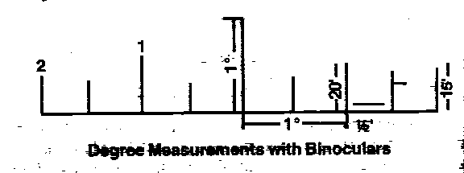

(b) **Hand Angles**. This is a rough method which is sufficiently accurate for practical purposes. The various degree measurements are given in the diagrams below. Remember to keep the left (LEFT) hand fully stretched and tilt it in the required direction. As the size of hand varies considerably the figures given below are approximate only. Each person should with the help of a degree scale check his hand for degrees.

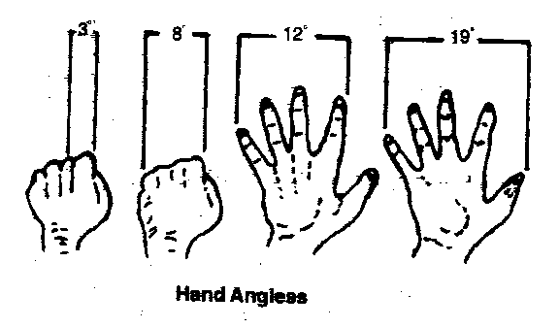

(c) **Sight and Sight Protectors of the Rifle**

The rifle held in the aiming position gives the following degree measurements:-

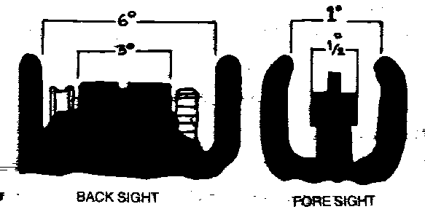

(i) Within the inner edges of back-sight (i) Within the inner edges of

protector 6 degree. fore-sight protector 1 degree.

(ii) Length of the rectangle of the (ii) Bed of fore- sight protector blade-

back-sight – 3 degree. ½ degree.

**Finger’s Breadth and Hand Span Method**

19. This is a rough alternative to the degree method for use as an elementary training aid. In this method the LEFT arm is outstretched. One eye is closed and deflections to the Left and Right are given in fingers, ie hold the hand so that the left edge of a finger is in line with the reference point, if the Right edge of the same finger is in line with the object, the object, is one finger width to the Right of the reference point. Announce this lateral interval, announce it as ‘Right one finger’. When two fingers can be applied to this lateral interval, announce it as ‘Right two fingers’ Similarly this interval can be measured as hand span (Hindustani equivalent ‘Balisht’) representing the distance between the thumb and little fingers when the arm hand and fingers are outstretched. Avoid intervals of more than one hand span as they are difficult to measure. This method can be used with or without clock ray i.e.

“GATE, DAHINE – EK Baje-ek ungal JHONPARI:

Or

“GATE, BAEN-EK Balisht – JHONPARI”

**Miscellaneous Methods**

20. Some miscellaneous methods are given below:-

(a) **Firing a Burst from LMG**. This method should be used with discretion as it is likely to give away own position, and surprise will be lost.

(b) **Moving Object**. Useful aids for drawing attention but not for using a reference point. One does often come across moving objects like cattle.

(c) **Use of Pointer Staff.** Indicating targets to individuals with the aid of a pointer staff.

(d) **An Unusual Object**. Something which is not part of the natural pattern, will be recognized easily and quickly provided there are not too many in the area e.g. smoke rising or hay stack.

(e) **Use of Intermediate Object**. An intermediate object may be used for indicating a difficult target. Example No 1 Section-reference Darakht Baen-9 baje 8 degrees – do chhoti jharian-baen jhari 7 baje – 3 degree ghas ki ganji.

21. If an object is not recognized after being indicated use a different method of indication.

**Verification**

22. To ensure that an indication has been correctly recognized it may be desirable to check back. To do this the person indicating will say ‘ Check back’. The recipient will then indicate some other landmark using the target previously indicated as his reference point e.g.

(a) The indicator might say-

‘TEMPLE-DAHINE 2 baje – CHHOTA DARAKHT.

Call it CHHOTA DARKHT – Check back.

(b) The recipient might say

“CHHOTA DARAKHT – BAEN – 7 baje – 2 degree PULIA”

23 Only those who have not recognized object or target after it has been indicated, will shout ‘ Not seen”, silence will imply that the indication has been followed.

**How to Describe**

24. Some point are given below:-

(a) When describing an area on the ground which includes landmark in the rear of an observer, such as an assembly area, start with the general line of direction. Then go round in clock wise direction finishing with the landmark first pointed out.

(b) When describing an area within an arc, in front of an observe, start with the general line of direction and then indicate the landmark from LEFT to RIGHT. Reference points, if required, are given out after the general line of direction.

(c) When two land marks are in the same line, describe the one nearer to you first and the distant one later in case initiative is with you, if the initiative is with the enemy, describe the distant land mark first and nearer one subsequently.

**Sequence of Indication**

25. The easy way to remember this sequence is to remember the word ‘GRAD’. The sequence is as follows:-

(a) **Designation of Group**. Designation or name of the group to be given out first i.e. No.1 Section.

(b) **Range**. Range to the target to be given out next i.e. No. 1 Section -200, the word ‘Yards’ will not be used as it is understood that the range is in yards. Note that the range should be given in fifty and hundred only. For example 350, 250,200 and NOT 325 or 275 and so on.

(c) **Aid**. If an aid such as direction has been used it will be given out after the range. The direction will be in relation to the general line of direction.

**Description**

26. (a) Describe the target (No 1 Section – 350- Adha baen – Pul).

(b) If no aid is used then the description of the target will follow the range e.g ‘No. 1 Section - 200 Pull’ Description of the target is the most important of all. It should be clear and unmistakable. This can be achieved by describing some prominent trait or characteristic of the target e.g. Kale tane wala darakht’. Or Do Khirkion wala ghar’.

(c) Some-time it may be necessary to describe a target by its position in relation to the objects e.g. ‘Ganne ke khet pe baen kone wali mitti ki dheri’.

**Conclusion.**

27. To achieve success in war it is of utmost importance that the target is understood and recognized by the troops. It is of no use reaching/capturing a target not intended to as this may jeopardise the plans.

**SECTION-6**

**MOVEMENT WITH & WITHOUT ARMS**

**(ONLY FOR SW)**

**General**

1. A knowledge of how to move correctly and how to use ground is important to enable individuals and groups of individuals to close with the enemy, while exposing themselves as little as possible to enemy’s view and fire. A knowledge to move correctly using correct cover as per the ground is essential. This is also essential for snipers and the patrols to accomplish their tasks. Every feature, natural and artificial, must be used to provide cover from the fire and view.

2. The method of movement are given below:-

(a) **Crawling by Day with Rifle**

(i) Monkey run.

(ii) Leopard crawl.

(iii) Walk.

(iv) Roll.

(b) **Crawling by Day with LMG**

(i) Knee crawl.

(ii) Side crawl.

(iii) Leopard crawl.

(c) **Crawling by Night**

(i) Ghost walk.

(ii) Cat walk.

(iii) Kitten crawl.

**Crawling by Day**

3. **Monkey Run**. Ther is useful for moving behind low cover upto about two feet high. Go fast for about 15 yards, drop flat, pause and then crawl further. The method of crawling is explained below:-

(a) **Without Arms**. This is done on hands and knees. Hands are moved forward in turn and so are the knees. Every time a hand is moved forward, the knee corresponding to it is also moved forward to the spot vacated by the hand. When silence is more important then speed. The knee should be placed on the exact spot vacated by the hand. When silence is more important than speed, the knee should be placed on the exact spot vacated by the corresponding hands. The hand should reach forward to safe place.

(b) **With Rifle**. The rifle may be held in the Right hand at the point of balance. Care must be taken to keep the muzzle up to prevent dirt from getting in.

4. **Leopard or Stomach Crawl**. This is useful for moving behind low cover. The method of crawling is explained below:-

(a) **Without Arms**. This is done on elbows and knees. Hug the ground with chest and crouch flat on the ground and arms, outstretched in front. Propulsion is obtained from alternate elbows and knees movement. While crawling roll slightly from side to side as each knee is bent. Avoid kicking up the heels and keep the head, body and elbows close to the ground. Alternatively, one knee only can be used the other led trailing along the ground.

(b) **With Rifle**. This is done on knees and elbows by moving the rifle forward holding the RIGHT hand under the rifle between the point of balance and the outer hand. An alternative method is to grip the rifle diagonally across the body with small of the butt underneath the RIGHT arm pit.

5. **Walk**

(a) Never walk with the head bent as this affords no protection but hinders observation. Walk with head up and observe all the while. Silence is important when crossing hard ground, the least noise is made if the outside of the sole of the boot is placed first on the ground. Balance is essential to silent movement and this is assisted by keeping the knees slightly bent.

(b) **With Rifle**. Rifle is held in the LEFT hand across the body, ready for instant action. Carry the rifle so that it looks as a part of you. The alternative method is to carry rifle near the front swivel and the RIGHT hand holding the small of the butt.

6.  **Roll**

(a) Roll away keeping the arms to the sides or stretched forward. This is often the quickest way of getting away from a spot where the enemy has seen you. Practice is necessary if the tendency to giddiness is to be overcome.

(b) **With Rifle**. When rolling to the right keep the rifle into the RIGHT side and vice versa.

**Crawling with LMG**

7. **Knee Crawl (No.1)**

(a) This is useful for moving behind waist height cover e.g. wall, hedge rows.

(b) This one is with the LMG only. The LMG is held in the left HAND. LEFT foot, Right knee and Right hand are placed on the ground. The body weight is taken on the RIGHT knee. The Right and the Left foot are moved forward simultaneously followed by the RIGHT knee.

8. **Side Crawl (No. 1)**. Lie on a side and rest the gun on the instep of lower leg which is kept flat to the ground. Hold the carrying handle with the Right hand and the barrel with the LEFT. Propulsion is obtained by kicking with upper leg.

9. **Leopard Crawl (No. 1)**. Take the gun forward to the limit of the extent of the arms and propel the body forward by legs using the leopard crawl method.

10. **Combined Leopard Crawl (Nos 1 & 2)**. No 1 grips the small of the butt in her left hand, No 2 grips the bipod legs in her Right hand. They both move forward using the leopard crawl. No 1’s LEFT arm and leg keep step with No. 2’s RIGHT arm and leg and vice versa.

11. **Combined Leopard Crawl by Bounds (Nos 1 & 2)** . Nos 1 & 2 crawl forward 2 to 3 yards, and lift the gun forward. In this method the gun is kept continuously in the firing position.

**Crawling by Night**

12. **Ghost Walk**. For all night movements silence is more important then speed. Silence can only be achieved by perfect balance. Stand up, lift the legs high to avoid long grass and sweep them outwards in a semicircular motion. Feel gently with the toes for a foothold. Makes sure that one foot is safe before the next foot moves, and knee slightly bent. Always lie down when you halt at night

13. **Cat Walk**. Get down on the hands and knee and move each hand forward searching the ground carefully, making sure there are no twigs, then raise the knee and put it sown on the spot where the hand is. Then move the hand forward again. This is very slow method but very sure.

14. **Kitten Crawl**. If the ground is covered with twigs the normal stomach crawl make noise. When moving very close to the enemy and when perfect silence is essential the only sure method is to keep raising the whole body off the ground on the forearms and the toes pressing forwards lowering the body, feeling carefully with hands each time. This is very slow and tiring method which requires considerable practice, but is invaluable. Accurate information at night can often only be obtained by movement very close to the enemy.

15. **Stalk.** Ground however carefully selected together with camouflage alone is not sufficient to enable us approach the enemy. One must use it like an animal staking its prey instinctively and unerringly. The use of ground and camouflage combined with the actual move forms the basis of all minor tactics.

**Points to Remember**

16. (a) Move from cover to cover and make use of natural camouflage. Stop, observe and listen from bound to bound and do not keep moving forward the whole time.

(b) Watch your front and flanks.

(c) Crawl slows the movement and hiders observation, therefore crawl only when you must. After crawling for some distance stop, listen and observe and then crawl further.

(d) Weapons must always be kept ready for use.

(e) Look carefully and all round for enemy.

(f) Double across small gaps.

(g) If shot at, drop and crawl away to a side.

1. Check equipment for noise.

(j) Always consider an alternative route.

(k) Do not disturb the birds, if this can be helped.

**BATTLE CRAFT**

**SECTION-7**

**FIELD SIGNAL**

**General**

1. It is not always possible to give verbal orders through words of mouth because of battle noise, security reasons and intervening distance being too great for effective voice control.

**Signal With Hand**

2. (a) Deploy Right arm fully extended above head and waved

from side to side, palm open.

(b) Advance Right arm swung from rear to front in ‘under arm

blowing’ fashion.

(c) Halt Right arm raised to full extent above head.

(d) Turn About Right arm raised and bent above head.

(e) Change direction Right arm raised to front in line with shoulder.

Body then turned in required direction.

(f) Close Right hand place on top of head, elbow to the right.

|  |  |  |
| --- | --- | --- |
| (g) | Quick Time | Right hand raised to line of shoulder, elbow close to the side. |
| (h) | Double March | Right fist clenched, moved up and down between thigh and shoulder several times. |
| (j) | Follow me | Right arm swung from rear to front above the shoulder, in ‘over arm bowling’ fashion. |
| (k) | Last order completed | Right hand to salute, then arm raised in air finger extended. |
| (l) | Last order Not understood | Both hands, cupped behind the ears. |
| (m) | Commander to close | Right arm to the side at 45 degrees to the body, first  clenched. |
| (n) | Enemy in sight specific numbers | Both arms waved on sides ‘Bird fashion’ followed by number, indicated by number of fingers held up. |
| (o) | Enemy Approaching | Both hands open, palm inwards at waist level, with inwards scooping motion. |
| (p) | Enemy position suspected | Both hands, first clenched, raised to shoulder level, followed by indication of direction. |
| (q) | Enemy LMG firing | Right hand thumb down signal. |
| (r) | Engage Target by Fire | Both hands clasped above the head (boxer fashion). |
| (s) | Attack | Punching motion with Right or Left hand according to direction of attack. |
| (t) | Closed to Rendezvous | Close sign followed by both hands clasped in front of body at waist level. |
| (u) | Infantry obstacle ahead | Both hands crossed in front of body at the waist, palm open downwards. |

|  |  |  |  |
| --- | --- | --- | --- |
| **Signals With Weapons** | | |  |
|  |  |  |  |
| 3. | (a) | Enemy in Sight in small number | Rifle held above the head parallel to the ground, muzzle in the direction of the enemy. |
|  | (b) | Enemy in Sight in large number | As per (a) above, but arm moved up and down several times. |
|  | (c) | Advance | Both arms raised to form the letter ‘U’. |
| **Signals With Whistle** | | |  |
|  |  |  |  |
| 4. | (a) | Cautionary Blast | A short blast to draw attention to a signal or order about to be given. |
|  | (b) | The Alarm Blast | A succession of alternate long and short whistle. |
|  | (c) | Enemy Aircraft | A succession of short blasts. |
|  | (d) | Enemy Aircraft departed | Two long blasts repeated at interval of five second. |

**SECTION- 8**

**SECTION FORMATION**

1. The factors which influence the section commander in his choice of formation are as follows:-

(a) Ground.

(b) Task.

(c) Type and direction of enemy fire.

(d) Need for security and control by the section.

(e) Necessity of producing the maximum fire with minimum delay.

2. A section is normally split into two groups, namely the LMG group and the rifle group. These groups facilitate fire and movement.

3. The LMG group should usually be on the open flank or the flank which will provide the best intermediate fire positions. The interval between individuals should be about 4.6 m (5 yards) by day. The distances between groups will vary to suit the ground.

4. Section formations, with advantage and disadvantages, are as follows:-

|  |  |  |  |
| --- | --- | --- | --- |
|  | **Formation** | **Advantage** | **Disadvantage** |
| (a) | **Single File** | Good for control, not vulnerable to enfilade fire, useful for moving along ditches, narrow defiles and so on. | Bad for fire production, vulnerable to frontal fire. |
| (b) | **File**. | Good for control. Useful for moving along broad roads, wide nullahs and so on. | Not good for fire production, vulnerable to frontal fire. |
| (c) | **Diamond**. | Good for control, not vulnerable to enfilade fire, good for all round fire production and observation. | Present a good target to frontal fire. Not very good for fire production to the front. |
| (d) | **Arrow-head** | Good depth, not vulnerable to frontal fire, good for fire production, probably the best formation for crossing open ground. | Control more difficult than in diamond. |
| (e) | **Spread-head** | Good depth, less vulnerable to enfilade fire than arrow head, LMG group not committed immediately on contact. | Control difficult. Delay in fire production. |
| (f) | **Extended Line** | The formation used in the final assault. Very good for fire production (from the hip) and bayonet fighting. | Control difficult. Very vulnerable to enfilade fire, no depth. |

5. In each of the section formations, the positioning of the LMG and rifle groups is the responsibility of the section commander. He may order a gap to be left between groups and may even split his rifle group into parts as is frequently done in jungle fighting. His own position in the section should ensure good command and control.

**SECTION-9**

**FIRE AND MOVEMENT**

**General**

1. The primary aim of the infantry is to close with the enemy and destroy him. It is only possible to move forward against opposition by skilful use of ground, with the help of supporting fire or by a combination of both. The enemy will select positions which, as far as possible, give no ground cover to the attackers. By means of fire, mines and other obstacles he will attempt to halt the latter’s advance. Supporting fire is, therefore, necessary to keep the enemy’s head down and make movement possible. The combination of fire and movement is the basis of platoon and section tactics. It demands from the soldier the highest standards of weapon training and fieldcraft.

2. There are five basic considerations for fire and movement. These are as follows:-

(a) There should be no exposed ground without covering fire.

(b) Control by the commander.

(c) The angle of covering fire from direct firing weapons should be as wide as possible without loss of control or time.

(d) Full use should be made of all available cover. When cover is lacking the use of smoke (smoke grenade) should be considered.

(e) Full use should be made of all available weapons for covering fire.

**Ground Appreciation**

3. In a battle, fire and movement is applied according to the type of country over which it is fought. In open country the problem is how to find cover; in close country, there is the difficulty of finding positions with good observation and field of fire. In attack or defence, the skilful use of ground can help to gain in developing an eye for ground. Ground should be considered from the enemy’s point of view. It should be appreciated under the following headings:-

(a) Fire positions.

(b) Observation positions.

(c) Cover from fire.

(d) Cover from view.

(e) Obstacles.

4. **Types of Cover**. Cover from view is often not cover from fire, especially if the move to cover has been seen by the enemy. Concealment from enemy air and ground observation is the chief means of gaining surprise. Some of the main types of cover are:-

(a) Undulating ground which is the least obvious form of cover; when skillfully used, it protects from direct fire and gives no ranging marks to the enemy.

(b) Sunken roads, beds of streams and ditches which give good cover from view and often from fire as well. However, there is always a danger that the enemy may pay special attention to them; they may be mined or booby-trapped and precautions against ambush must be taken. If the roads or ditches are straight, the enemy will be able to fire down them in enfilade.

(c) Hedges and bushes give cover from view but not from fire. In open country they may make good ranging marks for the enemy.

(d) Standing crops give cover from view but movement through them can generally be detected.

(e) Woods which give cover to men and vehicles from enemy air and ground observation. They give some protection from small arm fire but HE bombs and shells will explode in the branches of trees and will cause heavy casualties unless troops are dug in and have overhead protection.

(f) Buildings and walls afford concealment and protection from small arms fire and shell splinters. When isolated they make good ranging marks for the enemy.

5. **Dead Ground**. Ground which a soldier can not see from his position is called dead ground. Platoon and section commanders should be able to recognise ground which is likely to be dead to the enemy. Ground can only be described as dead in relation to the position of an observer. Troops under cover or in dead ground are safe from enemy observed fire but not from indirect fire. These areas are always likely to be selected by the enemy as defensive fire tasks for his artillery and mortars. Dead ground is also safe from detection by battle field surveillance radars, as these have line of sight limitations.

6. **Common Mistakes**. The wrong use of ground may lead to casualties and loss of surprise; some common mistakes are:-

(a) Carelessness by troops while making a reconnaissance, such as unfolding a map in the open or not using a covered approach to an OP.

(b) Unnecessary movement in a position overlooked by the enemy.

(c) Using conspicuous landmarks such as isolated trees, bushes or cottages.

(d) Halting troops near road or track junctions or other mapped features which are always registered as targets by the enemy.

(e) Bad track discipline.

(f) Failure to guard against enemy air observation.

**Maps and Air Photographs**

7. Maps and air photographs should be used together to obtain the best picture of the ground. The two aids are complementary as is shown by listing the advantages and limitation of air photographs:-

(a) **Advantage**.

(i) Are more up-to-date.

(ii) Gives more detail.

(iii) Show the size and shape of features accurately.

(iv) Allow gradient to be seen in relief with a stereoscope.

(b) **Limitations**

(i) Complete geographical cover almost impossible.

(ii) Expensive to produce.

(iii) Scales vary.

(iv) Details of heights not given.

8. Only the topographical information given by air photographs needs to be understood. The interpretation of the details of enemy defences is the task of the experts. Very little time need be spent in mastering the theoretical knowledge of map reading but a great deal of practice is required. The use of the prismatic compass and the protractor must also be mastered by sub-unit commanders. Navigation is a science and never a guess. An officer must have complete trust in his compass; this only comes with practice.

**Selection of Fire Positions**

9. The ideal fire position should:-

(a) Provide cover from fire.

(b) Provide cover from view.

(c) Afford a good view of the ground to be watched or target to be engaged.

(d) Provide room in which to use the weapon freely.

(e) Have a covered approach.

(f) Be easy to advance from.

10. The selection of fire positions requires a knowledge both of the characteristics of weapons and of the use of ground. A direct firing weapon must be sited with an eye at the level from which it is to fire. A target which is clear to a man standing may be invisible to one lying down.

11. Sometimes it may be necessary to site fire positions on trees, rooftops, haystacks or walls to produce fire effect. This may result in plunging fire, but this must be overcome by accurate shooting. Cunning concealed fire positions will puzzle the enemy, protect the troops from observed fire and safeguard them against air attack.

**Fire Control in Attack and Defence**

12. There is a big distinction between fire control in attack and in defence. In attack men should be allowed a great deal of latitude in opening fire. Speed and immediate fire effect is what is required. With a well concealed enemy it will often be necessary to “neutralise” an area by fire since few definite targets will be visible. In defence, the vital factor in fire control is that early opening of fire may give away positions to the enemy and jeopardize concealment. Normally, a section commander will lay down a line in front of his section post beyond which fire will not be opened without his orders. This is particularly important where a long field of fire is available. In any case fire will normally be opened on the orders of the section commander.

**Movement**

13. Movement in the face of the enemy should be covered by fire. This does not mean that it is impossible to move unless a heavy weight of fire is brought down on the enemy. An important part of an attack is the movement towards the objective, supporting fire is one of the aids to that movement. A knowledge of how to move and how to use ground for movement is essential to enable troops to close with the enemy with minimum casualties, undetected in the zone of arc of battle field surveillance radars.

14. Usually, troops advancing by day in action will move at a brisk walking pace until they make contact; in the final stages of the assault, they will double. They may have to double or crawl at other times; for example if attacking troops move into enemy defensive fire, it is usually best to double forward and through it; to lie down is often dangerous as well as useless. Doubling and crawling are both tiring however, and should only be used in short spells in critical situations particularly for crossing open ground in full view of the enemy. The commander must himself decide on his pace from his personal knowledge of the state of fitness of his men. In general the aim must always be to keep moving determinedly towards the enemy at the best possible speed.

15. When crossing an open space like a gap in a hedge, it is best for the whole section or group to double across it together, before the enemy has time to fire effectively. When wider gaps are under enemy observation, it may be necessary to filter men across now and again by crawling in ones and twos.

**SECTION-10**

**SECTION BATTLE DRILL**

**General**

1. A section will rarely be employed in an operation by itself but the action of a section is the basis for action of bigger subunits or units and, therefore, it must be thoroughly understood.

2. The Section Battle Drill is divided into 4 stages.

(a) Stage – 1 – Action on coming under effective fire.

(b) Stage – II – Locating and neutralising the enemy.

(c) Stage – III- Attack.

1. Stag – IV- Re–organization.

**Action on Coming under Effective Fire**

3. The Section Commander, as he advances, will constantly be on the look out for:-

(a) New reference point for fire control orders. He may describe these to the section as they advance and each may acknowledge with a signal or shout ‘Not seen’ if he had failed to recognize the reference points, and.

(b) Position where the section can take cover in the event of coming under effective fire. Whenever, possible the section commander will indicate such positions in form of anticipatory orders e.g. ‘if we come under effective fire, LMG group takes cover in those bushes, rifle group along that bank’.

4. It is instinctive to most men to drop down on the ground, when under fire. The men should not go to ground till the effective fire of the enemy is brought down or the order ‘Take Cover’ is given by the Section Commander. On receiving order for taking cover the following action will normally be taken by each man of the section:-

(a) Run to the nearest cover or that already indicated by the Section Commander in his anticipatory orders.

(b) Every man will dive or drop into the cover and crawl away so that the enemy has not got his sights on anyone when he re-appears.

(c) Take position and observe the enemy.

1. Apply sight and fire on spotting the enemy without waiting for an order from the section commander.
2. Bunching together should be avoided at times and apart from No 1 and 2 of sthe LMG group, when necessary, no man in the open by day should ever be less than 5 yards from his nearest fellow , depending on the cover available.

(f) On ‘TAKE COVER’ order by the section commander, DASH-DOWN-CRAWL-OBSERVE-SIGHTS-FIRE (If the enemy has been located).

**Locating and Neutralizing the Enemy**

5. **Locating**. The location of enemy and its fire is usually not easy. The following drill will be followed for locating the enemy.

(a) **By Observation**. Look in the area from which the ‘thump’ came. The time between the ‘crack’ and the ‘thump’ gives an indication of the range. If nothing is seen after about 30 seconds or so, it is very unlikely that enemy will be located by looking.

(b) **By Fire**. The section commander will give a fire control order to a couple of rifleman to fire two shots each into likely cover. The rest of the section will observe their area of observation carefully. If there is no answer to fire, then the section commander should try another couple of rifleman at some other target. If there is still no enemy fire, either they are well trained or they have withdrawn.

(c)  **By Movement**. The section commander will order one or two men to get up and double forward about 10 yards to a different cover. He might do this again if it draws no fire. If the enemy troops are there, they must be extremely well trained not to fall for these tricks and start firing at such poor targets. (A man getting up and moving fast for about 10 yards is a very difficult target to hit). If there is still no enemy reaction then the section commander must continue the advance.

**Target Indication**

6. If any soldier of the section located the enemy before the section commander, he will insert a tracer round into his rifle, shout ‘Watch my Tracer’ and fire and continue to fire, until, the section commander issues fire control order or orders to stop the fire.

**Neutralisation**

7. (a) As soon as the section commander knows the position of the enemy he must give a fire control order to bring on the enemy sufficient weight of the section fire power to neutralize them. If certain individuals have already started the firing, the section commander will resume control by preceding his fire control order with the order ‘STOP’.

(b) Having won the fire fight, the section commander must retain the fire initiative by cautiously bringing fire down on the enemy whilst he manoeuvers closer in order to assault them.

**The Assault**

8. The section commander will decide whether to attack from the flank or right flank depending upon the position of the LMG group, the position of the enemy and the routes available.

9. The section commander’s orders, for the assault are confined to :-

(a) LEFT or RIGHT flanking (to indicate which side of the LMG group, the rifle group will work).

(b) Which group will move first and.

(c) Place to which LMG group will move, if it is to move first.

10. The main points to note are:-

(a) The section commander will lead the rifle group in person, he is normally in the centre.

(b) Covering fire will be provided for all movements in the open. The angle of the fire should be as wide as possible.

(c) When the rifle group gets down into fire position after a bound, the LMG group must move forward into a new fire position automatically. Once the LMG group is in a position from which it can support the assault from a good angle, the rifle group will move in one bound. Before the assault goes in, the rifleman armed with the grenade discharger cup and the projector strim grenade should be ordered to remove these from their rifle, if necessary.

(d) Normally the assault will start at the ‘walk’ with firing being carried out from the shoulder or the hip (marching fire). The section doubles only during last 100 to 50 yards when the section commander gives order ‘CHARGE’.

(e) No 1 and No 2 of the LMG group must carry sufficient magazines to support a normal section attack.

(f) As the assault goes in, the LMG group will fire as long as possible and then switch its fire across the objective just in front of the rifle group.

**Re-Organisation**

11. Once the assault is made the following action will take place as drill:-

(a) The LMG group will rejoin the fire group ‘at the double’ immediately it sees the rifle group take cover after the assault.

(b) The section commander will organize a search of the area of the objective for any enemy hiding or wounded. Rifle numbers detailed to search will be covered by other rifleman.

(c) The section commander will check positions of rifleman and LMG group, allot arcs of observation and detail reference points.

(d) The section commander will check:-

(i) Causalities,

(ii) Ammunition expenditure, and

(iii) Refilling of LMG magazine.

(e) The section commander will await the platoon commander for further orders.

**SECTION-11**

**FIRE CONTROL ORDERS**

**Introduction**

1. By opening of fire indiscriminately, too early or at too great a range, the defender’s position will be disclosed prematurely which will mean wasting of ammunition without advantage. This means Section Commander should be able to control the fire of his section by exercising good fire discipline.

**Important Terms**

2. Certain terms given below are commonly used in connection with fire control:-

(a) **Fire Unit**. Any number of men firing under the command of one man, usually, a section. The person responsible for giving the executive order of fire, is the fire unit commander.

(b) **Fire Direction Orders**. These are the orders which the fire unit commander receives from his superior, telling him when, at what target and with what intensity to open fire. A section commander will receive fire direction orders from his platoon commander. They include special directions about opening and withholding fire.

(c) **Fire Control Orders**. These are orders given by the fire unit commander to direct and control the fire of the section. Emphasis should be on control and supervision. These orders are the final with complete instructions after all factors have been considered and before fire is actually opened.

(d) **Arc of Fire**. This denotes the area of ground for which the fire unit is responsible and with in which it will engage targets. An arc of fire, must not be confused with field of fire which is the area upon which it will be possible to fire effectively in any direction.

**Points for Section Commander**

3. There are certain points which must be remembered before giving a fire control order. These are explained below:-

(a) **Indication**. No fire control order can be effective unless the target is clearly indicated and can be easily recognized by the men of the fire unit.

(b) **Range Visibility and Vulnerability**. It should be considered if the range, visibility and vulnerability of the target justify fire at all. Would it be better to wait and get a more vulnerable or more complete surprise?

(c) **Best Weapon to Use** . What is the best weapon to use, although the LMG is the main weapon of the section, the target may be more suitable for the fire of the riflemen only or for a combination of both weapons.

(d) **Single Round or Burst**. Should the fire be in single rounds or in burst. Should it be rapid or at the normal rate? Rapid rate is justified only on a comparatively few occasions when it allows the maximum effect to be gained from surprise when an especially vulnerable target presents itself or to cover move in the final phase of an assault.

**How to Give Fire Orders**

4. Having decided to open fire, the next problem is how to give the orders. The four main rules which must be followed are as under:-

(a) The orders should be given clearly, calmly and consciously.

(b) It should be given loudly, so as to be heard over the noise of battle but should not be louder than required.

(c) It must be given as an order, and obeyed as such.

(d) It must be given with adequate pauses, so that those being addressed may have time to take the correct action, for example, there must be time for sight adjustment after the range is ordered. No 1 Section (Pause) 300 (Pause) fire when you see a target.

**Types of Control Orders**

5. There are four types of control orders. These are explained below:-

(a) **Delayed Fire Order**

(i) “ No. 1 Section – 600-enemy approaching await my orders”.

(ii) “No. 1 Section 600-enemy advancing through jungle, fire when enemy reaches, open ground”.

(b) **Opportunity Fire Order**

“No. 1 Section. Enemy hidden in broken ground, fire when seen”.

(c) **LMG Group Fire Order**. “LMG group sight down – enemy running left to right – fire”

(d) **Full Fire Order**

(i) **Pin Point Target**. “No 2 Rifleman – 300 Tree Right – 50 RED HUT- enemy sniper-fire”.

(ii) **Area Target**. “LMG-Group -500-Tree-Right Grove, enemy section, burst fire”.

**Sequence of Fire Order**

6. An accepted sequence should always be used in order to avoid confusion, or misunderstanding. The suggested code work is ‘GRIT’, each letter of which signifies stage in fire orders as follows:-

**G**-The Group of the section which is addressed, that is the LMG group or the whole section. An order starting with “No 1 Section” indicates that the whole of No. 1 Section will fire. “LMG-Group or Rifles Group” means that the group named only will fire.

**R**-The Range to the target. To ensure accuracy of fire and to concentrate attention on a limited area of ground.

**I**- The Indication of the point of aim by its description.

**T**-The type of fire to be employed.

**Conclusion**

7. Fire control orders are essential to maintain surprise, save ammunition and engage targets with speed. The correct sequence must be followed to avoid confusion.

**SECTION-12**

# TYPES AND CONDUCT OF PATROLS

**(ONLY FOR SD)**

## General

1. Patrolling is the acid test of a trained cadets individual training. The success of any operation depends largely on the availability of accurate and timely information about the enemy. This information is mostly obtained by patrols.

2. Patrolling develops four essential qualities of the fighting man:-

* 1. Discipline
  2. Comradeship
  3. Aggressiveness.
  4. Alertness.

**Functions**

3. There are two functions performed by patrols:-

1. **Reconnaissance.** To obtain information upon which commanders can base their plans.
2. **Protection.** It involves preventing enemy patrols from obtaining information or giving early warning of the approach of enemy forces.

**Types of Patrols**

4. There are two types of patrols:-

(a) Reconnaissance Patrols (Recce Patrols)

(b) Protective Patrols.

### Recce Patrols

5. The aim is to gain information secretly and silently without getting involved in fight. It may however have to fight some times for information which should be conveyed to proper commander in time to be of value.

6. **Composition**. The party should be small. It should consist of a patrol leader usually an officer or a JCO and his escort of one or two men. Where it is evident that information can not be obtained unless the patrol is prepared to fight, its strength must be adjusted in accordance with the requirements.

7. **Arms**. It is ideal to carry only close quarter battle weapons. Heavier weapons should be avoided.

### Protective Patrols

8. **Duties**. Patrols engaged in protective duties will have to patrol on the front allotted to them. Their tasks will include to deny approaches to enemy patrols and obtain earliest possible information of the approach of the enemy.

### Strength and composition

9. Patrols engaged in protective duties should be prepared to fight and should be organized accordingly. The strength will depend on the task. This must be supported by a carefully worked out fire plan if required.

### Technical Representatives

10. Patrols whose tasks are solely of obtaining information of technical nature will include representatives of technical arms. The commanders of such patrols are infantry officers, irrespective of the rank of the specialist representatives included in the patrol.

### Stages of Patrolling

11. There are three stages of patrolling:-

1. Preparation.
2. Conduct.
3. Debriefing.

**TASKS**

### General

12. Patrols may be employed for various tasks according to the needs of the situation. The main tasks are however as follows:-

### Recce Patrols

13. **Tasks**

(a) Location and details of enemy position.

(b) Location of obstacles laid by enemy and constant plotting of features.

(c) Study enemy habits.

(d) Any other specific information asked.

### Protective Patrols

14. (a) To deny approaches to enemy patrols and obtain earliest possible information of the approach of the enemy.

(b) To gain and confirm topographical information including that of artificial obstacles.

(c) To give early warning of the enemy’s intentions.

1. To deny information to enemy patrols.
2. To dominate ‘No Man’s Land’.
3. To protect flanks by aggressive patrolling.

**RESPONSIBILITIES OF PATROL LEADER AND SCOUTS**

### Responsibilities of Patrol Leader

15. The patrol leader being the commander of the patrol party, is responsible and accountable for the following:-

(a) Quick thinking and out line planning.

(b) Selection of men. Same man should not be taken time and again. None should be suffering from cough or other ailment. Keep few reserves.

(c) Details of arms and ammunition to be carried by each.

(d) Any special equipment to be carried.

(e) Communication.

(f) Gaining maximum information.

(g) Detailed recce and planning.

(h) Briefing of patrol.

(j) **Rehearsals.** Rehearsals of the following should be carried out when ever time is available.

(i) Formations.

(ii) Method of crossing obstacles.

1. Action on meeting the enemy.
2. Protective measure during the halts.

(k) Final inspection.

1. Successful conduct of the patrol and completion of assigned tasks.
2. Debriefing.

###### RESPONSIBILITY OF SCOUTS

**General**

16. Scouts are a pair of soldiers from the section who work ahead of the section when it is on move except when another section is leading. These two men work as the eyes and the ears of the section. Their function is to:-

(a) Protect the section by giving early warning of the enemy and to prevent their section from getting either ambushed or from under enemy fire unexpectedly.

(b) Increase the speed of move of their section by permitting it to move more closed up than it would if there was no one between the section and the enemy.

### Some Points to Remember

17. (a) Scouts should move from cover to cover using the correct methods of observation around cover.

(b) Scouts should move by short bound in area where enemy is suspected.

(c) A pair of scouts should move one behind another and should keep each other within easy voice control .The leading scout should often look over his shoulder to ensure that he has the second scout in visual contact. However, it is for the second scout to keep up.

(d) Scouts must always be alert.

(e) Scouts must protect each other by placing themselves in such a way that they can cover each other by fire.

(f) Scouts move as individuals making use of ground and cover.

1. Scouts must always remain in contact with the unit through the sub-units commander.
2. Communication are from front to rear. Contact is visual.

(j) Scouts must so move on ground and take cover in such a way that they do not give away each others position.

(k) Scouts must not bunch together on bounds.

### Conclusion

18. The training and efficiency of a section is judged from the work of the scouts. Its speed and safety depends upon them. They should work in pairs making intelligent use of the ground.

**ADMINISTRATIVE REQUIREMENTS**

### General

19. In any military operation however, large or small scale it be, the administration is of paramount importance and plays a vital role in the ultimate analysis. No operation can sustain for long without an effective and sound administrative back up and hence need no emphasis.

20. For the successful conduct of a patrol the following administrative aspects should be borne in mind:-

(a) Composition of patrol and selection of men.

(b) Dress and equipment.

(c) Arms, amn and equipment.

(d) Food including extra rations to be carried.

(e) Water consumption and discipline.

(f) Evacuation of casualties if any.

(g) Rest and refit.

(h) Communication with in and out side patrol.

(i) Security, Items of security value should be discarded.

(k) Any special equipment specially required for night operations.

**CONDUCT OF PATROL**

21. **Formations.** The formation adopted by a patrol will depend on

(a) Cover.

(b) Control.

(c) Protection.

(d) Ground.

22. The exact formation adopted will also be affected by the size of the patrol and individual preference of the patrol leader. It must at all times provide for effective control by the commander and the security of the patrol.

23. **Patrol Base**. A patrol base is established in an area of tactical importance close to the enemy but not observed or dominated by him. Radio sets, stretcher bearers and the men and material not required by subsidiary patrols are left here. Necessity of patrol base will arise when:-

(a) ‘No Man’s Land’ is wide,

(b) Two more small patrols are required to be sent from there, and

(c) There is a danger of small isolated patrols suffering serious interference from the enemy on the way.

24. A patrol base should be:-

(a) Suitable for defence and always have enough strength for this,

(b) Neither too close to be safe, nor too far to be useful, 500 to 700 yds by day and 300 to 400 yds by night is a rough guide in open country.

(c) Easily recognisable at night.

### Some Practical Hints

25. The following points are worth noting:-

(a) For better observation move on high ground during day and on low ground during night.

(b) Be alert and avoid obvious places like bridges, villages, roads, tracks, junctions. Patrols should use land marks to keep direction while keeping clear of them.

(c) Move by bounds, one foot on the ground.

(d) Do not give away your presence by shine, light, coughing or rattling.

(e) Observe and note down whatever you can while enroute.

(f) Be aggressive if you meet the enemy and cannot avoid without being detected. In an encounter the patrol which shoots first is likely to win.

(g) While returning, do not lose the information gained by unnecessarily getting involved in a fight.

(h) If not sure whether an object is moving, do not look at it continuously but fix its position relative to a star or another object. Look away and look back to see whether its position has changed. A bush will ‘present arm’ if you stare at it long enough.

(j) Noises at night sound closer than they really are conversely any noise made by your own patrol goes a long way.

(k) A careful balance must be maintained between speed and silence. At night, it is easier to hear than to see. You cannot listen on the move. It is advisable, therefore, in the early stages, to move rapidly from point to point, stop frequently and listen. Nearing the enemy, silence is more important than speed.

(l) Detail one man (Get away man) before setting out, who, if the patrol gets heavily involved, may be ordered to try and return with such information as has been obtained. For such patrols RVs detailed are usually the bounds, so that the men know where to re-assemble it they are scattered.

### Debriefing

26. Immediately on return to its own unit, the patrol leader should report the return of the patrol and give a brief report of his task. Any thing of urgent nature which may affect the conduct of operation should be told immediately. A detailed interrogation should be done of the whole patrol preferably by the same officer who briefed. Debriefing should be done when the patrol has collected the thoughts but before their memory becomes dim. The following points should be remembered:-

(a) Air photographs should be used for checking information regarding ground.

(b) The patrol commander should be allowed to tell his own story without interruptions.

(c) Important information should be cross-checked with other members of the patrol. A great deal of tact and care is required in this. It is not necessary to interrogate every member of the team,but key personnel and the representatives of other arms, if any, should always be interrogated.

(d) Any information of immediate importance must be passed on at once to those affected by it. The interruption thus caused in the interrogation of the patrol has to be accepted.

(e) Tired men are not very communicative. Detailed interrogation should be carried out after the patrol has had some rest. Hot tea and a smoke can be a great help.

(f) There is a normal tendency for exaggeration but it should not be taken for granted that all reports are exaggerated.

(g) Patrolling is difficult and very tiring. Interrogation should, therefore, be done with sympathy and understanding.

(h) All information collected by interrogation should be checked with any other information if already available.

##### **Conclusion**

27. The success of any patrol depends upon careful preparation, good leadership, determination of all member of the patrol, good warning and high morale.